UNITED STATES
SECURITIES AND EXCHANGE COMMISSION
Washington, D.C. 20549

FORM 8-K

CURRENT REPORT
Pursuant to Section 13 or 15(d)
of the Securities Exchange Act of 1934

Date of Report (Date of earliest event reported): July 28, 2026

CENTERPOINT ENERGY, INC.
(Exact name of registrant as specified in its charter)

Texas |  | 1-31447 |  | 74-0694415
(State or other jurisdiction |  | (Commission File Number) |  | (IRS Employer
of incorporation) |  |  |  | Identification No.)

1111 Louisiana
Houston Texas | 77002
(Address of principal executive offices) | (Zip Code)

Registrant’s telephone number, including area code: | (713) 207-1111

Check the appropriate box below if the Form 8-K filing is intended to simultaneously satisfy the filing obligation of the registrant under any of the following provisions (see General Instruction A.2. below):

☐ Written communications pursuant to Rule 425 under the Securities Act (17 CFR 230.425)

☐ Soliciting material pursuant to Rule 14a-12 under the Exchange Act (17 CFR 240.14a-12)

☐ Pre-commencement communications pursuant to Rule 14d-2(b) under the Exchange Act (17 CFR 240.14d-2(b))

☐ Pre-commencement communications pursuant to Rule 13e-4(c) under the Exchange Act (17 CFR 240.13e-4(c))

Securities registered pursuant to Section 12(b) of the Act:
Title of each class | Trading Symbol(s) | Name of each exchange on which registered
Common Stock, $0.01 par value | CNP | The New York Stock Exchange
 |  | NYSE Texas

Indicate by check mark whether the registrant is an emerging growth company as defined in Rule 405 of the Securities Act of 1933 (§230.405) or Rule 12b-2 of the Securities Exchange Act of 1934 (§240.12b-2).

Emerging Growth Company ☐

If an emerging growth company, indicate by check mark if the registrant has elected not to use the extended transition period for complying with any new or revised financial accounting standards provided pursuant to Section 13(a) of the Exchange Act. ☐

 | Item 2.02. | Results of Operations and Financial Conditions.

On July 28, 2026, CenterPoint Energy, Inc. (“CenterPoint Energy”) reported second quarter 2026 earnings. For additional information regarding CenterPoint Energy’s second quarter 2026 earnings, please refer to CenterPoint Energy’s press release attached to this report as Exhibit 99.1 (the “Press Release”), which Press Release is incorporated by reference herein.

 | Item 7.01. | Regulation FD Disclosure.

CenterPoint Energy is holding a conference call to discuss its second quarter 2026 earnings on July 28, 2026. Information about the call can be found in the Press Release furnished herewith as Exhibit 99.1. For additional information regarding CenterPoint Energy’s second quarter 2026 earnings, please refer to the supplemental materials that are being posted on CenterPoint Energy’s website and are attached to this report as Exhibit 99.2 (the “Supplemental Materials”), which Supplemental Materials are incorporated by reference herein.

 | Item 9.01. | Financial Statements and Exhibits.

The information in the Press Release and the Supplemental Materials is being furnished, not filed, pursuant to Items 2.02 and 7.01, respectively. Accordingly, the information in the Press Release and the Supplemental Materials will not be incorporated by reference into any registration statement filed by CenterPoint Energy under the Securities Act of 1933, as amended, unless specifically identified therein as being incorporated therein by reference.

 | (d) | Exhibits.

EXHIBIT  NUMBER | EXHIBIT DESCRIPTION
99.1 | Press Release issued July 28, 2026 regarding CenterPoint Energy’s second quarter 2026 earnings
99.2 | Supplemental Materials regarding CenterPoint Energy’s second quarter 2026 earnings
104 | Cover Page Interactive Data File - the cover page XBRL tags are embedded within the Inline XBRL document

SIGNATURE

Pursuant to the requirements of the Securities Exchange Act of 1934, the registrant has duly caused this report to be signed on its behalf by the undersigned hereunto duly authorized.

 | CENTERPOINT ENERGY, INC.
Date: July 28, 2026 | By: | /s/ Russell K. Wright
 |  | Russell K. Wright
 |  | Vice President and Chief Accounting Officer

Exhibit 99.1

 | For more information contact  Media:  Communications  Media.Relations@CenterPointEnergy.com  Investors:  Ben Vallejo / Ellie Wood  Phone 713.207.6500

CenterPoint Energy reports strong Q2 2026 results; provides update on ERCOT’s Batch
Zero process; increases 10-year capital plan; reiterates full-year 2026 guidance

 | • | Reports Q2 2026 earnings of $0.37 per diluted share on a GAAP basis and $0.40 per diluted share on a non-GAAP basis (“non-GAAP EPS”)

 | • | Reiterates its 2026 non-GAAP EPS guidance range of at least the midpoint of $1.89-$1.91, which, at the midpoint, would represent 8% growth over 2025 delivered results 1

 | • | Highlights over 17 gigawatts of Batch Zero submissions, of which approximately 14 gigawatts are expected to be eligible as base load or studied load

 | • | Increases 10-year capital investment plan by $1.2 billion without increasing current equity financing guide; 10-year capital investment plan now totals $66.7 billion

Houston – July 28, 2026 – CenterPoint Energy, Inc. (NYSE: CNP), or “CenterPoint,” today reported net income of $244 million, or $0.37 per diluted share, on a GAAP basis for the second quarter of 2026, compared to $0.30 per diluted share in the comparable period of 2025.

Non-GAAP EPS for the second quarter of 2026 was $0.40 per diluted share, compared to $0.29 per diluted share in the comparable period of 2025. These strong second quarter results were primarily driven by growth and regulatory recovery, which contributed $0.10 per share of favorability compared to the second quarter of 2025. O&M contributed $0.02 per share of favorable variance compared to last year. These drivers were partially offset by $0.01 per share of unfavorable weather and usage and $0.01 per share of unfavorability from increased interest expense over the comparable quarter of 2025. Lastly, other items contributed $0.01 per share of favorable variance when compared to the second quarter of 2025. This variance was primarily related to the amortization of deferred equity in connection with previous storm securitizations which was partially offset by other taxes and equity dilution.

CenterPoint increased its 10-year capital investment plan by $1.2 billion to $66.7 billion of planned investment from 2026 through 2035, reflecting incremental investment to support accelerating demand from large load customers in Houston, as well as refined investment estimates for the Downtown Houston Revitalization project.

1 CenterPoint is unable to present a quantitative reconciliation of forward-looking non-GAAP diluted earnings per share without unreasonable effort because changes in the value of ZENS (as defined herein) and related securities, future impairments, and other unusual items are not estimable and are difficult to predict due to various factors outside of management’s control.

1

The company also announced that it submitted over 17 gigawatts of large load projects through ERCOT’s Batch Zero process, of which approximately 14 gigawatts are expected to be eligible as base load or studied load. In the aggregate, these approximately 14 gigawatts of projects would represent more than a 65% increase from our current Houston Electric peak system demand of 21 gigawatts.

“As part of our industry’s unprecedented and dynamic era of growth, our teams are converting that momentum into tangible results for our customers, large businesses seeking new connections, and our shareholders. At mid-year, we have delivered strong second quarter results that reflect the strength of our increasing customer-driven capital plan and the progress we continue to make across our strategic priorities. While we remain laser focused on delivering improvements in resiliency and reliability for our customers, we know that the most impactful way we can positively affect customer affordability is to help facilitate regional economic growth and connect more new customers onto our system. We remain confident in our ability to deliver these positive customer impacts, strong financial results and long-term value,” said Jason Wells, Chair of the Board, President and CEO of CenterPoint.

“Houston Electric’s growth trajectory continues to underscore our unique position to help facilitate the region’s continued economic growth. As part of the ERCOT process, we now have approximately 14 gigawatts of eligible base or studied load projected by 2031, which would be over a 65% increase from our current system peak demand. CenterPoint’s ability to leverage existing system capacity, track record of executing large load connections, and ability to make targeted investments to unlock additional expansion is allowing us to move at the speed of business and deliver benefits for all customers. Over the next decade, these new connections are forecasted to meaningfully reduce Houston Electric’s residential and commercial delivery charges by at least $5 billion. With the $1.2 billion increase to our capital plan and the significant customer demand we continue to see, we remain confident in our ability to deliver one of the most compelling, tangible and executable growth opportunities in the utility sector.” concluded Wells.

2

Earnings Outlook

In addition to presenting its financial results in accordance with GAAP, including presentation of net income or income available to common shareholders (loss) and diluted earnings (loss) per share, CenterPoint provides guidance based on non-GAAP income and non-GAAP diluted earnings per share. Generally, a non-GAAP financial measure is a numerical measure of a company’s historical or future financial performance that excludes or includes amounts that are not normally excluded or included in the most directly comparable GAAP financial measure.

Management evaluates CenterPoint’s financial performance in part based on non-GAAP income and non-GAAP diluted earnings per share. Management believes that presenting these non-GAAP financial measures enhances an investor’s understanding of CenterPoint’s overall financial performance by providing them with an additional meaningful and relevant comparison of current and anticipated future results across periods. The adjustments made in these non-GAAP financial measures exclude items that management believes do not most accurately reflect the company’s fundamental business performance. These excluded items are reflected in the reconciliation tables of this news release, where applicable. CenterPoint’s non-GAAP income and non-GAAP diluted earnings per share measures should be considered as a supplement to, and not as a substitute for, or superior to, net income and diluted earnings per share, which respectively are the most directly comparable GAAP financial measures. These non-GAAP financial measures also may be different than non-GAAP financial measures used by other companies.

2025 and 2026 non-GAAP EPS and 2026 non-GAAP EPS guidance range

 | • | 2025 and 2026 non-GAAP EPS and 2026 non-GAAP EPS guidance excludes:

 | ◦ | Earnings or losses from the change in value of CenterPoint’s 2.0% Zero-Premium Exchangeable Subordinated Notes due 2029 (“ZENS”) and related securities;

 | ◦ | Gains, losses and impacts, including related expenses, associated with mergers and divestitures, such as the divestiture of our Louisiana and Mississippi natural gas LDC businesses and the announced sale of our Ohio natural gas LDC business;

 | ◦ | Impacts related to temporary emergency electric energy facilities (“TEEEF”) once they are no longer part of our rate-regulated business.

In providing 2025 and 2026 non-GAAP EPS and 2026 non-GAAP EPS guidance, CenterPoint does not consider the items noted above and other potential impacts such as changes in accounting standards, impairments, or other unusual items, which could have a material impact on GAAP reported results for the applicable guidance period. The 2026 non-GAAP EPS guidance range also considers assumptions for certain significant variables that may impact earnings, such as customer growth and usage including normal weather, throughput, recovery of capital invested, effective tax rates, financing activities and related interest rates, and regulatory and judicial proceedings. To the extent actual results deviate from these assumptions, the 2026 non-GAAP EPS guidance range may not be met, or the projected annual non-GAAP EPS growth rate may change. CenterPoint is unable to present a quantitative reconciliation of forward-looking non-GAAP diluted earnings per share without unreasonable effort because changes in the value of ZENS and related securities, future impairments, and other unusual items are not estimable and are difficult to predict due to various factors outside of management’s control.

3

Reconciliation of consolidated net income and diluted earnings per share (GAAP) to non-GAAP income and non-GAAP diluted earnings per share

Three Months Ended
June 30, 2026
 |  | Dollars in  millions |  |  |  | Diluted  EPS(1)
Consolidated net income and diluted EPS on a GAAP basis |  | $ | 244 |  |  | $ | 0.37
ZENS-related mark-to-market (gains) losses:
Equity securities (net of tax benefit of $32)(2)(3) |  |  | 119 |  |  |  | 0.18
Indexed debt securities (net of tax expense of $31)(2) |  |  | (117 | ) |  |  | (0.18 | )
Impacts associated with mergers and divestitures (net of tax expense of $4)(2) |  |  | 3 |  |  |  | 0.00
Impacts associated with TEEEF Units removed from Rate Base (net of tax benefit of $5)(4) |  |  | 19 |  |  |  | 0.03
Consolidated income and diluted EPS on a non-GAAP basis(5) |  | $ | 268 |  |  | $ | 0.40

 | 1) | Quarterly diluted EPS on both a GAAP and non-GAAP basis are based on the weighted average number of shares of common stock outstanding during the quarter, and the sum of the quarters may not equal year-to-date diluted EPS
 | 2) | Taxes are computed based on the impact removing such item would have on tax expense. Taxes related to the Ohio natural gas LDC business sale are booked proportionately by applying the projected annual effective tax rate percentage to income earned each quarter in accordance with GAAP
 | 3) | Comprised of common stock of AT&T Inc., Charter Communications, Inc., and Warner Bros. Discovery, Inc.
 | 4) | Represents impacts related to temporary emergency electric energy facilities following the removal of the units from our rate regulated business
 | 5) | The calculation on a per-share basis may not add down due to rounding

Reconciliation of consolidated net income (loss) and diluted earnings (loss) per share (GAAP) to non-GAAP income and non-GAAP diluted earnings per share

 |  | Six Months Ended June 30, 2026
 |  | Dollars in  millions |  |  |  | Diluted  EPS(1)
Consolidated net income and diluted EPS on a GAAP basis |  | $ | 560 |  |  | $ | 0.84
ZENS-related mark-to-market (gains) losses:
Equity securities (net of tax benefit of $22)(2)(3) |  |  | 83 |  |  |  | 0.13
Indexed debt securities (net of tax expense of $22)(2) |  |  | (82 | ) |  |  | (0.13 | )
Impacts associated with mergers and divestitures (net of tax expense of $11)(2)(4) |  |  | 37 |  |  |  | 0.05
Impacts associated with TEEEF Units removed from Rate Base (net of tax benefit of $10)(5) |  |  | 38 |  |  |  | 0.06
Consolidated on a non-GAAP basis(6) |  | $ | 636 |  |  | $ | 0.96

 | 1) | Quarterly diluted EPS on both a GAAP and non-GAAP basis are based on the weighted average number of shares of common stock outstanding during the quarter, and the sum of the quarters may not equal year-to-date diluted EPS
 | 2) | Taxes are computed based on the impact removing such item would have on tax expense. Taxes related to the Ohio natural gas LDC business sale are booked proportionately by applying the projected annual effective tax rate percentage to income earned each quarter in accordance with GAAP
 | 3) | Comprised of common stock of AT&T Inc., Charter Communications, Inc., and Warner Bros. Discovery, Inc.
 | 4) | Includes $13 million loss on early debt extinguishment associated with the planned divestiture of the Ohio natural gas LDC business and removes income tax impacts related to the sale
 | 5) | Represents impacts related to temporary emergency electric energy facilities following the removal of the units from our rate regulated business
 | 6) | The calculation on a per-share basis may not add down due to rounding

4

Reconciliation of consolidated net income and diluted earnings per share (GAAP) to non-GAAP income and non-GAAP diluted earnings per share

Three Months Ended
June 30, 2025
 |  | Dollars in  millions |  |  |  | Diluted  EPS(1)
Consolidated net income (loss) and diluted EPS on a GAAP basis |  | $ | 198 |  |  | $ | 0.30
ZENS-related mark-to-market (gains) losses:
Equity securities (net of tax expense of $9)(2)(3) |  |  | (35 | ) |  |  | (0.05 | )
Indexed debt securities (net of tax benefit of $9)(2) |  |  | 34 |  |  |  | 0.05
Impacts associated with mergers and divestitures (net of tax expense of $12)(2)(4) |  |  | (21 | ) |  |  | (0.03 | )
Impacts associated with TEEEF Units removed from Rate Base (net of tax benefit of $3)(5) |  |  | 12 |  |  |  | 0.02
Consolidated income and diluted EPS on a non-GAAP basis(6) |  | $ | 188 |  |  | $ | 0.29

 | 1) | Quarterly diluted EPS on both a GAAP and non-GAAP basis are based on the weighted average number of shares of common stock outstanding during the quarter, and the sum of the quarters may not equal year-to-date diluted EPS
 | 2) | Taxes are computed based on the impact removing such item would have on tax expense. Taxes related to the Louisiana and Mississippi natural gas LDC business sale are booked proportionately by applying the projected annual effective tax rate percentage to income earned each quarter in accordance with GAAP. Additional tax expense related primarily to the write-off of non-deductible goodwill was reflected in tax expense over the remainder of 2025 and excluded from non-GAAP EPS
 | 3) | Comprised of common stock of AT&T Inc., Charter Communications, Inc., and Warner Bros. Discovery, Inc.
 | 4) | Includes gain on early extinguishment of debt with proceeds from the divestiture of the Louisiana and Mississippi natural gas LDC businesses
 | 5) | Represents impacts related to temporary emergency electric energy facilities following the removal of the units from our rate regulated business
 | 6) | The calculation on a per-share basis may not add down due to rounding

Reconciliation of consolidated net income and diluted earnings per share (GAAP) to non-GAAP income and non-GAAP diluted earnings per share

Twelve Months Ended
December 31, 2025
 |  | Dollars in  millions |  |  |  | Diluted  EPS(1)
Consolidated net income and diluted EPS on a GAAP basis |  | $ | 1,052 |  |  | $ | 1.60
ZENS-related mark-to-market (gains) losses:
Equity securities (net of tax benefit of $11)(2)(3) |  |  | 40 |  |  |  | 0.06
Indexed debt securities (net of tax expense of $12)(2) |  |  | (43 | ) |  |  | (0.07 | )
Impacts associated with mergers and divestitures (net of tax expense of $22)(2)(4) |  |  | 60 |  |  |  | 0.09
Impacts associated with TEEEF Units removed from Rate Base (net of tax benefit of $12)(5) |  |  | 46 |  |  |  | 0.07
Consolidated income and diluted EPS on a non-GAAP basis(6) |  | $ | 1,155 |  |  | $ | 1.76

5

 | 1) | Quarterly diluted EPS on both a GAAP and non-GAAP basis are based on the weighted average number of shares of common stock outstanding during the quarter, and the sum of the quarters may not equal year-to-date diluted EPS
 | 2) | Taxes are computed based on the impact removing such item would have on tax expense. Taxes related to the Louisiana and Mississippi natural gas LDC business sale are booked proportionately by applying the projected annual effective tax rate percentage to income earned each quarter in accordance with GAAP. Additional tax expense related primarily to the write-off of non-deductible goodwill was reflected in tax expense over the remainder of 2025 and excluded from non-GAAP EPS
 | 3) | Comprised of common stock of AT&T Inc., Charter Communications, Inc., and Warner Bros. Discovery, Inc.
 | 4) | Includes $37 million loss on sale associated with the divestiture of our Louisiana and Mississippi natural gas LDC businesses and gain on early extinguishment of debt with proceeds from the divestiture of the Louisiana and Mississippi natural gas LDC businesses
 | 5) | Represents impacts related to temporary emergency electric energy facilities following the removal of the units from our rate regulated business
 | 6) | The calculation on a per-share basis may not add down due to rounding

Filing of Form 10-Q for CenterPoint Energy, Inc.

Today, CenterPoint Energy, Inc. filed with the Securities and Exchange Commission (“SEC”) its Quarterly Report on Form 10-Q for the quarter ended June 30, 2026. A copy of that report is available on the company’s website, under the Investors section. Investors and others should note that we may announce material information using SEC filings, press releases, public conference calls, webcasts, and the Investor Relations page of our website. In the future, we will continue to use these channels to distribute material information about the company and to communicate important information about the company, key personnel, corporate initiatives, regulatory updates, and other matters. Information that we post on our website could be deemed material; therefore, we encourage investors, the media, our customers, business partners and others interested in our company to review the information we post on our website.

Webcast of Earnings Conference Call

CenterPoint’s management will host an earnings conference call on July 28, 2026, at 7:00 a.m. Central time / 8:00 a.m. Eastern time. Interested parties may listen to a live audio broadcast of the conference call on the company’s website under the Investors section. A replay of the call can be accessed approximately two hours after the completion of the call and will be archived on the website for at least one year.

About CenterPoint Energy, Inc.

As the only investor owned electric and gas utility based in Texas, CenterPoint Energy, Inc. (NYSE: CNP) is an energy delivery company with electric transmission and distribution, power generation and natural gas distribution operations that serve more than 7 million metered customers in Indiana, Minnesota, Ohio and Texas. As of June 30, 2026, the company owned approximately $48.3 billion in assets. With approximately 8,800 employees, CenterPoint Energy and its predecessor companies have been in business for more than 150 years. For more information, visit CenterPointEnergy.com.

Forward-looking Statements

This news release includes, and the earnings conference call will include forward-looking statements within the meaning of Section 27A of the Securities Act of 1933, as amended, and Section 21E of the Securities Exchange Act of 1934, as amended. All statements other than statements of historical fact included in this news release and the earnings conference call are forward-looking statements made in good faith by CenterPoint and are intended to qualify for the safe harbor from liability established by the Private Securities Litigation Reform Act of 1995, including statements concerning CenterPoint’s expectations, beliefs, plans, objectives, goals, strategies, future operations, events, financial position, earnings and guidance, growth, costs, prospects, capital investments or performance or underlying assumptions and other statements that are not historical facts. You should not place undue reliance on forward-looking statements. When used in this news release and the conference call, the words "anticipate," "believe," "continue," "could," "estimate," "expect," "forecast," "goal," "intend," "may," "objective," "plan," "potential," "predict," "projection," "should," "target," "will" or other similar words are intended to identify forward-looking statements. The absence of these words, however, does not mean that the statements are not forward-looking.

6

Examples of forward- looking statements in this news release or on the earnings conference call include statements about CenterPoint’s 10-year capital investment plan and the projects and programs therein (which include Houston Electric’s Greater Houston Resiliency Initiative, System Resiliency Plan, the Houston Downtown Revitalization Project, industrial load growth projects, large load customers and 765 kilovolt transmission projects, and other plans, projects and programs relating to electric transmission, generation, resiliency, reliability, safety, gas meter upgrades, and system modernization), including the amount of gigawatts expected to be connected to the Houston Electric system, timing, execution, financing, costs, affordability, and anticipated benefits thereof, including the amount and timing of anticipated cost savings for customers, regulatory matters relating thereto, including ERCOT’s approval of the amount of gigawatts to be added to the system, allocation of such gigawatts between base and studied load and the impact to timing of the energization of such projects as a result, and related matters, other capital investments and opportunities therefor (including with respect to incremental capital opportunities, deployment of capital, execution, financing and timing of such projects, and anticipated benefits related thereto), future earnings and guidance, CenterPoint’s goals regarding the resiliency, reliability, and safety of our electric and gas systems, CenterPoint’s long-term growth rate and plans related thereto, dividend growth and payouts, customer charges, customer bills and rate affordability (including forecasts of potential customer savings), operations and maintenance expense reductions, the announced sale of our Ohio natural gas LDC business (including with respect to timing, anticipated benefits, and related matters, such as the Seller’s Note), anticipated benefits thereof, regulatory matters including the timing of, projections for, recovery through and anticipated benefits from the settlement of, rate cases and interim capital trackers for CenterPoint and its subsidiaries (as applicable), base rate growth and population growth and economic development in CenterPoint’s service territories, CenterPoint’s ability to support economic growth, meet customer needs and improve customer experiences, Houston Electric’s release of its 15 large 27 megawatt (“MW”) to 32 MW temporary emergency electric energy facilities (“TEEEF”) units to the San Antonio area and its ability to complete one or more other future transactions involving various sizes of TEEEF units (including with respect to timing, filings related thereto, corresponding reductions in Houston Electric’s TEEEF fleet capacity, anticipated benefits including with respect to revenue generation, rates, expected market demand for the units, and related matters), the timing and extent of CenterPoint's recovery of costs and investments, electric demand growth (including industrial load growth) in CenterPoint’s service territories (including forecasts and the drivers thereof, our ability to meet capacity needs related thereto, interconnection requests and projects related thereto and our ability to connect customers, anticipated timing and the speed with which we can energize such projects and the charges and bills related to such projects, capital investment opportunities related thereto, the timing of investments related thereto, and anticipated benefits of such growth), transmission planning studies and anticipated results thereof, financing plans (including in relation to operating cash flow, capital recycling, and the need for, timing of, and anticipated benefits of any future equity or debt issuances, forward sales, and securitization, credit metrics and parent level debt), preparation for weather conditions, CenterPoint’s 2.0% Zero-Premium Exchangeable Subordinated Notes due 2029 (“ZENS”) and impacts of the maturity of ZENS, CenterPoint’s credit health, tax structure and liability (including with respect to the Corporate Alternative Minimum Tax and guidance related thereto), balance sheet health, future financial condition, financial performance and results of operations, value creation, opportunities and expectations. We have based our forward-looking statements on our management’s beliefs and assumptions based on information currently available to our management at the time the statements are made. We caution you that assumptions, beliefs, expectations, intentions, and projections about future events may and often do vary materially from actual results. Therefore, we cannot assure you that actual results will not differ materially from those expressed or implied by our forward-looking statements. Each forward-looking statement contained in this news release or discussed on the earnings conference call speaks only as of the date of this release or the earnings conference call.

7

Some of the factors that could cause actual results to differ from those expressed or implied by our forward-looking information include, but are not limited to, risks and uncertainties relating to: (1) the business strategies and strategic initiatives, restructurings, joint ventures and acquisitions or dispositions of assets or businesses involving CenterPoint or its industry, including the ability to successfully complete such strategies, initiatives, transactions or plans on the timelines we expect or at all, such as the proposed sale of our Ohio natural gas LDC business, which we cannot assure you will have the anticipated benefits to us; (2) industrial, commercial and residential growth in CenterPoint’s service territories and changes in market demand and energy consumption, including in relation to the expansion of data centers, energy refining and exports, advanced manufacturing and logistics, as well as the effects of energy efficiency measures, technological advances and demographic patterns, and our ability to appropriately estimate/forecast and effectively manage such demand and the business opportunities relating to such matters (including the receipt of timely large-load interconnection regulatory approvals) as well as obtain the anticipated benefits, including related to customer affordability, associated with such demand; (3) the amount of gigawatts projected to be connected to the Houston Electric system and the timing of such additional large-load customer connections and associated energization; (4) CenterPoint’s ability to fund and invest planned capital, and the timely recovery of its investments, including those related to CenterPoint’s 10-year capital plan; (5) the ability to execute and complete CenterPoint’s planned capital projects and programs, including those within CenterPoint’s 10- year capital plan, in a timely and cost-effective manner and within budget, obtain the anticipated benefits of such projects, and manage costs and impacts of such projects on customer affordability; (6) CenterPoint’s ability to successfully construct, operate, repair, maintain, replace and restart electric generating facilities, natural gas facilities, TEEEF and electric transmission facilities; (7) the timing and success of, and the ability to obtain approval for matters relating to, Houston Electric’s release of its large TEEEF units to the San Antonio area, proposed removal of its medium TEEEF units, reduction of its TEEEF fleet capacity and reduction of rates to reflect the removal of the large and medium TEEEF units from Houston Electric’s TEEEF fleet, as well as the ability to complete one or more other future transactions involving the large and medium TEEEF units on acceptable terms and conditions within the anticipated timeframe; (8) financial market and general economic conditions, including access to debt and equity capital, economic uncertainty and volatility, inflation, potential for recession, interest rates, and their effect on sales, prices and costs; (9) disruptions to the global supply chain, labor shortages and scarcity of certain materials, including as a result of changes in U.S. and foreign trade policy and geopolitical and economic uncertainty or instability, including the conflict involving Iran; (10) actions by credit rating agencies, including any potential downgrades to credit ratings; (11) the timing and impact of regulatory proceedings and actions and legal proceedings, including those related to, among other things, Hurricane Beryl, Houston Electric’s TEEEF units and the February 2021 winter storm event, and requested or favorable adjustments to rates and approval of other requested items as part of base rate proceedings or interim rate mechanisms; (12) federal, state and local legislative, executive and regulatory actions or developments, including any actions resulting from Hurricane Beryl, pipeline integrity and safety, actions relating to our facilities and changes in regulation, legislation and governmental actions pertaining to the utility model (including actions relating to base rate proceedings or interim rate mechanisms, including the required timing thereof), trade (including tariffs, bans, retaliatory trade measures taken against the United States or related government action), tax legislation and guidance (including further changes to or clarification of the One Big Beautiful Bill Act and the Inflation Reduction Act), the implementation of budget and spending cuts to federal government agencies and programs, effects of government shutdowns, and developments related to the environment; (13) the impact of public health threats; (14) severe weather events, natural disasters and other climate-related impacts, and CenterPoint’s ability to mitigate such impacts, including the approval and timing of securitization issuances; (15) damages to our network, facilities and systems, including as a result of wildfires; (16) changes in business plans; (17) changes to technology and our ability to anticipate, adapt to and implement technological changes and advances in and our ability to timely adopt, develop and deploy, artificial intelligence; (18) operations and maintenance costs, our ability to control such costs and cost-related impacts on the affordability of our rates for our customers; (19) CenterPoint’s ability to timely obtain and maintain necessary land rights, licenses, permits, easements and approvals from landowners and local, state, federal and other regulatory authorities on acceptable terms and resolve disputes or third-party challenges to such licenses, permits or approvals, as applicable; (20) CenterPoint’s ability to execute on its strategy, initiatives, targets and goals, including its energy transition goals and operations and maintenance goals; and (21) other factors discussed in CenterPoint’s Annual Report on Form 10-K for the fiscal year ended December 31, 2025 and CenterPoint’s Quarterly Report Form 10-Q for the quarters ended March 31, 2026 and June 30, 2026, including under “Risk Factors,” “Cautionary Statements Regarding Forward-Looking Information” and “Management’s Discussion and Analysis of Financial Condition and Results of Operations — Certain Factors Affecting Future Earnings” in such report and in other filings with the Securities and Exchange Commission (“SEC”) by CenterPoint, which can be found at www.centerpointenergy.com on the Investor Relations page or on the SEC website at www.sec.gov.

8

Exhibit 99.2

 | 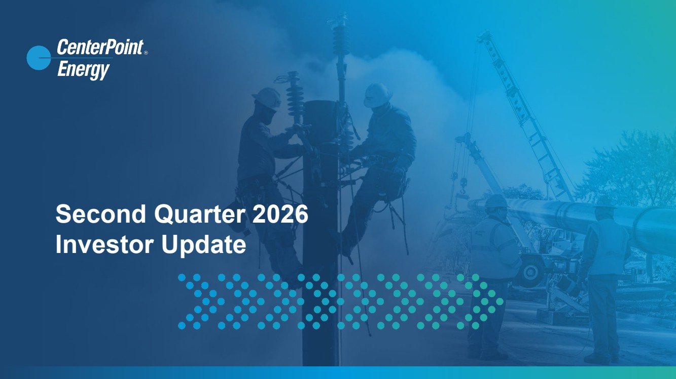 | CenterPoint Energy | 1 Second Quarter 2026 Investor Update
 | 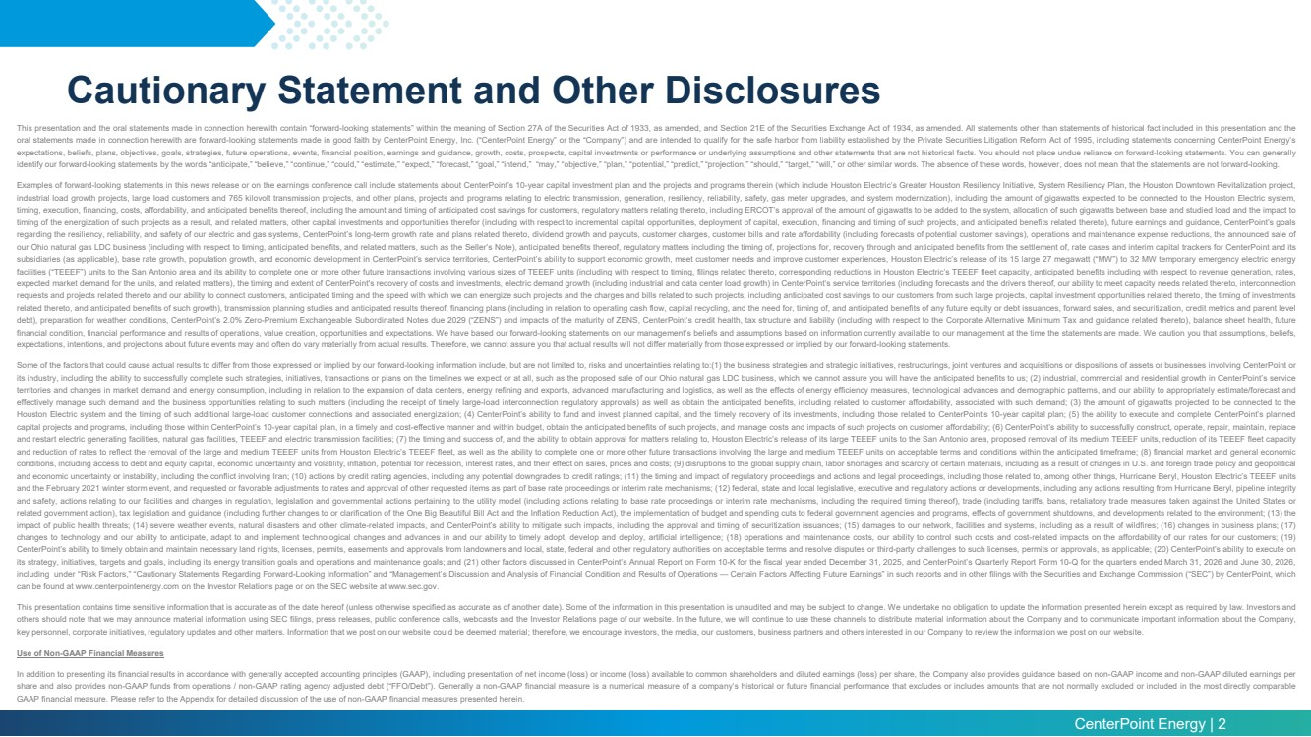 | CenterPoint Energy | 2 Cautionary Statement and Other Disclosures This presentation and the oral statements made in connection herewith contain “forward-looking statements” within the meaning of Section 27A of the Securities Act of 1933, as amended, and Section 21E of the Securities Exchange Act of 1934, as amended. All statements other than statements of historical fact included in this presentation and the oral statements made in connection herewith are forward-looking statements made in good faith by CenterPoint Energy, Inc. (“CenterPoint Energy” or the “Company”) and are intended to qualify for the safe harbor from liability established by the Private Securities Litigation Reform Act of 1995, including statements concerning CenterPoint Energy’s expectations, beliefs, plans, objectives, goals, strategies, future operations, events, financial position, earnings and guidance, growth, costs, prospects, capital investments or performance or underlying assumptions and other statements that are not historical facts. You should not place undue reliance on forward-looking statements. You can generally identify our forward-looking statements by the words “anticipate,” “believe,” “continue,” “could,” “estimate,” “expect,” “forecast,” “goal,” “intend,” “may,” “objective,” “plan,” “potential,” “predict,” “projection,” “should,” “target,” “will,” or other similar words. The absence of these words, however, does not mean that the statements are not forward-looking. Examples of forward-looking statements in this news release or on the earnings conference call include statements about CenterPoint’s 10-year capital investment plan and the projects and programs therein (which include Houston Electric’s Greater Houston Resiliency Initiative, System Resiliency Plan, the Houston Downtown Revitalization project, industrial load growth projects, large load customers and 765 kilovolt transmission projects, and other plans, projects and programs relating to electric transmission, generation, resiliency, reliability, safety, gas meter upgrades, and system modernization), including the amount of gigawatts expected to be connected to the Houston Electric system, timing, execution, financing, costs, affordability, and anticipated benefits thereof, including the amount and timing of anticipated cost savings for customers, regulatory matters relating thereto, including ERCOT’s approval of the amount of gigawatts to be added to the system, allocation of such gigawatts between base and studied load and the impact to timing of the energization of such projects as a result, and related matters, other capital investments and opportunities therefor (including with respect to incremental capital opportunities, deployment of capital, execution, financing and timing of such projects, and anticipated benefits related thereto), future earnings and guidance, CenterPoint’s goals regarding the resiliency, reliability, and safety of our electric and gas systems, CenterPoint’s long-term growth rate and plans related thereto, dividend growth and payouts, customer charges, customer bills and rate affordability (including forecasts of potential customer savings), operations and maintenance expense reductions, the announced sale of our Ohio natural gas LDC business (including with respect to timing, anticipated benefits, and related matters, such as the Seller’s Note), anticipated benefits thereof, regulatory matters including the timing of, projections for, recovery through and anticipated benefits from the settlement of, rate cases and interim capital trackers for CenterPoint and its subsidiaries (as applicable), base rate growth, population growth, and economic development in CenterPoint’s service territories, CenterPoint’s ability to support economic growth, meet customer needs and improve customer experiences, Houston Electric’s release of its 15 large 27 megawatt (“MW”) to 32 MW temporary emergency electric energy facilities (“TEEEF”) units to the San Antonio area and its ability to complete one or more other future transactions involving various sizes of TEEEF units (including with respect to timing, filings related thereto, corresponding reductions in Houston Electric’s TEEEF fleet capacity, anticipated benefits including with respect to revenue generation, rates, expected market demand for the units, and related matters), the timing and extent of CenterPoint's recovery of costs and investments, electric demand growth (including industrial and data center load growth) in CenterPoint’s service territories (including forecasts and the drivers thereof, our ability to meet capacity needs related thereto, interconnection requests and projects related thereto and our ability to connect customers, anticipated timing and the speed with which we can energize such projects and the charges and bills related to such projects, including anticipated cost savings to our customers from such large projects, capital investment opportunities related thereto, the timing of investments related thereto, and anticipated benefits of such growth), transmission planning studies and anticipated results thereof, financing plans (including in relation to operating cash flow, capital recycling, and the need for, timing of, and anticipated benefits of any future equity or debt issuances, forward sales, and securitization, credit metrics and parent level debt), preparation for weather conditions, CenterPoint’s 2.0% Zero-Premium Exchangeable Subordinated Notes due 2029 (“ZENS”) and impacts of the maturity of ZENS, CenterPoint’s credit health, tax structure and liability (including with respect to the Corporate Alternative Minimum Tax and guidance related thereto), balance sheet health, future financial condition, financial performance and results of operations, value creation, opportunities and expectations. We have based our forward-looking statements on our management’s beliefs and assumptions based on information currently available to our management at the time the statements are made. We caution you that assumptions, beliefs, expectations, intentions, and projections about future events may and often do vary materially from actual results. Therefore, we cannot assure you that actual results will not differ materially from those expressed or implied by our forward-looking statements. Some of the factors that could cause actual results to differ from those expressed or implied by our forward-looking information include, but are not limited to, risks and uncertainties relating to:(1) the business strategies and strategic initiatives, restructurings, joint ventures and acquisitions or dispositions of assets or businesses involving CenterPoint or its industry, including the ability to successfully complete such strategies, initiatives, transactions or plans on the timelines we expect or at all, such as the proposed sale of our Ohio natural gas LDC business, which we cannot assure you will have the anticipated benefits to us; (2) industrial, commercial and residential growth in CenterPoint’s service territories and changes in market demand and energy consumption, including in relation to the expansion of data centers, energy refining and exports, advanced manufacturing and logistics, as well as the effects of energy efficiency measures, technological advances and demographic patterns, and our ability to appropriately estimate/forecast and effectively manage such demand and the business opportunities relating to such matters (including the receipt of timely large-load interconnection regulatory approvals) as well as obtain the anticipated benefits, including related to customer affordability, associated with such demand; (3) the amount of gigawatts projected to be connected to the Houston Electric system and the timing of such additional large-load customer connections and associated energization; (4) CenterPoint’s ability to fund and invest planned capital, and the timely recovery of its investments, including those related to CenterPoint’s 10-year capital plan; (5) the ability to execute and complete CenterPoint’s planned capital projects and programs, including those within CenterPoint’s 10-year capital plan, in a timely and cost-effective manner and within budget, obtain the anticipated benefits of such projects, and manage costs and impacts of such projects on customer affordability; (6) CenterPoint’s ability to successfully construct, operate, repair, maintain, replace and restart electric generating facilities, natural gas facilities, TEEEF and electric transmission facilities; (7) the timing and success of, and the ability to obtain approval for matters relating to, Houston Electric’s release of its large TEEEF units to the San Antonio area, proposed removal of its medium TEEEF units, reduction of its TEEEF fleet capacity and reduction of rates to reflect the removal of the large and medium TEEEF units from Houston Electric’s TEEEF fleet, as well as the ability to complete one or more other future transactions involving the large and medium TEEEF units on acceptable terms and conditions within the anticipated timeframe; (8) financial market and general economic conditions, including access to debt and equity capital, economic uncertainty and volatility, inflation, potential for recession, interest rates, and their effect on sales, prices and costs; (9) disruptions to the global supply chain, labor shortages and scarcity of certain materials, including as a result of changes in U.S. and foreign trade policy and geopolitical and economic uncertainty or instability, including the conflict involving Iran; (10) actions by credit rating agencies, including any potential downgrades to credit ratings; (11) the timing and impact of regulatory proceedings and actions and legal proceedings, including those related to, among other things, Hurricane Beryl, Houston Electric’s TEEEF units and the February 2021 winter storm event, and requested or favorable adjustments to rates and approval of other requested items as part of base rate proceedings or interim rate mechanisms; (12) federal, state and local legislative, executive and regulatory actions or developments, including any actions resulting from Hurricane Beryl, pipeline integrity and safety, actions relating to our facilities and changes in regulation, legislation and governmental actions pertaining to the utility model (including actions relating to base rate proceedings or interim rate mechanisms, including the required timing thereof), trade (including tariffs, bans, retaliatory trade measures taken against the United States or related government action), tax legislation and guidance (including further changes to or clarification of the One Big Beautiful Bill Act and the Inflation Reduction Act), the implementation of budget and spending cuts to federal government agencies and programs, effects of government shutdowns, and developments related to the environment; (13) the impact of public health threats; (14) severe weather events, natural disasters and other climate-related impacts, and CenterPoint’s ability to mitigate such impacts, including the approval and timing of securitization issuances; (15) damages to our network, facilities and systems, including as a result of wildfires; (16) changes in business plans; (17) changes to technology and our ability to anticipate, adapt to and implement technological changes and advances in and our ability to timely adopt, develop and deploy, artificial intelligence; (18) operations and maintenance costs, our ability to control such costs and cost-related impacts on the affordability of our rates for our customers; (19) CenterPoint’s ability to timely obtain and maintain necessary land rights, licenses, permits, easements and approvals from landowners and local, state, federal and other regulatory authorities on acceptable terms and resolve disputes or third-party challenges to such licenses, permits or approvals, as applicable; (20) CenterPoint’s ability to execute on its strategy, initiatives, targets and goals, including its energy transition goals and operations and maintenance goals; and (21) other factors discussed in CenterPoint’s Annual Report on Form 10-K for the fiscal year ended December 31, 2025, and CenterPoint’s Quarterly Report Form 10-Q for the quarters ended March 31, 2026 and June 30, 2026, including under “Risk Factors,” “Cautionary Statements Regarding Forward-Looking Information” and “Management’s Discussion and Analysis of Financial Condition and Results of Operations — Certain Factors Affecting Future Earnings” in such reports and in other filings with the Securities and Exchange Commission (“SEC”) by CenterPoint, which can be found at www.centerpointenergy.com on the Investor Relations page or on the SEC website at www.sec.gov. This presentation contains time sensitive information that is accurate as of the date hereof (unless otherwise specified as accurate as of another date). Some of the information in this presentation is unaudited and may be subject to change. We undertake no obligation to update the information presented herein except as required by law. Investors and others should note that we may announce material information using SEC filings, press releases, public conference calls, webcasts and the Investor Relations page of our website. In the future, we will continue to use these channels to distribute material information about the Company and to communicate important information about the Company, key personnel, corporate initiatives, regulatory updates and other matters. Information that we post on our website could be deemed material; therefore, we encourage investors, the media, our customers, business partners and others interested in our Company to review the information we post on our website. Use of Non-GAAP Financial Measures In addition to presenting its financial results in accordance with generally accepted accounting principles (GAAP), including presentation of net income (loss) or income (loss) available to common shareholders and diluted earnings (loss) per share, the Company also provides guidance based on non-GAAP income and non-GAAP diluted earnings per share and also provides non-GAAP funds from operations / non-GAAP rating agency adjusted debt (“FFO/Debt”). Generally a non-GAAP financial measure is a numerical measure of a company’s historical or future financial performance that excludes or includes amounts that are not normally excluded or included in the most directly comparable GAAP financial measure. Please refer to the Appendix for detailed discussion of the use of non-GAAP financial measures presented herein.
 | 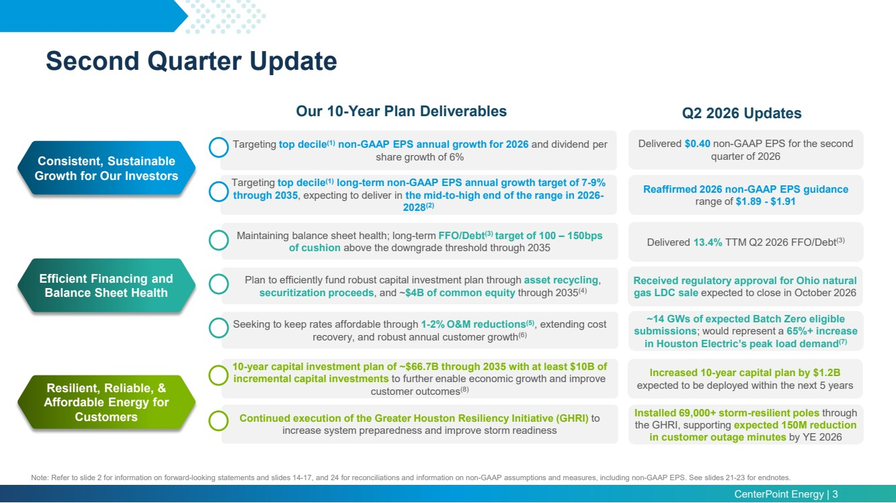 | CenterPoint Energy | 3 Second Quarter Update Note: Refer to slide 2 for information on forward-looking statements and slides 14-17, and 24 for reconciliations and information on non-GAAP assumptions and measures, including non-GAAP EPS. See slides 21-23 for endnotes. Consistent, Sustainable Growth for Our Investors Resilient, Reliable, & Affordable Energy for Customers Efficient Financing and Balance Sheet Health Our 10-Year Plan Deliverables Q2 2026 Updates Delivered $0.40 non-GAAP EPS for the second quarter of 2026 Reaffirmed 2026 non-GAAP EPS guidance range of $1.89 - $1.91 Received regulatory approval for Ohio natural gas LDC sale expected to close in October 2026 ~14 GWs of expected Batch Zero eligible submissions; would represent a 65%+ increase in Houston Electric’s peak load demand(7) Increased 10-year capital plan by $1.2B expected to be deployed within the next 5 years Delivered 13.4% TTM Q2 2026 FFO/Debt(3) Installed 69,000+ storm-resilient poles through the GHRI, supporting expected 150M reduction in customer outage minutes by YE 2026 Targeting top decile(1) non-GAAP EPS annual growth for 2026 and dividend per share growth of 6% Targeting top decile(1) long-term non-GAAP EPS annual growth target of 7-9% through 2035, expecting to deliver in the mid-to-high end of the range in 2026- 2028(2) Maintaining balance sheet health; long-term FFO/Debt(3) target of 100 – 150bps of cushion above the downgrade threshold through 2035 Plan to efficiently fund robust capital investment plan through asset recycling, securitization proceeds, and ~$4B of common equity through 2035(4) Seeking to keep rates affordable through 1-2% O&M reductions(5), extending cost recovery, and robust annual customer growth(6) 10-year capital investment plan of ~$66.7B through 2035 with at least $10B of incremental capital investments to further enable economic growth and improve customer outcomes(8) Continued execution of the Greater Houston Resiliency Initiative (GHRI) to increase system preparedness and improve storm readiness
 | 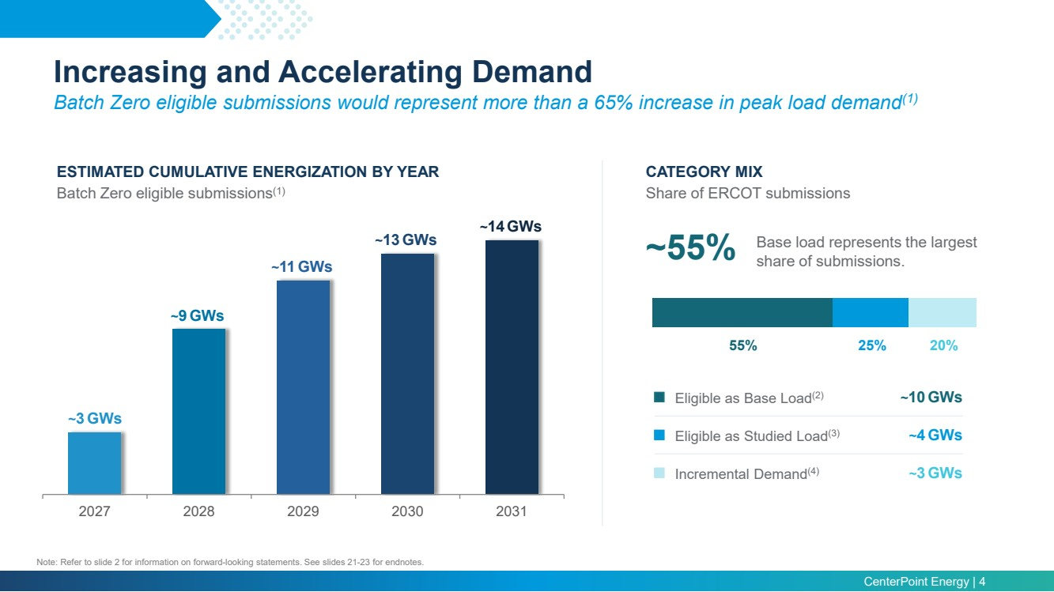 | CenterPoint Energy | 4 2027 2028 2029 2030 2031 ESTIMATED CUMULATIVE ENERGIZATION BY YEAR Batch Zero eligible submissions(1) CATEGORY MIX Share of ERCOT submissions ~3 GWs ~9 GWs ~11GWs ~13GWs ~55% Base load represents the largest share of submissions. 55% 25% 20% Eligible as Base Load(2) ~10GWs Eligible as Studied Load(3) ~4 GWs Incremental Demand(4) ~3 GWs Increasing and Accelerating Demand Batch Zero eligible submissions would represent more than a 65% increase in peak load demand(1) Note: Refer to slide 2 for information on forward-looking statements. See slides 21-23 for endnotes. ~14GWs
 | 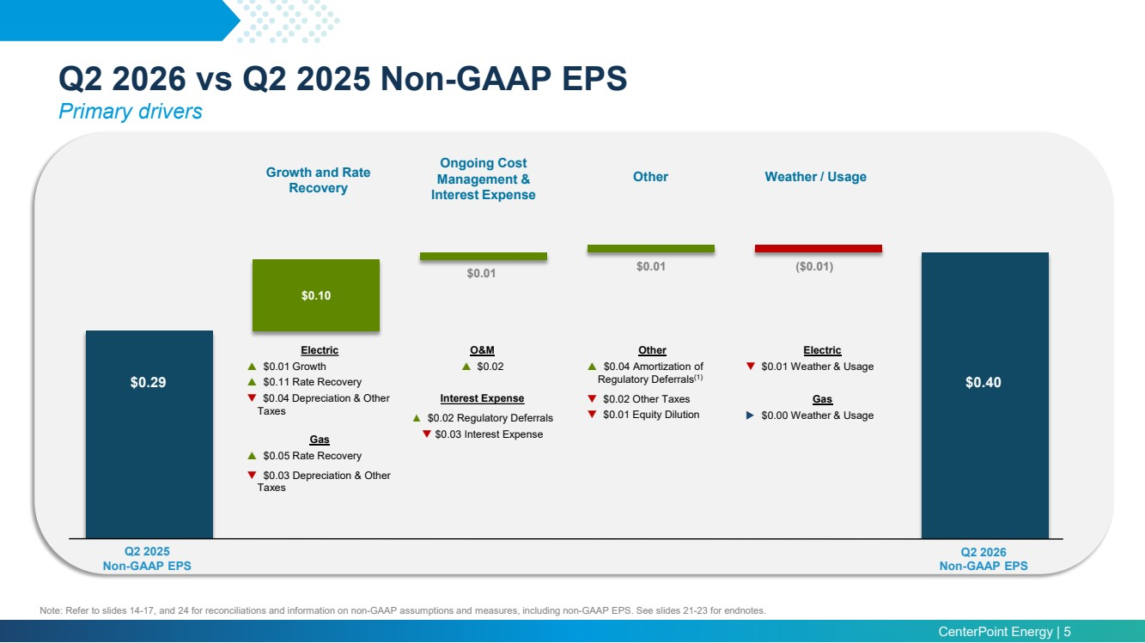 | CenterPoint Energy | 5 Q2 2026 vs Q2 2025 Non-GAAP EPS Primary drivers Note: Refer to slides 14-17, and 24 for reconciliations and information on non-GAAP assumptions and measures, including non-GAAP EPS. See slides 21-23 for endnotes. $0.10 Q2 2025 Non-GAAP EPS Q2 2026 Non-GAAP EPS $0.29 Growth and Rate Recovery Other Ongoing Cost Management & Interest Expense Weather / Usage Electric $0.01 Growth $0.11 Rate Recovery $0.04 Depreciation & Other Taxes Gas $0.05 Rate Recovery $0.03 Depreciation & Other Taxes $0.40 $0.01 $0.01 ($0.01) O&M $0.02 Interest Expense ▲ $0.02 Regulatory Deferrals $0.03 Interest Expense Other $0.04 Amortization of Regulatory Deferrals(1) $0.02 Other Taxes $0.01 Equity Dilution Electric $0.01 Weather & Usage Gas $0.00 Weather & Usage
 | 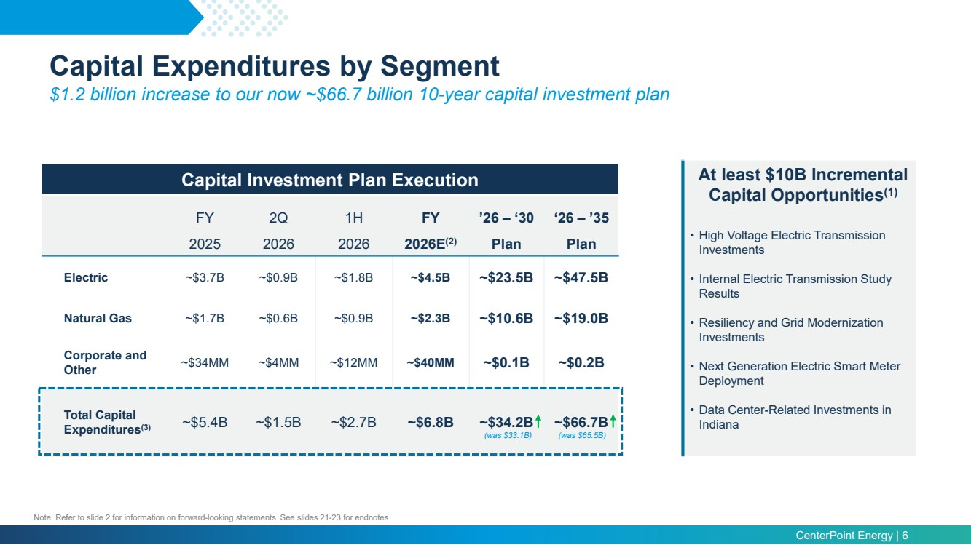 | CenterPoint Energy | 6 Capital Expenditures by Segment $1.2 billion increase to our now ~$66.7 billion 10-year capital investment plan FY 2Q 1H FY ’26 – ‘30 ‘26 – ’35 2025 2026 2026 2026E(2) Plan Plan Electric ~$3.7B ~$0.9B ~$1.8B ~$4.5B ~$23.5B ~$47.5B Natural Gas ~$1.7B ~$0.6B ~$0.9B ~$2.3B ~$10.6B ~$19.0B Corporate and Other ~$34MM ~$4MM ~$12MM ~$40MM ~$0.1B ~$0.2B Total Capital Expenditures(3) ~$5.4B ~$1.5B ~$2.7B ~$6.8B ~$34.2B ~$66.7B Capital Investment Plan Execution At least $10B Incremental Capital Opportunities(1) • High Voltage Electric Transmission Investments • Internal Electric Transmission Study Results • Resiliency and Grid Modernization Investments • Next Generation Electric Smart Meter Deployment • Data Center-Related Investments in Indiana Note: Refer to slide 2 for information on forward-looking statements. See slides 21-23 for endnotes. (was $33.1B) (was $65.5B)
 | 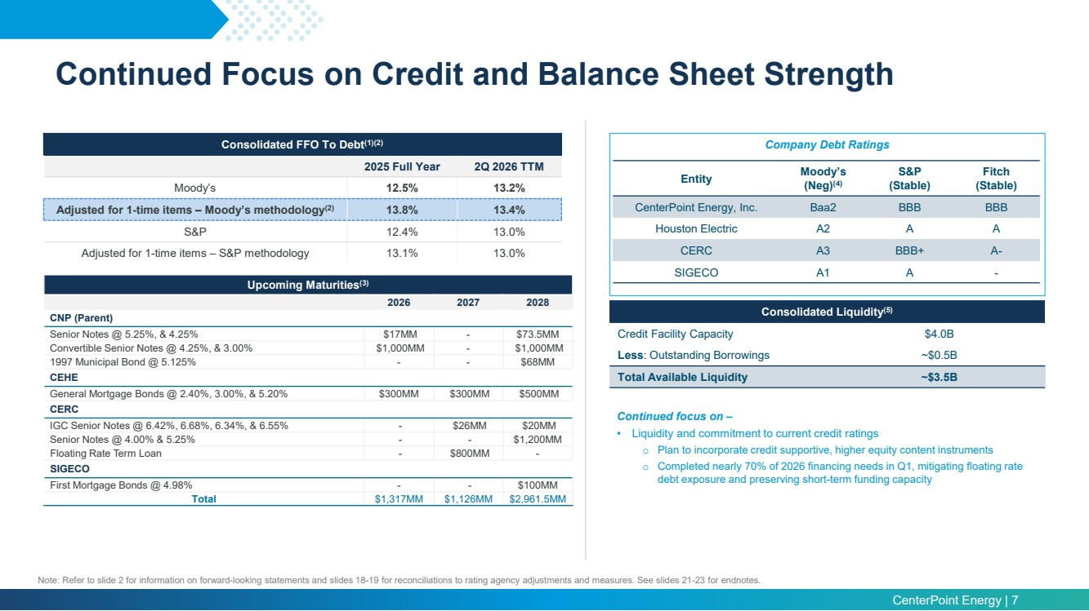 | CenterPoint Energy | 7 Entity Moody’s (Neg)(4) S&P (Stable) Fitch (Stable) CenterPoint Energy, Inc. Baa2 BBB BBB Houston Electric A2 A A CERC A3 BBB+ A-SIGECO A1 A - Consolidated FFO To Debt Company Debt Ratings (1)(2) 2025 Full Year 2Q 2026 TTM Moody’s 12.5% 13.2% Adjusted for 1-time items – Moody’s methodology(2) 13.8% 13.4% S&P 12.4% 13.0% Adjusted for 1-time items – S&P methodology 13.1% 13.0% Continued focus on – • Liquidity and commitment to current credit ratings o Plan to incorporate credit supportive, higher equity content instruments o Completed nearly 70% of 2026 financing needs in Q1, mitigating floating rate debt exposure and preserving short-term funding capacity Consolidated Liquidity(5) Credit Facility Capacity $4.0B Less: Outstanding Borrowings ~$0.5B Total Available Liquidity ~$3.5B Continued Focus on Credit and Balance Sheet Strength Note: Refer to slide 2 for information on forward-looking statements and slides 18-19 for reconciliations to rating agency adjustments and measures. See slides 21-23 for endnotes. Upcoming Maturities(3) 2026 2027 2028 CNP (Parent) Senior Notes @ 5.25%, & 4.25% $17MM - $73.5MM Convertible Senior Notes @ 4.25%, & 3.00% $1,000MM - $1,000MM 1997 Municipal Bond @ 5.125% - - $68MM CEHE General Mortgage Bonds @ 2.40%, 3.00%, & 5.20% $300MM $300MM $500MM CERC IGC Senior Notes @ 6.42%, 6.68%, 6.34%, & 6.55% - $26MM $20MM Senior Notes @ 4.00% & 5.25% - - $1,200MM Floating Rate Term Loan - $800MM - SIGECO First Mortgage Bonds @ 4.98% - - $100MM Total $1,317MM $1,126MM $2,961.5MM
 | 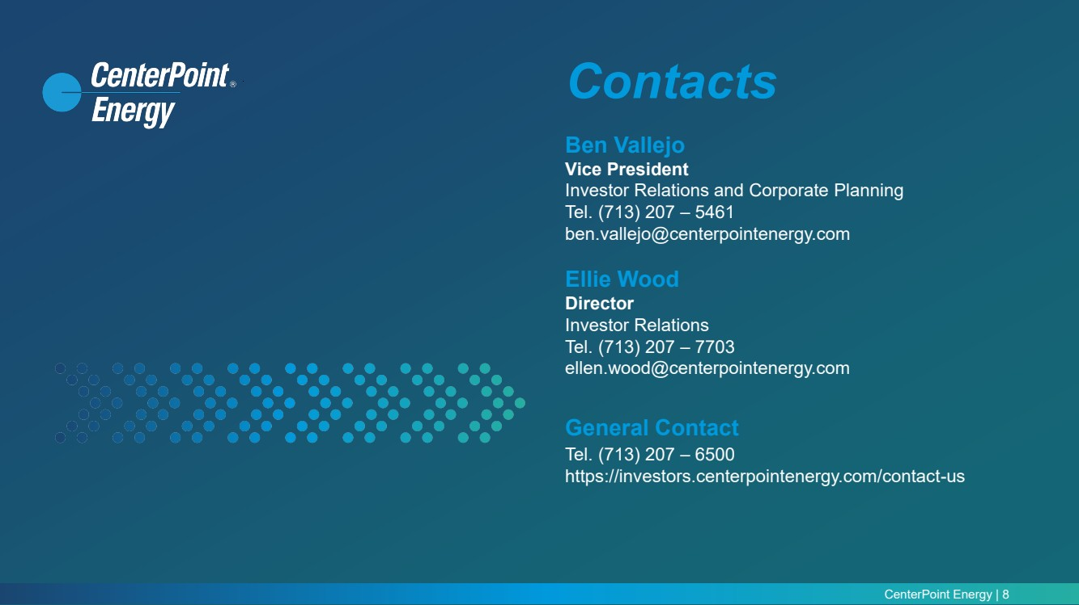 | CenterPoint Energy | 8 Contacts Ben Vallejo Vice President Investor Relations and Corporate Planning Tel. (713) 207 – 5461 ben.vallejo@centerpointenergy.com Ellie Wood Director Investor Relations Tel. (713) 207 – 7703 ellen.wood@centerpointenergy.com General Contact Tel. (713) 207 – 6500 https://investors.centerpointenergy.com/contact-us
 |  | CenterPoint Energy | 9 Appendix
 | 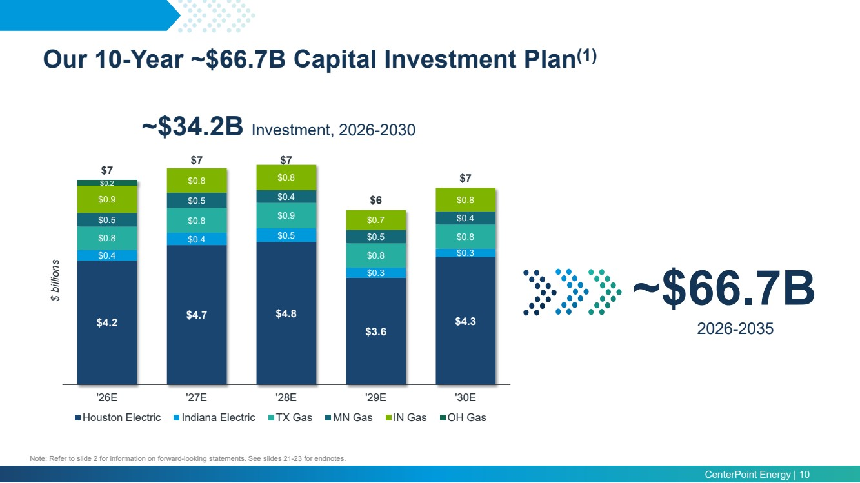 | CenterPoint Energy | 10 Our 10-Year ~$66.7B Capital Investment Plan(1) $4.2 $4.7 $4.8 $3.6 $4.3 $0.4 $0.4 $0.5 $0.3 $0.3 $0.8 $0.8 $0.9 $0.8 $0.8 $0.5 $0.5 $0.4 $0.5 $0.4 $0.9 $0.8 $0.8 $0.7 $0.8 $0.2 $7 $7 $7 $6 $7 '26E '27E '28E '29E '30E $ billions Houston Electric Indiana Electric TX Gas MN Gas IN Gas OH Gas ~$34.2B Investment, 2026-2030 ~$66.7B 2026-2035 Note: Refer to slide 2 for information on forward-looking statements. See slides 21-23 for endnotes.
 | 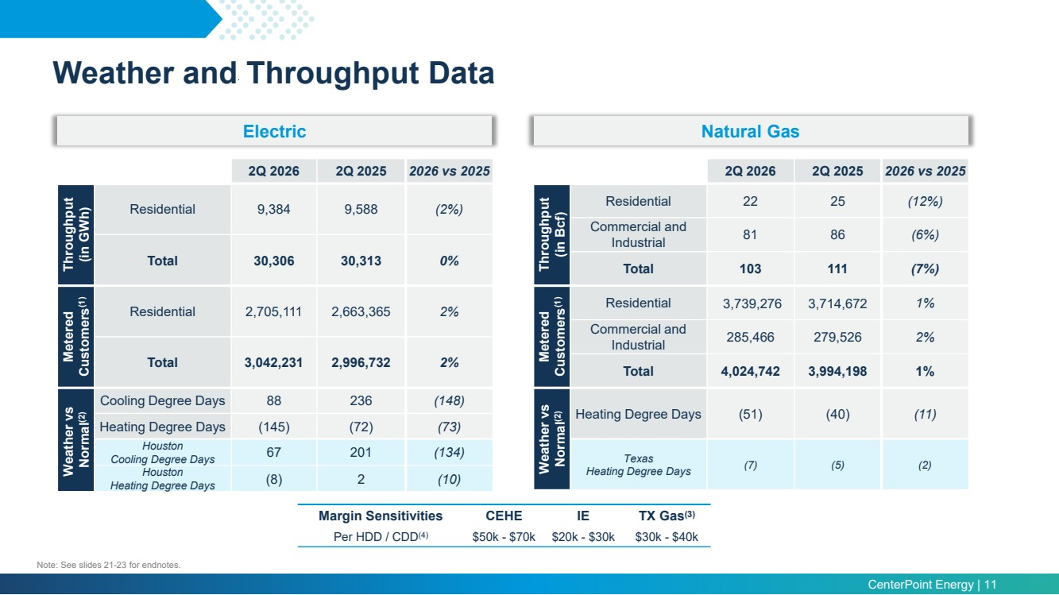 | CenterPoint Energy | 11 aaaaaaaaa Electric Natural Gas 2Q 2026 2Q 2025 2026 vs 2025 Throughput (in GWh) Residential 9,384 9,588 (2%) Total 30,306 30,313 0% Metered Customers(1) Residential 2,705,111 2,663,365 2% Total 3,042,231 2,996,732 2% Weather vs Normal(2) Cooling Degree Days 88 236 (148) Heating Degree Days (145) (72) (73) Houston Cooling Degree Days 67 201 (134) Houston Heating Degree Days (8) 2 (10) 2Q 2026 2Q 2025 2026 vs 2025 Throughput (in Bcf) Residential 22 25 (12%) Commercial and Industrial 81 86 (6%) Total 103 111 (7%) Metered Customers(1) Residential 3,739,276 3,714,672 1% Commercial and Industrial 285,466 279,526 2% Total 4,024,742 3,994,198 1% Weather vs Normal(2) Heating Degree Days (51) (40) (11) Texas Heating Degree Days (7) (5) (2) Margin Sensitivities CEHE IE TX Gas(3) Per HDD / CDD(4) $50k - $70k $20k - $30k $30k - $40k Note: See slides 21-23 for endnotes. Weather and Throughput Data
 | 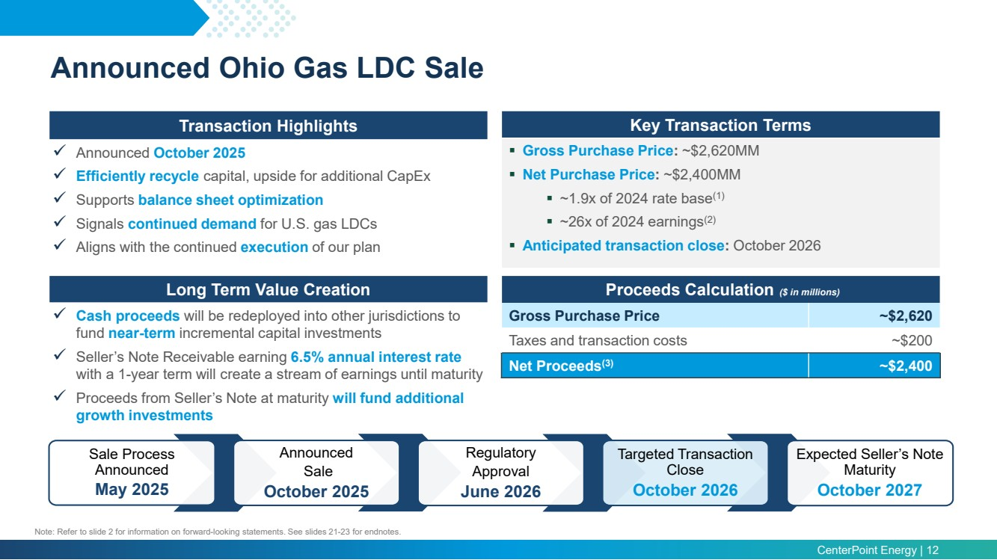 | CenterPoint Energy | 12 Transaction Highlights Announced October 2025 Efficiently recycle capital, upside for additional CapEx Supports balance sheet optimization Signals continued demand for U.S. gas LDCs Aligns with the continued execution of our plan Key Transaction Terms Gross Purchase Price: ~$2,620MM Net Purchase Price: ~$2,400MM ~1.9x of 2024 rate base(1) ~26x of 2024 earnings(2) Anticipated transaction close: October 2026 Proceeds Calculation ($ in millions) Gross Purchase Price ~$2,620 Taxes and transaction costs ~$200 Net Proceeds(3) ~$2,400 Long Term Value Creation Cash proceeds will be redeployed into other jurisdictions to fund near-term incremental capital investments Seller’s Note Receivable earning 6.5% annual interest rate with a 1-year term will create a stream of earnings until maturity Proceeds from Seller’s Note at maturity will fund additional growth investments Note: Refer to slide 2 for information on forward-looking statements. See slides 21-23 for endnotes. Expected Seller’s Note Maturity October 2027 Sale Process Announced May 2025 Announced Sale October 2025 Regulatory Approval June 2026 Targeted Transaction Close October 2026 Announced Ohio Gas LDC Sale
 | 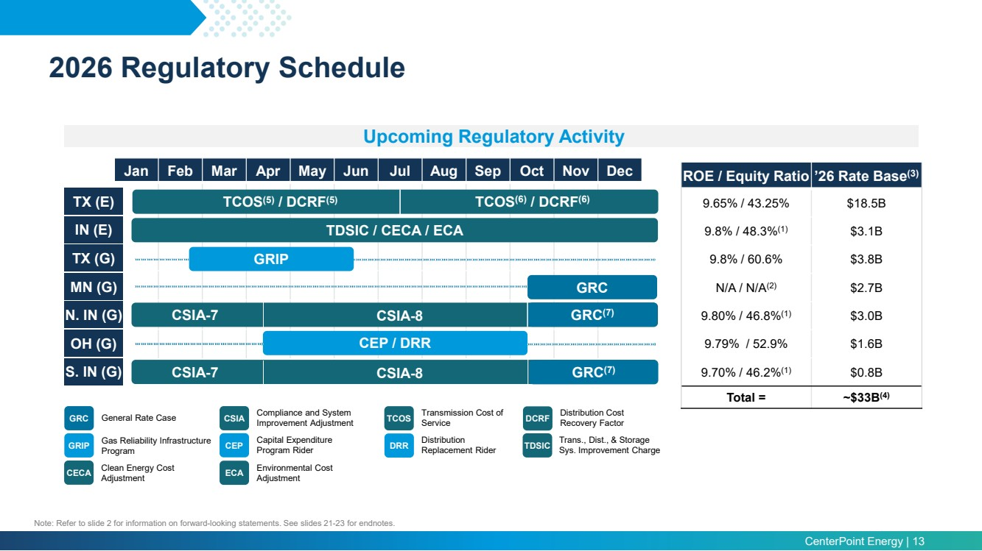 | CenterPoint Energy | 13 Jan Feb Mar Apr May Jun Jul Aug Sep Oct Nov Dec TX (E) IN (E) TX (G) MN (G) N. IN (G) OH (G) S. IN (G) ROE / Equity Ratio ’26 Rate Base(3) 9.65% / 43.25% $18.5B 9.8% / 48.3%(1) $3.1B 9.8% / 60.6% $3.8B N/A / N/A(2) $2.7B 9.80% / 46.8%(1) $3.0B 9.79% / 52.9% $1.6B 9.70% / 46.2%(1) $0.8B Total = ~$33B(4) Upcoming Regulatory Activity CSIA-7 GRC GRC General Rate Case TDSIC / CECA / ECA Settlement filed April 23 TCOS(5) / DCRF(5) GRIP Gas Reliability Infrastructure Program CSIA Compliance and System Improvement Adjustment CEP Capital Expenditure Program Rider GRIP CSIA-8 CSIA-7 CSIA-8 CSIA-9 TCOS Transmission Cost of Service Distribution Replacement Rider DCRF Distribution Cost Recovery Factor TDSIC Trans., Dist., & Storage Sys. Improvement Charge CECA Clean Energy Cost Adjustment ECA Environmental Cost Adjustment TCOS(6) / DCRF(6) CEP / DRR DRR Note: Refer to slide 2 for information on forward-looking statements. See slides 21-23 for endnotes. 2026 Regulatory Schedule GRC(7) GRC(7)
 | 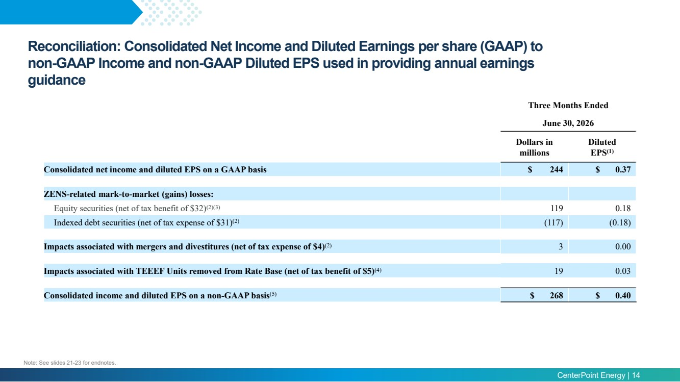 | CenterPoint Energy | 14 aaaaaaaaa Three Months Ended June 30, 2026 Dollars in millions Diluted EPS(1) Consolidated net income and diluted EPS on a GAAP basis $ 244 $ 0.37 ZENS-related mark-to-market (gains) losses: Equity securities (net of tax benefit of $32)(2)(3) 119 0.18 Indexed debt securities (net of tax expense of $31)(2) (117) (0.18) Impacts associated with mergers and divestitures (net of tax expense of $4)(2) 3 0.00 Impacts associated with TEEEF Units removed from Rate Base (net of tax benefit of $5)(4) 19 0.03 Consolidated income and diluted EPS on a non-GAAP basis(5) $ 268 $ 0.40 Reconciliation: Consolidated Net Income and Diluted Earnings per share (GAAP) to non-GAAP Income and non-GAAP Diluted EPS used in providing annual earnings guidance Note: See slides 21-23 for endnotes.
 | 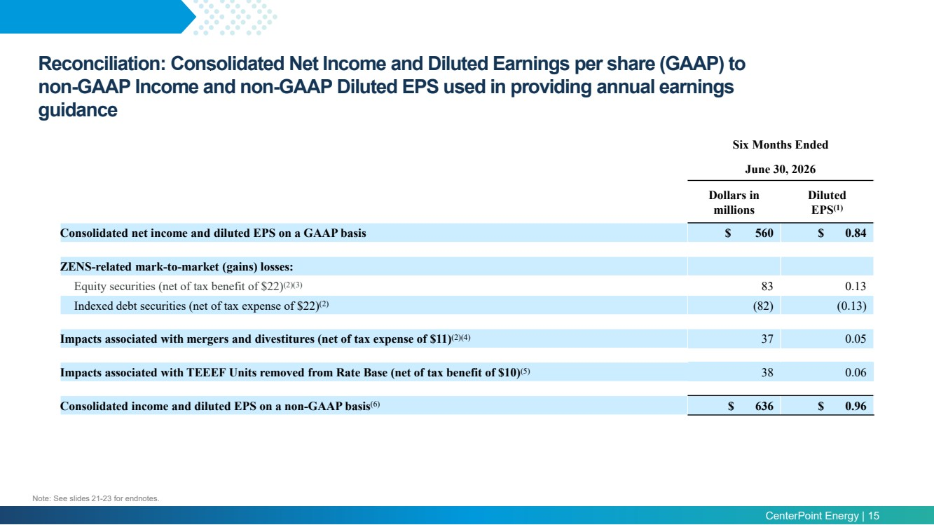 | CenterPoint Energy | 15 aaaaaaaaa Six Months Ended June 30, 2026 Dollars in millions Diluted EPS(1) Consolidated net income and diluted EPS on a GAAP basis $ 560 $ 0.84 ZENS-related mark-to-market (gains) losses: Equity securities (net of tax benefit of $22)(2)(3) 83 0.13 Indexed debt securities (net of tax expense of $22)(2) (82) (0.13) Impacts associated with mergers and divestitures (net of tax expense of $11)(2)(4) 37 0.05 Impacts associated with TEEEF Units removed from Rate Base (net of tax benefit of $10)(5) 38 0.06 Consolidated income and diluted EPS on a non-GAAP basis(6) $ 636 $ 0.96 Reconciliation: Consolidated Net Income and Diluted Earnings per share (GAAP) to non-GAAP Income and non-GAAP Diluted EPS used in providing annual earnings guidance Note: See slides 21-23 for endnotes.
 | 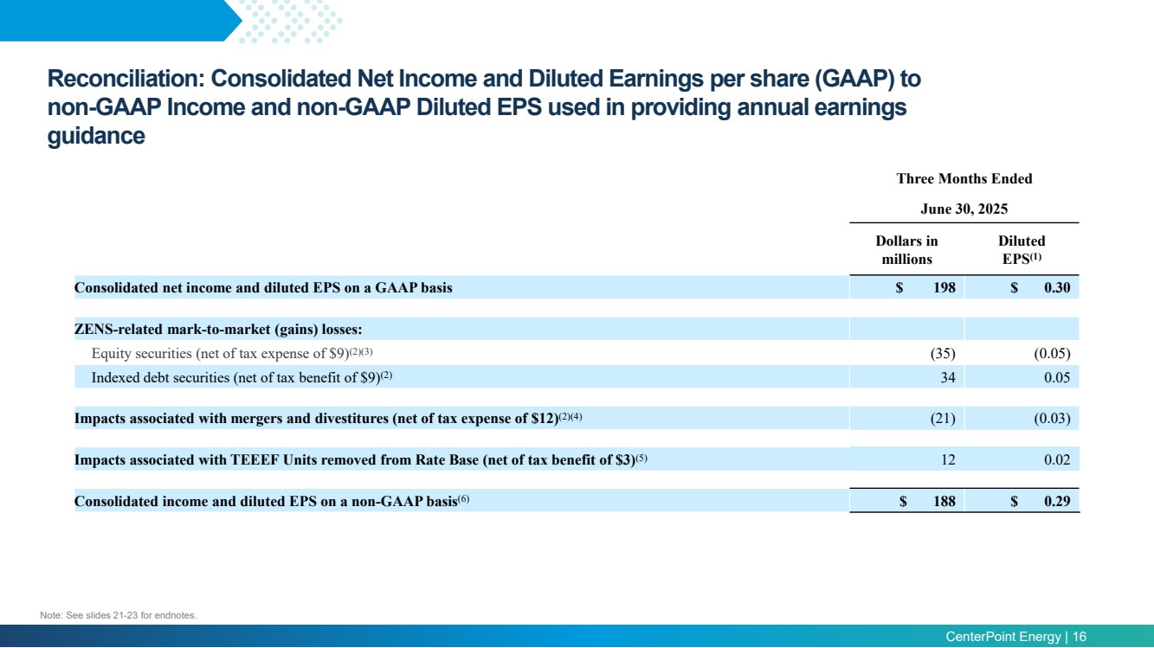 | CenterPoint Energy | 16 aaaaaaaaa Three Months Ended June 30, 2025 Dollars in millions Diluted EPS(1) Consolidated net income and diluted EPS on a GAAP basis $ 198 $ 0.30 ZENS-related mark-to-market (gains) losses: Equity securities (net of tax expense of $9)(2)(3) (35) (0.05) Indexed debt securities (net of tax benefit of $9)(2) 34 0.05 Impacts associated with mergers and divestitures (net of tax expense of $12)(2)(4) (21) (0.03) Impacts associated with TEEEF Units removed from Rate Base (net of tax benefit of $3)(5) 12 0.02 Consolidated income and diluted EPS on a non-GAAP basis(6) $ 188 $ 0.29 Reconciliation: Consolidated Net Income and Diluted Earnings per share (GAAP) to non-GAAP Income and non-GAAP Diluted EPS used in providing annual earnings guidance Note: See slides 21-23 for endnotes.
 | 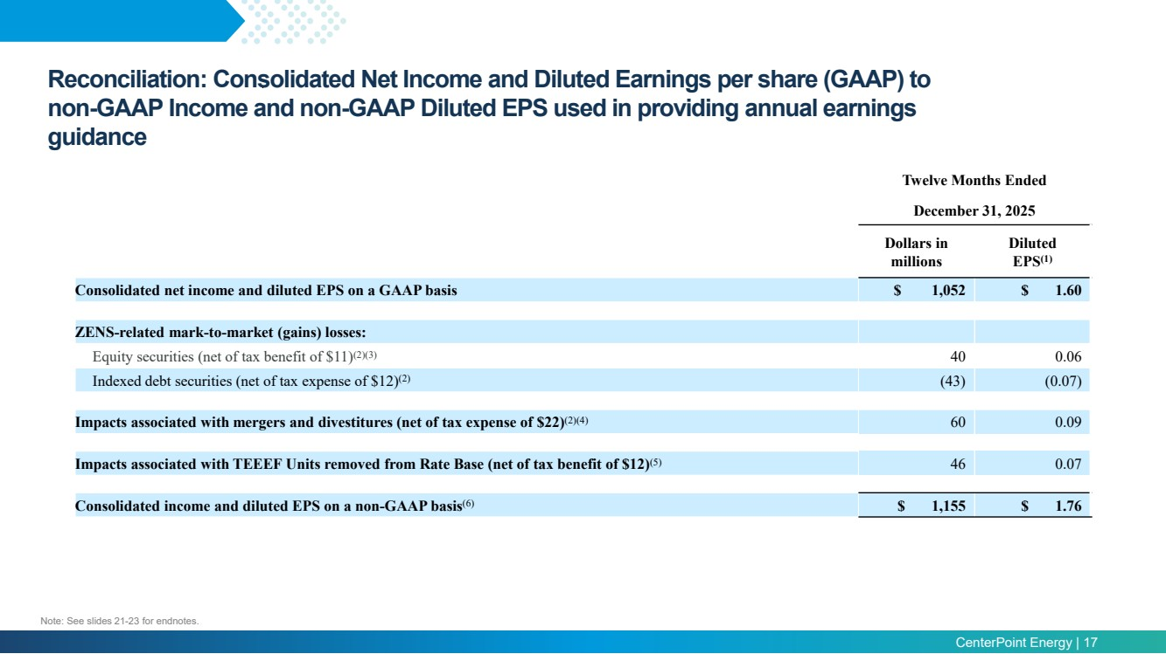 | CenterPoint Energy | 17 aaaaaaaaa Reconciliation: Consolidated Net Income and Diluted Earnings per share (GAAP) to non-GAAP Income and non-GAAP Diluted EPS used in providing annual earnings guidance Twelve Months Ended December 31, 2025 Dollars in millions Diluted EPS(1) Consolidated net income and diluted EPS on a GAAP basis $ 1,052 $ 1.60 ZENS-related mark-to-market (gains) losses: Equity securities (net of tax benefit of $11)(2)(3) 40 0.06 Indexed debt securities (net of tax expense of $12)(2) (43) (0.07) Impacts associated with mergers and divestitures (net of tax expense of $22)(2)(4) 60 0.09 Impacts associated with TEEEF Units removed from Rate Base (net of tax benefit of $12)(5) 46 0.07 Consolidated income and diluted EPS on a non-GAAP basis(6) $ 1,155 $ 1.76 Note: See slides 21-23 for endnotes.
 | 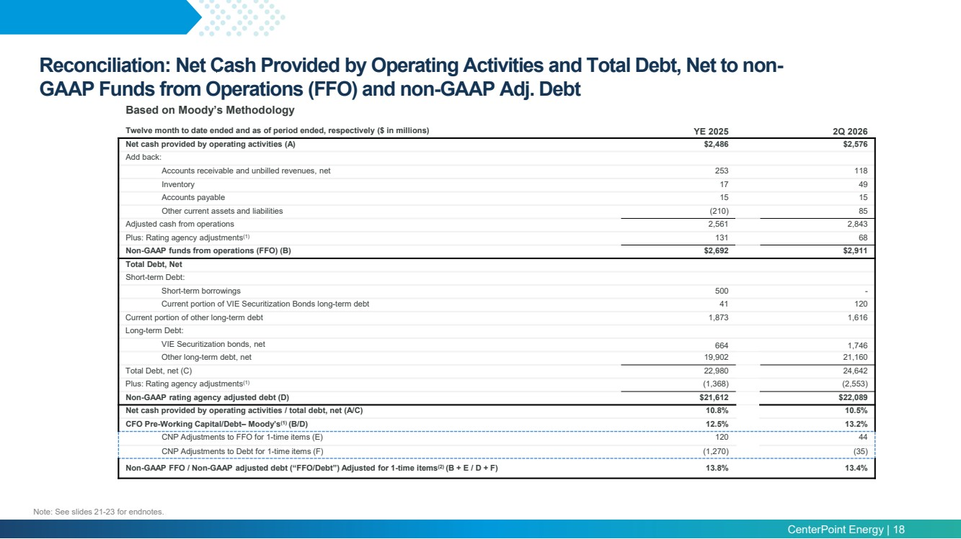 | CenterPoint Energy | 18 aaaaaaaaa Twelve month to date ended and as of period ended, respectively ($ in millions) YE 2025 2Q 2026 Net cash provided by operating activities (A) $2,486 $2,576 Add back: Accounts receivable and unbilled revenues, net 253 118 Inventory 17 49 Accounts payable 15 15 Other current assets and liabilities (210) 85 Adjusted cash from operations 2,561 2,843 Plus: Rating agency adjustments(1) 131 68 Non-GAAP funds from operations (FFO) (B) $2,692 $2,911 Total Debt, Net Short-term Debt: Short-term borrowings 500 - Current portion of VIE Securitization Bonds long-term debt 41 120 Current portion of other long-term debt 1,873 1,616 Long-term Debt: VIE Securitization bonds, net 664 1,746 Other long-term debt, net 19,902 21,160 Total Debt, net (C) 22,980 24,642 Plus: Rating agency adjustments(1) (1,368) (2,553) Non-GAAP rating agency adjusted debt (D) $21,612 $22,089 Net cash provided by operating activities / total debt, net (A/C) 10.8% 10.5% CFO Pre-Working Capital/Debt– Moody’s(1) (B/D) 12.5% 13.2% CNP Adjustments to FFO for 1-time items (E) 120 44 CNP Adjustments to Debt for 1-time items (F) (1,270) (35) Non-GAAP FFO / Non-GAAP adjusted debt (“FFO/Debt”) Adjusted for 1-time items(2) (B + E / D + F) 13.8% 13.4% Based on Moody’s Methodology Reconciliation: Net Cash Provided by Operating Activities and Total Debt, Net to non-GAAP Funds from Operations (FFO) and non-GAAP Adj. Debt Note: See slides 21-23 for endnotes.
 | 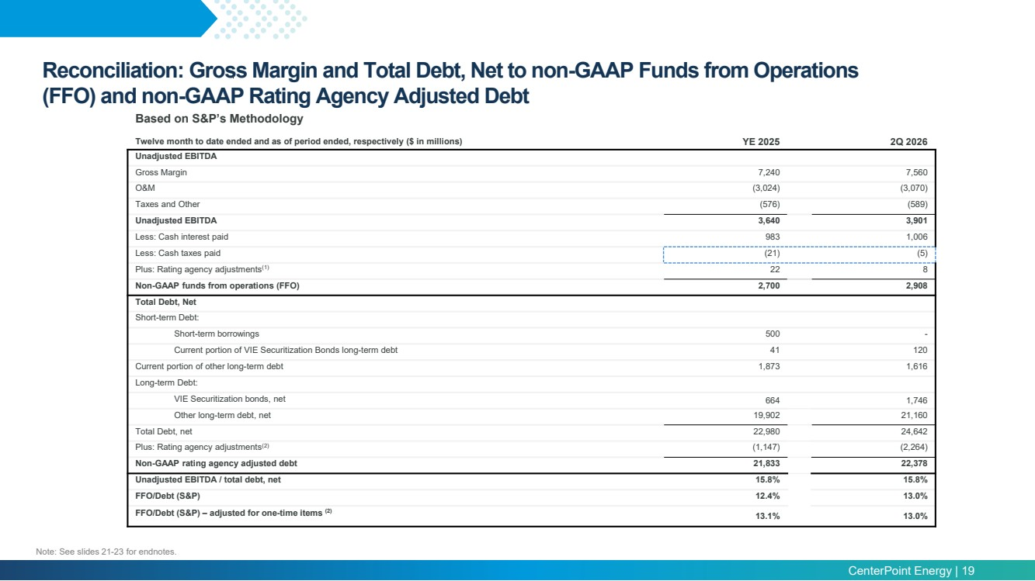 | CenterPoint Energy | 19 Reconciliation: Gross Margin and Total Debt, Net to non-GAAP Funds from Operations (FFO) and non-GAAP Rating Agency Adjusted Debt Based on S&P’s Methodology Twelve month to date ended and as of period ended, respectively ($ in millions) YE 2025 2Q 2026 Unadjusted EBITDA Gross Margin 7,240 7,560 O&M (3,024) (3,070) Taxes and Other (576) (589) Unadjusted EBITDA 3,640 3,901 Less: Cash interest paid 983 1,006 Less: Cash taxes paid (21) (5) Plus: Rating agency adjustments(1) 22 8 Non-GAAP funds from operations (FFO) 2,700 2,908 Total Debt, Net Short-term Debt: Short-term borrowings 500 - Current portion of VIE Securitization Bonds long-term debt 41 120 Current portion of other long-term debt 1,873 1,616 Long-term Debt: VIE Securitization bonds, net 664 1,746 Other long-term debt, net 19,902 21,160 Total Debt, net 22,980 24,642 Plus: Rating agency adjustments(2) (1,147) (2,264) Non-GAAP rating agency adjusted debt 21,833 22,378 Unadjusted EBITDA / total debt, net 15.8% 15.8% FFO/Debt (S&P) 12.4% 13.0% FFO/Debt (S&P) – adjusted for one-time items (2) 13.1% 13.0% Note: See slides 21-23 for endnotes.
 | 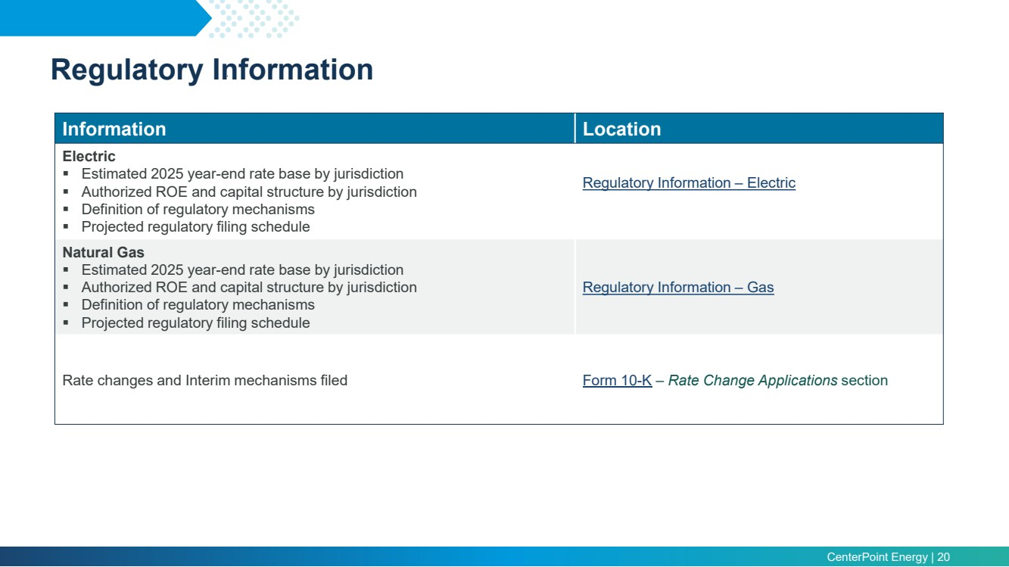 | CenterPoint Energy | 20 aaaaaaaaa Information Location Electric Estimated 2025 year-end rate base by jurisdiction Authorized ROE and capital structure by jurisdiction Definition of regulatory mechanisms Projected regulatory filing schedule Regulatory Information – Electric Natural Gas Estimated 2025 year-end rate base by jurisdiction Authorized ROE and capital structure by jurisdiction Definition of regulatory mechanisms Projected regulatory filing schedule Regulatory Information – Gas Rate changes and Interim mechanisms filed Form 10-K – Rate Change Applications section Regulatory Information
 | 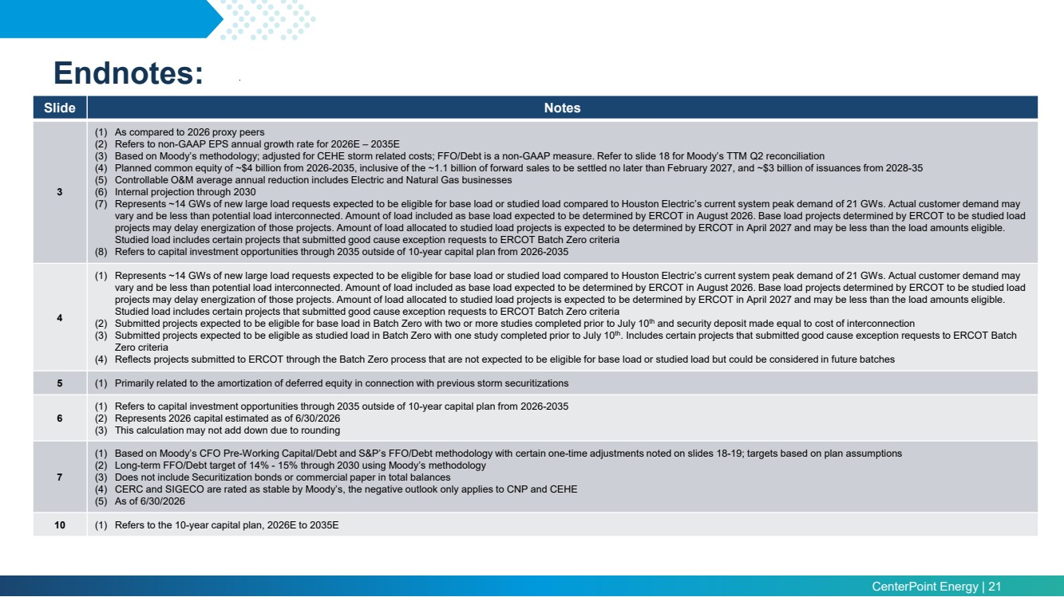 | CenterPoint Energy | 21 Endnotes: Slide Notes 3 (1) As compared to 2026 proxy peers (2) Refers to non-GAAP EPS annual growth rate for 2026E – 2035E (3) Based on Moody’s methodology; adjusted for CEHE storm related costs; FFO/Debt is a non-GAAP measure. Refer to slide 18 for Moody’s TTM Q2 reconciliation (4) Planned common equity of ~$4 billion from 2026-2035, inclusive of the ~1.1 billion of forward sales to be settled no later than February 2027, and ~$3 billion of issuances from 2028-35 (5) Controllable O&M average annual reduction includes Electric and Natural Gas businesses (6) Internal projection through 2030 (7) Represents ~14 GWs of new large load requests expected to be eligible for base load or studied load compared to Houston Electric’s current system peak demand of 21 GWs. Actual customer demand may vary and be less than potential load interconnected. Amount of load included as base load expected to be determined by ERCOT in August 2026. Base load projects determined by ERCOT to be studied load projects may delay energization of those projects. Amount of load allocated to studied load projects is expected to be determined by ERCOT in April 2027 and may be less than the load amounts eligible. Studied load includes certain projects that submitted good cause exception requests to ERCOT Batch Zero criteria (8) Refers to capital investment opportunities through 2035 outside of 10-year capital plan from 2026-2035 4 (1) Represents ~14 GWs of new large load requests expected to be eligible for base load or studied load compared to Houston Electric’s current system peak demand of 21 GWs. Actual customer demand may vary and be less than potential load interconnected. Amount of load included as base load expected to be determined by ERCOT in August 2026. Base load projects determined by ERCOT to be studied load projects may delay energization of those projects. Amount of load allocated to studied load projects is expected to be determined by ERCOT in April 2027 and may be less than the load amounts eligible. Studied load includes certain projects that submitted good cause exception requests to ERCOT Batch Zero criteria (2) Submitted projects expected to be eligible for base load in Batch Zero with two or more studies completed prior to July 10th and security deposit made equal to cost of interconnection (3) Submitted projects expected to be eligible as studied load in Batch Zero with one study completed prior to July 10th. Includes certain projects that submitted good cause exception requests to ERCOT Batch Zero criteria (4) Reflects projects submitted to ERCOT through the Batch Zero process that are not expected to be eligible for base load or studied load but could be considered in future batches 5 (1) Primarily related to the amortization of deferred equity in connection with previous storm securitizations 6 (1) Refers to capital investment opportunities through 2035 outside of 10-year capital plan from 2026-2035 (2) Represents 2026 capital estimated as of 6/30/2026 (3) This calculation may not add down due to rounding 7 (1) Based on Moody’s CFO Pre-Working Capital/Debt and S&P’s FFO/Debt methodology with certain one-time adjustments noted on slides 18-19; targets based on plan assumptions (2) Long-term FFO/Debt target of 14% - 15% through 2030 using Moody’s methodology (3) Does not include Securitization bonds or commercial paper in total balances (4) CERC and SIGECO are rated as stable by Moody’s, the negative outlook only applies to CNP and CEHE (5) As of 6/30/2026 10 (1) Refers to the 10-year capital plan, 2026E to 2035E
 | 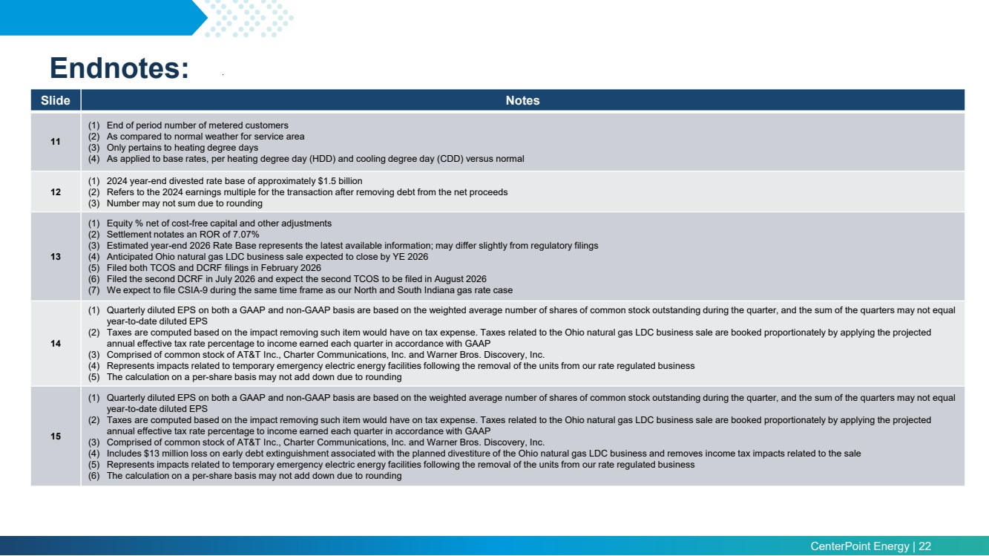 | CenterPoint Energy | 22 Endnotes: Slide Notes 11 (1) End of period number of metered customers (2) As compared to normal weather for service area (3) Only pertains to heating degree days (4) As applied to base rates, per heating degree day (HDD) and cooling degree day (CDD) versus normal 12 (1) 2024 year-end divested rate base of approximately $1.5 billion (2) Refers to the 2024 earnings multiple for the transaction after removing debt from the net proceeds (3) Number may not sum due to rounding 13 (1) Equity % net of cost-free capital and other adjustments (2) Settlement notates an ROR of 7.07% (3) Estimated year-end 2026 Rate Base represents the latest available information; may differ slightly from regulatory filings (4) Anticipated Ohio natural gas LDC business sale expected to close by YE 2026 (5) Filed both TCOS and DCRF filings in February 2026 (6) Filed the second DCRF in July 2026 and expect the second TCOS to be filed in August 2026 (7) We expect to file CSIA-9 during the same time frame as our North and South Indiana gas rate case 14 (1) Quarterly diluted EPS on both a GAAP and non-GAAP basis are based on the weighted average number of shares of common stock outstanding during the quarter, and the sum of the quarters may not equal year-to-date diluted EPS (2) Taxes are computed based on the impact removing such item would have on tax expense. Taxes related to the Ohio natural gas LDC business sale are booked proportionately by applying the projected annual effective tax rate percentage to income earned each quarter in accordance with GAAP (3) Comprised of common stock of AT&T Inc., Charter Communications, Inc. and Warner Bros. Discovery, Inc. (4) Represents impacts related to temporary emergency electric energy facilities following the removal of the units from our rate regulated business (5) The calculation on a per-share basis may not add down due to rounding 15 (1) Quarterly diluted EPS on both a GAAP and non-GAAP basis are based on the weighted average number of shares of common stock outstanding during the quarter, and the sum of the quarters may not equal year-to-date diluted EPS (2) Taxes are computed based on the impact removing such item would have on tax expense. Taxes related to the Ohio natural gas LDC business sale are booked proportionately by applying the projected annual effective tax rate percentage to income earned each quarter in accordance with GAAP (3) Comprised of common stock of AT&T Inc., Charter Communications, Inc. and Warner Bros. Discovery, Inc. (4) Includes $13 million loss on early debt extinguishment associated with the planned divestiture of the Ohio natural gas LDC business and removes income tax impacts related to the sale (5) Represents impacts related to temporary emergency electric energy facilities following the removal of the units from our rate regulated business (6) The calculation on a per-share basis may not add down due to rounding
 | 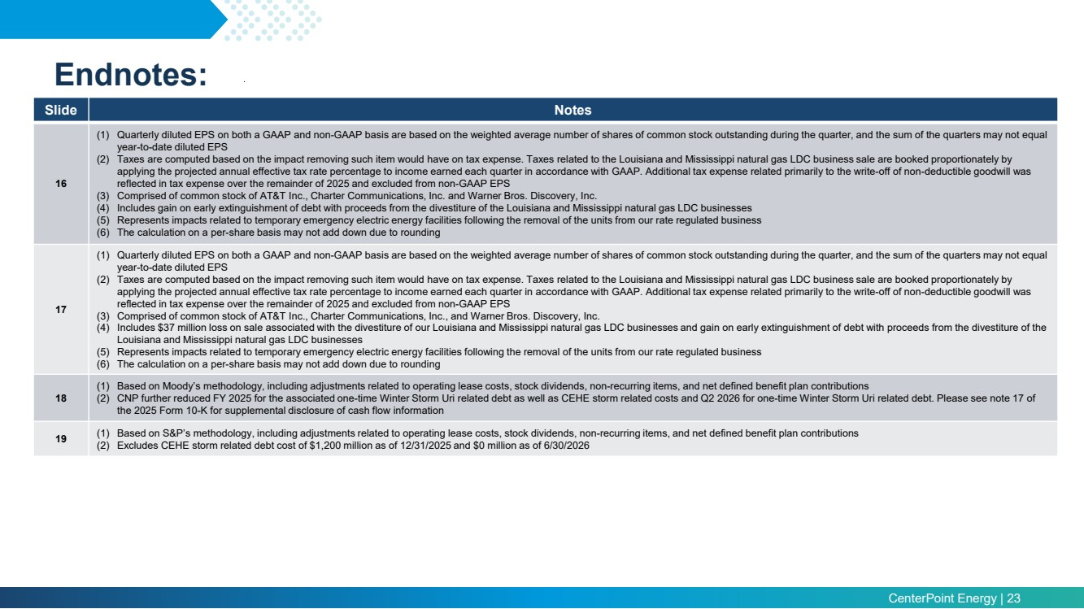 | CenterPoint Energy | 23 Endnotes: Slide Notes 16 (1) Quarterly diluted EPS on both a GAAP and non-GAAP basis are based on the weighted average number of shares of common stock outstanding during the quarter, and the sum of the quarters may not equal year-to-date diluted EPS (2) Taxes are computed based on the impact removing such item would have on tax expense. Taxes related to the Louisiana and Mississippi natural gas LDC business sale are booked proportionately by applying the projected annual effective tax rate percentage to income earned each quarter in accordance with GAAP. Additional tax expense related primarily to the write-off of non-deductible goodwill was reflected in tax expense over the remainder of 2025 and excluded from non-GAAP EPS (3) Comprised of common stock of AT&T Inc., Charter Communications, Inc. and Warner Bros. Discovery, Inc. (4) Includes gain on early extinguishment of debt with proceeds from the divestiture of the Louisiana and Mississippi natural gas LDC businesses (5) Represents impacts related to temporary emergency electric energy facilities following the removal of the units from our rate regulated business (6) The calculation on a per-share basis may not add down due to rounding 17 (1) Quarterly diluted EPS on both a GAAP and non-GAAP basis are based on the weighted average number of shares of common stock outstanding during the quarter, and the sum of the quarters may not equal year-to-date diluted EPS (2) Taxes are computed based on the impact removing such item would have on tax expense. Taxes related to the Louisiana and Mississippi natural gas LDC business sale are booked proportionately by applying the projected annual effective tax rate percentage to income earned each quarter in accordance with GAAP. Additional tax expense related primarily to the write-off of non-deductible goodwill was reflected in tax expense over the remainder of 2025 and excluded from non-GAAP EPS (3) Comprised of common stock of AT&T Inc., Charter Communications, Inc., and Warner Bros. Discovery, Inc. (4) Includes $37 million loss on sale associated with the divestiture of our Louisiana and Mississippi natural gas LDC businesses and gain on early extinguishment of debt with proceeds from the divestiture of the Louisiana and Mississippi natural gas LDC businesses (5) Represents impacts related to temporary emergency electric energy facilities following the removal of the units from our rate regulated business (6) The calculation on a per-share basis may not add down due to rounding 18 (1) Based on Moody’s methodology, including adjustments related to operating lease costs, stock dividends, non-recurring items, and net defined benefit plan contributions (2) CNP further reduced FY 2025 for the associated one-time Winter Storm Uri related debt as well as CEHE storm related costs and Q2 2026 for one-time Winter Storm Uri related debt. Please see note 17 of the 2025 Form 10-K for supplemental disclosure of cash flow information 19 (1) Based on S&P’s methodology, including adjustments related to operating lease costs, stock dividends, non-recurring items, and net defined benefit plan contributions (2) Excludes CEHE storm related debt cost of $1,200 million as of 12/31/2025 and $0 million as of 6/30/2026
 | 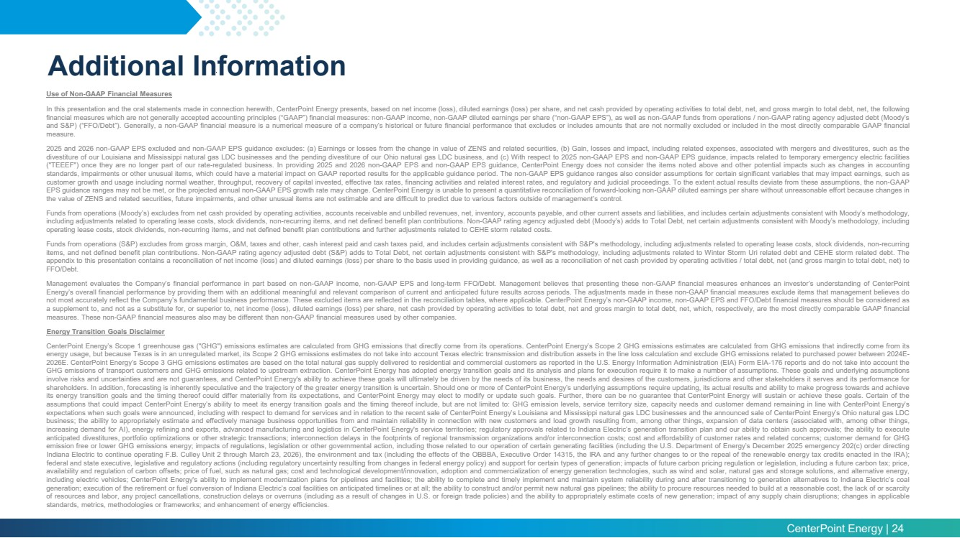 | CenterPoint Energy | 24 Additional Information Use of Non-GAAP Financial Measures In this presentation and the oral statements made in connection herewith, CenterPoint Energy presents, based on net income (loss), diluted earnings (loss) per share, and net cash provided by operating activities to total debt, net, and gross margin to total debt, net, the following financial measures which are not generally accepted accounting principles (“GAAP”) financial measures: non-GAAP income, non-GAAP diluted earnings per share (“non-GAAP EPS”), as well as non-GAAP funds from operations / non-GAAP rating agency adjusted debt (Moody’s and S&P) (“FFO/Debt”). Generally, a non-GAAP financial measure is a numerical measure of a company’s historical or future financial performance that excludes or includes amounts that are not normally excluded or included in the most directly comparable GAAP financial measure. 2025 and 2026 non-GAAP EPS excluded and non-GAAP EPS guidance excludes: (a) Earnings or losses from the change in value of ZENS and related securities, (b) Gain, losses and impact, including related expenses, associated with mergers and divestitures, such as the divestiture of our Louisiana and Mississippi natural gas LDC businesses and the pending divestiture of our Ohio natural gas LDC business, and (c) With respect to 2025 non-GAAP EPS and non-GAAP EPS guidance, impacts related to temporary emergency electric facilities ("TEEEF") once they are no longer part of our rate-regulated business. In providing 2025 and 2026 non-GAAP EPS and non-GAAP EPS guidance, CenterPoint Energy does not consider the items noted above and other potential impacts such as changes in accounting standards, impairments or other unusual items, which could have a material impact on GAAP reported results for the applicable guidance period. The non-GAAP EPS guidance ranges also consider assumptions for certain significant variables that may impact earnings, such as customer growth and usage including normal weather, throughput, recovery of capital invested, effective tax rates, financing activities and related interest rates, and regulatory and judicial proceedings. To the extent actual results deviate from these assumptions, the non-GAAP EPS guidance ranges may not be met, or the projected annual non-GAAP EPS growth rate may change. CenterPoint Energy is unable to present a quantitative reconciliation of forward-looking non-GAAP diluted earnings per share without unreasonable effort because changes in the value of ZENS and related securities, future impairments, and other unusual items are not estimable and are difficult to predict due to various factors outside of management’s control. Funds from operations (Moody’s) excludes from net cash provided by operating activities, accounts receivable and unbilled revenues, net, inventory, accounts payable, and other current assets and liabilities, and includes certain adjustments consistent with Moody’s methodology, including adjustments related to operating lease costs, stock dividends, non-recurring items, and net defined benefit plan contributions. Non-GAAP rating agency adjusted debt (Moody’s) adds to Total Debt, net certain adjustments consistent with Moody’s methodology, including operating lease costs, stock dividends, non-recurring items, and net defined benefit plan contributions and further adjustments related to CEHE storm related costs. Funds from operations (S&P) excludes from gross margin, O&M, taxes and other, cash interest paid and cash taxes paid, and includes certain adjustments consistent with S&P's methodology, including adjustments related to operating lease costs, stock dividends, non-recurring items, and net defined benefit plan contributions. Non-GAAP rating agency adjusted debt (S&P) adds to Total Debt, net certain adjustments consistent with S&P's methodology, including adjustments related to Winter Storm Uri related debt and CEHE storm related debt. The appendix to this presentation contains a reconciliation of net income (loss) and diluted earnings (loss) per share to the basis used in providing guidance, as well as a reconciliation of net cash provided by operating activities / total debt, net (and gross margin to total debt, net) to FFO/Debt. Management evaluates the Company’s financial performance in part based on non-GAAP income, non-GAAP EPS and long-term FFO/Debt. Management believes that presenting these non-GAAP financial measures enhances an investor’s understanding of CenterPoint Energy’s overall financial performance by providing them with an additional meaningful and relevant comparison of current and anticipated future results across periods. The adjustments made in these non-GAAP financial measures exclude items that management believes do not most accurately reflect the Company’s fundamental business performance. These excluded items are reflected in the reconciliation tables, where applicable. CenterPoint Energy’s non-GAAP income, non-GAAP EPS and FFO/Debt financial measures should be considered as a supplement to, and not as a substitute for, or superior to, net income (loss), diluted earnings (loss) per share, net cash provided by operating activities to total debt, net and gross margin to total debt, net, which, respectively, are the most directly comparable GAAP financial measures. These non-GAAP financial measures also may be different than non-GAAP financial measures used by other companies. Energy Transition Goals Disclaimer CenterPoint Energy’s Scope 1 greenhouse gas ("GHG") emissions estimates are calculated from GHG emissions that directly come from its operations. CenterPoint Energy’s Scope 2 GHG emissions estimates are calculated from GHG emissions that indirectly come from its energy usage, but because Texas is in an unregulated market, its Scope 2 GHG emissions estimates do not take into account Texas electric transmission and distribution assets in the line loss calculation and exclude GHG emissions related to purchased power between 2024E-2026E. CenterPoint Energy’s Scope 3 GHG emissions estimates are based on the total natural gas supply delivered to residential and commercial customers as reported in the U.S. Energy Information Administration (EIA) Form EIA-176 reports and do not take into account the GHG emissions of transport customers and GHG emissions related to upstream extraction. CenterPoint Energy has adopted energy transition goals and its analysis and plans for execution require it to make a number of assumptions. These goals and underlying assumptions involve risks and uncertainties and are not guarantees, and CenterPoint Energy's ability to achieve these goals will ultimately be driven by the needs of its business, the needs and desires of the customers, jurisdictions and other stakeholders it serves and its performance for shareholders. In addition, forecasting is inherently speculative and the trajectory of the greater energy transition is uncertain. Should one or more of CenterPoint Energy’s underlying assumptions require updating, its actual results and ability to make progress towards and achieve its energy transition goals and the timing thereof could differ materially from its expectations, and CenterPoint Energy may elect to modify or update such goals. Further, there can be no guarantee that CenterPoint Energy will sustain or achieve these goals. Certain of the assumptions that could impact CenterPoint Energy’s ability to meet its energy transition goals and the timing thereof include, but are not limited to: GHG emission levels, service territory size, capacity needs and customer demand remaining in line with CenterPoint Energy’s expectations when such goals were announced, including with respect to demand for services and in relation to the recent sale of CenterPoint Energy’s Louisiana and Mississippi natural gas LDC businesses and the announced sale of CenterPoint Energy’s Ohio natural gas LDC business; the ability to appropriately estimate and effectively manage business opportunities from and maintain reliability in connection with new customers and load growth resulting from, among other things, expansion of data centers (associated with, among other things, increasing demand for AI), energy refining and exports, advanced manufacturing and logistics in CenterPoint Energy's service territories; regulatory approvals related to Indiana Electric’s generation transition plan and our ability to obtain such approvals; the ability to execute anticipated divestitures, portfolio optimizations or other strategic transactions; interconnection delays in the footprints of regional transmission organizations and/or interconnection costs; cost and affordability of customer rates and related concerns; customer demand for GHG emission free or lower GHG emissions energy; impacts of regulations, legislation or other governmental action, including those related to our operation of certain generating facilities (including the U.S. Department of Energy’s December 2025 emergency 202(c) order directing Indiana Electric to continue operating F.B. Culley Unit 2 through March 23, 2026), the environment and tax (including the effects of the OBBBA, Executive Order 14315, the IRA and any further changes to or the repeal of the renewable energy tax credits enacted in the IRA); federal and state executive, legislative and regulatory actions (including regulatory uncertainty resulting from changes in federal energy policy) and support for certain types of generation; impacts of future carbon pricing regulation or legislation, including a future carbon tax; price, availability and regulation of carbon offsets; price of fuel, such as natural gas; cost and technological development/innovation, adoption and commercialization of energy generation technologies, such as wind and solar, natural gas and storage solutions, and alternative energy, including electric vehicles; CenterPoint Energy's ability to implement modernization plans for pipelines and facilities; the ability to complete and timely implement and maintain system reliability during and after transitioning to generation alternatives to Indiana Electric’s coal generation; execution of the retirement or fuel conversion of Indiana Electric’s coal facilities on anticipated timelines or at all; the ability to construct and/or permit new natural gas pipelines; the ability to procure resources needed to build at a reasonable cost, the lack of or scarcity of resources and labor, any project cancellations, construction delays or overruns (including as a result of changes in U.S. or foreign trade policies) and the ability to appropriately estimate costs of new generation; impact of any supply chain disruptions; changes in applicable standards, metrics, methodologies or frameworks; and enhancement of energy efficiencies.

