UNITED STATES SECURITIES AND EXCHANGE COMMISSION

WASHINGTON, D.C. 20549

__________________

FORM 10-Q

(Mark One)

- QUARTERLY REPORT PURSUANT TO SECTION 13 OR 15(d) OF THE SECURITIES EXCHANGE ACT OF 1934

For the quarterly period ended March 31, 2026

OR

- TRANSITION REPORT PURSUANT TO SECTION 13 OR 15(d) OF THE SECURITIES EXCHANGE ACT OF 1934 FOR THE TRANSITION PERIOD FROM __________________ TO __________________

Commission file number 1-31447

CenterPoint Energy, Inc.

(Exact name of registrant as specified in its charter)

Texas |  |  | 74-0694415
(State or other jurisdiction of incorporation or organization) |  |  | (I.R.S. Employer Identification No.)
1111 Louisiana | Houston | Texas | 77002
(Address of Principal Executive Offices) |  |  | (Zip Code)
 |  | (713) 207-1111
 | Registrant's telephone number, including area code
 | Commission file number 1-3187
 | CenterPoint Energy Houston Electric, LLC
 | (Exact name of registrant as specified in its charter)
Texas |  |  | 22-3865106
(State or other jurisdiction of incorporation or organization) |  |  | (I.R.S. Employer Identification No.)
1111 Louisiana | Houston | Texas | 77002
(Address of Principal Executive Offices) |  |  | (Zip Code)
 |  | (713) 207-1111
 | Registrant's telephone number, including area code
 | Commission file number 1-13265
 | CenterPoint Energy Resources Corp.
 | (Exact name of registrant as specified in its charter)
Delaware |  |  | 76-0511406
(State or other jurisdiction of incorporation or organization) |  |  | (I.R.S. Employer Identification No.)
1111 Louisiana | Houston | Texas | 77002
(Address of Principal Executive Offices) |  |  | (Zip Code)
 |  | (713) 207-1111
 | Registrant's telephone number, including area code
 | Securities registered pursuant to Section 12(b) of the Act:

 | Registrant |  | Title of each class |  |  | Trading Symbol |  |  | Name of each exchange on which registered
CenterPoint Energy, Inc. |  |  | Common Stock, $0.01 par value |  |  |  | CNP |  |  | New York Stock Exchange
 |  |  |  |  |  |  |  |  |  | NYSE Texas
CenterPoint Energy Houston Electric, LLC |  |  | 6.95% General Mortgage Bonds due 2033 |  |  |  | n/a |  |  | New York Stock Exchange
CenterPoint Energy Resources Corp. |  |  | 6.625% Senior Notes due 2037 |  |  |  | n/a |  |  | New York Stock Exchange

Indicate by check mark whether the registrant (1) has filed all reports required to be filed by Section 13 or 15(d) of the Securities Exchange Act of 1934 during the preceding 12 months (or for such shorter period that the registrant was required to file such reports), and (2) has been subject to such filing requirements for the past 90 days.

CenterPoint Energy, Inc. | Yes | ☑ | No | o
CenterPoint Energy Houston Electric, LLC | Yes | ☑ | No | o
CenterPoint Energy Resources Corp. | Yes | ☑ | No | o

Indicate by check mark whether the registrant has submitted electronically every Interactive Data File required to be submitted pursuant to Rule 405 of Regulation S-T (§232.405 of this chapter) during the preceding 12 months (or for such shorter period that the registrant was required to submit such files).

CenterPoint Energy, Inc. | Yes | ☑ | No | o
CenterPoint Energy Houston Electric, LLC | Yes | ☑ | No | o
CenterPoint Energy Resources Corp. | Yes | ☑ | No | o

Indicate by check mark whether the registrant is a large accelerated filer, an accelerated filer, a non-accelerated filer, a smaller reporting company, or an emerging growth company. See the definitions of “large accelerated filer,” “accelerated filer,” “smaller reporting company,” and “emerging growth company” in Rule 12b-2 of the Exchange Act.

 | Large accelerated filer | Accelerated filer | Non-accelerated filer | Smaller reporting | Emerging growth
 | Large accelerated filer | Accelerated filer | Non-accelerated filer | company | company
CenterPoint Energy, Inc. | ☑ | o | o | ☐ | ☐
CenterPoint Energy Houston Electric, LLC | o | o | ☑ | ☐ | ☐
CenterPoint Energy Resources Corp. | o | o | ☑ | ☐ | ☐

If an emerging growth company, indicate by check mark if the registrant has elected not to use the extended transition period for complying with any new or revised financial accounting standards provided pursuant to Section 13(a) of the Exchange Act. o

Indicate by check mark whether the registrant is a shell company (as defined in Rule 12b-2 of the Exchange Act).

CenterPoint Energy, Inc. | Yes | ☐ | No | ☑
CenterPoint Energy Houston Electric, LLC | Yes | ☐ | No | ☑
CenterPoint Energy Resources Corp. | Yes | ☐ | No | ☑

Indicate the number of shares outstanding of each of the issuers’ classes of common stock as of April 15, 2026:

CenterPoint Energy, Inc. | 654,169,480 | shares of common stock outstanding, excluding 166 shares held as treasury stock
CenterPoint Energy Houston Electric, LLC | 1,000 | common shares outstanding, all held by Utility Holding, LLC, a wholly-owned subsidiary of CenterPoint Energy, Inc.
CenterPoint Energy Resources Corp. | 1,000 | shares of common stock outstanding, all held by Utility Holding, LLC, a wholly-owned subsidiary of CenterPoint Energy, Inc.

CenterPoint Energy Houston Electric, LLC and CenterPoint Energy Resources Corp. meet the conditions set forth in General Instructions H(1)(a) and (b) of Form 10-Q and are therefore filing this form with the reduced disclosure format specified in General Instruction H(2) of Form 10-Q.

 |  |  |  |  |  |  |  |  |  |  |  |  |  |  |  |  |  |  | TABLE OF CONTENTS
PART I. | FINANCIAL INFORMATION
Item 1. |  | Financial Statements |  |  |  |  |  |  |  |  |  |  |  |  |  |  |  |  |  |  |  |  |  |  |  |  | 1
 |  | CenterPoint Energy, Inc. and Subsidiaries Financial Statements (Unaudited) |  |  |  |  |  |  |  |  |  |  |  |  |  |  |  |  |  |  |  |  |  |  |  |  | 1
 |  | CenterPoint Energy Houston Electric, LLC and Subsidiaries Financial Statements (Unaudited) |  |  |  |  |  |  |  |  |  |  |  |  |  |  |  |  |  |  |  |  |  |  |  |  | 6
 |  | CenterPoint Energy Resources Corp. and Subsidiaries Financial Statements (Unaudited) |  |  |  |  |  |  |  |  |  |  |  |  |  |  |  |  |  |  |  |  |  |  |  |  | 10
 |  | Combined Notes to Interim Condensed Financial Statements (Unaudited) |  |  |  |  |  |  |  |  |  |  |  |  |  |  |  |  |  |  |  |  |  |  |  |  | 15
 |  |  | (1) | Background and Basis of Presentation |  |  |  |  |  |  |  |  |  |  |  |  |  |  |  |  |  |  |  |  |  |  | 15
 |  |  | (2) | Accounting Policies and Recent Accounting Pronouncements |  |  |  |  |  |  |  |  |  |  |  |  |  |  |  |  |  |  |  |  |  |  | 16
 |  |  | (3) | Held for Sale, Divestitures and Acquisition (CenterPoint Energy and CERC) |  |  |  |  |  |  |  |  |  |  |  |  |  |  |  |  |  |  |  |  |  |  | 17
 |  |  | (4) | Revenue |  |  |  |  |  |  |  |  |  |  |  |  |  |  |  |  |  |  |  |  |  |  | 19
 |  |  | (5) | Employee Benefit Plans |  |  |  |  |  |  |  |  |  |  |  |  |  |  |  |  |  |  |  |  |  |  | 20
 |  |  | (6) | Regulatory Matters |  |  |  |  |  |  |  |  |  |  |  |  |  |  |  |  |  |  |  |  |  |  | 21
 |  |  | (7) | Fair Value Measurements |  |  |  |  |  |  |  |  |  |  |  |  |  |  |  |  |  |  |  |  |  |  | 25
 |  |  | (8) | Equity Securities and Indexed Debt Securities (ZENS) (CenterPoint Energy) |  |  |  |  |  |  |  |  |  |  |  |  |  |  |  |  |  |  |  |  |  |  | 26
 |  |  | (9) | Short-term Borrowings and Long-term Debt |  |  |  |  |  |  |  |  |  |  |  |  |  |  |  |  |  |  |  |  |  |  | 27
 |  |  | (10) Income Taxes |  |  |  |  |  |  |  |  |  |  |  |  |  |  |  |  |  |  |  |  |  |  |  | 30
 |  |  | (11) Commitments and Contingencies |  |  |  |  |  |  |  |  |  |  |  |  |  |  |  |  |  |  |  |  |  |  |  | 30
 |  |  | (12) Earnings Per Share (CenterPoint Energy) |  |  |  |  |  |  |  |  |  |  |  |  |  |  |  |  |  |  |  |  |  |  |  | 36
 |  |  | (13) Reportable Segments |  |  |  |  |  |  |  |  |  |  |  |  |  |  |  |  |  |  |  |  |  |  |  | 36
 |  |  | (14) Related Party Transactions (Houston Electric and CERC) |  |  |  |  |  |  |  |  |  |  |  |  |  |  |  |  |  |  |  |  |  |  |  | 39
 |  |  | (15) Equity (CenterPoint Energy) |  |  |  |  |  |  |  |  |  |  |  |  |  |  |  |  |  |  |  |  |  |  |  | 40
 |  |  | (16) Subsequent Events |  |  |  |  |  |  |  |  |  |  |  |  |  |  |  |  |  |  |  |  |  |  |  | 41
Item 2. |  | Management’s Discussion and Analysis of Financial Condition and Results of Operations |  |  |  |  |  |  |  |  |  |  |  |  |  |  |  |  |  |  |  |  |  |  |  |  | 42
 |  |  | Recent Events |  |  |  |  |  |  |  |  |  |  |  |  |  |  |  |  |  |  |  |  |  |  |  | 42
 |  |  | Consolidated Results of Operations |  |  |  |  |  |  |  |  |  |  |  |  |  |  |  |  |  |  |  |  |  |  |  | 43
 |  |  | Results of Operations by Reportable Segment |  |  |  |  |  |  |  |  |  |  |  |  |  |  |  |  |  |  |  |  |  |  |  | 44
 |  |  | Certain Factors Affecting Future Earnings |  |  |  |  |  |  |  |  |  |  |  |  |  |  |  |  |  |  |  |  |  |  |  | 52
 |  |  | Liquidity and Capital Resources |  |  |  |  |  |  |  |  |  |  |  |  |  |  |  |  |  |  |  |  |  |  |  | 52
Item 3. |  | Quantitative and Qualitative Disclosures about Market Risk |  |  |  |  |  |  |  |  |  |  |  |  |  |  |  |  |  |  |  |  |  |  |  |  | 61
Item 4. |  | Controls and Procedures |  |  |  |  |  |  |  |  |  |  |  |  |  |  |  |  |  |  |  |  |  |  |  |  | 62

PART II. | OTHER INFORMATION
Item 1. | Legal Proceedings |  |  |  |  | 62
Item 1A. | Risk Factors |  |  |  |  | 62
Item 5. | Other Information |  |  |  |  | 62
Item 6. | Exhibits |  |  |  |  | 62
 | Signatures |  |  |  |  | 65

i

 | GLOSSARY
AFUDC | Allowance for funds used during construction
AI | Artificial intelligence
ARO | Asset retirement obligation
ARP | Alternative revenue program
ASU | Accounting Standards Update
AT&T Common | AT&T Inc. common stock
ATM Forward Purchasers | Bank of America, N.A., Barclays Bank PLC, Citibank, N.A., Goldman Sachs & Co. LLC, JPMorgan Chase Bank, National
 | Association, Mizuho Markets Americas LLC, MUFG Securities EMEA plc and Royal Bank of Canada
ATM Forward Sellers | BofA Securities, Inc. Barclays Capital Inc., Citigroup Global Markets Inc., Goldman Sachs & Co. LLC, J.P. Morgan Securities LLC,
 | Mizuho Securities USA LLC, MUFG Securities Americas Inc. and RBC Capital Markets, LLC
ATM Managers | BofA Securities, Inc., Barclays Capital Inc., Citigroup Global Markets Inc., Goldman Sachs & Co. LLC, J.P. Morgan Securities LLC,
 | Mizuho Securities USA LLC, MUFG Securities Americas Inc. and RBC Capital Markets, LLC
Bcf | Billion cubic feet
Board | Board of Directors of CenterPoint Energy, Inc.
Bond Companies | Transition Bond Company IV, Restoration Bond Company II and Restoration Bond Company III, each a consolidated VIE that is a
 | wholly-owned, bankruptcy-remote, special purpose entity formed solely for the purpose of securitizing transition property or system
 | restoration property through the issuance of transition bonds and system restoration bonds
CAMT | Corporate Alternative Minimum Tax
CCR | Coal Combustion Residuals
CECA | Clean Energy Cost Adjustment
CEIP | CenterPoint Energy Intrastate Pipelines, LLC, a wholly-owned subsidiary of CERC Corp.
CenterPoint Energy | CenterPoint Energy, Inc., and its subsidiaries
CEOH | Vectren Energy Delivery of Ohio, LLC, doing business as CenterPoint Energy Ohio, which converted its corporate structure from
 | Vectren Energy Delivery of Ohio, Inc. to an Ohio limited liability company on June 13, 2022, formerly a wholly-owned subsidiary of
 | Vectren, acquired by CERC on June 30, 2022
CEP | Capital Expenditure Program
CERC | CERC Corp., together with its subsidiaries
CERC Corp. | CenterPoint Energy Resources Corp.
Charter Common | Charter Communications, Inc. common stock
CIP | Conservation Improvement Program
CODM | Chief Operating Decision Maker, who is each Registrant’s Chief Operating Executive
Common Stock | CenterPoint Energy, Inc. common stock, par value $0.01 per share
CPCN | Certificate of Public Convenience and Necessity
CPS Energy | City Public Service Board of San Antonio, Texas
CSIA | Compliance and System Improvement Adjustment
DCRF | Distribution Cost Recovery Factor
DRR | Distribution Replacement Rider
DSMA | Demand Side Management Adjustment
ECA | Environmental Cost Adjustment
EDIT | Excess deferred income taxes
EECRF | Energy Efficiency Cost Recovery Factor
EEFC | Energy Efficiency Funding Component
EEFR | Energy Efficiency Funding Rider
Energy Systems Group | Energy Systems Group, LLC, previously a wholly-owned subsidiary of Vectren
EPA | Environmental Protection Agency
Equity Distribution Agreement | Equity Distribution Agreement, dated as of January 10, 2024, by and between CenterPoint Energy, the ATM Managers, the ATM
 | Forward Purchasers and the ATM Forward Sellers
Equity Purchase Agreement | Equity Purchase Agreement, dated as of May 21, 2023, by and between Vectren Energy Services and ESG Holdings Group
ERCOT | Electric Reliability Council of Texas
ESG Holdings Group | ESG Holdings Group, LLC, a Delaware limited liability company, and an affiliate of Oaktree Capital Management

ii

 | GLOSSARY
Exchange Act | The Securities Exchange Act of 1934, as amended
February 2021 Winter Storm Event | The extreme and unprecedented winter weather event in February 2021 (Winter Storm Uri) that resulted in electricity generation supply
 | shortages, including in Texas, and natural gas supply shortages and increased wholesale prices of natural gas in the United States,
 | primarily due to prolonged freezing temperatures
FASB | Financial Accounting Standards Board
FERC | Federal Energy Regulatory Commission
Fitch | Fitch Ratings, Inc.
Form 10-Q | Quarterly Report on Form 10-Q
GAAP | Generally Accepted Accounting Principles
General Mortgage | General Mortgage Indenture, dated as of October 10, 2002, between Houston Electric and JPMorgan Chase Bank, as Trustee, as
 | supplemented
GHG | Greenhouse gas
GRIP | Gas Reliability Infrastructure Program
GWh | Gigawatt-hours
Houston Electric | CenterPoint Energy Houston Electric, LLC and its subsidiaries
Hurricane Beryl | The powerful and destructive storm that made landfall in Texas on July 8, 2024 and caused widespread damage to Houston Electric’s
 | electric system
IDEM | Indiana Department of Environmental Management
Indiana Electric | Operations of SIGECO’s electric transmission and distribution services, and includes its power generating and wholesale power
 | operations
Indiana Gas | Indiana Gas Company, Inc., formerly a wholly-owned subsidiary of Vectren, acquired by CERC on June 30, 2022
Indiana North | Gas operations of Indiana Gas
Indiana South | Gas operations of SIGECO
Interim Condensed Financial Statements | Unaudited condensed consolidated interim financial statements and combined notes
IRA | Inflation Reduction Act of 2022
IRP | Integrated Resource Plan
IRS | Internal Revenue Service
IURC | Indiana Utility Regulatory Commission
kW | Kilowatt
LAMS Asset Purchase Agreement | Asset Purchase Agreement, dated as of February 19, 2024, by and among CERC Corp. and the LAMS Buyers
LAMS Buyers | Delta North Louisiana Gas Company, LLC (f/k/a Delta Utilities No. LA, LLC), a Delaware limited liability company, Delta South
 | Louisiana Gas Company, LLC (f/k/a Delta Utilities S. LA, LLC), a Delaware limited liability company, Delta Mississippi Gas
 | Company, LLC (f/k/a Delta Utilities MS, LLC), a Delaware limited liability company, and Delta Energy Resources, LLC (f/k/a Delta
 | Shared Services Co., LLC), a Delaware limited liability company
LDC | Local distribution company
M&DOT | Mortgage and Deed of Trust, dated November 1, 1944, between Houston Lighting and Power Company and Chase Bank of Texas,
 | National Association (formerly, South Texas Commercial National Bank of Houston), as Trustee, as amended and supplemented
May 2024 Storm Events | The sudden and destructive severe weather events in May 2024 that included hurricane-like winds and tornadoes and resulted in
 | widespread damage to Houston Electric’s electric delivery system
MDL | Multi-district litigation
MGP | Manufactured gas plant
MISO | Midcontinent Independent System Operator
Moody’s | Moody’s Investors Service, Inc.
MW | Megawatt(s)
NERC | North American Electric Reliability Corporation
NFGC | National Fuel Gas Company, a New Jersey corporation
NRG | NRG Energy, Inc.
NYSE | New York Stock Exchange
OBBBA | One Big Beautiful Bill Act of 2025
Ohio Securities Purchase Agreement | Securities Purchase Agreement, dated as of October 20, 2025, by and between CERC Corp. and NFGC
Origis | Origis Energy USA Inc.
OUCC | Indiana Office of Utility Consumer Counselor

iii

 | GLOSSARY
Posey Solar | Posey Solar, LLC, a special purpose entity
PPA | Power purchase agreement
PRP | Potentially responsible party
PTCs | Production Tax Credits
PUCO | Public Utilities Commission of Ohio
PUCT | Public Utility Commission of Texas
Railroad Commission | Railroad Commission of Texas
Registrant | Each of CenterPoint Energy, Inc., CenterPoint Energy Houston Electric, LLC and CenterPoint Energy Resources Corp.
REP | Retail electric provider
Restoration Bond Company II | CenterPoint Energy Restoration Bond Company II, LLC, a wholly-owned subsidiary of Houston Electric
Restoration Bond Company II Securitization Bonds | Restoration Bond Company II’s Series 2025-A Senior Secured System Restoration Bonds
Restoration Bond Company III | CenterPoint Energy Restoration Bond Company III, LLC, a wholly-owned subsidiary of Houston Electric
Restoration Bond Company III Securitization Bonds | Restoration Bond Company III’s Series 2026-A Senior Secured System Restoration Bonds
S&P | S&P Global Ratings
SEC | Securities and Exchange Commission
Securities Act | The Securities Act of 1933, as amended
Securitization Bonds | Transition bonds issued by Transition Bond Company IV, system restoration bonds issued by Restoration Bond Company II and
 | Restoration Bond Company III and SIGECO Securitization Bonds issued by the SIGECO Securitization Subsidiary
Seller Note Agreement | Seller Note Agreement by and between CERC Corp. and NFGC to be entered into at the closing of the proposed sale of all of the
 | issued and outstanding equity interests in CEOH to NFGC contemplated by the Ohio Securities Purchase Agreement
SIGECO | Southern Indiana Gas and Electric Company, a wholly-owned subsidiary of Vectren
SIGECO Securitization Bonds | SIGECO Securitization Subsidiary’s Series 2023-A Senior Secured Securitization Bonds relating to the securitization of qualified costs
 | in connection with the retirement of SIGECO’s A.B. Brown Units 1 and 2 coal-fired generation facilities
SIGECO Securitization Subsidiary | SIGECO Securitization I, LLC, a direct, wholly-owned subsidiary of SIGECO
SOAH | Texas State Office of Administrative Hearings
SOFR | Secured Overnight Financing Rate
SRC | Sales Reconciliation Component
TBD | To be determined
TCA | Texas Consumer Association
TCOS | Transmission Cost of Service
TCRF | Transmission Cost Recovery Factor
TDSIC | Transmission, Distribution and Storage System Improvement Charge
TDU | Transmission and distribution utility
TEEEF | Assets leased or costs incurred as “temporary emergency electric energy facilities” under the Public Utility Regulatory Act Section
 | 39.918, also referred to as temporary generation
TEEEF Rule | Texas Administrative Code, Title 16, Section 25.56, which became effective January 8, 2025 and refined the scope of TEEEF filings
 | that can be made pursuant to Public Utility Regulatory Act Section 39.918
Transition Bond Company IV | CenterPoint Energy Transition Bond Company IV, LLC, a wholly-owned subsidiary of Houston Electric
Transition Services Agreement | Transition Services Agreement, dated as of March 31, 2025, by and among CenterPoint Energy Resources Corp., Delta North
 | Louisiana Gas Company, LLC, Delta South Louisiana Gas Company, LLC, Delta Mississippi Gas Company, LLC, and Delta Energy
 | Resources, LLC
Utility Holding | Utility Holding, LLC, a wholly-owned subsidiary of CenterPoint Energy
Vectren | Vectren, LLC, which converted its corporate structure from Vectren Corporation to a limited liability company on June 30, 2022, a
 | wholly-owned subsidiary of CenterPoint Energy as of February 1, 2019
Vectren Energy Services | Vectren Energy Services Corporation, an Indiana corporation and a wholly-owned subsidiary of CenterPoint Energy
VIE | Variable interest entity
Vistra Energy Corp. | Texas-based energy company focused on the competitive energy and power generation markets

iv

 |  | GLOSSARY
VRP |  | Voluntary Remediation Program
WBD |  | Warner Bros. Discovery, Inc.
WBD Common |  | Warner Bros. Discovery, Inc. Series A common stock
ZENS |  | 2.0% Zero-Premium Exchangeable Subordinated Notes due 2029
ZENS-Related Securities |  | As of March 31, 2026 and December 31, 2025, consisted of AT&T Common, Charter Common and WBD Common
2025 Form 10-K |  | Annual Report on Form 10-K for the fiscal year ended December 31, 2025 as filed with the SEC on February 19, 2026
2026 | Convertible Notes | CenterPoint Energy’s 4.25% Convertible Senior Notes due 2026
2029 | Convertible Notes | CenterPoint Energy’s 2.875% Convertible Senior Notes due 2029
2029 | Convertible Notes Indenture | Indenture, dated as of February 26, 2026, by and between CenterPoint Energy and The Bank of New York Mellon Trust Company,
 |  | National Association, as trustee

v

CAUTIONARY STATEMENT REGARDING FORWARD-LOOKING INFORMATION

From time to time the Registrants make statements concerning their expectations, beliefs, plans, objectives, goals, strategies, future events or performance and underlying assumptions and other statements that are not historical facts. These statements are “forward-looking statements” within the meaning of the Private Securities Litigation Reform Act of 1995. Actual results may differ materially from those expressed or implied by these statements. You can generally identify forward-looking statements by the words “anticipate,” “believe,” “continue,” “could,” “estimate,” “expect,” “forecast,” “goal,” “intend,” “may,” “objective,” “plan,” “potential,” “predict,” “projection,” “should,” “target,” “will” or other similar words.

The Registrants have based their forward-looking statements on management’s beliefs and assumptions based on information reasonably available to management at the time the statements are made. The Registrants caution you that assumptions, beliefs, expectations, intentions and projections about future events may and often do vary materially from actual results. Therefore, the Registrants cannot assure you that actual results will not differ materially from those expressed or implied by the Registrants’ forward-looking statements. In this combined Form 10-Q, unless context requires otherwise, the terms “our,” “we” and “us” are used as abbreviated references to CenterPoint Energy, Inc. together with its consolidated subsidiaries, including Houston Electric, CERC and SIGECO.

The following are some of the factors that could cause actual results to differ from those expressed or implied by the Registrants’ forward-looking statements and apply to all Registrants unless otherwise indicated:

- The business strategies and strategic initiatives, restructurings, joint ventures and acquisitions or dispositions of assets or businesses involving us or our industry, including the ability to successfully complete such strategies, initiatives, transactions or plans on the timelines we expect or at all, such as the announced sale of our Ohio natural gas LDC business, which we cannot assure will have the anticipated benefits to us;
- industrial, commercial and residential growth in our service territories and changes in market demand and energy consumption, including in relation to the expansion of data centers (associated with, among other things, increasing demand for AI), energy refining and exports, advanced manufacturing and logistics, as well as the effects of energy efficiency measures, technological advances and demographic patterns, and our ability to appropriately estimate/forecast and effectively manage such demand and the business opportunities and projects relating to such matters as well as obtain the anticipated benefits, including relating to customer affordability, associated with such growth;
- our ability to fund and invest planned capital and the timely recovery of our investments, including the timing of and amounts sought for those related to our 10-year capital plan;

- our ability to execute and complete our planned capital projects and programs, including those within our 10-year capital plan, in a timely and cost-effective manner and within budget, obtain the anticipated benefits of such projects, and manage costs and impacts of such projects on customer affordability;
- our ability to successfully construct, operate, repair, maintain, replace and restart electric generating facilities, natural gas facilities, TEEEF and electric transmission facilities, as applicable, including in the event of an outage and in relation to complying with applicable environmental, reliability and safety standards;
- timely and appropriate rate actions that allow and authorize timely recovery of costs and a reasonable return on investment, including the timing of and amounts sought for recovery of Houston Electric’s applicable TEEEF leases and restoration costs relating to, among other things, Hurricane Beryl, and requested or favorable adjustments to rates and approval of other requested items as part of base rate proceedings or interim rate mechanisms;
- the timing and success of, and our ability to obtain approval for matters relating to, Houston Electric’s release of its large TEEEF units to the San Antonio area, proposed removal of its medium TEEEF units, reduction of its TEEEF fleet capacity and reduction of rates to reflect the removal of the large and medium TEEEF units from Houston Electric’s TEEEF fleet, as well as Houston Electric’s ability to complete one or more other future transactions involving the large and medium TEEEF units on acceptable terms and conditions within the anticipated timeframe;
- economic conditions in regional and national markets, including economic uncertainty and volatility, potential for recession, changes to and increases in inflation and interest rates, and their effect on sales, prices and costs;
- severe weather events, natural disasters and other climate-related impacts, including the impact of severe weather events on operations, capital, legislation and/or regulations, such as seen in connection with the February 2021 Winter Storm Event, the May 2024 Storm Events and Hurricane Beryl;
- volatility in the markets for natural gas as a result of, among other factors, inflation, adverse weather conditions, supply and demand changes, availability of competitively priced alternative energy sources, political and geopolitical instability, commodity production levels and storage capacity, energy and environmental legislation and regulation and economic and financial market conditions;
- non-payment for our services due to financial distress of our customers and the ability of our customers, including REPs, to satisfy their obligations to CenterPoint Energy, Houston Electric and CERC, and the negative impact on such ability related to adverse economic conditions and severe weather events;

vi

- public health threats, and their effect on our operations, business and financial condition, our industries and the communities we serve, U.S. and world financial markets and supply chains, potential regulatory actions and changes in customer and stakeholder behavior relating thereto;

- federal, state and local legislative, executive and regulatory actions or developments affecting various aspects of our businesses, including, among others, any actions resulting from Hurricane Beryl, energy deregulation or re-regulation, pipeline integrity and safety, actions relating to our facilities and changes in regulation, legislation and governmental action pertaining to the utility model, trade (including tariffs, bans, retaliatory trade measures taken against the United States or related governmental action), the implementation of budget and spending cuts to federal government agencies and programs, effects of government shutdowns, policies incentivizing or disincentivizing the development or utilization of alternative sources of generation (including distributed generation), health care, finance and actions regarding the rates charged by our regulated businesses;

- disruptions to the global supply chain, inflation, labor shortages and scarcity of certain materials, including as a result of changes in U.S. and foreign trade policy, economic uncertainty, regulatory and policy instability, political and geopolitical uncertainty and instability, including the conflict involving Iran, severe weather and other catastrophic events, changes in laws, executive orders, legislation and other governmental action, increased competition for skilled labor and increases in demand for electricity, that could prevent CenterPoint Energy from securing the resources and labor needed to, among other things, fully execute on its strategy and 10-year capital plan, and otherwise impact the affordability of our rates for our customers;
- operations and maintenance costs, our ability to control such costs and cost-related impacts on the affordability of our rates for our customers;

- our ability to timely obtain and maintain necessary land rights, licenses, permits, easements and approvals from landowners and local, federal and other regulatory authorities on acceptable terms and resolve disputes or third-party challenges to such licenses, permits or approvals as applicable;
- direct or indirect effects on our facilities, resources, operations, reputation and financial condition resulting from terrorism, vandalism, cyberattacks or intrusions, data security breaches or other security incidents, threats or attempts to disrupt our businesses or the businesses of supply chain stakeholders (including by foreign actors), or other catastrophic events such as fires, earthquakes, explosions, leaks, floods, droughts, hurricanes, tornadoes, derecho events, ice storms and other severe weather events, wildfires, pandemic health events, geopolitical conflict, civil unrest or other occurrences;
- the impact of negative opinions of us or our utility services that our customers, investors, legislators, regulators, creditors, rating agencies or other stakeholders may have or develop, which could result from a variety of factors, including actual or perceived failures in system reliability and safety, the speed of our response to service interruptions, rates and customer affordability, our ability to successfully execute our capital plan, media coverage and actions by third parties;
- damages to our network, facilities and systems, including as a result of wildfires, as well as to third-party property resulting in outages or shortages in our service territories, and losses in excess of insurance liability coverage;
- tax legislation and guidance and any changes in tax laws under the current or future administrations, including any further changes to or clarification of the IRA or the OBBBA, and any potential changes to tax rates, CAMT imposed, tax credits and/or interest deductibility, as well as uncertainties involving state commissions’ and local municipalities’ regulatory requirements and determinations regarding the treatment of EDIT and our rates;
- our ability to mitigate weather impacts through normalization or rate mechanisms, and the effectiveness of such mechanisms;

- actions by credit rating agencies, including any potential downgrades to credit ratings;

- local, state and federal legislative, executive and regulatory actions or developments relating to the environment, including, among others, those related to global climate risk, air emissions, GHG emissions, carbon emissions, wastewater discharges and the handling and disposal of CCR that could impact operations, cost recovery of generation plant costs and related assets, and CenterPoint Energy’s energy transition goals;
- the impact of unplanned facility outages or other closures;

- the sufficiency of our insurance coverage, including availability, cost, coverage and terms and ability to recover claims;

- impacts from CenterPoint Energy’s pension and postretirement benefit plans, such as the investment performance and increases to net periodic costs as a result of plan settlements and changes in assumptions, including discount rates;
- changes in interest rates and their impact on costs of borrowing and the valuation of CenterPoint Energy’s pension benefit obligation;

- commercial bank and financial market conditions, including disruptions in the banking industry, our access to capital, the cost of such capital, the results of our financing and refinancing efforts, including availability of funds in the capital markets, and impacts on our vendors, customers and suppliers;
- inability of various counterparties to meet their obligations to us;

- the extent and effectiveness of our risk management activities;

vii

- timely and appropriate regulatory actions, which include actions allowing requested securitization for any hurricanes or other severe weather events, such as Hurricane Beryl, or natural disasters or other amounts sought for recovery of costs, including stranded coal-fired generation asset costs;
- our ability to attract, effectively transition, motivate and retain an appropriately qualified workforce, identify and develop top talent to succeed management and maintain good labor relations;
- changes in technology, including with respect to efficient battery storage or the emergence or growth of new, developing or alternative sources of generation, and their adoption by consumers, and our ability to anticipate, adapt to and implement technological changes;
- advances in AI and our success in timely adopting, developing and deploying AI;

- the timing and outcome of any audits, disputes and other proceedings related to taxes;

- the recording of impairment charges;

- political and economic developments and actions, including energy and environmental policies under the current administration;

- CenterPoint Energy’s ability to execute on its strategy, initiatives, targets and goals, including energy transition goals and operations and maintenance expenditure goals;

- the outcome of litigation, including litigation related to the February 2021 Winter Storm Event and Hurricane Beryl;

- the effect of changes in and application of accounting standards and pronouncements; and

- other factors discussed in “Risk Factors” in Part I, Item 1A of the Registrants’ combined 2025 Form 10-K, which are incorporated herein by reference, Part II, Item 1A of this combined Form 10-Q, and in other reports that the Registrants file from time to time with the SEC.

You should not place undue reliance on forward-looking statements. Each forward-looking statement speaks only as of the date of the particular statement and, other than as required under applicable securities laws, the Registrants undertake no obligation to update or revise any forward-looking statements. Investors should note that the Registrants announce material financial and other information in SEC filings, press releases and public conference calls. Based on guidance from the SEC, the Registrants may use the Investors section of CenterPoint Energy’s website (http://www.centerpointenergy.com) to communicate with investors about the Registrants. It is possible that the financial and other information posted there could be deemed to be material information. The information on CenterPoint Energy’s website is not part of this combined Form 10-Q.

viii

Table of Contents

PART I. FINANCIAL INFORMATION

Item 1. FINANCIAL STATEMENTS

 | CENTERPOINT ENERGY, INC. AND SUBSIDIARIES
 | CONDENSED STATEMENTS OF CONSOLIDATED INCOME
 | (Unaudited)
 |  | Three Months Ended March 31,
 |  | 2026 |  |  | 2025
 |  | (in millions, except per share amounts)
Revenues:
Utility revenues | $ |  | 2,960 |  | $ | 2,906
Non-utility revenues |  |  | 15 |  |  | 14
Total |  |  | 2,975 |  |  | 2,920
Expenses:
Utility natural gas, fuel and purchased power |  |  | 970 |  |  | 1,006
Non-utility cost of revenues, including natural gas |  |  | 1 |  |  | 1
Operation and maintenance |  |  | 766 |  |  | 747
Depreciation and amortization |  |  | 423 |  |  | 363
Taxes other than income taxes |  |  | 157 |  |  | 154
Total |  |  | 2,317 |  |  | 2,271
Operating Income |  |  | 658 |  |  | 649
Other Income (Expense):
Loss on sale |  |  | — |  |  | (43)
Gain on equity securities |  |  | 45 |  |  | 79
Loss on indexed debt securities |  |  | (44) |  |  | (79)
Interest expense and other finance charges |  |  | (265) |  |  | (234)
Interest expense on Securitization Bonds |  |  | (14) |  |  | (4)
Other income, net |  |  | 29 |  |  | 10
Total |  |  | (249) |  |  | (271)
Income Before Income Taxes |  |  | 409 |  |  | 378
Income tax expense |  |  | 93 |  |  | 81
Net Income |  | $ | 316 |  | $ | 297
Basic Earnings Per Common Share | $ |  | 0.48 |  | $ | 0.45
Diluted Earnings Per Common Share |  | $ | 0.48 |  | $ | 0.45
Weighted Average Common Shares Outstanding, Basic |  |  | 653 |  |  | 652
Weighted Average Common Shares Outstanding, Diluted |  |  | 659 |  |  | 653

See Combined Notes to Interim Condensed Financial Statements

1

Table of Contents

CENTERPOINT ENERGY, INC. AND SUBSIDIARIES

CONDENSED CONSOLIDATED BALANCE SHEETS

(Unaudited)

 | March 31, 2026 |  |  |  | December 31, 2025
 |  | (in millions)
ASSETS
Current Assets:
Cash and cash equivalents ($54 and $34 related to VIEs, respectively) | $ | 639 |  | $ | 38
Investment in equity securities |  | 555 |  |  | 510
Accounts receivable ($14 and $6 related to VIEs, respectively), less allowance for credit losses of $29 and $25, respectively |  | 872 |  |  | 806
Accrued unbilled revenues ($10 and $4 related to VIEs, respectively), less allowance for credit losses of $1 and $2, respectively |  | 408 |  |  | 600
Materials and supplies |  | 578 |  |  | 517
Natural gas and coal inventory |  | 89 |  |  | 215
Taxes receivable |  | 26 |  |  | 36
Current assets held for sale |  | 2,631 |  |  | 2,669
Regulatory assets |  | 264 |  |  | 170
Prepaid expenses and other current assets ($12 and $6 related to VIEs, respectively) |  | 125 |  |  | 140
Total current assets |  | 6,187 |  |  | 5,701
Property, Plant and Equipment, Net:
Property, plant and equipment |  | 45,201 |  |  | 44,676
Less: accumulated depreciation and amortization |  | 10,939 |  |  | 10,620
Property, plant and equipment, net |  | 34,262 |  |  | 34,056
Other Assets:
Goodwill |  | 3,550 |  |  | 3,550
Regulatory assets ($1,848 and $683 related to VIEs, respectively) |  | 3,610 |  |  | 3,005
Other non-current assets |  | 228 |  |  | 222
Total other assets |  | 7,388 |  |  | 6,777
Total Assets | $ | 47,837 |  | $ | 46,534

See Combined Notes to Interim Condensed Financial Statements

2

Table of Contents

CENTERPOINT ENERGY, INC. AND SUBSIDIARIES

CONDENSED CONSOLIDATED BALANCE SHEETS – (continued)

(Unaudited)

 | March 31, 2026 |  |  | December 31, 2025
 | (in millions, except par value and shares)
LIABILITIES AND SHAREHOLDERS’ EQUITY
Current Liabilities:
Short-term borrowings | $ | — |  | $ | 500
Current portion of VIE Securitization Bonds long-term debt |  | 92 |  |  | 41
Current portion of other long-term debt |  | 2,115 |  |  | 1,873
Indexed debt securities derivative |  | 606 |  |  | 564
Accounts payable |  | 1,023 |  |  | 1,300
Taxes accrued ($4 and $4 related to VIEs, respectively) |  | 208 |  |  | 344
Interest accrued ($21 and $7 related to VIEs, respectively) |  | 278 |  |  | 313
Dividends accrued |  | — |  |  | 150
Customer deposits ($3 and $2 related to VIEs, respectively) |  | 89 |  |  | 89
Current liabilities held for sale |  | 471 |  |  | 520
Other current liabilities ($15 and $15 related to VIEs, respectively) |  | 430 |  |  | 566
Total current liabilities |  | 5,312 |  |  | 6,260
Other Liabilities:
Deferred income taxes, net ($4 and $6 related to VIEs, respectively) |  | 4,692 |  |  | 4,602
Benefit obligations |  | 477 |  |  | 491
Regulatory liabilities |  | 2,650 |  |  | 2,692
Other non-current liabilities |  | 781 |  |  | 770
Total other liabilities |  | 8,600 |  |  | 8,555
Long-term Debt, Net:
VIE Securitization Bonds, net |  | 1,797 |  |  | 664
Other long-term debt, net |  | 20,679 |  |  | 19,902
Total long-term debt, net |  | 22,476 |  |  | 20,566
Commitments and Contingencies (Note 11)
Shareholders’ Equity:
Common stock, $0.01 par value, 1,000,000,000 shares authorized, 654,163,245 shares and 652,869,575 shares outstanding, respectively |  | 6 |  |  | 6
Additional paid-in capital |  | 9,110 |  |  | 9,130
Retained earnings |  | 2,359 |  |  | 2,043
Accumulated other comprehensive loss |  | (26) |  |  | (26)
Total shareholders’ equity |  | 11,449 |  |  | 11,153
Total Liabilities and Shareholders’ Equity | $ | 47,837 |  | $ | 46,534

See Combined Notes to Interim Condensed Financial Statements

3

Table of Contents

CENTERPOINT ENERGY, INC. AND SUBSIDIARIES

CONDENSED STATEMENTS OF CONSOLIDATED CASH FLOWS

(Unaudited)

 | Three Months Ended March 31,
 | 2026 |  |  | 2025
 |  | (in millions)
Cash Flows from Operating Activities:
Net income | $ | 316 |  | $ | 297
Adjustments to reconcile net income to net cash provided by operating activities:
Depreciation and amortization |  | 423 |  |  | 363
Deferred income taxes |  | 78 |  |  | 45
Loss on sale |  | — |  |  | 43
Gain on equity securities |  | (45) |  |  | (79)
Loss on indexed debt securities |  | 44 |  |  | 79
Pension and postretirement contributions |  | (20) |  |  | (63)
Changes in other assets and liabilities:
Accounts receivable and unbilled revenues, net |  | 193 |  |  | (125)
Inventory |  | 65 |  |  | 110
Accounts payable |  | (259) |  |  | (216)
Other current assets |  | (134) |  |  | 124
Other current liabilities |  | (344) |  |  | (264)
Other non-current assets |  | (12) |  |  | 80
Other non-current liabilities |  | (29) |  |  | 15
Other operating activities, net |  | 6 |  |  | 1
Net cash provided by operating activities |  | 282 |  |  | 410
Cash Flows from Investing Activities:
Capital expenditures |  | (1,198) |  |  | (1,038)
Payment for asset acquisition |  | — |  |  | (357)
Proceeds from divestitures |  | — |  |  | 1,219
Other investing activities, net |  | 10 |  |  | (58)
Net cash used in investing activities |  | (1,188) |  |  | (234)
Cash Flows from Financing Activities:
Decrease in short-term borrowings, net |  | — |  |  | (3)
Proceeds from (payments of) commercial paper, net |  | (979) |  |  | 569
Proceeds from long-term debt and term loans, net |  | 3,441 |  |  | 665
Payments of long-term debt and term loans, including make-whole premiums |  | (748) |  |  | (11)
Payment of debt issuance costs |  | (24) |  |  | (8)
Payment of dividends on Common Stock |  | (150) |  |  | (143)
Other financing activities, net |  | (27) |  |  | (16)
Net cash provided by financing activities |  | 1,513 |  |  | 1,053
Net Increase in Cash, Cash Equivalents and Restricted Cash |  | 607 |  |  | 1,229
Cash, Cash Equivalents and Restricted Cash at Beginning of Period |  | 49 |  |  | 30
Cash, Cash Equivalents and Restricted Cash at End of Period | $ | 656 |  | $ | 1,259
Supplemental Disclosure of Cash Flow Information
Cash paid for interest, net of capitalized interest | $ | 309 |  | $ | 290
Refunds received for income taxes, net |  | — |  |  | (3)
Supplemental Disclosure of Non-cash Transactions
Accounts payable related to capital expenditures | $ | 445 |  | $ | 334
ROU assets obtained in exchange for lease liabilities |  | — |  |  | 35

See Combined Notes to Interim Condensed Financial Statements

4

Table of Contents

CENTERPOINT ENERGY, INC. AND SUBSIDIARIES

CONDENSED STATEMENTS OF CONSOLIDATED CHANGES IN EQUITY

(Unaudited)

 |  |  | Three Months Ended March 31,
 | 2026 |  |  |  |  |  | 2025
 | Shares |  |  | Amount |  |  | Shares |  |  | Amount
 | (in millions of dollars and shares, except authorized shares and par
 |  |  |  | value)
Common Stock, $0.01 par value; authorized 1,000,000,000 shares
Balance, beginning of period | 653 |  | $ | 6 |  |  | 652 |  | $ | 6
Balance, end of period | 653 |  |  | 6 |  |  | 652 |  |  | 6
Additional Paid-in-Capital
Balance, beginning of period |  |  |  | 9,130 |  |  |  |  |  | 9,105
Issuances related to benefit and investment plans |  |  |  | (20) |  |  |  |  |  | (8)
Balance, end of period |  |  |  | 9,110 |  |  |  |  |  | 9,097
Retained Earnings
Balance, beginning of period |  |  |  | 2,043 |  |  |  |  |  | 1,572
Net income |  |  |  | 316 |  |  |  |  |  | 297
Balance, end of period |  |  |  | 2,359 |  |  |  |  |  | 1,869
Accumulated Other Comprehensive Loss
Balance, beginning of period |  |  |  | (26) |  |  |  |  |  | (17)
Balance, end of period |  |  |  | (26) |  |  |  |  |  | (17)
Total Shareholders’ Equity |  |  | $ | 11,449 |  |  |  |  | $ | 10,955

See Combined Notes to Interim Condensed Financial Statements

5

Table of Contents

CENTERPOINT ENERGY HOUSTON ELECTRIC, LLC AND SUBSIDIARIES

(AN INDIRECT, WHOLLY-OWNED SUBSIDIARY OF CENTERPOINT ENERGY, INC.)

CONDENSED STATEMENTS OF CONSOLIDATED INCOME

(Unaudited)

 | Three Months Ended March 31,
 | 2026 |  |  | 2025
 |  | (in millions)
Revenues | $ | 991 |  | $ | 884
Expenses:
Operation and maintenance |  | 472 |  |  | 448
Depreciation and amortization |  | 232 |  |  | 179
Taxes other than income taxes |  | 81 |  |  | 75
Total |  | 785 |  |  | 702
Operating Income |  | 206 |  |  | 182
Other Income (Expense):
Interest expense and other finance charges |  | (100) |  |  | (86)
Interest expense on Securitization Bonds |  | (10) |  |  | —
Other income, net |  | 23 |  |  | 8
Total |  | (87) |  |  | (78)
Income Before Income Taxes |  | 119 |  |  | 104
Income tax expense |  | 23 |  |  | 20
Net Income | $ | 96 |  | $ | 84

See Combined Notes to Interim Condensed Financial Statements

6

Table of Contents

CENTERPOINT ENERGY HOUSTON ELECTRIC, LLC AND SUBSIDIARIES

(AN INDIRECT, WHOLLY-OWNED SUBSIDIARY OF CENTERPOINT ENERGY, INC.)

CONDENSED CONSOLIDATED BALANCE SHEETS

(Unaudited)

 |  | March 31, 2026 |  |  |  | December 31, 2025
 |  |  | (in millions)
 | ASSETS
 | Current Assets:
 | Cash and cash equivalents ($39 and $25 related to VIEs, respectively) | $ | 39 |  | $ | 25
 | Accounts and notes receivable, net ($13 and $5 related to VIEs, respectively), less allowance for credit losses of $2 and $2, respectively |  | 338 |  |  | 326
 | Accrued unbilled revenues ($8 and $3 related to VIEs, respectively) |  | 141 |  |  | 169
 | Accounts and notes receivable–affiliated companies |  | 768 |  |  | 4
 | Materials and supplies |  | 412 |  |  | 357
 | Prepaid expenses and other current assets ($11 and $4 related to VIEs, respectively) |  | 34 |  |  | 49
 | Total current assets |  | 1,732 |  |  | 930
 | Property, Plant and Equipment, Net:
 | Property, plant and equipment |  | 24,090 |  |  | 23,947
 | Less: accumulated depreciation and amortization |  | 5,114 |  |  | 4,944
 | Property, plant and equipment, net |  | 18,976 |  |  | 19,003
 | Other Assets:
 | Regulatory assets ($1,551 and $384 related to VIEs, respectively) |  | 2,242 |  |  | 1,612
 | Other non-current assets |  | 37 |  |  | 33
 | Total other assets |  | 2,279 |  |  | 1,645
 | Total Assets | $ | 22,987 |  | $ | 21,578
 | LIABILITIES AND MEMBER’S EQUITY
 | Current Liabilities:
 | Short-term borrowings | $ | — |  | $ | 500
 | Current portion of VIE Securitization Bonds long-term debt |  | 78 |  |  | 27
 | Current portion of other long-term debt |  | 600 |  |  | 300
 | Accounts payable |  | 583 |  |  | 579
 | Accounts and notes payable–affiliated companies |  | 159 |  |  | 151
 | Taxes accrued |  | 146 |  |  | 265
 | Interest accrued ($15 and $5 related to VIEs, respectively) |  | 136 |  |  | 133
 | Other current liabilities ($18 and $17 related to VIEs, respectively) |  | 186 |  |  | 198
 | Total current liabilities |  | 1,888 |  |  | 2,153
 | Other Liabilities:
 | Deferred income taxes, net |  | 1,636 |  |  | 1,609
 | Benefit obligations |  | 38 |  |  | 38
 | Regulatory liabilities |  | 793 |  |  | 850
 | Other non-current liabilities |  | 142 |  |  | 144
 | Total other liabilities |  | 2,609 |  |  | 2,641
 | Long-term Debt, net:
 | VIE Securitization Bonds, net |  | 1,502 |  |  | 369
 | Other long-term debt, net |  | 9,377 |  |  | 8,883
 | Total long-term debt, net |  | 10,879 |  |  | 9,252
 | Commitments and Contingencies (Note 11)
 | Member’s Equity:
 | Common stock |  | — |  |  | —
 | Additional paid-in capital |  | 5,683 |  |  | 5,683
 | Retained earnings |  | 1,930 |  |  | 1,851
 | Accumulated other comprehensive loss |  | (2) |  |  | (2)
 | Total member’s equity |  | 7,611 |  |  | 7,532
 | Total Liabilities and Member’s Equity | $ | 22,987 |  | $ | 21,578

See Combined Notes to Interim Condensed Financial Statements

7

Table of Contents

CENTERPOINT ENERGY HOUSTON ELECTRIC, LLC AND SUBSIDIARIES

(AN INDIRECT, WHOLLY-OWNED SUBSIDIARY OF CENTERPOINT ENERGY, INC.)

CONDENSED STATEMENTS OF CONSOLIDATED CASH FLOWS

(Unaudited)

 | Three Months Ended March 31,
 | 2026 |  |  | 2025
 |  | (in millions)
Cash Flows from Operating Activities:
Net income | $ | 96 |  | $ | 84
Adjustments to reconcile net income to net cash provided by operating activities:
Depreciation and amortization |  | 232 |  |  | 179
Deferred income taxes |  | 20 |  |  | 11
Changes in other assets and liabilities:
Accounts receivable and unbilled revenues, net |  | 16 |  |  | 28
Accounts receivable/payable–affiliated companies |  | 62 |  |  | (25)
Inventory |  | (55) |  |  | 26
Accounts payable |  | 57 |  |  | (132)
Other current assets |  | 22 |  |  | 21
Other current liabilities |  | (138) |  |  | (109)
Other non-current assets |  | (43) |  |  | (58)
Other non-current liabilities |  | (47) |  |  | (15)
Other operating activities, net |  | (10) |  |  | (2)
Net cash provided by operating activities |  | 212 |  |  | 8
Cash Flows from Investing Activities:
Capital expenditures |  | (848) |  |  | (603)
(Increase) decrease in notes receivable–affiliated companies |  | (764) |  |  | 209
Other investing activities, net |  | 20 |  |  | (15)
Net cash used in investing activities |  | (1,592) |  |  | (409)
Cash Flows from Financing Activities:
Proceeds from long-term debt and term loan, net |  | 1,991 |  |  | 500
Payments of long-term debt |  | (500) |  |  | —
Decrease in notes payable–affiliated companies |  | (54) |  |  | —
Payment of debt issuance costs |  | (16) |  |  | (5)
Dividend to parent |  | (17) |  |  | (90)
Other financing activities, net |  | (3) |  |  | (1)
Net cash provided by financing activities |  | 1,401 |  |  | 404
Net Increase in Cash, Cash Equivalents and Restricted Cash |  | 21 |  |  | 3
Cash, Cash Equivalents and Restricted Cash at Beginning of Period |  | 29 |  |  | 14
Cash, Cash Equivalents and Restricted Cash at End of Period | $ | 50 |  | $ | 17
Supplemental Disclosure of Cash Flow Information
Cash paid for interest, net of capitalized interest | $ | 114 |  | $ | 90
Supplemental Disclosure of Non-cash Transactions
Accounts payable related to capital expenditures | $ | 314 |  | $ | 286

See Combined Notes to Interim Condensed Financial Statements

8

Table of Contents

CENTERPOINT ENERGY HOUSTON ELECTRIC, LLC AND SUBSIDIARIES

(AN INDIRECT, WHOLLY-OWNED SUBSIDIARY OF CENTERPOINT ENERGY, INC.)

CONDENSED STATEMENTS OF CONSOLIDATED CHANGES IN EQUITY

(Unaudited)

 |  |  | Three Months Ended March 31,
 | 2026 |  |  |  | 2025
 | Shares |  |  | Amount |  | Shares |  |  | Amount
 |  | (in millions, except share amounts)
Common Stock
Balance, beginning of period | 1,000 | $ |  | — | 1,000 |  |  | $ | —
Balance, end of period | 1,000 |  |  | — |  | 1,000 |  |  | —
Additional Paid-in-Capital
Balance, beginning of period |  |  |  | 5,683 |  |  |  |  | 5,589
Balance, end of period |  |  |  | 5,683 |  |  |  |  | 5,589
Retained Earnings
Balance, beginning of period |  |  |  | 1,851 |  |  |  |  | 1,571
Net income |  |  |  | 96 |  |  |  |  | 84
Dividend to parent |  |  |  | (17) |  |  |  |  | (90)
Balance, end of period |  |  |  | 1,930 |  |  |  |  | 1,565
Accumulated Other Comprehensive Loss
Balance, beginning of period |  |  |  | (2) |  |  |  |  | (1)
Balance, end of period |  |  |  | (2) |  |  |  |  | (1)
Total Member’s Equity |  |  | $ | 7,611 |  |  |  | $ | 7,153

See Combined Notes to Interim Condensed Financial Statements

9

Table of Contents

CENTERPOINT ENERGY RESOURCES CORP. AND SUBSIDIARIES

(AN INDIRECT, WHOLLY-OWNED SUBSIDIARY OF CENTERPOINT ENERGY, INC.)

CONDENSED STATEMENTS OF CONSOLIDATED INCOME

(Unaudited)

 | Three Months Ended March 31,
 | 2026 |  |  | 2025
 |  | (in millions)
Revenues:
Utility revenues | $ | 1,685 |  | $ | 1,776
Non-utility revenues |  | 12 |  |  | 12
Total |  | 1,697 |  |  | 1,788
Expenses:
Utility natural gas |  | 865 |  |  | 909
Non-utility cost of revenues, including natural gas |  | 1 |  |  | 1
Operation and maintenance |  | 249 |  |  | 256
Depreciation and amortization |  | 142 |  |  | 142
Taxes other than income taxes |  | 70 |  |  | 73
Total |  | 1,327 |  |  | 1,381
Operating Income |  | 370 |  |  | 407
Other Income (Expense):
Gain on sale |  | — |  |  | 52
Interest expense and other finance charges |  | (66) |  |  | (56)
Other income, net |  | 3 |  |  | 2
Total |  | (63) |  |  | (2)
Income Before Income Taxes |  | 307 |  |  | 405
Income tax expense |  | 77 |  |  | 100
Net Income | $ | 230 |  | $ | 305

See Combined Notes to Interim Condensed Financial Statements

10

Table of Contents

CENTERPOINT ENERGY RESOURCES CORP. AND SUBSIDIARIES

(AN INDIRECT, WHOLLY-OWNED SUBSIDIARY OF CENTERPOINT ENERGY, INC.)

CONDENSED CONSOLIDATED BALANCE SHEETS

(Unaudited)

 | March 31, 2026 |  |  |  | December 31, 2025
 |  | (in millions)
ASSETS
Current Assets:
Cash and cash equivalents | $ | 1 |  | $ | —
Accounts receivable, less allowance for credit losses of $24 and $19, respectively |  | 443 |  |  | 391
Accrued unbilled revenues, less allowance for credit losses of $1 and $2, respectively |  | 218 |  |  | 372
Accounts receivable–affiliated companies |  | 1 |  |  | 6
Materials and supplies |  | 114 |  |  | 114
Natural gas inventory |  | 54 |  |  | 165
Current assets held for sale |  | 2,457 |  |  | 2,495
Regulatory assets |  | 246 |  |  | 169
Prepaid expenses and other current assets |  | 35 |  |  | 48
Total current assets |  | 3,569 |  |  | 3,760
Property, Plant and Equipment, Net:
Property, plant and equipment |  | 14,878 |  |  | 14,540
Less: accumulated depreciation and amortization |  | 3,939 |  |  | 3,820
Property, plant and equipment, net |  | 10,939 |  |  | 10,720
Other Assets:
Goodwill |  | 1,242 |  |  | 1,242
Regulatory assets |  | 461 |  |  | 479
Other non-current assets |  | 63 |  |  | 63
Total other assets |  | 1,766 |  |  | 1,784
Total Assets | $ | 16,274 |  | $ | 16,264

See Combined Notes to Interim Condensed Financial Statements

11

Table of Contents

CENTERPOINT ENERGY RESOURCES CORP. AND SUBSIDIARIES

(AN INDIRECT, WHOLLY-OWNED SUBSIDIARY OF CENTERPOINT ENERGY, INC.)

CONDENSED CONSOLIDATED BALANCE SHEETS – (continued)

(Unaudited)

 | March 31, 2026 |  |  |  | December 31, 2025
 |  | (in millions)
LIABILITIES AND STOCKHOLDER’S EQUITY
Current Liabilities:
Current portion of long-term debt | $ | — |  | $ | 60
Accounts payable |  | 290 |  |  | 480
Accounts and notes payable–affiliated companies |  | 441 |  |  | 394
Taxes accrued |  | 191 |  |  | 165
Interest accrued |  | 47 |  |  | 74
Customer deposits |  | 76 |  |  | 76
Current liabilities held for sale |  | 471 |  |  | 520
Other current liabilities |  | 161 |  |  | 242
Total current liabilities |  | 1,677 |  |  | 2,011
Other Liabilities:
Deferred income taxes, net |  | 1,469 |  |  | 1,426
Benefit obligations |  | 61 |  |  | 62
Regulatory liabilities |  | 1,632 |  |  | 1,616
Other non-current liabilities |  | 316 |  |  | 317
Total other liabilities |  | 3,478 |  |  | 3,421
Long-term Debt, Net |  | 4,716 |  |  | 4,657
Commitments and Contingencies (Note 11)
Stockholder’s Equity:
Common stock |  | — |  |  | —
Additional paid-in capital |  | 4,519 |  |  | 4,519
Retained earnings |  | 1,869 |  |  | 1,641
Accumulated other comprehensive income |  | 15 |  |  | 15
Total stockholder’s equity |  | 6,403 |  |  | 6,175
Total Liabilities and Stockholder’s Equity | $ | 16,274 |  | $ | 16,264

See Combined Notes to Interim Condensed Financial Statements

12

Table of Contents

CENTERPOINT ENERGY RESOURCES CORP. AND SUBSIDIARIES

(AN INDIRECT, WHOLLY-OWNED SUBSIDIARY OF CENTERPOINT ENERGY, INC.)

CONDENSED STATEMENTS OF CONSOLIDATED CASH FLOWS

(Unaudited)

 | Three Months Ended March 31,
 | 2026 |  |  | 2025
 |  | (in millions)
Cash Flows from Operating Activities:
Net income | $ | 230 |  | $ | 305
Adjustments to reconcile net income to net cash provided by operating activities:
Depreciation and amortization |  | 142 |  |  | 142
Deferred income taxes |  | 37 |  |  | 26
Gain on sale |  | — |  |  | (52)
Pension and postretirement contributions |  | (2) |  |  | —
Changes in other assets and liabilities:
Accounts receivable and unbilled revenues, net |  | 167 |  |  | (139)
Accounts receivable/payable–affiliated companies |  | (2) |  |  | (19)
Inventory |  | 110 |  |  | 82
Accounts payable |  | (162) |  |  | (24)
Other current assets |  | (132) |  |  | 148
Other current liabilities |  | (110) |  |  | (44)
Other non-current assets |  | 22 |  |  | 108
Other non-current liabilities |  | (9) |  |  | 45
Other operating activities, net |  | 11 |  |  | —
Net cash provided by operating activities |  | 302 |  |  | 578
Cash Flows from Investing Activities:
Capital expenditures |  | (371) |  |  | (311)
Increase in notes receivable–affiliated companies |  | — |  |  | (1,222)
Proceeds from divestiture |  | — |  |  | 1,219
Other investing activities, net |  | 26 |  |  | (46)
Net cash used in investing activities |  | (345) |  |  | (360)
Cash Flows from Financing Activities:
Decrease in short-term borrowings, net |  | — |  |  | (3)
Payments of commercial paper, net |  | (559) |  |  | (107)
Proceeds from long-term debt and term loan, net |  | 800 |  |  | —
Payments of long-term debt and term loan |  | (248) |  |  | (10)
Increase in notes payable-affiliated companies |  | 54 |  |  | —
Dividends to parent |  | (2) |  |  | (97)
Other financing activities, net |  | (1) |  |  | (2)
Net cash provided by (used in) financing activities |  | 44 |  |  | (219)
Net Increase (Decrease) in Cash, Cash Equivalents and Restricted Cash |  | 1 |  |  | (1)
Cash, Cash Equivalents and Restricted Cash at Beginning of Period |  | — |  |  | 2
Cash, Cash Equivalents and Restricted Cash at End of Period | $ | 1 |  | $ | 1
Supplemental Disclosure of Cash Flow Information
Cash paid for interest, net of capitalized interest | $ | 139 |  | $ | 90
Supplemental Disclosure of Non-cash Transactions
Accounts payable related to capital expenditures | $ | 70 |  | $ | 80

See Combined Notes to Interim Condensed Financial Statements

13

Table of Contents

CENTERPOINT ENERGY RESOURCES CORP. AND SUBSIDIARIES

(AN INDIRECT, WHOLLY-OWNED SUBSIDIARY OF CENTERPOINT ENERGY, INC.)

CONDENSED STATEMENTS OF CONSOLIDATED CHANGES IN EQUITY

(Unaudited)

 |  |  | Three Months Ended March 31,
 | 2026 |  |  |  | 2025
 | Shares |  |  | Amount |  | Shares |  |  | Amount
 |  | (in millions, except share amounts)
Common Stock
Balance, beginning of period | 1,000 | $ |  | — | 1,000 |  |  | $ | —
Balance, end of period | 1,000 |  |  | — |  | 1,000 |  |  | —
Additional Paid-in-Capital
Balance, beginning of period |  |  |  | 4,519 |  |  |  |  | 4,519
Balance, end of period |  |  |  | 4,519 |  |  |  |  | 4,519
Retained Earnings
Balance, beginning of period |  |  |  | 1,641 |  |  |  |  | 1,732
Net income |  |  |  | 230 |  |  |  |  | 305
Dividend to parent |  |  |  | (2) |  |  |  |  | (97)
Balance, end of period |  |  |  | 1,869 |  |  |  |  | 1,940
Accumulated Other Comprehensive Income
Balance, beginning of period |  |  |  | 15 |  |  |  |  | 17
Balance, end of period |  |  |  | 15 |  |  |  |  | 17
Total Stockholder’s Equity |  |  | $ | 6,403 |  |  |  | $ | 6,476

See Combined Notes to Interim Condensed Financial Statements

14

Table of Contents

CENTERPOINT ENERGY, INC. AND SUBSIDIARIES

CENTERPOINT ENERGY HOUSTON ELECTRIC, LLC AND SUBSIDIARIES

CENTERPOINT ENERGY RESOURCES CORP. AND SUBSIDIARIES

COMBINED NOTES TO INTERIM CONDENSED FINANCIAL STATEMENTS

(1) Background and Basis of Presentation

General. This combined Form 10-Q is filed separately by three registrants: CenterPoint Energy, Inc., CenterPoint Energy Houston Electric, LLC and CenterPoint Energy Resources Corp. Information contained herein relating to any individual Registrant is filed by such Registrant solely on its own behalf. No Registrant makes any representation as to information relating exclusively to the other Registrants or the subsidiaries of CenterPoint Energy, Inc. other than itself or its subsidiaries.

Except as discussed in Note 9, no Registrant has an obligation in respect of any other Registrant’s debt securities, and holders of such debt securities should not consider the financial resources or results of operations of any Registrant other than the obligor in making a decision with respect to such securities.

Basis of Presentation. Included in this combined Form 10-Q are the Interim Condensed Financial Statements of the Registrants. The Interim Condensed Financial Statements, which omit certain financial statement disclosures, are unaudited and should be read with the Registrants’ financial statements included in the Registrants’ combined 2025 Form 10-K. The Combined Notes to the Interim Condensed Financial Statements apply to all Registrants and specific references to Houston Electric and CERC herein also pertain to CenterPoint Energy, unless otherwise indicated. Additionally, certain amounts from prior years have been reclassified to conform to the current presentation. The Interim Condensed Financial Statements reflect all normal and recurring adjustments that are, in the opinion of management, necessary to present fairly the financial position, results of operations and cash flows for the respective periods. Amounts reported in the Condensed Statements of Consolidated Income are not necessarily indicative of amounts expected for a full-year period due to the effects of, among other things, (a) seasonal fluctuations in demand for energy, (b) changes in energy commodity prices and the impact of tariffs, (c) timing of maintenance and other expenditures and (d) acquisitions and dispositions of businesses, assets and other interests.

Background. CenterPoint Energy is a public utility holding company. CenterPoint Energy’s operating subsidiaries own and operate electric transmission, distribution and generation facilities and natural gas distribution systems.

As of March 31, 2026, CenterPoint Energy’s indirect, wholly-owned operating subsidiaries included:

- Houston Electric, which provides electric transmission service to transmission service customers in the ERCOT region and distribution service to REPs serving the Texas Gulf Coast area that includes the city of Houston;

- CERC Corp., which (i) directly owns and operates natural gas distribution systems in Minnesota and Texas, (ii) indirectly, through Indiana Gas and CEOH, owns and operates natural gas distribution systems in Indiana and Ohio, respectively, and (iii) owns and operates permanent pipeline connections through interconnects with various interstate and intrastate pipeline companies through CEIP; and

- SIGECO, which provides energy delivery services to electric and natural gas customers located in and near Evansville in southwestern Indiana and owns and operates electric generation assets to serve its electric customers and optimizes those assets in the wholesale power market.

As of March 31, 2026, CenterPoint Energy’s reportable segments were Electric, Natural Gas, and Corporate and Other. Houston Electric and CERC each consist of a single reportable segment.

For a description of CenterPoint Energy’s reportable segments, see Note 13.

Principles of Consolidation. The accompanying Interim Condensed Financial Statements are prepared in conformity with GAAP. The accounts of the Registrants and their wholly-owned and majority-owned and controlled subsidiaries are included in the Interim Condensed Financial Statements. All intercompany transactions and balances are eliminated in consolidation; however, intercompany profits have not been eliminated when such amounts are probable of recovery under the affiliates’ rate regulation process.

As of March 31, 2026, CenterPoint Energy, Houston Electric and SIGECO had VIEs including Transition Bond Company IV, Restoration Bond Company II, Restoration Bond Company III and the SIGECO Securitization Subsidiary, which are consolidated. The consolidated VIEs are wholly-owned, bankruptcy-remote, special purpose entities that were formed solely for

15

Table of Contents

the purpose of securitizing transition property or system restoration property or facilitating the securitization financing of qualified costs. CenterPoint Energy, through SIGECO, has a controlling financial interest in the SIGECO Securitization Subsidiary and is its primary beneficiary. Houston Electric has a controlling financial interest in each of the Bond Companies and is the primary beneficiary of each of the Bond Companies. Creditors of CenterPoint Energy, Houston Electric and SIGECO have no recourse to any assets or revenues of the Bond Companies or the SIGECO Securitization Subsidiary, as applicable. The Securitization Bonds issued by these VIEs are payable only from and secured by transition property, system restoration property or securitization property, as applicable, and the bondholders have no recourse to the general credit of CenterPoint Energy, Houston Electric or SIGECO. For further information, see Note 6.

The preparation of the Registrants’ financial statements in conformity with GAAP requires management to make estimates and assumptions that affect the reported amounts of assets and liabilities, disclosure of contingent assets and liabilities at the date of the financial statements, and the reported amounts of revenues and expenses during the reporting period. Actual results could differ from those estimates.

(2) Accounting Policies and Recent Accounting Pronouncements

There have been no material changes in our significant accounting policies from those described in our combined 2025 Form 10-K.

Cash and Cash Equivalents and Restricted Cash

The table below provides a reconciliation of cash, cash equivalents and restricted cash reported in the Condensed Consolidated Balance Sheets to the amount reported in the Condensed Statements of Consolidated Cash Flows for the periods presented:

 |  |  |  |  | March 31, 2026 |  |  |  |  |  |  |  | December 31, 2025
 | CenterPoint Energy |  |  |  | Houston Electric |  |  | CERC |  | CenterPoint |  |  |  | Houston Electric |  |  | CERC
 |  | (3) |  |  |  |  |  |  |  | Energy |  |  |  |  |  |  | CERC
 |  |  |  |  |  |  |  | (in millions)
Cash and cash equivalents (1) | $ | 639 |  | $ | 39 |  | $ | 1 |  | $ | 38 |  | $ | 25 |  | $ | —
Restricted cash included in Prepaid expenses and other current assets (2) |  | 17 |  |  | 11 |  |  | — |  |  | 11 |  |  | 4 |  |  | —
Total cash, cash equivalents and restricted cash shown in Condensed | $ | 656 |  | $ | 50 |  | $ | 1 |  | $ | 49 |  | $ | 29 |  | $ | —
Statements of Consolidated Cash Flows | $ | 656 |  | $ | 50 |  | $ | 1 |  | $ | 49 |  | $ | 29 |  | $ | —

- Cash and cash equivalents related to VIEs as of March 31, 2026 and December 31, 2025 included $54 million and $34 million, respectively, at CenterPoint Energy and $39 million and $25 million, respectively, at Houston Electric.
- Restricted cash primarily related to accounts established by CenterPoint Energy and Houston Electric in connection with the issuance of the Securitization Bonds to collateralize the Securitization Bonds that were issued in these financing transactions. These restricted cash accounts are not available for withdrawal until the maturity of the Securitization Bonds.
- Cash and cash equivalents at CenterPoint Energy as of March 31, 2026 primarily related to the proceeds from the issuance of the Restoration Bond Company III Securitization Bonds in February 2026 at Houston Electric and additional financing transactions as described in Note 9.

Recent Accounting Pronouncements

In September 2025, the FASB issued ASU 2025-06, Intangibles—Goodwill and Other—Internal-Use Software (Subtopic 350-40): Targeted Improvements to the Accounting for Internal-Use Software (“ASU 2025-06”). This ASU modernizes the accounting for software costs to adapt to an incremental and iterative software development method. ASU 2025-06 is effective for annual periods beginning after December 15, 2027, and may be applied using a prospective, modified prospective or retrospective transition approach. The Registrants are currently evaluating the impact of this ASU on their respective consolidated financial statements.

In November 2024, the FASB issued ASU 2024-03, Income Statement—Reporting Comprehensive Income (Topic 220): Expense Disaggregation Disclosures (“ASU 2024-03”). This ASU improves disclosure of a public business entity’s expense by requiring disaggregated disclosure of expenses in commonly presented expense captions. ASU 2024-03 is effective for annual periods beginning after December 15, 2026, and for interim periods beginning after December 15, 2027. Early adoption is permitted. The Registrants are currently evaluating the impact of this ASU on their respective consolidated financial statements.

16

Table of Contents

Management believes that all other recently adopted and recently issued accounting standards that are not yet effective will not have a material impact on the Registrants’ financial position, results of operations or cash flows upon adoption.

(3) Held for Sale, Divestitures and Acquisition (CenterPoint Energy and CERC)

Held for Sale. On October 20, 2025, CERC Corp. entered into the Ohio Securities Purchase Agreement to sell all of the issued and outstanding equity interests in CEOH to NFGC. The purchase price is $2.62 billion, which is comprised of the following: (i) $1.42 billion in cash payable to CERC Corp. upon closing of the transaction, subject to adjustments as set forth in the Ohio Securities Purchase Agreement, including adjustments based on net working capital, regulatory assets and liabilities and capital expenditures at closing of the transaction; and (ii) a 364-day seller promissory note, in the original principal amount of $1.2 billion, to be issued by NFGC at the closing of the transaction and payable to CERC Corp. as provided by the terms and conditions of the Seller Note Agreement. The transaction is expected to close in the fourth quarter of 2026, subject to the satisfaction of customary closing conditions, including (i) the expiration or termination of the applicable waiting period under the Hart-Scott-Rodino Antitrust Improvements Act of 1976, as amended; (ii) completion of a notice filing and review with the PUCO; and (iii) customary conditions regarding the accuracy of the representations and warranties and compliance by the parties with their respective obligations under the Ohio Securities Purchase Agreement. The transaction is not subject to a financing condition and will not close prior to October 1, 2026 without the consent of CERC Corp. As of March 31, 2026, the assets included approximately 6,000 miles of transmission and distribution pipeline in Ohio serving approximately 337,000 metered customers. The Ohio natural gas LDC business is reflected in CenterPoint Energy’s Natural Gas reportable segment and CERC’s single reportable segment. A filing was made on January 9, 2026, notifying the PUCO of the execution of the Ohio Securities Purchase Agreement.

In October 2025, certain assets and liabilities representing the Ohio natural gas LDC business met the held for sale criteria. The assets and liabilities of the Ohio natural gas LDC business classified as held for sale in CenterPoint Energy’s and CERC’s Condensed Consolidated Balance Sheets, as applicable, included the following for the periods presented:

CenterPoint Energy

 | March 31, 2026 |  |  |  | December 31, 2025
 |  | (in millions)
Accounts receivable, net | $ | 67 |  | $ | 47
Accrued unbilled revenues |  | 29 |  |  | 45
Materials and supplies |  | 10 |  |  | 9
Property, plant and equipment, net |  | 1,774 |  |  | 1,803
Goodwill |  | 393 |  |  | 393
Regulatory assets |  | 358 |  |  | 372
Total current assets held for sale | $ | 2,631 |  | $ | 2,669
Accounts payable | $ | 72 |  | $ | 100
Taxes accrued |  | 31 |  |  | 37
Customer deposits |  | 5 |  |  | 5
Other current liabilities |  | 2 |  |  | 8
Regulatory liabilities |  | 320 |  |  | 328
Other non-current liabilities |  | 41 |  |  | 42
Total current liabilities held for sale | $ | 471 |  | $ | 520

17

Table of Contents

CERC

 | March 31, 2026 |  |  |  | December 31, 2025
 |  | (in millions)
Accounts receivable, net | $ | 67 |  | $ | 47
Accrued unbilled revenues |  | 29 |  |  | 45
Materials and supplies |  | 10 |  |  | 9
Property, plant and equipment, net |  | 1,774 |  |  | 1,803
Goodwill |  | 219 |  |  | 219
Regulatory assets |  | 358 |  |  | 372
Total current assets held for sale | $ | 2,457 |  | $ | 2,495
Accounts payable | $ | 72 |  | $ | 100
Taxes accrued |  | 31 |  |  | 37
Customer deposits |  | 5 |  |  | 5
Other current liabilities |  | 2 |  |  | 8
Regulatory liabilities |  | 320 |  |  | 328
Other non-current liabilities |  | 41 |  |  | 42
Total current liabilities held for sale | $ | 471 |  | $ | 520

Although the Ohio natural gas LDC business meets the held for sale criteria, its announced disposal does not represent a strategic shift for CenterPoint Energy and CERC as both will retain significant operations in, and will continue to invest in, their natural gas businesses. Therefore, the assets and liabilities, as well as the related income and expenses, associated with this transaction were not reflected as discontinued operations on CenterPoint Energy’s and CERC’s Condensed Consolidated Balance Sheets and Condensed Statements of Consolidated Income, as applicable. Since the depreciation on the assets of the Ohio natural gas LDC business will continue to be reflected in revenues through customer rates until the expected closing of the transaction and will be reflected in the carryover basis of the rate-regulated assets once sold, CenterPoint Energy and CERC will continue to record depreciation on those assets through the expected closing of the transaction.

The pre-tax income for the Ohio natural gas LDC business, excluding corporate allocations, included in CenterPoint Energy’s and CERC’s Condensed Statements of Consolidated Income is as follows for the periods presented:

 | Three Months Ended March 31,
 | 2026 |  | 2025
 |  | (in millions)
Income Before Income Taxes | $ | 32 | $ | 35

Divestiture of Louisiana and Mississippi natural gas LDC businesses. On February 19, 2024, CERC Corp. entered into the LAMS Asset Purchase Agreement, pursuant to which CERC Corp. agreed to sell its Louisiana and Mississippi natural gas LDC businesses. The purchase price for the Louisiana and Mississippi natural gas LDC businesses was $1.2 billion. The transaction closed on March 31, 2025. As of the closing date, the businesses included approximately 12,000 miles of main pipeline in Louisiana and Mississippi serving more than 380,000 customers. Prior to the sale, the Louisiana and Mississippi natural gas LDC businesses were reflected in CenterPoint Energy’s Natural Gas reportable segment and CERC’s single reportable segment, as applicable.

CenterPoint Energy and CERC recognized a loss of $43 million and a gain of $52 million, respectively, net of transaction costs of $21 million, in connection with the closing of the disposition of the Louisiana and Mississippi natural gas LDC businesses during the three months ended March 31, 2025. CenterPoint Energy and CERC received $6 million from the LAMS Buyers related to working capital and other customary adjustments set forth in the LAMS Asset Purchase Agreement during the three months ended March 31, 2026.

The pre-tax income for the Louisiana and Mississippi natural gas LDC businesses, excluding interest and corporate allocations, included in CenterPoint Energy’s and CERC’s Condensed Statements of Consolidated Income was $48 million during the three months ended March 31, 2025.

Effective on the date of the closing of the disposition of the Louisiana and Mississippi natural gas LDC businesses, CERC entered into the Transition Services Agreement, whereby CERC agreed to provide certain transition services, including accounting, customer operations, procurement, and technology functions, for a term of up to 24 months. Subject to the conditions in the Transition Services Agreement, the LAMS Buyers may terminate these support services with 60 days prior

18

Table of Contents

written notice. CenterPoint Energy’s and CERC’s charges to the LAMS Buyers for reimbursement of transition services costs were $12 million during the three months ended March 31, 2026. CenterPoint Energy’s and CERC’s Condensed Consolidated Balance Sheets included a receivable due from the LAMS Buyers for transition services in the amount of $11 million and $9 million as of March 31, 2026 and December 31, 2025, respectively.

Acquisition of Posey Solar. On March 7, 2025, SIGECO acquired 100% of the equity interests in Posey Solar, which was constructing a 191 MW solar array in Posey County, Indiana, for approximately $357 million. The purchase represents an asset acquisition. The lease obligations related to Posey Solar were approximately $35 million at the time of acquisition. The purchase was subject to terms and conditions in an order approved by the IURC on September 6, 2023, allowing Indiana Electric to recover project costs, net of PTCs, in rate base rather than a levelized rate, through base rates or the CECA mechanism, depending on which provides more timely recovery. On February 3, 2025, the IURC approved Indiana Electric’s request to convey PTCs to customers through the new tax adjustment rider. Posey Solar was placed into service on May 30, 2025. Indiana Electric began recovering on the asset through updated base rates on June 17, 2025.

(4) Revenue

The following tables disaggregate revenues by reportable segment and major source for the periods presented:

CenterPoint Energy

 |  |  |  |  | Three Months Ended March 31, 2026
 | Electric |  |  |  | Natural Gas |  |  | Corporate |  |  | Total
 | Electric |  |  |  |  |  |  | and Other |  |  | Total
 |  |  |  |  | (in millions)
Revenue from contracts with customers | $ | 1,213 |  | $ | 1,760 |  | $ | 2 |  | $ | 2,975
Other (1) |  | (4) |  |  | 5 |  |  | 1 |  |  | 2
Eliminations |  | — |  |  | (1) |  |  | (1) |  |  | (2)
Total revenues | $ | 1,209 |  | $ | 1,764 |  | $ | 2 |  | $ | 2,975
 |  |  |  |  | Three Months Ended March 31, 2025
 | Electric |  |  |  | Natural Gas |  |  | Corporate |  |  | Total
 | Electric |  |  |  |  |  |  | and Other |  |  | Total
 |  |  |  |  | (in millions)
Revenue from contracts with customers | $ | 1,072 |  | $ | 1,883 |  | $ | 1 |  | $ | 2,956
Other (1) |  | (6) |  |  | (30) |  |  | 1 |  |  | (35)
Eliminations |  | — |  |  | (1) |  |  | — |  |  | (1)
Total revenues | $ | 1,066 |  | $ | 1,852 |  | $ | 2 |  | $ | 2,920

(1) Primarily consists of income from ARPs and leases.

Houston Electric

Revenue from contracts with customers

Other (1)

Total revenues

Three Months Ended March 31,

 | 2026 |  |  | 2025
 | (in millions)
$ | 1,002 |  | $ | 892
 | (11) |  |  | (8)
$ | 991 |  | $ | 884

(1) Primarily consists of income from ARPs and leases.

CERC

Revenue from contracts with customers

Other (1)

Total revenues

Three Months Ended March 31,

 | 2026 |  |  | 2025
 | (in millions)
$ | 1,695 |  | $ | 1,819
 | 2 |  |  | (31)
$ | 1,697 |  | $ | 1,788

(1) Primarily consists of income from ARPs and leases.

19

Table of Contents

The opening and closing balances of accounts receivable and accrued unbilled revenues from contracts with customers are as follows:

CenterPoint Energy

 |  | Accounts Receivable (1) (2) |  | Accrued Unbilled Revenues (2)
 |  | (in millions)
Opening balance as of December 31, 2025 | $ | 722 |  | $ | 600
Closing balance as of March 31, 2026 |  | 780 |  |  | 408
Increase (decrease) | $ | 58 |  | $ | (192)

- Excludes balances related to customer or vendor cost reimbursements and insurance that are not attributable to revenues from contracts with customers.

- The opening balance as of December 31, 2025 and the closing balance as of March 31, 2026 also excluded amounts classified as held for sale associated with the Ohio natural gas LDC business.

Houston Electric

 |  | Accounts Receivable (1) |  |  | Accrued Unbilled Revenues
 |  | (in millions)
Opening balance as of December 31, 2025 | $ | 300 |  | $ | 169
Closing balance as of March 31, 2026 |  | 303 |  |  | 141
Increase (decrease) | $ | 3 |  | $ | (28)

(1) Excludes balances related to customer or vendor cost reimbursements and insurance that are not attributable to revenues from contracts with customers.

CERC

 |  | Accounts Receivable (1) (2) |  | Accrued Unbilled Revenues (2)
 |  | (in millions)
Opening balance as of December 31, 2025 | $ | 357 |  | $ | 372
Closing balance as of March 31, 2026 |  | 417 |  |  | 218
Increase (decrease) | $ | 60 |  | $ | (154)

  - Excludes balances related to customer or vendor cost reimbursements and insurance that are not attributable to revenues from contracts with customers.

  - The opening balance as of December 31, 2025 and the closing balance as of March 31, 2026 also excluded amounts classified as held for sale associated with the Ohio natural gas LDC business.

- Employee Benefit Plans

The Registrants’ net periodic cost, before considering amounts subject to overhead allocations for capital expenditure projects or for amounts subject to deferral for regulatory purposes, includes the following components relating to pension and postretirement benefits for the periods presented:

Pension Benefits (CenterPoint Energy)

 | Three Months Ended March 31,
 | 2026 |  |  | 2025
 |  | (in millions)
Service cost (1) | $ | 7 |  | $ | 6
Interest cost (2) |  | 19 |  |  | 20
Expected return on plan assets (2) |  | (21) |  |  | (20)
Amortization of net loss (2) |  | 7 |  |  | 7
Net periodic cost | $ | 12 |  | $ | 13

- Included in Operation and maintenance expense in CenterPoint Energy’s Condensed Statements of Consolidated Income, net of amounts capitalized and regulatory deferrals. 20

Table of Contents

(2) Included in Other income, net in CenterPoint Energy’s Condensed Statements of Consolidated Income, net of regulatory deferrals.

Postretirement Benefits

 |  |  |  |  |  |  |  | Three Months Ended March 31,
 |  |  |  |  | 2026 |  |  |  |  |  |  |  |  | 2025
 | CenterPoint Energy |  |  |  | Houston Electric |  |  | CERC |  | CenterPoint Energy |  |  |  | Houston Electric |  |  | CERC
 |  |  |  |  |  |  |  | (in millions)
Interest cost (1) | $ | 3 |  | $ | 1 |  | $ | 1 |  | $ | 3 |  | $ | 1 |  | $ | 1
Expected return on plan assets (1) |  | (1) |  |  | (1) |  |  | — |  |  | (1) |  |  | (1) |  |  | —
Amortization of prior service cost (credit) (1) |  | (1) |  |  | (1) |  |  | — |  |  | (1) |  |  | (1) |  |  | 1
Amortization of net loss (1) |  | (2) |  |  | (1) |  |  | — |  |  | (2) |  |  | (1) |  |  | (1)
Net periodic cost (benefit) | $ | (1) |  | $ | (2) |  | $ | 1 |  | $ | (1) |  | $ | (2) |  | $ | 1

(1) Included in Other income, net in each of the Registrants’ respective Condensed Statements of Consolidated Income, net of regulatory deferrals.

Benefit Plan Contributions

The table below reflects the contributions made to the pension and postretirement benefit plans during the period presented:

Three Months Ended March 31, 2026

CenterPoint Energy Houston Electric CERC

(in millions)

Pension plans | $ | 16 | $ | — | $ | —
Postretirement benefit plans |  | 4 |  | — |  | 2

(6) Regulatory Matters

Equity Return

The Registrants are at times allowed by a regulator to defer an equity return as part of the recoverable carrying costs of a regulatory asset. A deferred equity return is capitalized for rate-making purposes, but it is not included in the Registrant’s regulatory assets on its Condensed Consolidated Balance Sheets. The allowed equity return is recognized in the Condensed Statements of Consolidated Income as it is recovered in rates. The recoverable allowed equity return not yet recognized by the Registrants is as follows:

 |  |  |  | March 31, 2026 |  |  |  |  |  | December 31, 2025
 | CenterPoint Energy |  | Houston Electric (2) |  | CERC (3) |  |  | CenterPoint Energy |  | Houston Electric (2) |  |  | CERC (3)
 |  | (1) |  |  | CERC (3) |  |  |  | (1) |  |  |  | CERC (3)
 |  |  |  |  |  | (in millions)
Unrecognized equity return | $ | 328 | $ | 139 | $ | 123 |  | $ | 310 | $ | 135 | $ | 111

- In addition to the amounts described in (2) and (3) below, primarily includes CenterPoint Energy’s allowed equity return on post in-service carrying cost generally associated with investments in SIGECO.
- Primarily includes Houston Electric’s allowed equity return on TEEEF costs and certain storm restoration costs.

- Primarily includes CERC’s allowed equity return on post in-service carrying cost associated with certain distribution facilities replacement expenditures in Texas and at Indiana Gas.

21

Table of Contents

The table below reflects the amount of allowed equity return recognized by each Registrant in its Condensed Statements of Consolidated Income for the period presented:

 |  |  |  |  |  | Three Months Ended March 31,
 |  |  |  | 2026 |  |  |  |  |  |  | 2025
 | CenterPoint Energy |  |  | Houston Electric |  | CERC |  | CenterPoint Energy |  |  | Houston Electric |  | CERC
 |  |  |  |  |  | (in millions)
Allowed equity return recognized | $ | 12 | $ | 10 | $ | 1 |  | $ | 2 | $ | 1 | $ | 1

February 2021 Winter Storm Event

In February 2021, certain of the Registrants’ jurisdictions experienced an extreme and unprecedented winter weather event that resulted in prolonged freezing temperatures, which impacted their businesses. The February 2021 Winter Storm Event impacted wholesale prices of CenterPoint Energy’s and CERC’s natural gas purchases and their ability to serve customers in their natural gas service territories, including due to the reduction in available natural gas capacity and impacts to CenterPoint Energy’s and CERC’s natural gas supply portfolio activities, and the effects of weather on their systems and their ability to transport natural gas, among other things. The overall natural gas market, including the markets from which CenterPoint Energy and CERC sourced a significant portion of their natural gas for their operations, experienced significant impacts caused by the February 2021 Winter Storm Event, resulting in extraordinary increases in the cost of natural gas purchased by CenterPoint Energy and CERC of approximately $2 billion. CenterPoint Energy and CERC have completed recovery of natural gas costs in Indiana and Texas, and continue to recover the natural gas cost in Minnesota. As of March 31, 2026 and December 31, 2025, each of CenterPoint Energy and CERC had recorded current regulatory assets of $48 million and $70 million associated with the February 2021 Winter Storm Event.

See Note 11(c) for further information regarding litigation related to the February 2021 Winter Storm Event.

Texas Public Securitization

The Texas Natural Gas Securitization Finance Corporation issued customer rate relief bonds in March 2023, and on March 23, 2023, CenterPoint Energy and CERC, collectively, received approximately $1.1 billion in cash proceeds from the issuance and sale of the state’s customer rate relief bonds. As CenterPoint Energy and CERC have no future financial obligations for the repayment of the state’s customer rate relief bonds, the customer rate relief bonds are not recorded on CenterPoint Energy’s or CERC’s balance sheets. The state’s customer rate relief bonds are backed in part by customer rate relief property, including customer rate relief charges, which are non-bypassable uniform monthly volumetric charges to be paid by all existing and future sales customers as a component of each regulated utility’s gas cost, separate from their base rate. CERC acts as a collection agent, whose duties include management, servicing and administration of a portion of the customer rate relief property which is associated with the customer rate relief charge imposed on customers of CERC under the guidance and direction from the Railroad Commission. The Texas Natural Gas Securitization Finance Corporation, and not CenterPoint Energy or CERC, is the owner of the customer rate relief property. The assets of the Texas Natural Gas Securitization Finance Corporation are not available to pay creditors of CenterPoint Energy, CERC, or their affiliates. While the customer rate relief charges will be included by CERC in their monthly billings, the billing amount is established by the Railroad Commission. CERC will remit all customer rate relief charges collected to the financing entity set up by the Railroad Commission. Therefore, the collection and servicing of customer rate relief charges have no impact on the respective Statements of Consolidated Income of CenterPoint Energy or CERC.

Indiana Electric Securitization of Generation Retirements (CenterPoint Energy)

On June 29, 2023, in connection with the securitization of qualified costs associated with the retirements of Indiana Electric’s A.B. Brown coal-fired generation facilities, the SIGECO Securitization Subsidiary issued $341 million aggregate principal amount of the SIGECO Securitization Bonds and used a portion of the net proceeds from the issuance to purchase the securitization property from SIGECO.

The SIGECO Securitization Bonds are secured by the securitization property, which includes the right to recover, through non-bypassable securitization charges payable by SIGECO’s retail electric customers, such qualified costs. The SIGECO Securitization Subsidiary, and not SIGECO, is the owner of the securitization property, and the assets of the SIGECO Securitization Subsidiary are not available to pay the creditors of SIGECO or its affiliates, other than the SIGECO Securitization Subsidiary. SIGECO has no payment obligations with respect to the SIGECO Securitization Bonds except to

22

Table of Contents

remit collections of securitization charges as set forth in a servicing agreement between SIGECO and the SIGECO Securitization Subsidiary.

TEEEF (CenterPoint Energy and Houston Electric)

Pursuant to Texas legislation passed in 2021, Houston Electric entered into two leases for medium (5.7 MW) and large (27 MW to 32 MW) TEEEF. Houston Electric defers costs associated with the short-term and long-term leases that are probable of recovery and would otherwise be charged to expense in a regulatory asset, including allowed debt returns, and determined that such regulatory assets remain probable of recovery. Expenses associated with the short-term lease, including carrying costs, were deferred in a regulatory asset as a recoverable cost under the 2021 Texas legislation and totaled $75 million and $78 million as of March 31, 2026 and December 31, 2025, respectively. Expenses associated with the long-term lease, including variable costs associated with the operation and maintenance of the TEEEF, depreciation expense on the right of use asset and carrying costs, are deferred in a regulatory asset as a recoverable cost under the 2021 Texas legislation and totaled $104 million and $123 million as of March 31, 2026 and December 31, 2025, respectively.

Right of use finance lease assets, such as assets acquired under the long-term leases that are still included in the rate base of the regulated utility, are evaluated for impairment under the long-lived asset impairment model by assessing if a capital disallowance from a regulator is probable through monitoring the outcome of rate cases and other proceedings. Houston Electric continues to monitor the ongoing proceedings and did not record any impairments or disallowances on its right of use assets or TEEEF regulatory assets during the three months ended March 31, 2026 or 2025.

Effective January 1, 2023, all medium and large TEEEF were leased under the long-term lease agreement. The long-term lease agreement includes up to 519 MW of TEEEF, all of which were delivered as of December 31, 2022, triggering lease commencement at delivery, with an initial term ending in 2029 for all such TEEEF leases. The remaining finance lease liability associated with the commenced long-term TEEEF agreement was not significant as of March 31, 2026 and December 31, 2025 and relates to removal costs that will be incurred at the end of the lease term. As of March 31, 2026, Houston Electric had secured a first lien on the assets leased under the prepayment agreement.

On December 19, 2024, Houston Electric announced a proposal to release its 15 large TEEEF units to ERCOT at CPS Energy facilities to serve the greater San Antonio region for a period of up to two years. On April 18, 2025, a proposal was filed with the PUCT (Docket 57980) seeking approval of the aforementioned release to ERCOT and CPS Energy, a corresponding reduction to TEEEF fleet capacity and a rate reduction to reflect the removal of the 15 large TEEEF units from Houston Electric’s TEEEF fleet. On June 4, 2025, Houston Electric entered into definitive documentation (the “ERCOT Transaction”), subject to PUCT approval in Docket 57980, to release the 15 large TEEEF units to the San Antonio area until March 2027 unless terminated earlier pursuant to the provisions of the ERCOT Transaction, during which time Houston Electric will not receive revenue or profit from ERCOT and will not charge Houston-area customers for such TEEEF units while they remain in the San Antonio area serving ERCOT. Following the completion of service in the San Antonio area, Houston Electric anticipates that it would complete one or more future transactions involving the large TEEEF units; because the TEEEF units would not be available to serve customers during such time, Houston Electric plans to continue to not charge customers for these units for any future periods. On June 5, 2025, certain intervenors submitted a joint request for hearing. On July 9, 2025, the PUCT referred this docket to the SOAH. On October 13, 2025, intervenor testimony was filed. On November 21, 2025 Houston Electric filed supplemental testimony proposing removal of its five medium TEEEF units from its fleet and rates. On April 10, 2026, Houston Electric requested continued abatement until April 24, 2026 due to continued settlement discussions. Following removal of the large and medium TEEEF units from the regulated utility, as proposed in the aforementioned proceeding, such TEEEF units are subject to impairment testing under ASC 360.

On September 11, 2024, the TCA filed a complaint with the PUCT requesting that the PUCT modify its rulings with respect to its prior decisions related to Houston Electric’s TEEEF filings made in 2022 and 2023. Specifically, the TCA requested that the PUCT end cost recovery and return on investment on all the large and medium TEEEF units approved in Docket 53442. On June 29, 2025, Order No. 9 was issued to abate this complaint case until a final order is issued in Docket 57980.

Pursuant to Texas legislation passed in 2023, Houston Electric has entered into contractual arrangements to facilitate access to small (200 kW to 1,250 kW) TEEEF units. In January, 2025, the PUCT adopted the TEEEF Rule, which refined the scope of TEEEF filings that can be made pursuant to applicable Texas regulations, and in February 2026, the TEEEF Rule was amended pursuant to Texas Senate Bill 231 to, among other things, prohibit TDUs from entering into, renewing or extending leases for TEEEF units unless such units have a maximum generation capacity of 5 or fewer MW and are rapidly deployable. The TEEEF Rule has specific provisions relating to when and how utilities must request PUCT authorization to lease TEEEF units, and it generally requires a utility to obtain preapproval prior to renewing or entering into a new lease of TEEEF units, with exceptions

23

Table of Contents

for emergency situations or if the lease includes a provision allowing for the alteration of the lease based on applicable PUCT orders or rules. Houston Electric believes that it continues to need small TEEEF units, and on May 27, 2025, Houston Electric filed an application pursuant to the TEEEF Rule requesting preapproval to enter into two leases for a combined approximately 20 MW of TEEEF capacity comprised of 36 small TEEEF units, each with a capacity range of 200 kW to 1,250 kW, for respective terms of 36 months. Approval of Houston Electric’s request in this filing will have no cost impact on customers at this time because cost determination will occur in a future proceeding. On October 13, 2025, Houston Electric filed errata and supplemental testimony to modify its application to instead request preapproval of just one lease for all 36 small TEEEF units. On December 3, 2025, Houston Electric filed a stipulation and settlement agreement. On March 12, 2026, the PUCT issued an order authorizing Houston Electric to enter into a lease for a combined approximately 20 MW of TEEEF capacity comprised of 36 small TEEEF units, each with a capacity range of 200 kW to 1,250 kW, for a term of 36 months.

May 2024 Storm Events

Houston Electric’s electric delivery system suffered significant damage as a result of the May 2024 Storm Events. As is common with electric utilities serving coastal regions, the poles, towers, wires, street lights and pole-mounted equipment that comprise Houston Electric’s transmission and distribution system are not covered by property insurance.

In September 2025, Restoration Bond Company II issued approximately $401.5 million aggregate principal amount of the Restoration Bond Company II Securitization Bonds and used a portion of the net proceeds from the issuance to purchase the system restoration property, which was composed of system restoration costs previously classified within Regulatory assets and Property, plant and equipment on Houston Electric’s Condensed Consolidated Balance Sheets, from Houston Electric. Subsequent to the issuance of the Restoration Bond Company II Securitization Bonds, the system restoration property is reflected within Regulatory Assets on Houston Electric’s Condensed Consolidated Balance Sheets.

The Restoration Bond Company II Securitization Bonds are secured by the system restoration property, which includes the right to recover, through non-bypassable system restoration charges payable by Houston Electric’s retail electric customers, the qualified costs of Houston Electric associated with the May 2024 Storm Events authorized by the PUCT Financing Order. Restoration Bond Company II, not Houston Electric, is the owner of the system restoration property, and the assets of Restoration Bond Company II are not available to pay the creditors of Houston Electric or its affiliates, other than Restoration Bond Company II. Houston Electric has no payment obligations with respect to the Restoration Bond Company II Securitization Bonds except to remit collections of system restoration charges as set forth in a servicing agreement between Houston Electric and Restoration Bond Company II.

Hurricane Beryl and Subsequent Storm Events

Houston Electric’s electric delivery system suffered significant damage as a result of Hurricane Beryl and certain other significant storms. As is common with electric utilities serving coastal regions, the poles, towers, wires, street lights and pole-mounted equipment that comprise Houston Electric’s transmission and distribution system are not covered by property insurance.

In February 2026, Restoration Bond Company III issued approximately $1.193 billion aggregate principal amount of the Restoration Bond Company III Securitization Bonds and used a portion of the net proceeds from the issuance to purchase the system restoration property, which was composed of system restoration costs previously classified within Regulatory assets and Property, plant and equipment on Houston Electric’s Condensed Consolidated Balance Sheets, from Houston Electric. Subsequent to the issuance of the Restoration Bond Company III Securitization Bonds, the system restoration property is reflected within Regulatory Assets on Houston Electric’s Condensed Consolidated Balance Sheets.

The Restoration Bond Company III Securitization Bonds are secured by the system restoration property, which includes the right to recover, through non-bypassable system restoration charges payable by Houston Electric’s retail electric customers, the qualified costs of Houston Electric associated with Hurricane Beryl and certain other significant storms authorized by the PUCT in its Financing Order. Restoration Bond Company III, not Houston Electric, is the owner of the system restoration property, and the assets of Restoration Bond Company III are not available to pay the creditors of Houston Electric or its affiliates, other than Restoration Bond Company III. Houston Electric has no payment obligations with respect to the Restoration Bond Company III Securitization Bonds except to remit collections of system restoration charges as set forth in a servicing agreement between Houston Electric and Restoration Bond Company III.

See Note 11(c) for information regarding litigation related to Hurricane Beryl.

24

Table of Contents

(7) Fair Value Measurements

Assets and liabilities that are recorded at fair value in the Registrants’ Condensed Consolidated Balance Sheets are categorized based upon the level of judgment associated with the inputs used to measure their value. Hierarchical levels, as defined below and directly related to the amount of subjectivity associated with the inputs to fair valuations of these assets and liabilities, are as follows:

Level 1: Inputs are unadjusted quoted prices in active markets for identical assets or liabilities at the measurement date. The types of assets carried at Level 1 fair value generally are exchange-traded derivatives and equity securities.

Level 2: Inputs, other than quoted prices included in Level 1, are observable for the asset or liability, either directly or indirectly. Level 2 inputs include quoted prices for similar instruments in active markets and inputs other than quoted prices that are observable for the asset or liability. Fair value assets and liabilities that are generally included in this category are derivatives with fair values based on inputs from actively quoted markets. A market approach is utilized to value the Registrants’ Level 2 interest rate derivative assets or liabilities and natural gas derivative assets or liabilities, if any. CenterPoint Energy’s Level 2 indexed debt securities derivative is valued using an option model and a discounted cash flow model, which uses projected dividends on the ZENS-Related Securities and a discount rate as observable inputs.

Level 3: Inputs are unobservable for the asset or liability, and include situations where there is little, if any, market activity for the asset or liability. Unobservable inputs reflect the Registrants’ judgments about the assumptions market participants would use in pricing the asset or liability since limited market data exists. The Registrants develop these inputs based on the best information available, including the Registrants’ own data.

The Registrants determine the appropriate level for each financial asset and liability on a quarterly basis and recognize transfers between levels at the end of the reporting period. As of March 31, 2026 and December 31, 2025, the Registrants did not have any assets or liabilities classified as Level 3.

The following tables present information about the Registrants’ assets and liabilities measured at fair value on a recurring basis as of the dates presented and indicate the fair value hierarchy of the valuation techniques utilized by the Registrants to determine such fair value:

CenterPoint Energy

 |  |  |  |  | March 31, 2026 |  |  |  |  |  |  |  |  |  |  |  | December 31, 2025
 |  | Level 1 |  |  | Level 2 |  | Level 3 |  |  | Total |  |  |  | Level 1 |  |  | Level 2 |  | Level 3 |  |  |  | Total
Assets |  |  |  |  |  |  |  |  |  |  | (in millions)
Investment in equity securities | $ | 555 |  | $ | — |  | $ | — |  | $ | 555 |  | $ | 510 |  | $ | — |  | $ | — |  | $ | 510
Investments, including money market funds (1) (3) |  | 28 |  |  | — |  |  | — |  |  | 28 |  |  | 23 |  |  | — |  |  | — |  |  | 23
Total assets | $ | 583 |  | $ | — |  | $ | — |  | $ | 583 |  | $ | 533 |  | $ | — |  | $ | — |  | $ | 533
Liabilities
Indexed debt securities derivative | $ | — |  | $ | 606 |  | $ | — |  | $ | 606 |  | $ | — |  | $ | 564 |  | $ | — |  | $ | 564
Total liabilities | $ | — |  | $ | 606 |  | $ | — |  | $ | 606 |  | $ | — |  | $ | 564 |  | $ | — |  | $ | 564

Houston Electric

 |  |  |  |  | March 31, 2026 |  |  |  |  |  |  |  |  |  |  | December 31, 2025
 |  | Level 1 |  |  | Level 2 |  |  | Level 3 |  |  | Total |  | Level 1 |  |  | Level 2 |  |  | Level 3 |  |  |  | Total
Assets |  |  |  |  |  |  |  |  |  |  | (in millions)
Investments, including money market funds (2) (3) | $ | 11 |  | $ | — |  | $ | — |  | $ | 11 |  | $ | 6 |  | $ | — |  | $ | — |  | $ | 6
Total assets | $ | 11 |  | $ | — |  | $ | — |  | $ | 11 |  | $ | 6 |  | $ | — |  | $ | — |  | $ | 6

25

Table of Contents

CERC

 |  |  |  |  | March 31, 2026 |  |  |  |  |  |  |  |  |  |  |  | December 31, 2025
 |  | Level 1 |  |  | Level 2 |  | Level 3 |  |  | Total |  |  | Level 1 |  |  |  | Level 2 |  |  | Level 3 |  |  | Total
Assets |  |  |  |  |  |  |  |  |  | (in millions)
Investments, including money market funds (1) | $ | 16 |  | $ | — |  | $ | — |  | $ | 16 |  | $ | 16 |  | $ | — |  | $ | — |  | $ | 16
Total assets | $ | 16 |  | $ | — |  | $ | — |  | $ | 16 |  | $ | 16 |  | $ | — |  | $ | — |  | $ | 16

- Primarily included in Other non-current assets in the respective Condensed Consolidated Balance Sheets.

- Primarily included in Prepaid expenses and other current assets in the Condensed Consolidated Balance Sheets.

- Includes amounts associated with capital contributions made to the Bond Companies.

Estimated Fair Value of Financial Instruments

The fair values of cash and cash equivalents and investments in equity securities measured at fair value are estimated to be approximately equivalent to carrying amounts and have been excluded from the table below. Additionally, CenterPoint Energy’s ZENS indexed debt securities derivative is stated at fair value and is excluded from the table below. The fair value of each debt instrument included below is determined by multiplying the principal amount of each debt instrument by a combination of historical trading prices and comparable issue data. These liabilities, which are not measured at fair value in the Registrants’ Condensed Consolidated Balance Sheets, but for which the fair value is disclosed, would be classified as Level 2 in the fair value hierarchy.

 |  |  |  | March 31, 2026 |  |  |  |  |  | December 31, 2025
 | CenterPoint Energy |  | Houston Electric (1) |  |  | CERC |  | CenterPoint Energy |  | Houston Electric (1) |  |  | CERC
 |  | (1) |  |  |  |  |  |  | (1) |  |  |  | CERC
Short-term borrowings and long-term debt, including current |  |  |  |  |  | (in millions)
maturities
Carrying amount | $ | 24,683 | $ | 11,557 | $ | 4,716 |  | $ | 22,980 | $ | 10,079 | $ | 4,717
Fair value |  | 23,968 |  | 10,606 |  | 4,697 |  |  | 22,377 |  | 9,292 |  | 4,711

  - Includes Securitization Bonds.

- Equity Securities and Indexed Debt Securities (ZENS) (CenterPoint Energy)

(a) Equity Securities

Gains and losses on equity securities, net of transaction costs, are recorded in Gain (loss) on equity securities in CenterPoint Energy’s Condensed Statements of Consolidated Income. The following table presents unrealized gains (losses), net on equity securities owned by CenterPoint Energy for each period presented:

 | Three Months Ended March 31,
 | 2026 |  |  | 2025
 |  | (in millions)
AT&T Common | $ | 42 |  | $ | 56
Charter Common |  | 6 |  |  | 23
WBD Common |  | (3) |  |  | —
Total gains on equity securities, net | $ | 45 |  | $ | 79

26

Table of Contents

CenterPoint Energy and its subsidiaries hold shares of certain securities detailed in the table below, which are classified as trading securities. Shares of AT&T Common, Charter Common and WBD Common are expected to be held to facilitate CenterPoint Energy’s ability to meet its obligation under the ZENS. The following table presents information on CenterPoint Energy’s equity securities for each period presented:

 | Shares Held |  |  |  |  |  | Carrying Value
 | March 31, 2026 |  |  | December 31, 2025 |  |  | March 31, 2026 |  |  | December 31, 2025
 |  |  |  |  |  |  | (in millions)
AT&T Common | 10,212,945 |  |  | 10,212,945 |  | $ | 296 |  | $ | 254
Charter Common | 872,503 |  |  | 872,503 |  |  | 188 |  |  | 182
WBD Common | 2,470,685 |  |  | 2,470,685 |  |  | 68 |  |  | 71
Other |  |  |  |  |  |  | 3 |  |  | 3
Total |  |  |  |  |  | $ | 555 |  | $ | 510

(b) ZENS

In September 1999, CenterPoint Energy issued ZENS having an original principal amount of $1.0 billion, of which $828 million remained outstanding as of March 31, 2026. Each ZENS is exchangeable at the holder’s option at any time for an amount of cash equal to 95% of the market value of the reference shares attributable to such note. The number and identity of the reference shares attributable to each ZENS are adjusted for certain corporate events. CenterPoint Energy’s reference shares for each ZENS consisted of the following for the periods presented:

 | March 31, 2026 | December 31, 2025
 | (in shares)
AT&T Common | 0.7185 | 0.7185
Charter Common | 0.061382 | 0.061382
WBD Common | 0.173817 | 0.173817

On February 27, 2026, Paramount Skydance Corporation (“Paramount”) and WBD announced they entered into a definitive merger agreement under which Paramount will pay $31.00 per share in cash for all outstanding shares of WBD. If the merger closes, WBD shares would be exchanged for cash and as a result, reference shares would consist of AT&T Common and Charter Common. The merger is expected to close in the third quarter of 2026.

CenterPoint Energy pays interest on the ZENS at an annual rate of 2% plus the amount of any quarterly cash dividends paid in respect of the reference shares attributable to the ZENS. The principal amount of the ZENS is subject to increases or decreases to the extent that the annual yield from interest and cash dividends on the reference shares attributable to the ZENS is less than or more than 2.309%. The adjusted principal amount is defined in the ZENS instrument as “contingent principal.” As of March 31, 2026, the ZENS, having an original principal amount of $828 million, were outstanding and were exchangeable, at the option of the holders, for cash equal to 95% of the market value of the reference shares attributable to the ZENS.

(9) Short-term Borrowings and Long-term Debt

Debt Issuances. In January 2026, CERC Corp. entered into a delayed draw term loan agreement pursuant to which the banks party thereto have committed to provide term loans in an aggregate principal amount of up to $800 million by March 30, 2026 in up to three separate borrowings, subject to the satisfaction or waiver of certain customary conditions. The maturity date of the term loan is July 16, 2027. The borrowings under the term loan agreement bear interest at CERC’s option, at a rate per annum equal to either (i) Term SOFR (as defined in the term loan agreement), plus a margin of 0.85%, or (ii) the Alternate Base Rate (as defined in the term loan agreement). CERC Corp. borrowed $500 million on January 20, 2026 and borrowed the remaining $300 million on March 25, 2026. CERC used the proceeds thereof for general corporate purposes.

In February 2026, Restoration Bond Company III issued and sold approximately $1.193 billion aggregate principal amount of the Restoration Bond Company III Securitization Bonds in three tranches with initial principal amounts of $298,370,000, $397,825,000 and $497,279,000, with interest rates of 3.899%, 4.480% and 4.864% and scheduled final payment dates of December 2030, June 2035 and December 2039, respectively. Restoration Bond Company III used the net proceeds from the issuance to purchase the system restoration property from Houston Electric.

27

Table of Contents

In February 2026, Houston Electric issued and sold $800 million aggregate principal amount of its 4.85% General Mortgage Bonds, Series AR, due 2036. Total proceeds, net of transaction expenses and fees, were approximately $791 million, which was used for general limited liability company purposes, including capital expenditures and working capital purposes.

2029 Convertible Senior Notes. In February 2026, CenterPoint Energy issued and sold $650 million aggregate principal amount of the 2029 Convertible Senior Notes. The 2029 Convertible Notes bear interest at a rate of 2.875% per year. Total proceeds, net of transaction expenses and fees, were approximately $642 million, which were used for general corporate purposes.

Interest on the 2029 Convertible Notes is payable semiannually in arrears on May 15 and November 15 of each year, beginning on November 15, 2026. The 2029 Convertible Notes will mature on May 15, 2029, unless earlier converted or repurchased by CenterPoint Energy in accordance with their terms.

Prior to the close of business on the business day immediately preceding February 15, 2029, the 2029 Convertible Notes are convertible only under certain conditions. On or after February 15, 2029 until the close of business on the second scheduled trading day immediately preceding the maturity date, holders of the 2029 Convertible Notes may convert all or any portion of their 2029 Convertible Notes at any time at the conversion rate then in effect, irrespective of the conditions. CenterPoint Energy may not redeem the 2029 Convertible Notes prior to the maturity date.

Upon conversion of the 2029 Convertible Notes, CenterPoint Energy will pay cash up to the aggregate principal amount of the 2029 Convertible Notes to be converted and pay or deliver, as the case may be, cash, shares of Common Stock, or a combination of cash and shares of Common Stock, at CenterPoint Energy’s election, in respect of the remainder, if any, of CenterPoint Energy’s conversion obligation in excess of the aggregate principal amount of the 2029 Convertible Notes being converted. The conversion rate for the 2029 Convertible Notes is initially 18.6524 shares of Common Stock per $1,000 principal amount of 2029 Convertible Notes (equivalent to an initial conversion price of approximately $53.61 per share of Common Stock). The initial conversion price of the 2029 Convertible Notes represents a premium of approximately 25.0% over the last reported sale price of the Common Stock on the NYSE on February 23, 2026. Initially, a maximum of 15,155,010 shares of Common Stock may be issued upon conversion of the 2029 Convertible Notes based on the initial maximum conversion rate of 23.3154 shares of Common Stock per $1,000 principal amount of 2029 Convertible Notes. The conversion rate will be subject to adjustment in some events (as described in the 2029 Convertible Notes Indenture) but will not be adjusted for any accrued and unpaid interest.

Debt Repayments. On February 11, 2026, CERC Corp. commenced sending out notices of full prepayment relating to (i) $10 million aggregate principal amount of its 4.25% Senior Notes, Series B, due June 5, 2043, (ii) $40 million aggregate principal amount of its 4.36% Senior Notes, Series B, due December 15, 2045, (iii) $35 million aggregate principal amount of its 5.99% Senior Notes, Series C, due November 30, 2041, (iv) $60 million aggregate principal amount of its 5.02% Senior Notes, Series B, due November 30, 2026 and (v) $100 million aggregate principal amount of its

5.00% Senior Notes due February 3, 2042, pursuant to Note Purchase Agreements, each dated as of May 27, 2022, by and among CERC Corp. and the purchasers party thereto. Such notes were prepaid on March 27, 2026 at 100% of the principal amount plus accrued and unpaid interest and a Make-Whole Amount (as defined in the respective Note Purchase Agreements). Each of CenterPoint Energy and CERC recognized a loss on early extinguishment of debt of approximately $13 million for the three months ended March 31, 2026, which is included in Interest expense and other finance charges on their respective Statements of Consolidated Income.

In February 2026, Houston Electric repaid the $500 million outstanding amount of its term loan, including accrued and unpaid interest thereon, and, following the repayment, the term loan agreement was terminated.

28

Table of Contents

Credit Facilities. On January 29, 2025, CenterPoint Energy, Houston Electric, CERC and SIGECO each entered into extension agreements to, among other things, extend the maturity date of the lenders’ commitments under each of their respective credit agreements by one year, from December 6, 2027 to December 6, 2028. The Registrants had the following revolving credit facilities as of March 31, 2026:

 |  |  |  |  |  |  |  |  | Financial Covenant |  | Debt for Borrowed
 |  | Execution |  |  | Size of |  | Draw Rate of |  | Limit on Debt for |  | Money to Capital
Registrant |  |  |  |  | Size of |  |  |  | Borrowed Money to |  | Ratio as of |  | Termination Date
 |  | Date |  |  | Facility |  | SOFR plus (1) |  | Capital Ratio |  | March 31, 2026 (2) |  | Termination Date
 |  |  |  |  | (in millions)
CenterPoint Energy |  | December 6, 2022 |  | $ | 2,400 | 1.500% |  |  | 65.0% | (3) | 59.6% |  | December 6, 2028
CenterPoint Energy (4) |  | December 6, 2022 |  |  | 250 | 1.125% |  |  | 65.0% |  | 45.0% |  | December 6, 2028
Houston Electric |  | December 6, 2022 |  |  | 300 | 1.250% |  |  | 67.5% | (3) | 51.8% |  | December 6, 2028
CERC |  | December 6, 2022 |  |  | 1,050 | 1.125% |  |  | 65.0% |  | 40.3% |  | December 6, 2028
Total |  |  |  | $ | 4,000

- Based on credit ratings as of March 31, 2026.

- As defined in the revolving credit facility agreements, excluding Securitization Bonds.

- For CenterPoint Energy and Houston Electric, the financial covenant limit will temporarily increase to 70% if Houston Electric experiences damage from a natural disaster in its service territory and CenterPoint Energy certifies to the administrative agent that Houston Electric has incurred system restoration costs reasonably likely to exceed $100 million in a consecutive 12-month period, all or part of which Houston Electric intends to seek to recover through securitization financing. Such temporary increase in the financial covenant would be in effect from the date CenterPoint Energy delivers its certification until the earliest to occur of (i) the completion of the securitization financing, (ii) the first anniversary of CenterPoint Energy’s certification or (iii) the revocation of such certification.
- This credit facility was issued by SIGECO.

The Registrants, as well as the subsidiaries of CenterPoint Energy discussed above, were in compliance with all financial debt covenants as of March 31, 2026.

The table below reflects the utilization of the Registrants’ respective revolving credit facilities:

 |  |  |  |  |  | March 31, 2026 |  |  |  |  |  |  |  |  |  | December 31, 2025
Registrant |  | Loans |  |  | Letters |  |  | Commercial |  | Weighted Average |  |  | Loans |  |  | Letters |  |  | Commercial | Weighted Average
 |  | Loans |  |  | of Credit |  |  | Paper |  | Interest Rate |  |  |  |  |  | of Credit |  |  | Paper | Interest Rate
 |  |  |  |  |  |  |  |  | (in millions, except weighted average interest rate)
CenterPoint Energy (1) |  | $ | — |  | $ | — |  | $ | — | — % |  | $ | — |  | $ | — |  | $ | 420 | 3.78 %
CenterPoint Energy (2) |  |  | — |  |  | — |  |  | — | — % |  |  | — |  |  | — |  |  | — | — %
Houston Electric |  |  | — |  |  | — |  |  | — | — % |  |  | — |  |  | — |  |  | — | — %
CERC (1) |  |  | — |  |  | — |  |  | — | — % |  |  | — |  |  | — |  |  | 559 | 3.86 %
Total |  | $ | — |  | $ | — |  | $ | — |  |  | $ | — |  | $ | — |  | $ | 979

- CenterPoint Energy’s and CERC’s outstanding commercial paper generally have maturities of up to 60 days and 30 days, respectively, and are backstopped by the respective issuer’s long-term revolving credit facility.
- This credit facility was issued by SIGECO.

Liens. As of March 31, 2026, Houston Electric’s assets were subject to liens securing approximately $10.1 billion of general mortgage bonds outstanding under the General Mortgage, including approximately $68 million held in trust to secure pollution control bonds that mature in 2028 for which CenterPoint Energy is obligated. The general mortgage bonds that are held in trust to secure pollution control bonds are not reflected in Houston Electric’s condensed consolidated financial statements because of the contingent nature of the obligations. Houston Electric may issue additional general mortgage bonds on the basis of retired bonds, 70% of property additions or cash deposited with the trustee. As of March 31, 2026, approximately $4.8 billion of additional general mortgage bonds could be issued on the basis of retired bonds and 70% of property additions. No first mortgage bonds are outstanding under the M&DOT, and Houston Electric is contractually obligated to not issue any additional first mortgage bonds under the M&DOT and is undertaking actions to release the lien of the M&DOT and terminate the M&DOT.

29

Table of Contents

As of March 31, 2026, SIGECO had approximately $1.5 billion aggregate principal amount of first mortgage bonds outstanding. Generally, all of SIGECO’s real and tangible property is subject to the lien of SIGECO’s mortgage indenture which was amended and restated effective as of January 1, 2023. As of March 31, 2026, SIGECO was permitted to issue additional bonds under its mortgage indenture up to 70% of then currently unfunded property additions and approximately $947 million of additional first mortgage bonds could be issued on this basis.

- Income Taxes

The Registrants reported the following effective tax rates for the periods presented:

Three Months Ended March 31,

 | 2026 |  |  | 2025
CenterPoint Energy (1) |  | 23 % |  | 21 %
Houston Electric (2) |  | 19 % |  | 19 %
CERC (3) |  | 25 % |  | 25 %

- CenterPoint Energy’s higher effective tax rate for the three months ended March 31, 2026 compared to the three months ended March 31, 2025 was due primarily to a decrease in excess deferred income tax amortization of a regulatory liability resulting from the sale of Louisiana and Mississippi natural gas LDC businesses in the first quarter of 2025.
- Houston Electric’s effective tax rate for the three months ended March 31, 2026 compared to the three months ended March 31, 2025 was unchanged.

- CERC’s effective tax rate for the three months ended March 31, 2026 compared to the three months ended March 31, 2025 was unchanged. The impact of the decrease in excess deferred tax amortization of a regulatory liability resulting from the sale of Louisiana and Mississippi natural gas LDC businesses in the first quarter of 2025 offsets the decrease in state taxes from the sale of these businesses.

CenterPoint Energy reported a net uncertain tax liability, inclusive of interest and penalties, of $24 million as of March 31, 2026. The Registrants believe that it is reasonably possible that the Registrants will recognize an $18 million tax benefit, including penalties and interest, in the next 12 months as a result of a lapse of statutes on older exposures, a tax settlement, and/or a resolution of open audits.

Tax Audits and Settlements. Tax years through 2023 have been audited and settled with the IRS for CenterPoint Energy. For tax years 2024, 2025 and 2026, the Registrants are participants in the IRS’s Compliance Assurance Process.

(11) Commitments and Contingencies

(a) Purchase Obligations (CenterPoint Energy and CERC)

Commitments include minimum purchase obligations related to CenterPoint Energy’s and CERC’s Natural Gas reportable segment and CenterPoint Energy’s Electric reportable segment. Contracts with minimum payment obligations have various quantity requirements and durations and are not classified as non-trading derivative assets and liabilities in CenterPoint Energy’s and CERC’s Condensed Consolidated Balance Sheets as of March 31, 2026 and December 31, 2025 because these contracts meet an exception as “normal purchases contracts” or do not meet the definition of a derivative. Natural gas supply commitments also include transportation contracts that do not meet the definition of a derivative.

30

Table of Contents

As of March 31, 2026, CenterPoint Energy and CERC had the following undiscounted minimum purchase obligations:

 |  |  |  |  | CenterPoint Energy |  |  |  |  |  | CERC
 | Natural Gas Supply |  |  |  | Electric Supply (1) |  |  | Other (2) |  |  | Natural Gas Supply
 |  |  |  |  | (in millions)
Remainder of 2026 | $ | 460 |  | $ | 98 |  | $ | 116 |  | $ | 457
2027 |  | 606 |  |  | 158 |  |  | 149 |  |  | 602
2028 |  | 560 |  |  | 100 |  |  | 133 |  |  | 556
2029 |  | 539 |  |  | 98 |  |  | 2 |  |  | 535
2030 |  | 491 |  |  | 81 |  |  | 2 |  |  | 488
Thereafter |  | 1,366 |  |  | 1,538 |  |  | 78 |  |  | 1,343
Total | $ | 4,022 |  | $ | 2,073 |  | $ | 480 |  | $ | 3,981

- Primarily related to PPAs with commitments ranging from 20 years to 27 years.

- Primarily related to technology hardware and software agreements.

Excluded from the table above are estimates for cash outlays from other PPAs through Indiana Electric that do not have minimum thresholds but require payment when energy is generated by the provider. Costs arising from certain of these commitments are pass-through costs, generally collected dollar-for-dollar from retail customers through regulator-approved cost recovery mechanisms.

(b) Guarantees (CenterPoint Energy)

CenterPoint Energy recognizes guarantee obligations at fair value. CenterPoint Energy discloses parent company guarantees of a subsidiary’s obligation when that guarantee results in the exposure of a material obligation of the parent company even if the probability of fulfilling such obligation is considered remote.

On May 21, 2023, CenterPoint Energy, through Vectren Energy Services, entered into the Equity Purchase Agreement to sell Energy Systems Group. The sale closed on June 30, 2023.

In the normal course of business prior to the consummation of the transaction on June 30, 2023, CenterPoint Energy, primarily through Vectren, issued parent company level guarantees supporting Energy Systems Group’s obligations. When Energy Systems Group was wholly-owned by CenterPoint Energy, these guarantees did not represent incremental consolidated obligations, but rather, these guarantees represented guarantees of Energy Systems Group’s obligations to allow it to conduct business without posting other forms of assurance. For those obligations where potential exposure can be estimated, management estimated the maximum exposure under these guarantees to be approximately $430 million as of March 31, 2026 and expects the exposure to decrease pro rata. This exposure primarily relates to energy savings guarantees on federal energy savings performance contracts. Other parent company level guarantees, certain of which do not contain a cap on potential liability, were issued prior to the sale of Energy Systems Group in support of federal operations and maintenance projects for which a maximum exposure cannot be estimated based on the nature of the projects.

Under the terms of the Equity Purchase Agreement, ESG Holdings Group must generally use reasonable best efforts to replace existing CenterPoint Energy guarantees with credit support provided by a party other than CenterPoint Energy as of and after the closing of the transaction. The Equity Purchase Agreement also requires certain protections to be provided for any damages incurred by CenterPoint Energy in relation to these guarantees not released by closing. No additional guarantees were provided by CenterPoint Energy in favor of Energy Systems Group subsequent to the closing of the sale on June 30, 2023.

While there can be no assurance that performance under any of these parent company guarantees will not be required in the future, CenterPoint Energy considers the likelihood of a material amount being incurred to be remote. CenterPoint Energy believes that, from Energy Systems Group’s inception in 1994 to the closing of the sale of Energy Systems Group on June 30, 2023, Energy Systems Group had a history of generally meeting its performance obligations and energy savings guarantees and its installed products operated effectively. CenterPoint Energy recorded no amounts on its Condensed Consolidated Balance Sheets as of March 31, 2026 and December 31, 2025 related to its obligation under the outstanding guarantees.

- Legal, Environmental and Other Matters Legal Matters

Litigation Related to Hurricane Beryl. Various federal, state and local governmental and regulatory agencies and other entities called for or conducted inquiries and investigations into Hurricane Beryl, the efforts made by Houston Electric to

31

Table of Contents

prepare for, and respond to, this event, including the electric service outage issues, and the procurement of TEEEF. Moreover, additional governmental and regulatory agencies and other entities may conduct such inquiries and investigations. Ongoing and future inquiries, investigations and proposed legislation regarding Hurricane Beryl could adversely affect our business, financial condition, results of operations and cash flows, including with respect to our recovery of costs incurred as a result of Hurricane Beryl or future severe weather events; the assessment of financial penalties; changes to Houston Electric’s system, service territories, operations and/or regulatory treatment; and the viability for Houston Electric to continue leasing TEEEF. Further, on January 22, 2025, a putative shareholder of CenterPoint Energy, Donel Davidson, filed a derivative petition in Harris County District Court, Texas, alleging breach of fiduciary duty and unjust enrichment on behalf of CenterPoint Energy against certain of its current and former directors and officers citing, in part, the topics of these inquiries and investigations. The action seeks to recover damages and other relief from the defendants on behalf of CenterPoint Energy. The action was removed to the Texas Business Courts, and on June 18, 2025, the parties filed an agreed upon stipulation to stay the case, which was approved by the court on June 24, 2025. As of March 31, 2026, the case remains stayed. Additionally, on February 12, 2025, a second putative shareholder of CenterPoint Energy made a demand on the Board to investigate the same basic allegations raised in the derivative petition filed by Donel Davidson.

CenterPoint Energy, CenterPoint Energy Service Company, LLC and Houston Electric are subject to current and potential future litigation and claims arising out of Hurricane Beryl, which litigation and claims could include allegations of, among other things, personal injury, wrongful death, property damage, various economic losses in connection with loss of power, unlawful business practices, and others. Following Hurricane Beryl, several putative class actions were filed against CenterPoint Energy and/or Houston Electric in the District Courts of Harris County, Texas, on behalf of individuals or entities who claim losses due to power outages lasting at least 48 hours as a result of Hurricane Beryl, such actions consisting of the following proposed classes: (1) all restaurants in Harris County, Galveston County, and Montgomery County; (2) all residential customers; and (3) all health, wellness, medical and beauty facilities in Harris County. These putative classes asserted claims and theories of negligence, gross negligence, nuisance, fraud, and/or violation of Houston Electric’s tariff for retail delivery service, and each seeks damages in excess of $100 million for, among other things, business interruption, property damage and loss, cost of repair, loss of use and market value, lost income, nuisance, extreme mental anguish and/or punitive damages. On July 30, 2025, the plaintiffs in the putative class action on behalf of all residential customers nonsuited without prejudice all claims and causes of action. In addition, the plaintiffs in the other two putative class actions have amended their petitions to remove all class action allegations and assert claims of negligence, gross negligence, nuisance and/or intentional misconduct. One of those lawsuits is brought by approximately 220 individually named plaintiffs, and the other lawsuit includes approximately 50 individually named plaintiffs. Several individual actions have also been filed in Harris County District Courts asserting claims of negligence, negligence per se, negligent undertaking and/or gross negligence against CenterPoint Energy, CenterPoint Energy Service Company, LLC and/or Houston Electric. Certain plaintiffs in these actions allege personal injury or property damage and seek damages in excess of $1 million. These cases have been transferred to the designated MDL pretrial court. CenterPoint Energy, CenterPoint Energy Service Company, LLC and/or Houston Electric filed dispositive motions in the two former putative class action cases and certain of the individual actions. On December 1, 2025, the MDL pretrial court granted Houston Electric’s dispositive motion in one of the individual actions brought by a business alleging losses due to a power outage following Hurricane Beryl. On January 28, 2026, the MDL pretrial court denied dispositive motions filed by CenterPoint Energy, CenterPoint Energy Service Company, LLC and/or Houston Electric in individual actions alleging personal injury or property damage. Houston Electric filed notices of appeal of these orders, and its opening briefs were filed on April 13, 2026. On March 19, 2026, the MDL pretrial court ruled on CenterPoint Energy and/or Houston Electric’s dispositive motions in the two former putative class actions, granting the motions as to the plaintiffs’ claims for negligence, fraud and nuisance but denying them as to plaintiffs’ gross negligence claims. CenterPoint Energy, CenterPoint Energy Service Company, LLC and Houston Electric intend to vigorously defend themselves against the lawsuits. CenterPoint Energy and its subsidiaries have general and excess liability insurance policies that provide coverage for third party bodily injury and property damage claims. Given the nature of some allegations, certain insurers have disputed, and more insurers may dispute, coverage for some types of claims or damages that have been or may in the future be alleged by plaintiffs. For example, CenterPoint Energy has received from two insurers denials of indemnity coverage in the cases arising out of power outages based on the failure to supply exclusion, and those insurers have also reserved their rights with respect to coverage in those actions. CenterPoint Energy, CenterPoint Energy Service Company, LLC and Houston Electric intend to continue to pursue all available insurance coverage for all of these matters. To date, there have not been demands, quantification, disclosure or discovery of damages by any party to any of the above legal matters that are sufficient to enable CenterPoint Energy and its subsidiaries to estimate exposure. Given that, as well as the preliminary nature of the proceedings, the number of parties and complexity of issues involved, and the uncertainties of litigation, CenterPoint Energy and its subsidiaries are unable to predict the outcome or consequences of any of the foregoing matters or to estimate a range of potential losses.

Litigation Related to the February 2021 Winter Storm Event. Various legal proceedings are still pending against numerous entities with respect to the February 2021 Winter Storm Event, including against CenterPoint Energy, Houston Electric, and CERC. Like other Texas energy companies and TDUs, CenterPoint Energy and Houston Electric have become involved in certain investigations, litigation and other regulatory and legal proceedings regarding their efforts to restore power during the

32

Table of Contents

storm and their compliance with NERC, ERCOT and PUCT rules and directives. Additionally, like other natural gas market participants, CERC has been named in litigation alleging gas market manipulation.

CenterPoint Energy, Utility Holding, and Houston Electric, along with hundreds of other defendants (including ERCOT, power generation companies, other TDUs, natural gas producers, REPs, and other entities) received claims and lawsuits filed by plaintiffs alleging wrongful death, personal injury, property damage and other injuries and damages. As of March 31, 2026, there were approximately 220 pending lawsuits that are consolidated in Texas state court in Harris County, Texas, as part of the MDL proceeding related to the February 2021 Winter Storm Event, and CenterPoint Energy and Houston Electric, along with numerous other entities, have been named as defendants in approximately 150 of those lawsuits. The plaintiffs in the lawsuits asserted negligence, gross negligence and nuisance causes of action, among others, against CenterPoint Energy, Utility Holding and Houston Electric. Following the filing of dispositive motions under Rule 91a of the Texas Rules of Civil Procedure in five representative or “bellwether” cases in the MDL proceeding and related mandamus proceedings in the court of appeals and the Supreme Court of Texas, the plaintiffs’ claims against CenterPoint Energy and Houston Electric have been dismissed with the exception of the plaintiffs’ gross negligence claims. With respect to the plaintiffs’ gross negligence claims, the Supreme Court of Texas concluded that the plaintiffs should be given the opportunity to replead those claims. Following issuance of the decision of the Supreme Court of Texas on September 11, 2025, most plaintiffs filed amended petitions, and four bellwether cases have been selected for another round of motions to dismiss based on plaintiffs’ petitions. The MDL judge issued the briefing schedule for these pleadings-based motions, and the TDUs filed their initial briefing on April 17, 2026. The claims against Utility Holding have been dismissed in light of the judge’s initial rulings on the Rule 91a dispositive motions. The TDUs (including Houston Electric) also filed a motion to dismiss under Chapter 150 of the Texas Civil Practice and Remedies Code in one of the bellwether cases and argued that all of plaintiffs’ claims should be dismissed because the plaintiffs did not include a sufficient certificate of merit by a qualified engineer with their petition, as required by Texas law. On November 13, 2024, the MDL judge granted the TDUs’ motion to dismiss under Chapter 150, and on December 3, 2024, the plaintiffs filed a notice of appeal of that ruling. Briefing in this appellate proceeding is complete. Aside from the filing of amended pleadings and certain dispositive motions in response, all litigation otherwise remains stayed in the MDL. CenterPoint Energy and Houston Electric intend to vigorously defend themselves against the remaining claims.

In February 2023, multiple lawsuits were filed in state district court in Harris County and Tom Green County, Texas, against dozens of gas market participants in Texas, including natural gas producers, processors, pipelines, marketers, sellers, traders, gas utilities, and financial institutions. Plaintiffs named CERC as a defendant, along with “CenterPoint Energy Services, Inc.,” incorrectly identifying it as CERC’s parent company (CenterPoint Energy previously divested CenterPoint Energy Services, Inc.). There are two main remaining lawsuits—one filed in Harris County and one in Tom Green County—which were brought by an entity that purports to be an assignee of the claims of tens of thousands of persons and entities. These suits, generally allege that the defendants engaged in gas market manipulation, including by intentionally withholding, suppressing, or diverting supplies of natural gas in connection with the February 2021 Winter Storm Event. Plaintiffs allege that this manipulation impacted gas supply and prices and caused blackouts and other damage. Plaintiffs assert claims for tortious interference with existing contract, private nuisance, and unjust enrichment. The lawsuits do not specify the amount of damages sought, but seek broad categories of actual, compensatory, consequential, economic and punitive damages; restitution and disgorgement; pre- and post-judgment interest; costs and attorneys’ fees; and other relief. All of these lawsuits have been transferred to the existing MDL proceeding referenced above. These gas market cases are in addition to the 220 cases noted above regarding electric market issues.

CERC has vigorously defended itself against the claims raised in the gas market cases. On February 2, 2024, CERC filed pleas to the jurisdiction in the three cases in which it was served on February 2, 2024 and again on May 17, 2024; CERC also partially joined the other defendants’ motions to dismiss and additional pleas to the jurisdiction. On November 7, 2024 and November 11, 2024, the MDL judge granted defendants’ motion to dismiss and CERC’s plea to the jurisdiction in all three cases. As a result of these rulings, all claims against CERC were dismissed with prejudice. Plaintiffs have appealed these rulings, and the appeals have been assigned to the Court of Appeals for the First District of Texas. One of the three cases against CERC was a putative class action, but that case has been dismissed. On January 17, 2025, the plaintiffs in the putative class action case filed an unopposed motion to dismiss their appeal, which the Court of Appeals granted on February 4, 2025. CERC is still a defendant in two remaining cases. The parties have completed their briefing for the Court of Appeals for the First District of Texas and await a ruling.

To date, there have not been demands, quantification, disclosure or discovery of damages by any party to any of the above legal matters that are sufficient to enable CenterPoint Energy and its subsidiaries to estimate exposure. Given that, as well as the preliminary nature of the proceedings, the number of parties and complexity of issues involved, and the uncertainties of litigation, CenterPoint Energy and its subsidiaries are unable to predict the outcome or consequences of any of the foregoing matters or to estimate a range of potential losses. CenterPoint Energy and its subsidiaries have general and excess liability insurance policies that provide coverage for third party bodily injury and property damage claims. As CenterPoint Energy previously noted, given the nature of certain of the plaintiffs’ allegations, insurance coverage may not be available other than

33

Table of Contents

for third party bodily injury and property damage claims caused by an accident, and one of CenterPoint Energy’s insurers has reserved its rights with respect to coverage for plaintiffs’ claims in the gas market cases. CenterPoint Energy and its subsidiaries intend to continue to pursue all available insurance coverage for all of these matters.

Jefferson Parish. Several parishes and the State of Louisiana filed 42 suits under Louisiana’s State and Local Coastal Resources Management Act against hundreds of oil and gas companies seeking compensatory damages for contamination and erosion of the Louisiana coastline allegedly caused by historical oil and gas operations. One of the defendants in one of the lawsuits (filed in 2013 by the Parish of Jefferson) is Primary Fuels, Inc., a predecessor company of CenterPoint Energy, which operated in the oilfield at issue in the case from 1983-1989. All 42 suits were removed to Louisiana federal courts twice and were stayed for several years pending the federal courts’ consideration of various motions to remand and multiple appeals of remand orders. Several cases involving other parishes were remanded to Louisiana state court. To date, two of the 42 suits have substantially progressed in state court. The first case, Cameron Parish v. Auster Oil & Gas, Inc., et al., settled shortly before trial on confidential terms. The second case, Plaquemines Parish v. Rozel Operating Co., et al., was tried against one defendant, Chevron Corporation, and on April 4, 2025, the jury returned a verdict of $744.6 million. Before final judgment was entered, the Rozel case was stayed until the United States Supreme Court rules on the merits of a jurisdictional issue in a related case that does not include Primary Fuels, Inc. On April 17, 2026, the United States Supreme Court ruled on the jurisdictional issue in the related case, holding that the defendants satisfied a key requirement for federal jurisdiction in that case. The Supreme Court did not resolve whether defendants in other cases can satisfy the requirements for federal court jurisdiction. As of March 31, 2026, the federal district court had not ruled on Jefferson Parish’s motion to remand to state court the lawsuit which includes Primary Fuels, Inc. among the defendants. The timing of further progress in the Jefferson Parish case is uncertain and dependent in part on the court’s ruling on the motion to remand and further developments in other related cases.

Because of the procedurally preliminary nature of the proceedings in the case in which Primary Fuels, Inc. is a defendant, lack of information about both the scope of and damages for Jefferson Parish’s claim against Primary Fuels, Inc., the number of parties and complexity of issues involved, and the uncertainties of litigation, CenterPoint Energy and its subsidiaries are unable to predict the outcome or consequences of this matter or to estimate a range of potential losses. CenterPoint Energy intends to continue to vigorously defend itself against the claims raised and pursue any and all available insurance coverage.

Environmental Matters

MGP Sites. CenterPoint Energy, CERC and their predecessors, including predecessors of Vectren, operated MGPs in the past. The costs CenterPoint Energy or CERC, as applicable, expect to incur to fulfill their respective obligations are estimated by management using assumptions based on actual costs incurred, the timing of expected future payments and inflation factors, among others. While CenterPoint Energy and CERC have recorded obligations for all costs which are probable and estimable, including amounts they are presently obligated to incur in connection with activities at these sites, it is possible that future events may require remedial activities which are not presently foreseen, and those costs may not be subject to PRP or insurance recovery.

- Minnesota MGPs (CenterPoint Energy and CERC). With respect to certain Minnesota MGP sites, CenterPoint Energy and CERC have completed state-ordered remediation and continue state-ordered monitoring and water treatment. CenterPoint Energy and CERC recorded a liability as reflected in the table below for continued monitoring and any future remediation required by regulators in Minnesota.

- Indiana MGPs (CenterPoint Energy and CERC). In the Indiana Gas service territory, the existence, location and certain general characteristics of 26 gas manufacturing and storage sites have been identified for which CenterPoint Energy and CERC may have some remedial responsibility. A remedial investigation/feasibility study was completed at one of the sites under an agreed upon order between Indiana Gas and the IDEM, and a Record of Decision was issued by the IDEM in January 2000. The remaining sites have been submitted to the IDEM’s VRP.
CenterPoint Energy has also identified its involvement in five manufactured gas plant sites in SIGECO’s service territory, all of which are currently enrolled in the IDEM’s VRP. CenterPoint Energy is currently conducting some level of remedial activities, including groundwater monitoring at certain sites.

- Other MGPs (CenterPoint Energy and CERC). In addition to the Minnesota and Indiana sites, the EPA and other regulators have investigated MGP sites that were owned or operated by CenterPoint Energy or CERC or may have been owned by one of their former affiliates.

34

Table of Contents

Total costs that may be incurred in connection with addressing these sites cannot be determined at this time. The estimated accrued costs are limited to CenterPoint Energy’s and CERC’s share of the remediation efforts and are therefore net of exposures of other PRPs. The estimated range of possible remediation costs for the sites for which CenterPoint Energy and CERC believe they may have responsibility was based on remediation continuing for the minimum time frame given in the table below:

 |  | March 31, 2026
 |  | CenterPoint Energy |  | CERC
 |  | (in millions, except years)
Amount accrued for remediation | $ | 12 | $ | 10
Minimum estimated remediation costs |  | 9 |  | 7
Maximum estimated remediation costs |  | 49 |  | 41
Minimum years of remediation |  | 5 |  | 5
Maximum years of remediation |  | 50 |  | 50

The cost estimates are based on studies of a site or industry average costs for remediation of sites of similar size. The actual remediation costs will depend on the number of sites to be remediated, the participation of other PRPs, if any, and the remediation methods used.

CenterPoint Energy and CERC do not expect the ultimate outcome of these matters to have a material adverse effect on the financial condition, results of operations or cash flows of either CenterPoint Energy or CERC.

CCR Legacy Rule (CenterPoint Energy). On April 25, 2024, the EPA released its final Hazardous and Solid Waste Management System; Disposal of Coal Combustion Residuals from Electric Utilities; Legacy CCR Surface Impoundments rule (CCR Legacy Rule), which was published in the Federal Register in May 2024. The CCR Legacy Rule requires companies to investigate previously closed impoundments that were used historically for ash disposal or locations which have had ash placed on them in amounts set forth in the CCR Legacy Rule. On February 10, 2026, the EPA published a final rule extending various deadlines under the CCR Legacy Rule, including those related to facility evaluation requirements. The Registrants have completed their preliminary review of potential sites that will require further investigation under the CCR Legacy Rule and identified certain sites in Indiana for further evaluation. During 2024, Indiana Electric recorded an approximate $11 million ARO with a corresponding increase of $11 million to Property, plant and equipment for amounts recoverable for electric generation stations that are currently in service. These estimates reflect the discounted value of future estimated capping costs for an area of historic ash placement at F.B. Culley. Indiana Electric will continue to refine the assumptions, engineering analyses and resulting cost estimates associated with this ARO and such refinement could materially impact the amount of the estimated ARO. On April 13, 2026, the EPA published amendments to the CCR Legacy Rule which, if finalized, could rescind further investigation and remediation requirements for those Indiana Electric sites referenced above.

Other Environmental. From time to time, the Registrants identify the presence of environmental contaminants during operations or on property where their predecessors have conducted operations. Other such sites involving contaminants may be identified in the future. The Registrants have and expect to continue to remediate any identified sites consistent with state and federal legal obligations. From time to time, the Registrants have received notices, and may receive notices in the future, from regulatory authorities or others regarding status as a PRP in connection with sites found to require remediation due to the presence of environmental contaminants. In addition, the Registrants have been, or may be, named from time to time as defendants in litigation related to such sites. Although the ultimate outcome of such matters cannot be predicted at this time, the Registrants do not expect these matters, either individually or in the aggregate, to have a material adverse effect on their financial condition, results of operations or cash flows.

Other Proceedings

The Registrants are involved in other legal, environmental, tax and regulatory proceedings before various courts, regulatory commissions and governmental agencies regarding matters arising in the ordinary course of business. From time to time, the Registrants are also defendants in legal proceedings with respect to claims brought by various plaintiffs against broad groups of participants in the energy industry. Some of these proceedings involve substantial amounts. The Registrants regularly analyze current information and, as necessary, provide accruals for probable and reasonably estimable liabilities on the eventual disposition of these matters. The Registrants do not expect the disposition of these matters to have a material adverse effect on the Registrants’ financial condition, results of operations or cash flows.

35

Table of Contents

(12) Earnings Per Share (CenterPoint Energy)

The methodology for calculating basic and diluted earnings per share was disclosed in our combined 2025 Form 10-K. Except as described below, there have been no material changes in those disclosures.

Until settlement of the equity forwards executed in April 2025 and May 2025 further described in Note 15, dilutive earnings per common share reflects the dilutive impact of potential issuances of shares of Common Stock associated with the outstanding equity forwards. The dilutive effect of equity forwards is determined under the treasury stock method. Share dilution occurs when the average market price of Common Stock is higher than the forward sales price at the end of the reporting period.

Diluted earnings per common share will also reflect the dilutive effect of potential conversions of our convertible notes into shares of Common Stock. Convertible debt in which the principal amount must be settled in cash is excluded from the calculation of diluted earnings per common share. There would be no interest expense adjustment to the numerator for the cash-settled portion of the convertible notes because that portion will always be settled in cash. The conversion spread value in shares will be included in diluted earnings per common share using the if-converted method if the average market price of Common Stock is higher than the conversion price. The denominator of diluted earnings per common share is determined by dividing the conversion spread value of the share-settled portion of the convertible notes as of the reporting date by the average share price over the reporting period. For further details about the convertible notes, see Note 9.

The following table reconciles numerators and denominators of CenterPoint Energy’s basic and diluted earnings per common share for the periods presented:

 | Three Months Ended March 31,
 | 2026 |  |  | 2025
 | (in millions, except per share and share amounts)
Numerator:
Net income | $ | 316 |  | $ | 297
Denominator:
Weighted average common shares outstanding – basic |  | 653,417,000 |  |  | 652,161,000
Plus:
Restricted stock |  | 2,542,000 |  |  | 1,158,000
Equity forwards |  | 3,320,000 |  |  | —
Convertible notes (1) |  | 114,000 |  |  | —
Weighted average common shares outstanding – diluted |  | 659,393,000 |  |  | 653,319,000
Earnings Per Common Share:
Basic | $ | 0.48 |  | $ | 0.45
Diluted | $ | 0.48 |  | $ | 0.45

  - Related to the 2026 Convertible Notes.

- Reportable Segments

The Registrants’ determination of reportable segments considers the strategic operating units under which the CODM manages sales, allocates resources and assesses performance of various

products and services to wholesale or retail customers in differing regulatory environments.

As of March 31, 2026, reportable segments by Registrant and information about each Registrant’s CODM were as follows:

CenterPoint Energy

- CenterPoint Energy’s Electric reportable segment consisted of (i) electric transmission and distribution services in the Texas Gulf Coast area in the ERCOT region; (ii) electric transmission and distribution services primarily to southwestern Indiana; and (iii) power generation and wholesale power operations in the MISO region.

- CenterPoint Energy’s Natural Gas reportable segment following the closing of the sale of the Louisiana and Mississippi natural gas LDC businesses on March 31, 2025 consisted of (i) intrastate natural gas sales to, and natural gas transportation and distribution for residential, commercial, and industrial customers in Indiana, Minnesota, Ohio

36

Table of Contents

and Texas; and (ii) permanent pipeline connections through interconnects with various interstate and intrastate pipeline companies through CEIP. On October 20, 2025, CenterPoint Energy, through CERC Corp., entered into the Ohio Securities Purchase Agreement to sell all of the issued and outstanding equity interests in CEOH. The transaction is expected to close in the fourth quarter of 2026, subject to the satisfaction of customary closing conditions. For further information, see Note 3 to the Interim Condensed Financial Statements.

- CenterPoint Energy’s Corporate and Other reportable segment consisted of corporate support operations that support all of CenterPoint Energy’s business operations. CenterPoint Energy’s Corporate and Other also includes office buildings and other real estate used for business operations.

CenterPoint Energy’s CODM, the President and Chief Executive Officer, evaluates performance for all of its reportable segments based on segment net income. The CODM uses segment net income to allocate resources as part of the budgeting and forecasting process as well as during periodic budget-to-actual reviews.

Houston Electric

- Houston Electric’s single reportable segment consisted of electric transmission services to transmission service customers in the ERCOT region and distribution service to REPs serving the Texas Gulf Coast area that includes the city of Houston.

Houston Electric’s CODM, the President and Chief Executive Officer, evaluates performance for its single reportable segment based on segment net income. The CODM uses segment net income to allocate resources as part of the budgeting and forecasting process as well as during periodic budget-to-actual reviews.

CERC

- CERC’s single reportable segment following the closing of the sale of the Louisiana and Mississippi natural gas LDC businesses on March 31, 2025 consisted of (i) intrastate natural gas sales to, and natural gas transportation and distribution for, residential, commercial, and industrial customers in Indiana, Minnesota, Ohio and Texas; and (ii) permanent pipeline connections through interconnects with various interstate and intrastate pipeline companies through CEIP. On October 20, 2025, CenterPoint Energy, through CERC Corp., entered into the Ohio Securities Purchase Agreement to sell all of the issued and outstanding equity interests in CEOH. The transaction is expected to close in the fourth quarter of 2026, subject to the satisfaction of customary closing conditions. For further information, see Note 3 to the Interim Condensed Financial Statements.

CERC’s CODM, the President and Chief Executive Officer, evaluates performance for its single reportable segment based on segment net income. The CODM uses segment net income to allocate resources as part of the budgeting and forecasting process as well as during periodic budget-to-actual reviews.

Expenditures for long-lived assets include property, plant and equipment. Intersegment sales are eliminated in consolidation, except as described in Note 1.

37

Table of Contents

Financial data for reportable segments is as follows for the periods presented:

CenterPoint Energy

 |  |  |  |  |  |  |  |  |  |  |  |  |  | Three Months Ended March 31, 2026
 |  |  | Electric |  |  |  |  |  | Natural Gas |  |  |  |  | Corporate and |  |  |  |  | Total Reportable |  |  |  |  | Eliminations |  |  |  |  | Total
 |  |  | Electric |  |  |  |  |  |  |  |  |  |  | Other |  |  |  |  | Segments |  |  |  |  |  |  |  |  |  | Total
 |  |  |  |  |  |  |  |  |  |  |  |  |  | (in millions)
 | Revenues from external customers | $ |  | 1,209 |  | $ |  |  | 1,764 |  | $ |  |  | 2 |  |  | $ |  | 2,975 |  |  | $ |  | — |  |  | $ |  | 2,975
 | Intersegment revenues |  |  | — |  |  |  |  | 1 |  |  |  |  | 1 |  |  |  |  | 2 |  |  |  |  | (2) |  |  |  |  | —
 | Utility natural gas, fuel and purchased power |  |  | 81 |  |  |  |  | 890 |  |  |  |  | — |  |  |  |  | 971 |  |  |  |  | (1) |  |  |  |  | 970
 | Non-utility cost of revenues, including natural gas |  |  | — |  |  |  |  | 1 |  |  |  |  | — |  |  |  |  | 1 |  |  |  |  | — |  |  |  |  | 1
 | Operation and maintenance expenses |  |  | 513 |  |  |  |  | 258 |  |  |  |  | (4) |  |  |  |  | 767 |  |  |  |  | (1) |  |  |  |  | 766
 | Depreciation and amortization |  |  | 269 |  |  |  |  | 148 |  |  |  |  | 6 |  |  |  |  | 423 |  |  |  |  | — |  |  |  |  | 423
 | Taxes other than income taxes |  |  | 85 |  |  |  |  | 71 |  |  |  |  | 1 |  |  |  |  | 157 |  |  |  |  | — |  |  |  |  | 157
 | Interest expense and other finance charges |  |  | 131 |  |  |  |  | 70 |  |  |  |  | 87 |  |  |  |  | 288 |  |  |  |  | (9) |  |  |  |  | 279
 | Interest income (1) |  |  | (4) |  |  |  |  | — |  |  |  |  | (8) |  |  |  |  | (12) |  |  |  |  | 9 |  |  |  |  | (3)
 | Other income, net (2) |  |  | (22) |  |  |  |  | (4) |  |  |  |  | (1) |  |  |  |  | (27) |  |  |  |  | — |  |  |  |  | (27)
 | Income tax expense (benefit) |  |  | 16 |  |  |  |  | 81 |  |  |  |  | (4) |  |  |  |  | 93 |  |  |  |  | — |  |  |  |  | 93
 | Net income (loss) |  | $ | 140 |  |  |  | $ | 250 |  |  |  | $ | (74) |  |  | $ |  | 316 |  |  | $ |  | — |  |  | $ |  | 316
 |  |  |  |  |  |  |  |  |  |  |  |  |  | Three Months Ended March 31, 2025
 |  |  | Electric |  |  |  |  |  | Natural Gas |  |  | Corporate and Other |  |  |  |  |  |  | Total Reportable |  |  |  |  | Eliminations |  |  |  |  | Total
 |  |  | Electric |  |  |  |  |  |  |  |  |  |  |  |  |  |  |  | Segments |  |  |  |  |  |  |  |  |  | Total
 |  |  |  |  |  |  |  |  |  |  |  |  |  | (in millions)
 | Revenues from external customers | $ |  | 1,066 |  | $ |  |  | 1,852 |  | $ |  |  | 2 |  |  | $ |  | 2,920 |  |  | $ |  | — |  |  | $ |  | 2,920
 | Intersegment revenues |  |  | — |  |  |  |  | 1 |  |  |  |  | — |  |  |  |  | 1 |  |  |  |  | (1) |  |  |  |  | —
 | Utility natural gas, fuel and purchased power |  |  | 74 |  |  |  |  | 933 |  |  |  |  | — |  |  |  |  | 1,007 |  |  |  |  | (1) |  |  |  |  | 1,006
 | Non-utility cost of revenues, including natural gas |  |  | — |  |  |  |  | 1 |  |  |  |  | — |  |  |  |  | 1 |  |  |  |  | — |  |  |  |  | 1
 | Operation and maintenance expenses |  |  | 484 |  |  |  |  | 265 |  |  |  |  | (2) |  |  |  |  | 747 |  |  |  |  | — |  |  |  |  | 747
 | Depreciation and amortization |  |  | 210 |  |  |  |  | 147 |  |  |  |  | 6 |  |  |  |  | 363 |  |  |  |  | — |  |  |  |  | 363
 | Taxes other than income taxes |  |  | 78 |  |  |  |  | 74 |  |  |  |  | 2 |  |  |  |  | 154 |  |  |  |  | — |  |  |  |  | 154
 | Interest expense and other finance charges |  |  | 101 |  |  |  |  | 59 |  |  |  |  | 85 |  |  |  |  | 245 |  |  |  |  | (7) |  |  |  |  | 238
 | Income tax expense (benefit) |  |  | 25 |  |  |  |  | 105 |  |  |  |  | (49) |  |  |  |  | 81 |  |  |  |  | — |  |  |  |  | 81
 | Interest income (1) |  |  | (4) |  |  |  |  | (2) |  |  |  |  | (7) |  |  |  |  | (13) |  |  |  |  | 7 |  |  |  |  | (6)
 | Other expense (income), net (2) |  |  | (10) |  |  |  |  | 43 |  |  |  |  | 6 |  |  |  |  | 39 |  |  |  |  | — |  |  |  |  | 39
 | Net income (loss) | $ |  | 108 |  |  | $ |  | 228 |  |  | $ |  | (39) |  |  |  | $ | 297 |  |  |  | $ | — |  |  |  | $ | 297

- Interest income earned on cash and cash equivalents related to VIEs of less than $1 million for each of the three months ended March 31, 2026 and 2025 is included in Other income (expense), net on CenterPoint Energy’s Condensed Statements of Consolidated Income.
- Other income (expense), net primarily includes AFUDC equity, non-service cost for pension and postretirement benefits, Gain (loss) on equity securities, Gain (loss) on indexed debt securities and Loss on sale.

38

Table of Contents

 | Expenditures for Long-lived Assets
 | Three Months Ended March 31,
 | 2026 |  |  | 2025
 |  | (in millions)
Electric | $ | 834 |  | $ | 971
Natural Gas |  | 332 |  |  | 363
Corporate and Other |  | 8 |  |  | 6
Consolidated | $ | 1,174 |  | $ | 1,340
 |  | Total Assets
 | March 31, 2026 |  |  | December 31, 2025
 |  | (in millions)
Electric | $ | 28,051 |  | $ | 26,649
Natural Gas |  | 18,399 |  |  | 18,405
Corporate and Other (1) |  | 1,387 |  |  | 1,480
Consolidated | $ | 47,837 |  | $ | 46,534

(1) Total assets included pension and other postemployment-related regulatory assets of $377 million and $383 million as of March 31, 2026 and December 31, 2025, respectively.

Houston Electric

Houston Electric consists of a single reportable segment. For financial data related to income and expenses for the single reportable segment, see Houston Electric’s Condensed Statements of Consolidated Income. For financial data related to segment total assets, see Houston Electric’s Condensed Consolidated Balance Sheets. Expenditures for long-lived assets were $768 million and $579 million for the three months ended March 31, 2026 and 2025, respectively. Financial data related to interest income is as follows:

 | Three Months Ended March 31,
 | 2026 |  | 2025
 |  | (in millions)
Interest income (1) | $ | 3 | $ | 2

- Reflected in Other income (expense), net on Houston Electric’s Condensed Statements of Consolidated Income and includes interest income earned on cash and cash equivalents related to VIEs of less than $1 million for each of the three months ended March 31, 2026 and 2025.

CERC

CERC consists of a single reportable segment. For financial data related to income and expenses for the single reportable segment, see CERC’s Condensed Statements of Consolidated Income. For financial data related to segment total assets, see CERC’s Condensed Consolidated Balance Sheets. Expenditures for long-lived assets were $319 million and $291 million for the three months ended March 31, 2026 and 2025, respectively. Financial data related to interest income is as follows:

 | Three Months Ended March 31,
 | 2026 | 2025
 |  | (in millions)
Interest income (1) | $ | — $ | 1

  - Reflected in Other income (expense), net on CERC’s Condensed Statements of Consolidated Income.

- Related Party Transactions (Houston Electric and CERC)

Houston Electric and CERC participate in CenterPoint Energy’s money pool through which they can borrow or invest on a short-term basis. Funding needs are aggregated and external borrowing

or investing is based on the net cash position. The net funding requirements of the CenterPoint Energy money pool are expected to be met with borrowings under CenterPoint Energy’s revolving credit facility or the sale of CenterPoint Energy’s commercial paper.

39

Table of Contents

The table below summarizes CenterPoint Energy money pool activity as of the periods presented:

 |  | March 31, 2026 |  |  |  |  | December 31, 2025
 |  | Houston Electric |  | CERC |  |  | Houston Electric |  | CERC
 |  |  |  | (in millions, except interest rates)
Money pool investments (borrowings) (1) | $ | 764 | $ | (345) |  | $ | (54) | $ | (291)
Weighted average interest rate |  | 3.74 % |  | 3.74 % |  |  | 3.83 % |  | 3.83 %

- Included in Accounts and notes receivable–affiliated companies in Houston Electric’s and Accounts and notes payable–affiliated companies in CERC’s respective Condensed Consolidated Balance Sheets as of March 31, 2026 and Accounts and notes payable–affiliated companies in Houston Electric’s and CERC’s respective Condensed Consolidated Balance Sheets as of December 31, 2025.

Houston Electric and CERC affiliate-related transactions were as follows for the periods presented:

 |  |  |  | Three Months Ended March 31,
 |  | 2026 |  |  |  |  | 2025
 | Houston Electric |  |  | CERC |  | Houston Electric |  |  | CERC
 |  |  |  | (in millions)
Interest income (expense), net (1) | $ | 1 | $ | (1) |  | $ | 2 | $ | 1

- Interest income is included in Other income, net and interest expense is included in Interest expense and other finance charges on Houston Electric’s and CERC’s respective Condensed Statements of Consolidated Income.

CenterPoint Energy and its affiliates provide some corporate services to Houston Electric and CERC. The costs of services have been charged directly to Houston Electric and CERC using methods that management believes are reasonable. These methods include usage rates, dedicated asset assignment and proportionate corporate formulas based on operating expenses, assets, gross margin, employees and a composite of assets, gross margin and employees. Houston Electric and CERC provide other miscellaneous services to affiliates of CenterPoint Energy. Houston Electric provides certain services to CERC, including fleet services, shop services, geographic services, surveying and right-of-way services, radio communications, data circuit management and field operations. Additionally, CERC provides certain services to Houston Electric, including line locating and other miscellaneous services. Each of these services are billed at actual cost, either directly or as an allocation. These billings and charges are not necessarily indicative of what would have been incurred had subsidiaries of CenterPoint Energy, Houston Electric and CERC not been affiliates.

The table below presents charges (billings) for these services, which are included primarily in Operation and maintenance expenses on Houston Electric’s and CERC’s respective Condensed Statements of Consolidated Income for the periods presented:

 |  |  |  | Three Months Ended March 31,
 |  | 2026 |  |  |  |  | 2025
 | Houston Electric |  |  | CERC |  | Houston Electric |  |  | CERC
 |  |  |  | (in millions)
Corporate service charges | $ | 53 | $ | 63 |  | $ | 43 | $ | 55
Affiliate service charges (billings), net |  | — |  | (2) |  |  | (1) |  | 1

(15) Equity (CenterPoint Energy)

Dividends Declared and Paid (CenterPoint Energy)

CenterPoint Energy’s dividends declared and dividends paid are presented below:

 |  | Dividends Declared Per Share |  |  |  |  |  | Dividends Paid Per Share
 | Three Months Ended March 31, |  |  |  |  |  | Three Months Ended March 31,
 | 2026 | 2025 |  |  |  |  | 2026 |  |  | 2025
Common Stock | $ | — |  | $ | — |  | $ | 0.230 |  | $ | 0.220

40

Table of Contents

Common Stock (CenterPoint Energy)

(a) Equity Distribution Agreement

On January 10, 2024, CenterPoint Energy entered into an Equity Distribution Agreement with certain financial institutions with respect to the offering and sale from time to time of shares of Common Stock, having an aggregate gross sales price of up to $500 million. Sales of Common Stock may be made by any method permitted by applicable law and deemed to be an “at the market offering” as defined in Rule 415 of the Securities Act. The offer and sale of Common Stock under the Equity Distribution Agreement will terminate upon the earliest of (1) the sale of all Common Stock subject to the Equity Distribution Agreement, (2) termination of the Equity Distribution Agreement, or (3) May 17, 2026.

In April 2025, CenterPoint Energy entered into separate forward sale agreements pursuant to the Equity Distribution Agreement with certain of the ATM Forward Purchasers relating to 3,277,764 shares and 680,902 shares of Common Stock at an initial forward price of $36.29 per share and $36.72 per share, respectively. In May 2025, CenterPoint Energy entered into a forward sale agreement with an ATM Forward Purchaser relating to 521,962 shares of Common Stock at an initial forward price of $37.49 per share. On a settlement date or dates, if CenterPoint Energy elects to physically settle the forward sale agreements, CenterPoint Energy will issue shares of Common Stock to the counterparties at the then-applicable forward sale price. The forward price used to determine amounts due at settlement is calculated based on a floating interest rate factor equal to the overnight bank funding rate less a spread of 75 basis points, and will be subject to decrease on certain dates specified in the forward sale agreements by specified amounts related to expected dividends on the shares of the Common Stock during the term of the forward sale agreements. If the overnight bank funding rate is less than or more than the spread on any day, the interest rate factor will result in a reduction or an increase, respectively, of the forward sale price. As initial pricing terms were based on market prices for Common Stock, no amounts were recorded at the execution of the forward sale agreements. CenterPoint Energy will receive proceeds when settlement occurs and will record the proceeds in equity.

The forward sale agreements require CenterPoint Energy to, at its election on or prior to May 14, 2026, either (1) physically settle the transactions by issuing the total of 4,480,628 shares of Common Stock to the counterparties in exchange for cash of approximately $165 million or (2) net settle the transactions in whole or in part through the delivery or receipt of cash or shares of Common Stock. Pursuant to such net settlement provisions, these agreements could have been settled on March 31, 2026 by CenterPoint Energy’s delivery of approximately $29 million of cash or 663,633 shares of Common Stock to the banking counterparties if CenterPoint Energy unilaterally elected net cash or net share settlement, respectively. As of March 31, 2026, CenterPoint Energy had approximately $85 million of remaining capacity available under the at-the-market program. For the period covered by this Quarterly Report, CenterPoint Energy made no sales under the Equity Distribution Agreement.

(b) Forward Sale Agreements

In May 2025, CenterPoint Energy entered into separate forward sale agreements with certain financial institutions relating to an aggregate of 24,864,865 shares of Common Stock at an initial forward price of $36.26 per share. As initial pricing terms were based on market prices for Common Stock, no amounts were recorded at the execution of the forward sale agreements. CenterPoint Energy will receive proceeds when settlement occurs and will record the proceeds in equity.

The forward sale agreements require CenterPoint Energy to, at its election on or prior to February 25, 2027, either (1) physically settle the transactions by issuing the total of 24,864,865 shares of Common Stock to the counterparties in exchange for cash of $907 million or (2) net settle the transactions in whole or in part through the delivery or receipt of cash or shares of Common Stock. Pursuant to such net settlement provisions, these agreements could also have been settled on March 31, 2026 by CenterPoint Energy’s delivery of approximately $164 million of cash or 3,791,203 shares of Common Stock to the banking counterparties if CenterPoint Energy unilaterally elected net cash or net share settlement, respectively.

(16) Subsequent Events

Dividends Declared (CenterPoint Energy)

Equity Instrument |  | Declaration Date |  | Record Date |  | Payment Date |  |  | Per Share
Common Stock |  | April 16, 2026 |  | May 21, 2026 |  | June 11, 2026 |  | $ | 0.230

41

Table of Contents

Item 2. MANAGEMENT’S DISCUSSION AND ANALYSIS OF FINANCIAL CONDITION AND RESULTS OF OPERATIONS OF CENTERPOINT ENERGY, INC. AND SUBSIDIARIES

The following combined discussion and analysis should be read in combination with the Interim Condensed Financial Statements contained in Item 1 herein and the Registrants’ combined 2025 Form 10-K. The discussion of CenterPoint Energy’s consolidated financial information includes the results of CenterPoint Energy Houston Electric, LLC and CenterPoint Energy Resources Corp., which, along with CenterPoint Energy, Inc. are collectively referred to as the Registrants. Where appropriate, information relating to a specific Registrant has been segregated and labeled as such. Unless the context indicates otherwise, specific references to Houston Electric and CERC also pertain to CenterPoint Energy. In this combined Form 10-Q, the terms “our,” “we” and “us” are used as abbreviated references to CenterPoint Energy, Inc. together with its consolidated subsidiaries, including Houston Electric and CERC, unless otherwise stated. No Registrant makes any representation as to the information relating to the other Registrants or the subsidiaries of CenterPoint Energy, Inc. other than itself or its subsidiaries.

RECENT EVENTS

CenterPoint Energy Appointment of Chief Accounting Officer. On February 23, 2026, CenterPoint Energy announced the appointment of Russell K. Wright to the position of Vice President and Chief Accounting Officer of CenterPoint Energy, effective March 2, 2026.

Updated 10-Year Capital Plan. On February 19, 2026, CenterPoint Energy announced an increase in the 10-year capital plan of $500 million to reflect total capital expenditures of approximately $65.5 billion through 2035.The plan is expected to advance economic growth, enhance the experience of the Registrants’ customers and deliver consistent value for stakeholders across the Registrants’ jurisdictions.

Treasury Notice 2026-7. On February 18, 2026, Treasury Notice 2026-7 was issued. This notice allows an election to modify the computation of AFSI by including an adjustment to deduct certain repair and maintenance costs that are capitalized in the applicable financial statement.

TEEEF. In June 2025, Houston Electric entered into the ERCOT Transaction, subject to PUCT approval, to release its 15 large (27 MW to 32 MW) TEEEF units to ERCOT at CPS Energy facilities to serve the greater San Antonio region until March 2027 unless terminated earlier pursuant to the provisions of the ERCOT Transaction, reduce its TEEEF fleet capacity and reduce its rates to reflect removal of the large TEEEF units from its fleet. Following the completion of service in the San Antonio area, Houston Electric anticipates that it would complete one or more future transactions involving its large TEEEF units. As the large TEEEF units would not be available to serve Houston Electric customers during such time, Houston Electric plans to continue to not charge customers for these units for any future periods. In November 2025, Houston Electric proposed to remove its five medium (5.7 MW) TEEEF units and to remove the associated lease costs from its rates effective January 1, 2026. On April 10, 2026, Houston Electric requested continued abatement until April 24, 2026 due to continued settlement discussions. For additional information, see Note 6 to the Interim Condensed Financial Statements.

Regulatory Proceedings. For further information, see Note 6 to the Interim Condensed Financial Statements. For information related to our pending and completed regulatory proceedings to date in 2026, see “Liquidity and Capital Resources —Regulatory Matters” below.

Debt Transactions. For information about debt transactions to date in 2026, see Note 9 to the Interim Condensed Financial Statements.

42

Table of Contents

CENTERPOINT ENERGY CONSOLIDATED RESULTS OF OPERATIONS

For information regarding factors that may affect the future results of our consolidated operations, see “Risk Factors” in Part I, Item 1A of the Registrants’ combined 2025 Form 10-K.

Net income (loss) for the three months ended March 31, 2026 and 2025 was as follows:

 |  |  | Three Months Ended March 31,
 | 2026 |  |  |  |  | 2025 |  |  | Favorable (Unfavorable)
 |  |  |  |  |  | (in millions)
Electric | $ | 140 | $ |  |  | 108 |  | $ | 32
Natural Gas |  | 250 |  |  |  | 228 |  |  | 22
Corporate and Other (1) |  | (74) |  |  |  | (39) |  |  | (35)
Total CenterPoint Energy | $ | 316 |  |  | $ | 297 |  | $ | 19

(1) Includes unallocated corporate costs, interest income and interest expense and intercompany eliminations.

Three months ended March 31, 2026 compared to three months ended March 31, 2025

Net income increased $19 million primarily due to the following items:

- an increase in net income of $32 million for the Electric reportable segment, as further discussed below;

- an increase in net income of $22 million for the Natural Gas reportable segment, as further discussed below; and

- an increase in net loss of $35 million for the Corporate and Other reportable segment, primarily due to the impact of accrued income tax expense offset in other segments.

Income Tax Expense. For a discussion of effective tax rate per period, see Note 10 to the Interim Condensed Financial Statements.

43

Table of Contents

CENTERPOINT ENERGY’S RESULTS OF OPERATIONS BY REPORTABLE SEGMENT

CenterPoint Energy’s CODM views net income as the measure of profit or loss for the reportable segments. Segment results include inter-segment interest income and expense, which may result in inter-segment profit and loss.

The following discussion of CenterPoint Energy’s results of operations is further separated into two reportable segments, Electric and Natural Gas.

Electric (CenterPoint Energy)

For information regarding factors that may affect the future results of operations of CenterPoint Energy’s Electric reportable segment, see “Risk Factors — Risk Factors Affecting Operations — Electric Generation, Transmission and Distribution,” “— Risk Factors Affecting Regulatory, Environmental and Legal Risks,” “— Risk Factors Affecting Financial, Economic and Market Risks,” “— Risk Factors Affecting Safety and Security Risks” and “— General and Other Risks” in Part I, Item 1A of the Registrants’ combined 2025 Form 10-K.

The following table provides summary data of CenterPoint Energy’s Electric reportable segment:

 |  |  |  | Three Months Ended March 31,
 | 2026 |  |  |  | 2025 |  |  | Favorable (Unfavorable)
 |  | (in millions, except operating statistics)
Revenues | $ | 1,209 |  | $ | 1,066 |  | $ | 143
Expenses:
Utility natural gas, fuel and purchased power |  | 81 |  |  | 74 |  |  | (7)
Operation and maintenance |  | 513 |  |  | 484 |  |  | (29)
Depreciation and amortization |  | 269 |  |  | 210 |  |  | (59)
Taxes other than income taxes |  | 85 |  |  | 78 |  |  | (7)
Total expenses |  | 948 |  |  | 846 |  |  | (102)
Operating Income |  | 261 |  |  | 220 |  |  | 41
Other Income (Expense):
Interest expense and other finance charges |  | (131) |  |  | (101) |  |  | (30)
Other income, net |  | 26 |  |  | 14 |  |  | 12
Income Before Income Taxes |  | 156 |  |  | 133 |  |  | 23
Income tax expense |  | 16 |  |  | 25 |  |  | 9
Net Income | $ | 140 |  | $ | 108 |  | $ | 32
Throughput (in GWh):
Residential |  | 6,398 |  |  | 6,643 |  |  | (4)%
Total |  | 24,957 |  |  | 24,749 |  |  | 1 %
Weather (percentage of normal weather for service area):
Cooling degree days |  | 219 % |  |  | 138 % |  |  | 81 %
Heating degree days |  | 91 % |  |  | 105 % |  |  | (14)%
Number of metered customers at end of period:
Residential |  | 2,688,307 |  |  | 2,651,381 |  |  | 1 %
Total |  | 3,023,460 |  |  | 2,983,906 |  |  | 1 %

44

Table of Contents

The following table provides variance explanations for the three months ended March 31, 2026 compared to the three months ended March 31, 2025 by major income statement caption for

CenterPoint Energy’s Electric reportable segment:

 |  |  | Favorable (Unfavorable)
 |  |  | (in millions)
Revenues
Customer rates and the impact of the change in rate design |  | $ | 49
Transmission Revenues, including TCOS and TCRF, inclusive of costs billed by transmission providers, partially offset in operation and maintenance below |  |  | 53
Customer growth |  |  | 5
Energy efficiency, partially offset in operation and maintenance below |  |  | 1
Pass-through revenues, offset in operation and maintenance below |  |  | 5
Miscellaneous revenues, including service connections and off-system sales |  |  | 14
Bond Companies and SIGECO Securitization Subsidiary, offset in other line items below |  |  | 25
Weather, efficiency improvements and other usage impacts |  |  | (12)
Cost of fuel and purchased power, offset in utility natural gas, fuel and purchased power below |  |  | 3
Total |  | $ | 143
Utility natural gas, fuel and purchased power
Cost of purchased power, offset in revenues above |  | $ | 24
Cost of fuel, including coal, natural gas, and fuel oil, offset in revenues above |  |  | (31)
Total |  | $ | (7)
Operation and maintenance
Transmission costs billed by transmission providers, offset in revenues above |  | $ | (28)
Contract services |  |  | (8)
Energy efficiency, and other pass-through, offset in revenues above |  |  | (2)
Corporate support services |  |  | (5)
Labor and benefits |  |  | 6
All other operation and maintenance expense, including materials and supplies and insurance |  |  | 8
Total |  | $ | (29)
Depreciation and amortization
Ongoing additions to plant-in-service |  | $ | (29)
Amortization of regulatory assets |  |  | 9
Lease expense associated with TEEEF units no longer eligible for regulatory deferral |  |  | (24)
Bond Companies and SIGECO Securitization Subsidiary, offset in other line items |  |  | (15)
Total |  | $ | (59)
Taxes other than income taxes
Incremental capital projects placed in service, and the impact of updated property tax rates |  | $ | (7)
Total |  | $ | (7)
Interest expense and other finance charges
Changes in outstanding debt |  | $ | (17)
Bond Companies and SIGECO Securitization Subsidiary, offset in other line items above |  |  | (10)
Other, primarily AFUDC and impacts of regulatory deferrals |  |  | (3)
Total |  | $ | (30)
Other income, net
Other income, including AFUDC - equity |  | $ | 12
Total |  | $ | 12

Income Tax Expense. For a discussion of effective tax rate per period by Registrant, see Note 10 to the Interim Condensed Financial Statements.

45

Table of Contents

Natural Gas (CenterPoint Energy)

For information regarding factors that may affect the future results of operations of CenterPoint Energy’s Natural Gas reportable segment, see “Risk Factors — Risk Factors Affecting Operations

— Natural Gas,” “— Risk Factors Affecting Regulatory, Environmental and Legal Risks,” “— Risk Factors Affecting Financial, Economic and Market Risks,” “— Risk Factors Affecting Safety and Security Risks” and “— General and Other Risks” in Part I, Item 1A of the Registrants’ combined 2025 Form 10-K.

The following table provides summary data of CenterPoint Energy’s Natural Gas reportable segment:

 |  |  |  | Three Months Ended March 31,
 | 2026 |  |  |  | 2025 |  |  | Favorable (Unfavorable)
 |  | (in millions, except operating statistics)
Revenues | $ | 1,765 |  | $ | 1,853 |  | $ | (88)
Expenses:
Utility natural gas and fuel |  | 890 |  |  | 933 |  |  | 43
Non-utility cost of revenues, including natural gas |  | 1 |  |  | 1 |  |  | —
Operation and maintenance |  | 258 |  |  | 265 |  |  | 7
Depreciation and amortization |  | 148 |  |  | 147 |  |  | (1)
Taxes other than income taxes |  | 71 |  |  | 74 |  |  | 3
Total expenses |  | 1,368 |  |  | 1,420 |  |  | 52
Operating Income |  | 397 |  |  | 433 |  |  | (36)
Other Income (Expense):
Loss on sale |  | — |  |  | (43) |  |  | 43
Interest expense and other finance charges |  | (70) |  |  | (59) |  |  | (11)
Other income, net |  | 4 |  |  | 2 |  |  | 2
Income Before Income Taxes |  | 331 |  |  | 333 |  |  | (2)
Income tax expense |  | 81 |  |  | 105 |  |  | 24
Net Income | $ | 250 |  | $ | 228 |  | $ | 22
Throughput (in Bcf):
Residential |  | 95 |  |  | 118 |  |  | (19)%
Commercial and Industrial |  | 128 |  |  | 149 |  |  | (14)%
Total |  | 223 |  |  | 267 |  |  | (16)%
Weather (percentage of 10-year average for service area):
Heating degree days |  | 99 % |  |  | 99 % |  |  | — %
Number of metered customers at end of period:
Residential |  | 3,749,264 |  |  | 4,079,888 |  |  | (8)%
Commercial and Industrial |  | 288,159 |  |  | 306,075 |  |  | (6)%
Total |  | 4,037,423 |  |  | 4,385,963 |  |  | (8)%

46

Table of Contents

The following table provides variance explanations for the three months ended March 31, 2026 compared to the three months ended March 31, 2025 by major income statement caption for

CenterPoint Energy’s Natural Gas reportable segment:

 |  |  | Favorable (Unfavorable)
 |  |  | (in millions)
Revenues
Cost of natural gas, offset in utility natural gas and fuel below |  | $ | 15
Gross receipts tax, offset in taxes other than income taxes below |  |  | 3
Weather and usage |  |  | (18)
Non-volumetric and miscellaneous revenue |  |  | 1
Energy efficiency and other pass-through, offset in operation and maintenance below |  |  | 4
Non-utility revenues |  |  | 1
Customer growth |  |  | 5
Customer rates and impact of the change in rate design |  |  | 49
Impact of divestiture of Louisiana and Mississippi natural gas LDCs on March 31, 2025 |  |  | (148)
Total |  | $ | (88)
Utility natural gas and fuel
Cost of natural gas, offset in revenues above |  | $ | (15)
Impact of divestiture of Louisiana and Mississippi natural gas LDCs on March 31, 2025 |  |  | 58
Total |  | $ | 43
Operation and maintenance
All other operations and maintenance expense, including bad debt expense |  | $ | 6
Energy efficiency and other pass-through, offset in revenues above |  |  | (4)
Contract services |  |  | (15)
Impact of divestiture of Louisiana and Mississippi natural gas LDCs on March 31, 2025 |  |  | 20
Labor and benefits |  |  | (1)
Corporate support services |  |  | 1
Total |  | $ | 7
Depreciation and amortization
Ongoing additions to plant-in-service |  | $ | (18)
Amortization of regulatory assets |  |  | 3
Impact of divestiture of Louisiana and Mississippi natural gas LDCs on March 31, 2025 |  |  | 14
Total |  | $ | (1)
Taxes other than income taxes
Gross receipts tax, offset in revenues above |  | $ | (3)
Impact of divestiture of Louisiana and Mississippi natural gas LDCs on March 31, 2025 |  |  | 8
Incremental capital projects placed in service, and the impact of updated property tax rates |  |  | (2)
Total |  | $ | 3
Loss on sale
Loss on sale of Louisiana and Mississippi natural gas LDC businesses |  | $ | 43
Total |  | $ | 43
Interest expense and other finance charges
Changes in outstanding debt |  | $ | (23)
Other, primarily AFUDC and impacts of regulatory deferrals |  |  | 2
Impact of divestiture of Louisiana and Mississippi natural gas LDCs on March 31, 2025 |  |  | 10
Total |  | $ | (11)
Other income, net
Other income, including interest income from affiliated companies and AFUDC - Equity |  |  | 2
Total |  | $ | 2

Income Tax Expense. For a discussion of effective tax rate per period by Registrant, see Note 10 to the Interim Condensed Financial Statements.

47

Table of Contents

HOUSTON ELECTRIC CONSOLIDATED RESULTS OF OPERATIONS

Houston Electric’s CODM views net income as the measure of profit or loss for its single reportable segment. Houston Electric’s results of operations are affected by seasonal fluctuations in the demand for electricity. Houston Electric’s results of operations are also affected by, among other things, the actions of various governmental authorities having jurisdiction over rates Houston Electric charges, debt service costs, income tax expense, Houston Electric’s ability to collect receivables from REPs and Houston Electric’s ability to recover its regulatory assets. For more information regarding factors that may affect the future results of operations of Houston Electric’s business, see “Risk Factors — Risk Factors Affecting Operations — Electric Generation, Transmission and Distribution,” “— Risk Factors Affecting Regulatory, Environmental and Legal Risks,” “— Risk Factors Affecting Financial, Economic and Market Risks,” “— Risk Factors Affecting Safety and Security Risks” and “— General and Other Risks” in Part I, Item 1A of the Registrants’ combined 2025 Form 10-K and in Part II, Item 1A of this combined Form 10-Q.

The following table provides summary data of Houston Electric’s single reportable segment:

 |  |  |  | Three Months Ended March 31,
 |  | 2026 |  |  |  | 2025 |  |  | Favorable (Unfavorable)
 |  |  | (in millions, except operating statistics)
Revenues:
TDU | $ |  | 964 | $ |  | 884 |  | $ | 80
Bond Companies |  |  | 27 |  |  | — |  |  | 27
Total revenues |  |  | 991 |  |  | 884 |  |  | 107
Expenses:
Operation and maintenance, excluding Bond Companies |  |  | 472 |  |  | 448 |  |  | (24)
Depreciation and amortization, excluding Bond Companies |  |  | 215 |  |  | 179 |  |  | (36)
Taxes other than income taxes |  |  | 81 |  |  | 75 |  |  | (6)
Bond Companies |  |  | 17 |  |  | — |  |  | (17)
Total expenses |  |  | 785 |  |  | 702 |  |  | (83)
Operating Income |  |  | 206 |  |  | 182 |  |  | 24
Other Income (Expense):
Interest expense and other finance charges |  |  | (100) |  |  | (86) |  |  | (14)
Interest expense on Securitization Bonds |  |  | (10) |  |  | — |  |  | (10)
Other income, net |  |  | 23 |  |  | 8 |  |  | 15
Income Before Income Taxes |  |  | 119 |  |  | 104 |  |  | 15
Income tax expense |  |  | 23 |  |  | 20 |  |  | (3)
Net Income |  | $ | 96 |  | $ | 84 |  | $ | 12
Throughput (in GWh):
Residential |  |  | 6,054 |  |  | 6,274 |  |  | (4)%
Total |  |  | 23,664 |  |  | 23,802 |  |  | (1)%
Weather (percentage of 10-year average for service area):
Cooling degree days |  |  | 209 % |  |  | 137 % |  |  | 72 %
Heating degree days |  |  | 71 % |  |  | 106 % |  |  | (35)%
Number of metered customers at end of period:
Residential |  |  | 2,553,700 |  |  | 2,517,224 |  |  | 1 %
Total |  |  | 2,869,089 |  |  | 2,830,184 |  |  | 1 %
 | 48

The following table provides variance explanations for the three months ended March 31, 2026 compared to the three months ended March 31, 2025 by major income statement caption for

Houston Electric:

 |  |  | Favorable (Unfavorable)
 |  |  | (in millions)
Revenues
Customer rates and the impact of the change in rate design |  | $ | 25
Transmission Revenues, including TCOS and TCRF, inclusive of costs billed by transmission providers, partially offset in operation and maintenance below |  |  | 53
Customer growth |  |  | 5
Energy efficiency, partially offset in both operation and maintenance below |  |  | 1
Miscellaneous revenues |  |  | 5
Weather, efficiency improvements and other usage impacts |  |  | (9)
Bond Companies, offset in other line items below |  |  | 27
Total |  | $ | 107
Operation and maintenance, excluding Bond Companies
Transmission costs billed by transmission providers, offset in revenues above |  | $ | (28)
Contract services |  |  | (5)
Energy efficiency, offset in revenues above |  |  | (1)
Corporate support services |  |  | (5)
Labor and benefits |  |  | 7
All other operation and maintenance expense, including materials and supplies and insurance |  |  | 8
Total |  | $ | (24)
Depreciation and amortization, excluding Bond Companies
Ongoing additions to plant-in-service |  | $ | (22)
Amortization of regulatory assets |  |  | 10
Lease expense associated with TEEEF units no longer eligible for regulatory deferral |  |  | (24)
Total |  | $ | (36)
Taxes other than income taxes
Incremental capital projects placed in service, and the impact of changes to tax rates |  | $ | (6)
Total |  | $ | (6)
Bond Companies
Operations and maintenance and depreciation expense, offset in revenues above |  | $ | (17)
Total |  | $ | (17)
Interest expense and other finance charges
Changes in outstanding debt |  | $ | (12)
Other, primarily AFUDC and impacts of regulatory deferrals |  |  | (2)
Total |  | $ | (14)
Interest expense on Securitization Bonds
Change in outstanding principal balance, offset in revenues above |  | $ | (10)
Total |  | $ | (10)
Other income, net
Other income, including AFUDC - Equity |  | $ | 15
Total |  | $ | 15

Income Tax Expense. For a discussion of effective tax rate per period, see Note 10 to the Interim Condensed Financial Statements.

49

Table of Contents

CERC CONSOLIDATED RESULTS OF OPERATIONS

CERC’s CODM views net income as the measure of profit or loss for its single reportable segment. CERC’s results of operations are affected by seasonal fluctuations in the demand for natural gas. CERC’s results of operations are also affected by, among other things, the actions of various federal, state and local governmental authorities having jurisdiction over rates CERC charges, debt service costs and income tax expense, CERC’s ability to collect receivables from customers and CERC’s ability to recover its regulatory assets. For more information regarding factors that may affect the future results of operations for CERC’s business, see “Risk Factors — Risk Factors Affecting Operations — Natural Gas,” “— Risk Factors Affecting Regulatory, Environmental and Legal Risks,” “— Risk Factors Affecting Financial, Economic and Market Risks,” “— Risk Factors Affecting Safety and Security Risks” and “— General and Other Risks” in Part I, Item 1A of the Registrants’ combined 2025 Form 10-K.

 |  |  | Three Months Ended March 31,
 | 2026 |  |  |  | 2025 |  |  | Favorable (Unfavorable)
 |  | (in millions, except operating statistics)
Revenues | $ | 1,697 | $ |  | 1,788 |  | $ | (91)
Expenses:
Utility natural gas |  | 865 |  |  | 909 |  |  | 44
Non-utility cost of revenues, including natural gas |  | 1 |  |  | 1 |  |  | —
Operation and maintenance |  | 249 |  |  | 256 |  |  | 7
Depreciation and amortization |  | 142 |  |  | 142 |  |  | —
Taxes other than income taxes |  | 70 |  |  | 73 |  |  | 3
Total expenses |  | 1,327 |  |  | 1,381 |  |  | 54
Operating Income |  | 370 |  |  | 407 |  |  | (37)
Other Income (Expense):
Gain on sale |  | — |  |  | 52 |  |  | (52)
Interest expense and other finance charges |  | (66) |  |  | (56) |  |  | (10)
Other income, net |  | 3 |  |  | 2 |  |  | 1
Income Before Income Taxes |  | 307 |  |  | 405 |  |  | (98)
Income tax expense |  | 77 |  |  | 100 |  |  | 23
Net Income | $ | 230 |  | $ | 305 |  | $ | (75)
Throughput (in Bcf):
Residential |  | 92 |  |  | 115 |  |  | (20)%
Commercial and Industrial |  | 116 |  |  | 136 |  |  | (15)%
Total |  | 208 |  |  | 251 |  |  | (17)%
Weather (percentage of 10-year average for service area):
Heating degree days |  | 99 % |  |  | 99 % |  |  | — %
Number of metered customers at end of period:
Residential |  | 3,643,839 |  |  | 3,974,567 |  |  | (8)%
Commercial and Industrial |  | 277,517 |  |  | 295,417 |  |  | (6)%
Total |  | 3,921,356 |  |  | 4,269,984 |  |  | (8)%

50

Table of Contents

The following table provides variance explanations for the three months ended March 31, 2026 compared to the three months ended March 31, 2025 by major income statement caption for

CERC:

 |  |  | Favorable (Unfavorable)
 |  |  | (in millions)
Revenues
Cost of natural gas, offset in utility natural gas, fuel and purchased power below |  | $ | 15
Gross receipts tax, offset in taxes other than income taxes below |  |  | 3
Weather and usage |  |  | (18)
Energy efficiency and other pass-through, offset in operation and maintenance below |  |  | 4
Non-volumetric and miscellaneous revenue |  |  | 1
Non-utility revenues |  |  | 1
Customer growth |  |  | 4
Customer rates |  |  | 47
Impact of divestiture of Louisiana and Mississippi natural gas LDCs on March 31, 2025 |  | $ | (148)
Total |  | $ | (91)
Utility natural gas
Cost of natural gas, offset in revenues above |  | $ | (15)
Impact of divestiture of Louisiana and Mississippi natural gas LDCs on March 31, 2025 |  |  | 59
Total |  | $ | 44
Operation and maintenance
All other operations and maintenance expense, including bad debt expense |  | $ | 5
Energy efficiency and other pass-through, offset in revenues above |  |  | (4)
Contract services |  |  | (14)
Impact of divestiture of Louisiana and Mississippi natural gas LDCs on March 31, 2025 |  |  | 20
Labor and benefits |  |  | (1)
Corporate support services |  |  | 1
Total |  | $ | 7
Depreciation and amortization
Ongoing additions to plant-in-service |  | $ | (17)
Amortization of regulatory assets |  |  | 3
Impact of divestiture of Louisiana and Mississippi natural gas LDCs on March 31, 2025 |  |  | 14
Total |  | $ | —
Taxes other than income taxes
Gross receipts tax, offset in revenues above |  | $ | (3)
Incremental capital projects placed in service, and the impact of updated property tax rates |  |  | (2)
Impact of divestiture of Louisiana and Mississippi natural gas LDCs on March 31, 2025 |  |  | 8
Total |  | $ | 3
Gain on sale
Gain on sale of Louisiana and Mississippi natural gas LDC businesses |  | $ | (52)
Total |  | $ | (52)
Interest expense and other finance charges
Changes in outstanding debt |  | $ | (20)
Impact of divestiture of Louisiana and Mississippi natural gas LDCs on March 31, 2025 |  |  | 10
Total |  | $ | (10)
Other income, net
Other income, including interest income from affiliated companies and AFUDC - Equity |  | $ | 1
Total |  | $ | 1

Income Tax Expense. For a discussion of effective tax rate per period, see Note 10 to the Interim Condensed Financial Statements.

51

Table of Contents

CERTAIN FACTORS AFFECTING FUTURE EARNINGS

For information on other developments, factors and trends that may impact the Registrants’ future earnings, see “Management’s Discussion and Analysis of Financial Condition and Results of Operations — Certain Factors Affecting Future Earnings” in Part II, Item 7 and “Risk Factors” in Part I, Item 1A of the Registrants’ combined 2025 Form 10-K, and “Cautionary Statement Regarding Forward-Looking Information” in this combined Form 10-Q.

LIQUIDITY AND CAPITAL RESOURCES

Cash Flows

The following table summarizes the Registrants’ cash flows by category for the period presented:

 |  |  |  |  |  | Three Months Ended March 31,
 |  |  |  | 2026 |  |  |  |  |  |  | 2025
 | CenterPoint Energy |  |  | Houston Electric |  | CERC |  | CenterPoint Energy |  |  | Houston Electric |  | CERC
 |  |  |  |  |  | (in millions)
Cash provided by (used in):
Operating activities | $ | 282 | $ | 212 | $ | 302 |  | $ | 410 | $ | 8 | $ | 578
Investing activities |  | (1,188) |  | (1,592) |  | (345) |  |  | (234) |  | (409) |  | (360)
Financing activities |  | 1,513 |  | 1,401 |  | 44 |  |  | 1,053 |  | 404 |  | (219)

Operating Activities. The following items contributed to increased (decreased) net cash provided by operating activities for the three months ended March 31, 2026 compared to the three months ended March 31, 2025:

 | CenterPoint Energy |  |  |  | Houston |  |  | CERC
 | CenterPoint Energy |  |  |  | Electric |  |  | CERC
 |  |  |  |  | (in millions)
Changes in net income after adjusting for non-cash items | $ | 68 |  | $ | 74 |  | $ | (12)
Changes in working capital |  | (108) |  |  | 155 |  |  | (133)
Other non-current assets |  | (92) |  |  | 15 |  |  | (86)
Other non-current liabilities |  | (44) |  |  | (32) |  |  | (54)
Lower (higher) pension contribution |  | 43 |  |  | — |  |  | (2)
Other |  | 5 |  |  | (8) |  |  | 11
 | $ | (128) |  | $ | 204 |  | $ | (276)

Investing Activities. The following items contributed to (increased) decreased net cash used in investing activities for the three months ended March 31, 2026 compared to the three months ended

March 31, 2025:

 |  | CenterPoint Energy |  |  | Houston |  |  | CERC
 |  |  |  |  | Electric |  |  | CERC
 |  |  |  |  | (in millions)
Lower cash payments for asset acquisitions | $ | 357 |  | $ | — |  | $ | —
Net change in capital expenditures |  | (160) |  |  | (245) |  |  | (60)
Net change in notes receivable from affiliated companies |  | — |  |  | (973) |  |  | 1,222
Lower cash proceeds from divestitures |  | (1,219) |  |  | — |  |  | (1,219)
Other |  | 68 |  |  | 35 |  |  | 72
 | $ | (954) |  | $ | (1,183) |  | $ | 15

52

Table of Contents

Financing Activities. The following items contributed to (increased) decreased net cash provided by (used in) financing activities for the three months ended March 31, 2026 compared to the three months ended March 31, 2025:

 |  | CenterPoint Energy |  |  | Houston |  |  | CERC
 |  |  |  |  | Electric |  |  | CERC
 |  |  |  |  | (in millions)
Net changes in commercial paper outstanding | $ | (1,548) |  | $ | — |  | $ | (452)
Net changes in long-term debt and term loans outstanding, excluding commercial paper |  | 2,039 |  |  | 991 |  |  | 562
Net changes in debt issuance costs |  | (16) |  |  | (11) |  |  | —
Net changes in short-term borrowings |  | 3 |  |  | — |  |  | 3
Increased payment of dividends on Common Stock |  | (7) |  |  | — |  |  | —
Net change in notes payable to affiliated companies |  | — |  |  | (54) |  |  | 54
Change in dividend to parent |  | — |  |  | 73 |  |  | 95
Other |  | (11) |  |  | (2) |  |  | 1
 | $ | 460 |  | $ | 997 |  | $ | 263

Future Sources and Uses of Cash

The liquidity and capital requirements of the Registrants are affected primarily by results of operations, capital expenditures, storm restoration costs, debt service requirements, tax payments, working capital needs and various regulatory actions. Future capital expenditures are expected to primarily relate to investments in infrastructure. These capital expenditures are anticipated to enhance the safety, reliability and resiliency of our systems and deliver consistent value for stakeholders across the Registrants’ jurisdictions. In addition to dividend payments on CenterPoint Energy’s Common Stock and interest payments on debt, the Registrants’ principal anticipated cash requirements for the remainder of 2026 include the following:

 | CenterPoint Energy |  |  | Houston |  | CERC
 |  |  |  | Electric |  | CERC
 |  |  |  | (in millions)
Estimated capital expenditures | $ | 5,575 | $ | 3,317 | $ | 1,807
Scheduled principal payments on Securitization Bonds |  | 92 |  | 78 |  | —
Scheduled principal payments on debt instruments, excluding Securitization Bonds |  | 1,817 |  | 300 |  | —
Expected contributions to pension plans and other post-retirement plans |  | 66 |  | — |  | 3

The Registrants expect that anticipated cash needs for the remainder of 2026 will be met with available cash flow from operations, proceeds from the sale of our Ohio natural gas LDC business, as well as cash flows from financing (such as issuances of debt securities and equity securities upon physical settlement of outstanding forward sale agreements and borrowings under credit facilities, commercial paper issuances or other sources). At this time, CenterPoint Energy does not anticipate the need for further sales of shares of Common Stock under the Equity Distribution Agreement.
The issuance of securities in the capital markets and borrowings under additional credit facilities and term loans may not, however, be available on acceptable terms. The Registrants may, from time to time, redeem, repurchase or otherwise acquire their outstanding debt securities through open market purchases, tender offers or pursuant to the terms of such securities.

Off-Balance Sheet Arrangements

Other than Houston Electric’s general mortgage bonds issued as collateral for tax-exempt long-term debt of CenterPoint Energy as discussed in Note 9 and guarantees as discussed in Note 11(c) to the Interim Condensed Financial Statements, the Registrants have no off-balance sheet arrangements.

53

Table of Contents

Regulatory Matters

TEEEF (CenterPoint Energy and Houston Electric)

For information about TEEEF, see Note 6 to the Interim Condensed Financial Statements.

Hurricane Beryl (CenterPoint Energy and Houston Electric)

For additional information about the recovery of costs incurred in connection with Hurricane Beryl, see Note 6 to the Interim Condensed Financial Statements.

Indiana Electric CPCN (CenterPoint Energy)

PPAs

On August 25, 2021, Indiana Electric filed with the IURC seeking approval to purchase 150 MW of solar power, under a 20-year PPA, from Origis, which is developing a solar project in Knox County, Indiana. On May 4, 2022, the IURC issued an order approving Indiana Electric to enter into the Knox County PPA. In March 2022, when the results of the MISO interconnection study were completed, Origis advised Indiana Electric that the costs to construct the solar project in Knox County, Indiana had increased largely due to escalating commodity and supply chain costs impacting manufacturers worldwide. In August 2022, Indiana Electric and Origis entered into an amended PPA, which reiterated the terms contained in the 2021 PPA with certain modifications. On February 22, 2023, the IURC approved the Knox County solar amended PPA; however, due to MISO interconnection delays, the project in-service date was delayed from 2024 to 2026. The facility became operational on February 27, 2026. The power purchase costs will be recovered through the fuel adjustment clause proceedings over the term of the PPA.

On May 1, 2024, Indiana Electric filed with the IURC seeking approval to purchase 147 MW of wind power under a 25-year PPA with an affiliate of NextEra Energy, Inc., which is developing a wind project in Knox County, Illinois. On November 6, 2024, the IURC approved the Knox County wind PPA, which provided for the recovery of the purchase power costs through the fuel adjustment clause proceedings over the term of the PPA. The facility is targeted to be in operation in late 2026.

F.B. Culley Unit 2 (CenterPoint Energy)

While Indiana Electric’s 2025 IRP (similar to previous IRPs) preferred portfolios included the retirement of F.B. Culley Unit 2, a coal-fired generation unit, by the end of 2025, the U.S. Department of Energy issued emergency 202(c) orders (the “DOE Order”) in December 2025 and March 2026 directing Indiana Electric to continue operating the unit through June 21, 2026. Indiana Electric has filed a complaint with the FERC to request creation of a cost recovery/cost allocation mechanism. On March 19, 2026, FERC directed MISO to adopt a tariff amendment that would authorize the F.B. Culley unit to recover costs across load-serving entities situated in MISO’s north and central local reliability zones, otherwise known as MISO North and Central. A separate filing will be made at a later date with the FERC to seek recovery of all costs incurred to comply with the U.S. Department of Energy’s emergency 202(c) orders. Indiana Electric has also filed an application with the IURC in Cause No. 46350 to recover any compliance costs associated with the emergency 202(c) orders that are not recovered through the FERC proceedings. On April 15, 2026, Indiana Electric filed a Motion to Intervene in the United States Court of Appeals for the D.C. Circuit in response to the Public Interest Organizations’ appeal of the DOE Order. Indiana Electric intervened as the owner of F.B. Culley 2 that is the subject of the DOE Order representing Indiana Electric’s authority to recover the costs it has incurred to comply with the DOE Order.

Indiana Legislation (CenterPoint Energy)

Indiana Electric is evaluating legislation passed in 2026, including the following pieces of legislation that became law in Indiana’s 124th General Assembly:

Senate Enrolled Act 240 Surplus Interconnection Service (SIS) defines SIS as any portion of service that has not been used and is not reasonably expected to be needed; the use of which would result in the total amount of interconnection service at the point of interconnection remaining the same. The new law requires an electric utility to include an analysis of the potential for SIS to meet the immediate needs for capacity and energy at the utility-owned facilities in integrated resource plans. It also

54

Table of Contents

requires the IURC to consider whether a utility that has filed for approval of a certificate of public convenience and necessity has conducted a SIS analysis and whether the proposed construction will allow for the use of SIS.

House Enrolled Act 1002, a multi-faceted bill aimed at improving the affordability of electric rates, would do the following:

- beginning in 2026, require an electric utility to file a multi-year rate plan according to a prescribed schedule;

- apply a customer affordability performance metric and a service restoration performance metric to each year of the multi-year rate plan and use such metric to provide financial rewards or penalties based on the electricity supplier’s measured performance of the metric;
- require an electric utility to offer a low income customer assistance program by July 1, 2026 to be funded by at least 0.2% of jurisdictional revenues for residential customers and allow the utility to seek recovery of eligible program costs;
- prohibit an electric utility from terminating service to any customer on a day forecasted by the National Weather Service to have a heat index of at least 95 degrees Fahrenheit;

- modify the IURC’s authority related to use of emergency powers;

- apply a levelized billing plan to residential customers who are eligible and have applied for the Low Income Housing Energy Assistance Program; and

- require an electric utility to report certain residential customer data to the Office of the Utility Consumer Counselor on a quarterly basis.

Pursuant to House Enrolled Act 1002, Indiana Electric is required to file a multi-year rate case in January 2028.

Texas Legislation (CenterPoint Energy, Houston Electric and CERC)

The Registrants are evaluating the effects of certain legislation passed in 2025 and associated PUCT rulemaking projects, including the following pieces of legislation that became law during the 89th Texas Legislature:

- House Bill 4384, effective June 20, 2025, allows LDCs to recover post in-service carry costs (PISCC) in GRIP filings. This allows LDCs to defer for future recovery as a regulatory asset PISCC, depreciation expense and ad valorem taxes associated with unrecovered gross plant.
- Senate Bill 231, effective June 20, 2025, provides that, on or after the effective date, TDUs may only enter into, renew or extend leases for TEEEF units with a maximum generation capacity 5 or fewer MW and that are rapidly deployable, and that they may enter into leases without prior PUCT preapproval (as required by the TEEEF Rule) in the case of an emergency or if the lease includes a provision allowing for the alteration of the lease based on applicable PUCT orders or rules.
- Senate Bill 1963, effective September 1, 2025, allows ERCOT utilities to securitize system restoration costs using a third-party government agency, which may allow for the debt to be off balance sheet and an abbreviated proceeding timeline. This bill also lowered the system restoration costs threshold from $100 million to $50 million, provided the effectiveness tests are met.

Rate Change Applications

The Registrants are routinely involved in rate change applications before state regulatory authorities. Those applications include general rate cases, where the entire cost of service of the utility is assessed and reset. In addition, the Registrants are periodically involved in proceedings to adjust their capital tracking mechanisms (e.g., CSIA, DCRF, CEP, DRR, GRIP, TCOS, ECA, CECA and TDSIC), their decoupling mechanisms (e.g., decoupling and SRC), and their energy efficiency cost trackers (e.g., CIP, DSMA, EECRF, EEFC and EEFR).

The table below reflects significant applications pending or completed since the Registrants’ combined 2025 Form 10-K was filed with the SEC through the date of the filing of this combined

Form 10-Q:

55

Table of Contents

 |  | Annual Increase | Filing
Mechanism |  | (Decrease) (1) (in | Filing | Effective Date | Approval Date | Additional Information
Mechanism |  | millions) | Date | Effective Date | Approval Date | Additional Information
 |  |  |  |  | CenterPoint Energy and Houston Electric (PUCT)
TEEEF | $ | (24) | April 2025 | TBD | TBD | Seeks approval of: (1) the release of Houston Electric’s 15 large 32 MW TEEEF units to ERCOT at CPS Energy facilities to
 |  |  |  |  |  | serve the greater San Antonio region until March 2027 unless terminated earlier pursuant to the provisions of the ERCOT
 |  |  |  |  |  | Transaction; (2) a corresponding reduction to the capacity of the Houston Electric TEEEF fleet; and (3) a reduction and update
 |  |  |  |  |  | to Houston Electric’s rider TEEEF rate to reflect the removal of the 15 large 32 MW TEEEF units from Houston Electric’s
 |  |  |  |  |  | TEEEF fleet. Houston Electric will make no revenue or profit from ERCOT for the time period when the 15 large 32 MW
 |  |  |  |  |  | TEEEF units are in the San Antonio area being dispatched by ERCOT. In November 2025, Houston Electric also proposed to
 |  |  |  |  |  | remove the five medium 5.7 MW TEEEF units from its TEEEF fleet and remove the associated lease costs effective January 1,
 |  |  |  |  |  | 2026. On April 10, 2026, Houston Electric filed a letter requesting continued abatement until April 24, 2026 due to continued
 |  |  |  |  |  | settlement discussions.
TEEEF |  | N/A | May 2025 | March 2026 | March 2026 | Seeks authorization to lease small, 200 kW to 1,250 kW TEEEF units for 36 months in accordance with the TEEEF Rule.
 |  |  |  |  |  | Among other things, the TEEEF Rule generally requires that a utility obtain preapproval prior to renewing or entering into a
 |  |  |  |  |  | new lease of TEEEF units, with exceptions for emergency situations or if the lease includes a provision allowing for the
 |  |  |  |  |  | alteration of the lease based on applicable PUCT orders or rules. Approval of Houston Electric’s request in this filing will have
 |  |  |  |  |  | no cost impact on customers at this time, as cost determination will occur in a future proceeding. On March 12, 2026, the
 |  |  |  |  |  | PUCT issued an order authorizing Houston Electric to enter into a lease for a combined approximately 20 MW of TEEEF
 |  |  |  |  |  | capacity comprised of 36 small TEEEF units, each with a capacity range of 200 kW to 1,250 kW, for a term of 36 months.
DCRF | $ | 108 | February 2026 | TBD | TBD | Based on the net change in distribution invested capital since its last base rate proceeding of approximately $2.2 billion for the
 |  |  |  |  |  | period January 1, 2024 through December 31, 2025 for an incremental revenue increase of $108 million adjusted for load
 |  |  |  |  |  | growth. In April 2026, a stipulation and settlement agreement was filed, reducing the revenue requirement by $6.2 million to
 |  |  |  |  |  | reflect deferral of $52.3 million in investment related to certain system resiliency plan measures. For future DCRFs in 2026,
 |  |  |  |  |  | 2027, and 2028, Houston Electric agreed to defer additional costs in proportion to the amount invested in certain resiliency
 |  |  |  |  |  | measures as a percentage of the total estimated costs for those measures. This stipulation and settlement agreement is pending
 |  |  |  |  |  | PUCT approval.
TCOS | $ | 36 | February 2026 | April 2026 | April 2026 | Based on the net change in invested capital since its last TCOS proceeding of approximately $212 million for the period of
 |  |  |  |  |  | July 1, 2025 through December 31, 2025, along with the inclusion of regulatory assets of approximately $10 million
 |  |  |  |  |  | comprising certain system restoration operations and maintenance expenses and carrying costs associated with the May 2024
 |  |  |  |  |  | Storm Events and Hurricane Beryl.
 |  |  | CenterPoint Energy and CERC - Beaumont/East Texas, South Texas, Houston and Texas Coast (Railroad Commission)
GRIP | $ | 62 | February 2026 | TBD | TBD | Based on net change in invested capital of $394 million.
 |  |  |  |  | CenterPoint Energy - Indiana South - Electric (IURC)
TDSIC | $ | 2 | February 2026 | TBD | TBD | Requested an increase of $19.5 million to rate base, which reflects an approximately $2.1 million increase in current revenues,
 |  |  |  |  |  | of which 80% is included in the mechanism and 20% is deferred until the next rate case. The mechanism also includes a
 |  |  |  |  |  | change in (over)/under recovery variance of $(1.8) million.
 |  |  |  |  | CenterPoint Energy - Indiana South - Gas (IURC)
CSIA | $ | 3 | April 2026 | TBD | TBD | Requested an increase of $26.7million to rate base, which reflects an approximately $2.5 million increase in current revenues,
 |  |  |  |  |  | of which 80% is included in the mechanism and 20% is deferred until the next rate case. The mechanism also includes a
 |  |  |  |  |  | change in (over)/under recovery variance of $2.5 million. The OUCC is expected to file testimony on June 2, 2026. Indiana
 |  |  |  |  |  | South’s rebuttal is due on June 16, 2026. An evidentiary hearing is expected to be scheduled during the week of June 29, 2026.
 |  |  |  | CenterPoint Energy and CERC - Indiana North - Gas (IURC)
CSIA | $ | 14 | April 2026 | TBD | TBD | Requested an increase of $121.9 million to rate base, which reflects an approximately $14.4 million annual increase in current
 |  |  |  |  |  | revenues, of which 80% is included in the mechanism and 20% is deferred until the next rate case. The mechanism also
 |  |  |  |  |  | includes a change in (over)/under recovery variance of $9.2 million. The OUCC is expected to file testimony on June 2, 2026.
 |  |  |  |  |  | Indiana North’s rebuttal is due on June 16, 2026. The evidentiary hearing is expected to be scheduled during the week of June
 |  |  |  |  |  | 29, 2026.
 |  |  |  |  | CenterPoint Energy and CERC - Ohio - Gas (PUCO)
CEP | $ | 12 | March 2026 | TBD | TBD | Requested an increase of $98 million to rate base for investments made in 2025, which reflects an $11.7 million annual
 |  |  |  |  |  | increase in current revenues. A change in (over)/under-recovery variance of $(0.9) million is also included in rates. PUCO
 |  |  |  |  |  | selected Blue Ridge Auditing Services, LLC to conduct the audit. An audit report (unredacted) is expected to be filed under
 |  |  |  |  |  | seal by PUCO staff on June 30, 2026. CEOH plans to file any proposed redactions to the final audit report by July 7, 2026. The
 |  |  |  |  |  | final audit report is expected to be filed with any necessary redactions by PUCO staff on July 8, 2026.

56

Table of Contents

(1) Represents proposed increases (decreases) when effective date and/or approval date is not yet determined. Approved rates could differ materially from proposed rates.

GHG Emissions and Climate-Related Regulation and Compliance (CenterPoint Energy)

The issue of climate change has received focus at the state, federal and international level, and there are trends and uncertainties relating to GHG emissions and climate-related regulations and compliance that affect the Registrants. On February 18, 2026, the US EPA rescinded the 2009 endangerment finding in relation to GHG standards for mobile sources. Uncertainties remain as to the effect of the rescission on the GHG standards for fossil fuel-fired power plants, which are similarly being challenged on judicial review, and the effects of the rescission on preemption of state law. Compliance costs and other effects associated with climate change, reductions in GHG emissions and obtaining renewable energy sources remain uncertain; nevertheless, any new regulation or legislation relating to climate change will likely result in an increase in compliance costs. CenterPoint Energy will continue to monitor regulatory activity regarding GHG emission standards that may affect its business. Currently, CenterPoint Energy does not purchase carbon credits. In connection with its energy transition goals, CenterPoint Energy is expected to purchase carbon credits in the future; however, CenterPoint Energy does not currently expect the number of credits, or cost for those credits, to be material.

Climate Risk Trends and Uncertainties

There are climate risk trends and uncertainties that affect the Registrants. Changes in the U.S. presidential administration and significant expected increases in electric demand, as announced by organizations such as ERCOT and MISO, have shifted the energy landscape in the United States. This shift in federal domestic energy policy has resulted in uncertainty with respect to the scope and speed of future renewable generation infrastructure development and the role that existing renewable generation will play in support of the U.S. energy grid. The long-term impacts of this domestic energy policy shift are also uncertain, including with respect to impacts on the development of, and consequently the availability of, alternative energy sources (such as solar energy, including private solar, wind energy, microturbines, fuel cells, energy-efficient buildings and energy storage devices). Additionally, it is unclear whether, and if so how, the new domestic energy policy, including the potential suspension, revision or rescission of regulations restricting emissions (including methane emissions), and the repeal of the Endangerment Finding, will affect consumers’ and companies’ energy use, adoption of alternative energy sources or decisions to expand their facilities, including natural gas facilities.

Other Matters

Credit Facilities

The Registrants may draw on their respective revolving credit facilities from time to time to provide funds used for general corporate and limited liability company purposes, including to backstop CenterPoint Energy’s and CERC’s commercial paper programs. The facilities may also be utilized to obtain letters of credit. For further details related to the Registrants’ revolving credit facilities, see Note 9 to the Interim Condensed Financial Statements.

Based on the consolidated debt to capitalization covenant in the Registrants’ revolving credit facilities, the Registrants would have been permitted to utilize the full capacity of such revolving credit facilities, which aggregated approximately $4.0 billion as of March 31, 2026. As of April 15, 2026, the Registrants had the following revolving credit facilities and utilization of such facilities:
 |  |  |  |  |  | Amount Utilized as of April 15, 2026
Registrant |  |  | Size of Facility |  |  | Loans |  |  | Letters of Credit |  |  | Commercial Paper |  | Weighted Average |  | Termination Date
 |  |  |  |  |  |  |  |  |  |  |  | Commercial Paper |  | Interest Rate |  | Termination Date
 |  |  |  |  |  | (in millions)
CenterPoint Energy |  | $ | 2,400 |  | $ | — |  | $ | — |  | $ | — |  | —% |  | December 6, 2028
CenterPoint Energy (1) |  |  | 250 |  |  | — |  |  | — |  |  | — |  | —% |  | December 6, 2028
Houston Electric |  |  | 300 |  |  | — |  |  | — |  |  | — |  | —% |  | December 6, 2028
CERC |  |  | 1,050 |  |  | — |  |  | — |  |  | — |  | —% |  | December 6, 2028
Total |  | $ | 4,000 |  | $ | — |  | $ | — |  | $ | —

(1) This credit facility was issued by SIGECO.

The Registrants and SIGECO are currently in compliance with the various business and financial covenants in the four revolving credit facilities.

57

Table of Contents

Debt Transactions

For detailed information about the Registrants’ debt transactions to date in 2026, see Note 9 to the Interim Condensed Financial Statements.

Securities Registered with the SEC

On May 17, 2023, the Registrants filed a joint shelf registration statement with the SEC registering indeterminate principal amounts of Houston Electric’s general mortgage bonds, CERC Corp.’s senior debt securities and CenterPoint Energy’s senior debt securities and junior subordinated debt securities and an indeterminate number of shares of Common Stock, shares of preferred stock, depositary shares, as well as stock purchase contracts and equity units. The joint shelf registration statement will expire on May 17, 2026. For information related to the Registrants’ issuances of securities to date in 2026, see Note 9 to the Interim Condensed Financial Statements.

For information related to shares of Common Stock sold pursuant to the forward sale agreements and the Equity Distribution Agreement in 2025, see Note 15 to the Interim Condensed Financial Statements. No shares of Common Stock were sold or issued pursuant to a forward sale agreement or the Equity Distribution Agreement during the three months ended March 31, 2026.

Money Pool

The Registrants participate in a money pool through which they and certain of their subsidiaries can borrow or invest on a short-term basis. Funding needs are aggregated and external borrowing or investing is based on the net cash position. The net funding requirements of the CenterPoint Energy money pool are expected to be met with borrowings under CenterPoint Energy’s revolving credit facility or the sale of CenterPoint Energy’s commercial paper. The net funding requirements of the
CERC money pool are expected to be met with borrowings under CERC’s revolving credit facility or the sale of CERC’s commercial paper.

The table below summarizes CenterPoint Energy money pool activity by Registrant as of April 15, 2026:

 | Weighted Average Interest Rate |  |  | Houston Electric |  | CERC
 |  |  |  | (in millions)
Money pool investments (borrowings) | 3.74% |  | $ | 604 | $ | (184)

Impact on Liquidity of a Downgrade in Credit Ratings

The interest rate on borrowings under the credit facilities is based on the respective credit rating of each borrower. As of April 15, 2026, Moody’s, S&P and Fitch had assigned the following credit ratings to the borrowers:

 |  |  |  |  | Moody’s |  |  |  |  | S&P |  |  |  |  | Fitch
Registrant |  | Borrower/Instrument |  | Rating |  |  | Outlook (1) |  | Rating |  |  | Outlook (2) |  | Rating |  |  | Outlook (3)
CenterPoint Energy |  | CenterPoint Energy Senior Unsecured Debt |  | Baa2 |  |  | Negative |  | BBB |  |  | Stable |  | BBB |  |  | Stable
CenterPoint Energy |  | Vectren Corp. Issuer Rating |  | n/a |  |  | n/a |  | BBB+ |  |  | Stable |  | n/a |  |  | n/a
CenterPoint Energy |  | SIGECO Senior Secured Debt |  | A1 |  |  | Stable |  | A |  |  | Stable |  | n/a |  |  | n/a
Houston Electric |  | Houston Electric Senior Secured Debt |  | A2 |  |  | Negative |  | A |  |  | Stable |  | A |  |  | Stable
CERC |  | CERC Corp. Senior Unsecured Debt |  | A3 |  |  | Stable |  | BBB+ |  |  | Stable |  | A- |  |  | Stable
CERC |  | Indiana Gas Senior Unsecured Debt |  | n/a |  |  | n/a |  | BBB+ |  |  | Stable |  | n/a |  |  | n/a

- A Moody’s rating outlook is an opinion regarding the likely direction of an issuer’s rating over the medium term.

- An S&P outlook assesses the potential direction of a long-term credit rating over the intermediate to longer term.

- A Fitch rating outlook indicates the direction a rating is likely to move over a one- to two-year period.

The Registrants cannot assure that the ratings set forth above will remain in effect for any given period of time or that one or more of these ratings will not be lowered or withdrawn entirely by a rating agency. The Registrants note that these credit ratings are included for informational purposes and are not recommendations to buy, sell or hold the Registrants’ securities and may be revised or withdrawn at any time by the rating agency. Each rating should be evaluated independently of any other rating. Any future reduction or withdrawal of one or more of the Registrants’ credit ratings could have a material adverse

58

Table of Contents

impact on the Registrants’ ability to obtain short- and long-term financing, the cost of such financings and the execution of the Registrants’ commercial strategies.

A decline in credit ratings could increase borrowing costs under the Registrants’ revolving credit facilities. If the Registrants’ credit ratings had been downgraded one notch by S&P and Moody’s from the ratings that existed as of March 31, 2026, the impact on the borrowing costs under the four revolving credit facilities would have been insignificant. A decline in credit ratings would also increase the interest rate on long-term debt to be issued in the capital markets and could negatively impact the Registrants’ ability to complete capital market transactions and to access the commercial paper market. Additionally, a decline in credit ratings could increase cash collateral requirements and reduce earnings of CenterPoint Energy’s and CERC’s Natural Gas reportable segments.

Pipeline tariffs and contracts typically provide that if the credit ratings of a shipper or the shipper’s guarantor drop below a threshold level, which is generally investment grade ratings from both Moody’s and S&P, cash or other collateral may be demanded from the shipper in an amount equal to the sum of three months’ charges for pipeline services plus the unrecouped cost of any lateral built for such shipper. If the credit ratings of CERC Corp. decline below the applicable threshold levels, CERC might need to provide cash or other collateral of up to $233 million as of March 31, 2026. The amount of collateral will depend on seasonal variations in transportation levels.

ZENS and Securities Related to ZENS (CenterPoint Energy)

If CenterPoint Energy’s creditworthiness were to drop such that ZENS holders thought CenterPoint Energy’s liquidity was adversely affected or the market for the ZENS were to become illiquid, some ZENS holders might decide to exchange their ZENS for cash. Funds for the payment of cash upon exchange could be obtained from the sale of the shares of ZENS-Related Securities that CenterPoint Energy owns or from other sources. CenterPoint Energy owns shares of ZENS-Related Securities equal to approximately 100% of the reference shares used to calculate its obligation to the holders of the ZENS. ZENS exchanges result in a cash outflow because tax deferrals related to the ZENS and shares of ZENS-Related Securities would typically be reversed when ZENS are exchanged or otherwise retired and shares of ZENS-Related Securities are sold. The ultimate tax liability related to the ZENS and ZENS-Related Securities continues to increase by the amount of the tax benefit realized each year, and there could be a cash outflow when the taxes are paid as a result of the retirement or exchange of the ZENS. If all ZENS had been exchanged for cash on March 31, 2026, deferred taxes of approximately $911 million would have been payable in 2026, subject to reduction on account of available net operating loss carryforwards and CAMT carryforwards. If all the ZENS-Related Securities had been sold on March 31, 2026, capital gains taxes of approximately $81 million would have been payable in 2026 based on 2026 tax rates in effect. As of March 31, 2026, CenterPoint Energy had both net operating loss and CAMT carryforwards available from its filed 2024 federal income tax return that can be applied to largely offset the cash outflow that would result from a retirement or exchange of the ZENS. For additional information about ZENS, see Note 8 to the Interim Condensed Financial Statements.

Cross Defaults

Under the Registrants’ respective revolving credit facilities, a payment default on, or a non-payment default, event or condition that permits acceleration of, any indebtedness for borrowed money and certain other specified types of obligations (including guarantees) exceeding $125 million by the borrower or any of their respective significant subsidiaries will cause a default under such borrower’s respective credit facility or term loan agreement. Under SIGECO’s revolving credit facility, a payment default on, or a non-payment default, event or condition that permits acceleration of, any indebtedness for borrowed money and certain other specific types of obligations (including guarantees) exceeding $75 million by SIGECO or any of its significant subsidiaries will cause a default under SIGECO’s credit facility. A default by CenterPoint Energy would not trigger a default under its subsidiaries’ debt instruments or revolving credit facilities.

Possible Acquisitions, Divestitures and Joint Ventures

From time to time, the Registrants consider the acquisition or the disposition of assets or businesses or possible joint ventures, strategic initiatives or other joint ownership arrangements with respect to assets or businesses. Any determination to take action in this regard will be based on market conditions and opportunities existing at the time, and accordingly, the timing, size or success of any efforts and the associated potential capital commitments are unpredictable. The Registrants may seek to fund all or part of any such efforts with proceeds from debt and/or equity issuances. Debt or equity financing may not, however, be available to the Registrants at that time due to a variety of events, including, among others, maintenance of our credit ratings, industry conditions, general economic conditions, market conditions and market perceptions. As announced in February 2026, CenterPoint Energy has increased its planned capital expenditures in its Electric and Natural Gas businesses pursuant to its new 10-year capital plan, which calls for investment of at least $65.5 billion through 2035, and CenterPoint Energy may continue to increase such planned capital investments in the future. The Registrants may continue to explore asset sales as a means to

59

Table of Contents

efficiently finance a portion of their increased capital expenditures in the future, subject to the considerations listed above. For further information, see Note 3 to the Interim Condensed Financial Statements.

On October 20, 2025, CenterPoint Energy, through CERC Corp., entered into the Ohio Securities Purchase Agreement to sell all of the issued and outstanding equity interests in CEOH for total consideration of approximately $2.62 billion, subject to adjustment as set forth in the Ohio Securities Purchase Agreement. The transaction is expected to close in the fourth quarter of 2026, subject to the satisfaction of customary closing conditions. For further information, see Note 3 to the Interim Condensed Financial Statements.

Collection of Receivables from REPs (CenterPoint Energy and Houston Electric)

Houston Electric’s receivables from the distribution of electricity are collected from REPs that supply the electricity Houston Electric distributes to their customers. Before conducting business, a REP must register with the PUCT and must meet certain financial qualifications. Nevertheless, adverse economic conditions, weather events such as the February 2021 Winter Storm Event, structural problems in the market served by ERCOT or financial difficulties of one or more REPs could impair the ability of these REPs to pay for Houston Electric’s services or could cause them to delay such payments. Houston Electric depends on these REPs to remit payments on a timely basis, and any delay or default in payment by REPs could adversely affect Houston Electric’s cash flows. In the event of a REP default, Houston Electric’s tariff provides a number of remedies, including the option for Houston Electric to request that the PUCT suspend or revoke the certification of the REP. Applicable regulatory provisions require that customers be shifted to another REP or a provider of last resort if a REP cannot make timely payments. However, Houston Electric remains at risk for payments related to services provided prior to the shift to the replacement REP or the provider of last resort. If a REP were unable to meet its obligations, it could consider, among various options, restructuring under the bankruptcy laws, in which event such REP might seek to avoid honoring its obligations and claims might be made against Houston Electric involving payments it had received from such REP. If a REP were to file for bankruptcy, Houston Electric may not be successful in recovering accrued receivables owed by such REP that are unpaid as of the date the REP filed for bankruptcy. However, PUCT regulations authorize utilities, such as Houston Electric, to defer bad debts resulting from defaults by REPs for recovery in future rate cases, subject to a review of reasonableness and necessity.

Other Factors that Could Affect Cash Requirements

In addition to the above factors, the Registrants’ liquidity and capital resources could also be negatively affected by:

- cash collateral requirements that could exist in connection with certain contracts, including weather hedging arrangements, and natural gas purchases, natural gas price and natural gas storage activities of CenterPoint Energy’s and CERC’s Natural Gas reportable segment;
- acceleration of payment dates on certain gas supply contracts, under certain circumstances, as a result of increased natural gas prices, and concentration of natural gas suppliers (CenterPoint Energy and CERC);
- increased costs related to the acquisition of natural gas (CenterPoint Energy and CERC);

- increased costs of certain goods, materials or services due to, among other things, supply chain disruptions, inflation, labor shortages, scarcity of materials and changes in U.S. or foreign trade policy (including tariffs or other trade actions);
- increases in interest expense in connection with debt refinancings and borrowings under credit facilities or term loans or the use of alternative sources of financings, including financings due to the May 2024 Storm Events and Hurricane Beryl;

- various legislative, executive or regulatory actions at the federal, state and local levels, including actions in response to Hurricane Beryl and actions pertaining to U.S. or foreign trade policy (including tariffs or other trade actions) or other geopolitical matters;
- incremental collateral, if any, that may be required due to regulation of derivatives (CenterPoint Energy);

- the timing and outcome of rate actions regarding our recovery of costs and ability to make a reasonable return on investment;

- the ability of REPs, including REP affiliates of NRG and Vistra Energy Corp., to satisfy their obligations to CenterPoint Energy and Houston Electric;

- slower customer payments and increased write-offs of receivables due to higher natural gas prices, changing economic conditions, public health threats or severe weather events, such as the May 2024 Storm Events and Hurricane Beryl;
- the satisfaction of any obligations pursuant to guarantees;

- the outcome of litigation, including litigation related to the February 2021 Winter Storm Event and Hurricane Beryl;

- contributions to pension and postretirement benefit plans;

- recovery of any losses under applicable insurance policies;

- restoration costs and revenue losses resulting from future natural disasters such as hurricanes or other severe weather events and the timing of and amounts sought for recovery of such restoration costs; and

60

Table of Contents

- various other risks identified in “Risk Factors” in Part I, Item 1A of the Registrants’ combined 2025 Form 10-K, which are incorporated herein by reference, in Part II, Item 1A of this combined Form 10-Q, and in other reports that the Registrants file from time to time with the SEC.

Certain Contractual Limits on Our Ability to Issue Securities and Borrow Money

Certain provisions in certain note purchase agreements relating to debt issued by CERC have the effect of restricting the amount of secured debt issued by CERC and debt issued by subsidiaries of CERC Corp. Additionally, Houston Electric and SIGECO are limited in the amount of mortgage bonds they can issue by the General Mortgage and SIGECO’s mortgage indenture, respectively. For information about the total debt to capitalization financial covenants in the Registrants’ and SIGECO’s revolving credit facilities, see Note 9 to the Interim Condensed Financial Statements.

CRITICAL ACCOUNTING POLICIES

A critical accounting policy is one that is both important to the presentation of the Registrants’ financial condition and results of operations and requires management to make difficult, subjective or complex accounting estimates. An accounting estimate is an approximation made by management of a financial statement element, item or account in the financial statements. Accounting estimates in the Registrants’ historical consolidated financial statements measure the effects of past business transactions or events, or the present status of an asset or liability. Additionally, different estimates that the Registrants could have used or changes in an accounting estimate that are reasonably likely to occur could have a material impact on the presentation of their financial condition, results of operations or cash flows. The circumstances that make these judgments difficult, subjective and/or complex have to do with the need to make estimates about the effect of matters that are inherently uncertain. Estimates and assumptions about future events and their effects cannot be predicted with certainty. The Registrants base their estimates on historical experience and on various other assumptions that they believe to be reasonable under the circumstances, the results of which form the basis for making judgments. These estimates may change as new events occur, as more experience is acquired, as additional information is obtained and as the Registrants’ operating environment changes. Our critical accounting policies that we deemed the most material in nature were reported in our combined 2025 Form 10-K. There has been no material changes with regard to these critical accounting policies.

Item 3. QUANTITATIVE AND QUALITATIVE DISCLOSURES ABOUT MARKET RISK

Houston Electric and CERC meet the conditions specified in General Instruction H(1)(a) and (b) to Form 10-Q and are therefore permitted to use the reduced disclosure format for wholly-owned subsidiaries of reporting companies. Accordingly, Houston Electric and CERC have omitted from this report the information called for by Item 3 (Quantitative and Qualitative Disclosures About Market Risk) of Part I of the Form 10-Q.

Information regarding the Registrants’ quantitative and qualitative disclosures about market risk are disclosed in Part II, Item 7A of our combined 2025 Form 10-K. Except as described below, there have been no material changes in those disclosures.

Interest Rate Risk (CenterPoint Energy)

As of March 31, 2026, the Registrants had outstanding long-term debt and lease obligations and CenterPoint Energy had obligations under its ZENS that subject them to the risk of loss associated with movements in market interest rates. The Registrants seek to manage interest rate exposure by monitoring the effects of changes in market interest rates and using a combination of fixed and variable rate debt. Additionally, interest rate swaps are used to mitigate interest rate exposure when deemed appropriate.

CenterPoint Energy’s floating rate obligations aggregated $0.8 billion and $1.5 billion as of March 31, 2026 and December 31, 2025, respectively. If the floating interest rates were to increase by 100 basis points from March 31, 2026 rates, CenterPoint Energy’s combined interest expense would increase by approximately $8 million annually.

As of March 31, 2026 and December 31, 2025, CenterPoint Energy had outstanding fixed-rate debt (excluding indexed debt securities) aggregating $24.1 billion and $21.7 billion, respectively, in principal amount and having a fair value of $23.4 billion and $21.1 billion, respectively. Because these instruments are fixed-rate, they do not expose CenterPoint Energy to the risk of loss in earnings due to changes in market interest rates. However, the fair value of these instruments would increase by approximately $874 million if interest rates were to decline by 10% from their levels as of March 31, 2026. In general, such an increase in fair value would impact earnings and cash flows only if CenterPoint Energy were to reacquire all or a portion of these instruments in the open market prior to their maturity.

61

Table of Contents

Item 4. CONTROLS AND PROCEDURES

In accordance with Exchange Act Rules 13a-15 and 15d-15, the Registrants carried out separate evaluations, under the supervision and with the participation of each company’s management, including the principal executive officer and principal financial officer, of the effectiveness of the disclosure controls and procedures as of the end of the period covered by this report. Based on those evaluations, the principal executive officer and principal financial officer, in each case, concluded that the disclosure controls and procedures were effective as of March 31, 2026 to provide assurance that information required to be disclosed in the reports filed or submitted under the Exchange Act is recorded, processed, summarized and reported within the time periods specified in the SEC’s rules and forms and such information is accumulated and communicated to management, including the principal executive officer and principal financial officer, as appropriate to allow timely decisions regarding disclosure.

There has been no change in the Registrants’ internal controls over financial reporting that occurred during the three months ended March 31, 2026 that has materially affected, or is reasonably likely to materially affect, the Registrants’ internal controls over financial reporting.

PART II. OTHER INFORMATION

Item 1. LEGAL PROCEEDINGS

For a description of material legal and regulatory proceedings, including environmental legal proceedings that involve a governmental authority as a party and that the Registrants reasonably believe would result in $1,000,000 or more of monetary sanctions, exclusive of interest and costs, under federal, state and local laws that have been enacted or adopted regulating the discharge of materials into the environment or primarily for the purpose of protecting the environment, affecting the Registrants, see Note 11(c) to the Interim Condensed Financial Statements and “Management’s Discussion and Analysis of Financial Condition and Results of Operations — Liquidity and Capital Resources — Future Sources and Uses of Cash” and “— Regulatory Matters,” each of which is incorporated herein by reference. See also “Business — Regulation” and “— Environmental Matters” in Part I, Item 1 and “Legal Proceedings” in Part I, Item 3 of the Registrants’ combined 2025 Form 10-K.

Item 1A. RISK FACTORS

There have been no material changes from the risk factors disclosed in the Registrants’ combined 2025 Form 10-K.

Item 5. OTHER INFORMATION

Rule 10b5-1 Trading Arrangements

During the three months ended March 31, 2026, no director or officer of CenterPoint Energy, Houston Electric or CERC adopted or terminated a “Rule 10b5-1 trading arrangement” or “non-Rule 10b5-1 trading arrangement,” as each term is defined in Item 408 of Regulation S-K.

Item 6. EXHIBITS

Exhibits filed herewith are designated by a cross (†); all exhibits not so designated are incorporated by reference to a prior filing as indicated. Agreements included as exhibits are included only to provide information to investors regarding their terms. The agreements listed below may contain representations, warranties and other provisions that were made, among other things, to provide the parties thereto with specified rights and obligations and to allocate risk among them, and such agreements should not be relied upon as constituting or providing any factual disclosures about the Registrants, any other persons, any state of affairs or other matters.

Pursuant to Item 601(b)(4)(iii)(A) of Regulation S-K, the Registrants have not filed as exhibits to this combined Form 10-Q certain long-term debt instruments, including indentures, under which the total amount of securities authorized does not exceed 10% of the total assets of the Registrants and its subsidiaries on a consolidated basis. The Registrants hereby agree to furnish a copy of any such instrument to the SEC upon request.

62

Table of Contents

Exhibit |  |  |  |  |  |  |  |  |  |  |  |  |  |  |  |  |  |  |  |  |  |  |  |  |  |  |  |  |  |  |  |  |  |  |  | Report or Registration |  | SEC File or |  | Exhibit
 |  |  |  |  |  |  |  |  | Description |  |  |  |  |  |  |  |  |  |  |  |  |  |  |  |  |  |  |  |  |  |  |  |  |  |  |  |  | Registration |  |  |  | CenterPoint Energy |  | Houston Electric |  | CERC
Number |  |  |  |  |  |  |  |  |  |  |  |  |  |  |  |  |  |  |  |  |  |  |  |  |  |  |  |  |  |  |  |  |  |  |  | Statement |  | Number |  | Reference |  |  |  |  |  | CERC
2.1* |  |  | Asset Purchase Agreement, dated February 19, 2024, among |  |  |  |  |  |  |  |  |  |  |  |  |  |  |  |  |  |  |  |  |  |  |  |  |  |  |  |  |  |  |  |  | CenterPoint Energy’s Form 8-K |  | 1-31447 |  | 1.1 |  | x |  |  |  | x
 |  |  | CenterPoint Energy Resources Corp. and Delta Utilities No. |  |  |  |  |  |  |  |  |  |  |  |  |  |  |  |  |  |  |  |  |  |  |  |  |  |  |  |  |  |  |  |  | dated February 19, 2024
 |  |  | LA, LLC, Delta Utilities S. LA, LLC, Delta Utilities MS,
 |  |  | LLC, and Delta Shared Services Co., LLC
2.2* |  |  | Securities Purchase Agreement, dated October 20, 2025, by |  |  |  |  |  |  |  |  |  |  |  |  |  |  |  |  |  |  |  |  |  |  |  |  |  |  |  |  |  |  |  |  | CenterPoint Energy’s Form 8-K |  | 1-31447 |  | 2.1 |  | x |  |  |  | x
 |  |  | and between CenterPoint Energy Resources Corp. and |  |  |  |  |  |  |  |  |  |  |  |  |  |  |  |  |  |  |  |  |  |  |  |  |  |  |  |  |  |  |  |  | dated October 20, 2025
 |  |  | National Fuel Gas Company
3.1 |  |  | Amended and Restated Certificate of Formation of |  |  |  |  |  |  |  |  |  |  |  |  |  |  |  |  |  |  |  |  |  |  |  |  |  |  |  |  |  |  |  |  | CenterPoint Energy’s Form 8-K |  | 1-31447 |  | 3.1 |  | x
 |  |  | CenterPoint Energy |  |  |  |  |  |  |  |  |  |  |  |  |  |  |  |  |  |  |  |  |  |  |  |  |  |  |  |  |  |  |  |  | dated April 16, 2026
3.2 |  |  | Restated Certificate of Formation of Houston Electric |  |  |  |  |  |  |  |  |  |  |  |  |  |  |  |  |  |  |  |  |  |  |  |  |  |  |  |  |  |  |  |  | Houston Electric’s Form 10-Q for |  | 1-3187 |  | 3.1 |  |  |  | x
 |  |  |  |  |  |  |  |  |  |  |  |  |  |  |  |  |  |  |  |  |  |  |  |  |  |  |  |  |  |  |  |  |  |  |  | the quarter ended June 30, 2011
3.3 |  |  | Certificate of Incorporation of RERC Corp. |  |  |  |  |  |  |  |  |  |  |  |  |  |  |  |  |  |  |  |  |  |  |  |  |  |  |  |  |  |  |  |  | CERC Form 10-K for the year |  | 1-13265 |  | 3(a)(1) |  |  |  |  |  | x
 |  |  |  |  |  |  |  |  |  |  |  |  |  |  |  |  |  |  |  |  |  |  |  |  |  |  |  |  |  |  |  |  |  |  |  | ended December 31, 1997
3.4 |  |  | Certificate of Amendment changing the name to Reliant |  |  |  |  |  |  |  |  |  |  |  |  |  |  |  |  |  |  |  |  |  |  |  |  |  |  |  |  |  |  |  |  | CERC Form 10-K for the year |  | 1-13265 |  | 3(a)(3) |  |  |  |  |  | x
 |  |  | Energy Resources Corp. |  |  |  |  |  |  |  |  |  |  |  |  |  |  |  |  |  |  |  |  |  |  |  |  |  |  |  |  |  |  |  |  | ended December 31, 1998
3.5 |  |  | Certificate of Amendment changing the name to CenterPoint |  |  |  |  |  |  |  |  |  |  |  |  |  |  |  |  |  |  |  |  |  |  |  |  |  |  |  |  |  |  |  |  | CERC Form 10-Q for the quarter |  | 1-13265 |  | 3(a)(4) |  |  |  |  |  | x
 |  |  | Energy Resources Corp. |  |  |  |  |  |  |  |  |  |  |  |  |  |  |  |  |  |  |  |  |  |  |  |  |  |  |  |  |  |  |  |  | ended June 30, 2003
3.6 |  |  | Fifth Amended and Restated Bylaws of CenterPoint Energy |  |  |  |  |  |  |  |  |  |  |  |  |  |  |  |  |  |  |  |  |  |  |  |  |  |  |  |  |  |  |  |  | CenterPoint Energy’s Form 8-K |  | 1-31447 |  | 3.1 |  | x
 |  |  |  |  |  |  |  |  |  |  |  |  |  |  |  |  |  |  |  |  |  |  |  |  |  |  |  |  |  |  |  |  |  |  |  | dated September 26, 2025
3.7 |  |  | Amended and Restated Limited Liability Company |  |  |  |  |  |  |  |  |  |  |  |  |  |  |  |  |  |  |  |  |  |  |  |  |  |  |  |  |  |  |  |  | Houston Electric’s Form 10-Q for |  | 1-3187 |  | 3.2 |  |  |  | x
 |  |  | Agreement of Houston Electric |  |  |  |  |  |  |  |  |  |  |  |  |  |  |  |  |  |  |  |  |  |  |  |  |  |  |  |  |  |  |  |  | the quarter ended June 30, 2011
3.8 |  |  | Bylaws of RERC Corp. |  |  |  |  |  |  |  |  |  |  |  |  |  |  |  |  |  |  |  |  |  |  |  |  |  |  |  |  |  |  |  |  | CERC Form 10-K for the year |  | 1-13265 |  | 3(b) |  |  |  |  |  | x
 |  |  |  |  |  |  |  |  |  |  |  |  |  |  |  |  |  |  |  |  |  |  |  |  |  |  |  |  |  |  |  |  |  |  |  | ended December 31, 1997
3.9 |  |  | Statement of Resolutions Deleting Shares Designated Series |  |  |  |  |  |  |  |  |  |  |  |  |  |  |  |  |  |  |  |  |  |  |  |  |  |  |  |  |  |  |  |  | CenterPoint Energy’s Form 10-K |  | 1-31447 |  | 3(c) |  | x
 |  |  | A Preferred Stock of CenterPoint Energy |  |  |  |  |  |  |  |  |  |  |  |  |  |  |  |  |  |  |  |  |  |  |  |  |  |  |  |  |  |  |  |  | for the year ended December 31,
 |  |  |  |  |  |  |  |  |  |  |  |  |  |  |  |  |  |  |  |  |  |  |  |  |  |  |  |  |  |  |  |  |  |  |  | 2011
4.1 |  |  | Indenture dated as of February 26, 2026, between |  |  |  |  |  |  |  |  |  |  |  |  |  |  |  |  |  |  |  |  |  |  |  |  |  |  |  |  |  |  |  |  | CenterPoint Energy’s Form 8-K |  | 1-31447 |  | 4.1 |  | x
 |  |  |  |  |  |  |  |  |  |  |  |  |  |  |  |  |  |  |  |  |  |  |  |  |  |  |  |  |  |  |  |  |  |  |  | dated February 26, 2026
 |  |  | CenterPoint Energy, Inc. and The Bank of New York Mellon
 |  |  | Trust Company, National Association, as trustee
4.2 |  |  | General Mortgage Indenture, dated as of October 10, 2002, |  |  |  |  |  |  |  |  |  |  |  |  |  |  |  |  |  |  |  |  |  |  |  |  |  |  |  |  |  |  |  |  | Houston Electric’s Form 10-Q for |  | 1-3187 |  | 4(j)(1) |  |  |  | x
 |  |  | between Houston Electric and The Bank of New York Mellon |  |  |  |  |  |  |  |  |  |  |  |  |  |  |  |  |  |  |  |  |  |  |  |  |  |  |  |  |  |  |  |  | the quarter ended September 30,
 |  |  | Trust Company, National Association (successor in trust to |  |  |  |  |  |  |  |  |  |  |  |  |  |  |  |  |  |  |  |  |  |  |  |  |  |  |  |  |  |  |  |  | 2002
 |  |  | JPMorgan Chase Bank)
4.3 |  |  | Ninth Supplemental Indenture, dated as of November 12, |  |  |  |  |  |  |  |  |  |  |  |  |  |  |  |  |  |  |  |  |  |  |  |  |  |  |  |  |  |  |  |  | CenterPoint Energy’s Form 10-K |  | 1-31447 |  | 4(e)(10) |  |  |  | x
 |  |  | 2002, to Exhibit 4.2 |  |  |  |  |  |  |  |  |  |  |  |  |  |  |  |  |  |  |  |  |  |  |  |  |  |  |  |  |  |  |  |  | for the year ended December 31,
 |  |  |  |  |  |  |  |  |  |  |  |  |  |  |  |  |  |  |  |  |  |  |  |  |  |  |  |  |  |  |  |  |  |  |  | 2002
4.4 |  |  | Twentieth Supplemental Indenture, dated as of December 9, |  |  |  |  |  |  |  |  |  |  |  |  |  |  |  |  |  |  |  |  |  |  |  |  |  |  |  |  |  |  |  |  | Houston Electric’s Form 8-K dated |  | 1-3187 |  | 4.2 |  |  |  | x
 |  |  | 2008, to Exhibit 4.2 |  |  |  |  |  |  |  |  |  |  |  |  |  |  |  |  |  |  |  |  |  |  |  |  |  |  |  |  |  |  |  |  | January 9, 2009
4.5 |  |  | Thirty-Ninth Supplemental Indenture, dated as of February |  |  |  |  |  |  |  |  |  |  |  |  |  |  |  |  |  |  |  |  |  |  |  |  |  |  |  |  |  |  |  |  | Houston Electric’s Form 8-K dated |  | 1-3187 |  | 4.4 |  |  |  | x
 |  |  | 27, 2026, to Exhibit 4.2 |  |  |  |  |  |  |  |  |  |  |  |  |  |  |  |  |  |  |  |  |  |  |  |  |  |  |  |  |  |  |  |  | February 25, 2026
†4.6 |  |  | Officer’s Certificate, dated as of February 27, 2026 |  |  |  |  |  |  |  |  |  |  |  |  |  |  |  |  |  |  |  |  |  |  |  |  |  |  |  |  |  |  |  |  |  |  |  |  |  |  |  |  | x
4.7 |  |  | Indenture by and among CenterPoint Energy Restoration |  |  |  |  |  |  |  |  |  |  |  |  |  |  |  |  |  |  |  |  |  |  |  |  |  |  |  |  |  |  |  |  | Houston Electric’s Form 8-K dated |  | 1-3187 |  | 4.1 |  |  |  | x
 |  |  | Bond Company III, LLC, U.S. Bank Trust Company, |  |  |  |  |  |  |  |  |  |  |  |  |  |  |  |  |  |  |  |  |  |  |  |  |  |  |  |  |  |  |  |  | February 26, 2026
National Association, as Indenture Trustee, and U.S. Bank
National Association, as Securities Intermediary (including
the forms of the System Restoration Bonds and the form of
Series Supplement), dated as of February 26, 2026

63

Table of Contents

Exhibit |  |  |  |  |  |  |  |  |  |  |  |  |  |  |  |  |  |  |  |  | Report or Registration |  | SEC File or |  | Exhibit
 |  |  |  |  |  | Description |  |  |  |  |  |  |  |  |  |  |  |  |  |  |  |  | Registration |  |  |  | CenterPoint Energy |  | Houston Electric |  | CERC
Number |  |  |  |  |  |  |  |  |  |  |  |  |  |  |  |  |  |  |  |  | Statement |  | Number |  | Reference |  |  |  |  |  | CERC
4.8 |  |  | Series Supplement by and between CenterPoint Energy |  |  |  |  |  |  |  |  |  |  |  |  |  |  |  |  |  | Houston Electric’s Form 8-K dated |  | 1-3187 |  | 4.2 |  |  |  | x
 |  |  |  |  |  |  |  |  |  |  |  |  |  |  |  |  |  |  |  |  | February 26, 2026
 |  |  | Restoration Bond Company III, LLC and U.S. Bank Trust
 |  |  | Company, National Association, as Indenture Trustee, dated
 |  |  | as of February 26, 2026
10.1 |  |  | Term Loan Agreement, dated as of January 16, 2026, among |  |  |  |  |  |  |  |  |  |  |  |  |  |  |  |  |  | CERC’s Form 8-K dated January |  | 1-13265 |  | 10.1 |  |  |  |  |  | x
 |  |  | CenterPoint Energy Resources Corp., as Borrower, Toronto |  |  |  |  |  |  |  |  |  |  |  |  |  |  |  |  |  | 16, 2026
 |  |  | Dominion (Texas) LLC, as Administrative Agent, and the
 |  |  | banks named therein
†31.1.1 |  |  | Rule 13a-14(a)/15d-14(a) Certification of Jason P. Wells |  |  |  |  |  |  |  |  |  |  |  |  |  |  |  |  |  |  |  |  |  |  |  | x
†31.1.2 |  |  | Rule 13a-14(a)/15d-14(a) Certification of Jesus Soto, Jr. |  |  |  |  |  |  |  |  |  |  |  |  |  |  |  |  |  |  |  |  |  |  |  |  |  | x
†31.1.3 |  |  | Rule 13a-14(a)/15d-14(a) Certification of Jesus Soto, Jr. |  |  |  |  |  |  |  |  |  |  |  |  |  |  |  |  |  |  |  |  |  |  |  |  |  |  |  | x
†31.2.1 |  |  | Rule 13a-14(a)/15d-14(a) Certification of Christopher A. |  |  |  |  |  |  |  |  |  |  |  |  |  |  |  |  |  |  |  |  |  |  |  | x
 |  |  | Foster
†31.2.2 |  |  | Rule 13a-14(a)/15d-14(a) Certification of Christopher A. |  |  |  |  |  |  |  |  |  |  |  |  |  |  |  |  |  |  |  |  |  |  |  |  |  | x
 |  |  | Foster
†31.2.3 |  |  | Rule 13a-14(a)/15d-14(a) Certification of Christopher A. |  |  |  |  |  |  |  |  |  |  |  |  |  |  |  |  |  |  |  |  |  |  |  |  |  |  |  | x
 |  |  | Foster
†32.1.1 |  |  | Section 1350 Certification of Jason P. Wells |  |  |  |  |  |  |  |  |  |  |  |  |  |  |  |  |  |  |  |  |  |  |  | x
†32.1.2 |  |  | Section 1350 Certification of Jesus Soto, Jr. |  |  |  |  |  |  |  |  |  |  |  |  |  |  |  |  |  |  |  |  |  |  |  |  |  | x
†32.1.3 |  |  | Section 1350 Certification of Jesus Soto, Jr. |  |  |  |  |  |  |  |  |  |  |  |  |  |  |  |  |  |  |  |  |  |  |  |  |  |  |  | x
†32.2.1 |  |  | Section 1350 Certification of Christopher A. Foster |  |  |  |  |  |  |  |  |  |  |  |  |  |  |  |  |  |  |  |  |  |  |  | x
†32.2.2 |  |  | Section 1350 Certification of Christopher A. Foster |  |  |  |  |  |  |  |  |  |  |  |  |  |  |  |  |  |  |  |  |  |  |  |  |  | x
†32.2.3 |  |  | Section 1350 Certification of Christopher A. Foster |  |  |  |  |  |  |  |  |  |  |  |  |  |  |  |  |  |  |  |  |  |  |  |  |  |  |  | x
†101.INS |  |  | Inline XBRL Instance Document - the instance document |  |  |  |  |  |  |  |  |  |  |  |  |  |  |  |  |  |  |  |  |  |  |  | x |  | x |  | x
 |  |  | does not appear in the Interactive Data File because its XBRL
 |  |  | tags are embedded within the Inline XBRL document
†101.SCH |  |  | Inline XBRL Taxonomy Extension Schema Document |  |  |  |  |  |  |  |  |  |  |  |  |  |  |  |  |  |  |  |  |  |  |  | x |  | x |  | x
†101.CAL |  |  | Inline XBRL Taxonomy Extension Calculation Linkbase |  |  |  |  |  |  |  |  |  |  |  |  |  |  |  |  |  |  |  |  |  |  |  | x |  | x |  | x
 |  |  | Document
†101.DEF |  |  | Inline XBRL Taxonomy Extension Definition Linkbase |  |  |  |  |  |  |  |  |  |  |  |  |  |  |  |  |  |  |  |  |  |  |  | x |  | x |  | x
 |  |  | Document
†101.LAB |  |  | Inline XBRL Taxonomy Extension Labels Linkbase |  |  |  |  |  |  |  |  |  |  |  |  |  |  |  |  |  |  |  |  |  |  |  | x |  | x |  | x
 |  |  | Document
†101.PRE |  |  | Inline XBRL Taxonomy Extension Presentation Linkbase |  |  |  |  |  |  |  |  |  |  |  |  |  |  |  |  |  |  |  |  |  |  |  | x |  | x |  | x
 |  |  | Document
†104 |  |  | Cover Page Interactive Data File (formatted as Inline XBRL |  |  |  |  |  |  |  |  |  |  |  |  |  |  |  |  |  |  |  |  |  |  |  | x |  | x |  | x
 |  |  | and contained in Exhibit 101)

- Schedules to this agreement have been omitted pursuant to Items 601(a)(5) and 601(b)(2) of Regulation S-K. A copy of any omitted schedules will be furnished supplementally to the SEC upon request; provided, however, that the parties may request confidential treatment pursuant to Rule 24b-2 of the Exchange Act for any document so furnished.

64

Table of Contents

SIGNATURES

Pursuant to the requirements of the Securities Exchange Act of 1934, each registrant has duly caused this report to be signed on its behalf by the undersigned thereunto duly authorized.

CENTERPOINT ENERGY, INC.

CENTERPOINT ENERGY HOUSTON ELECTRIC, LLC

CENTERPOINT ENERGY RESOURCES CORP.

By: | /s/ Russell K. Wright
 | Russell K. Wright
 | Vice President and Chief Accounting Officer
 | (Duly Authorized Officer and Principal Accounting Officer)

Date: April 23, 2026

65

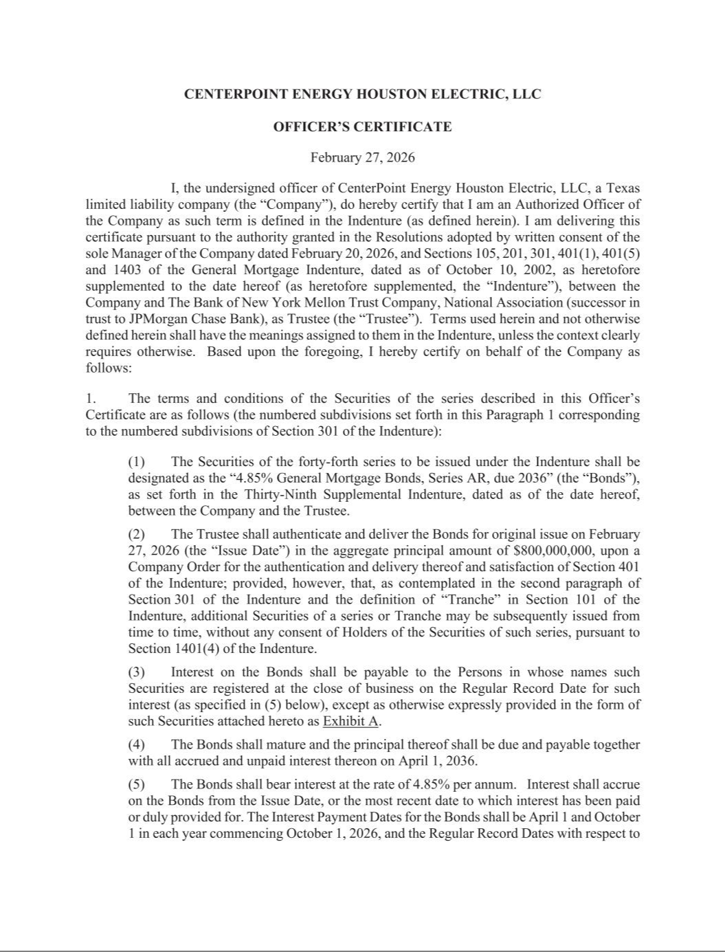

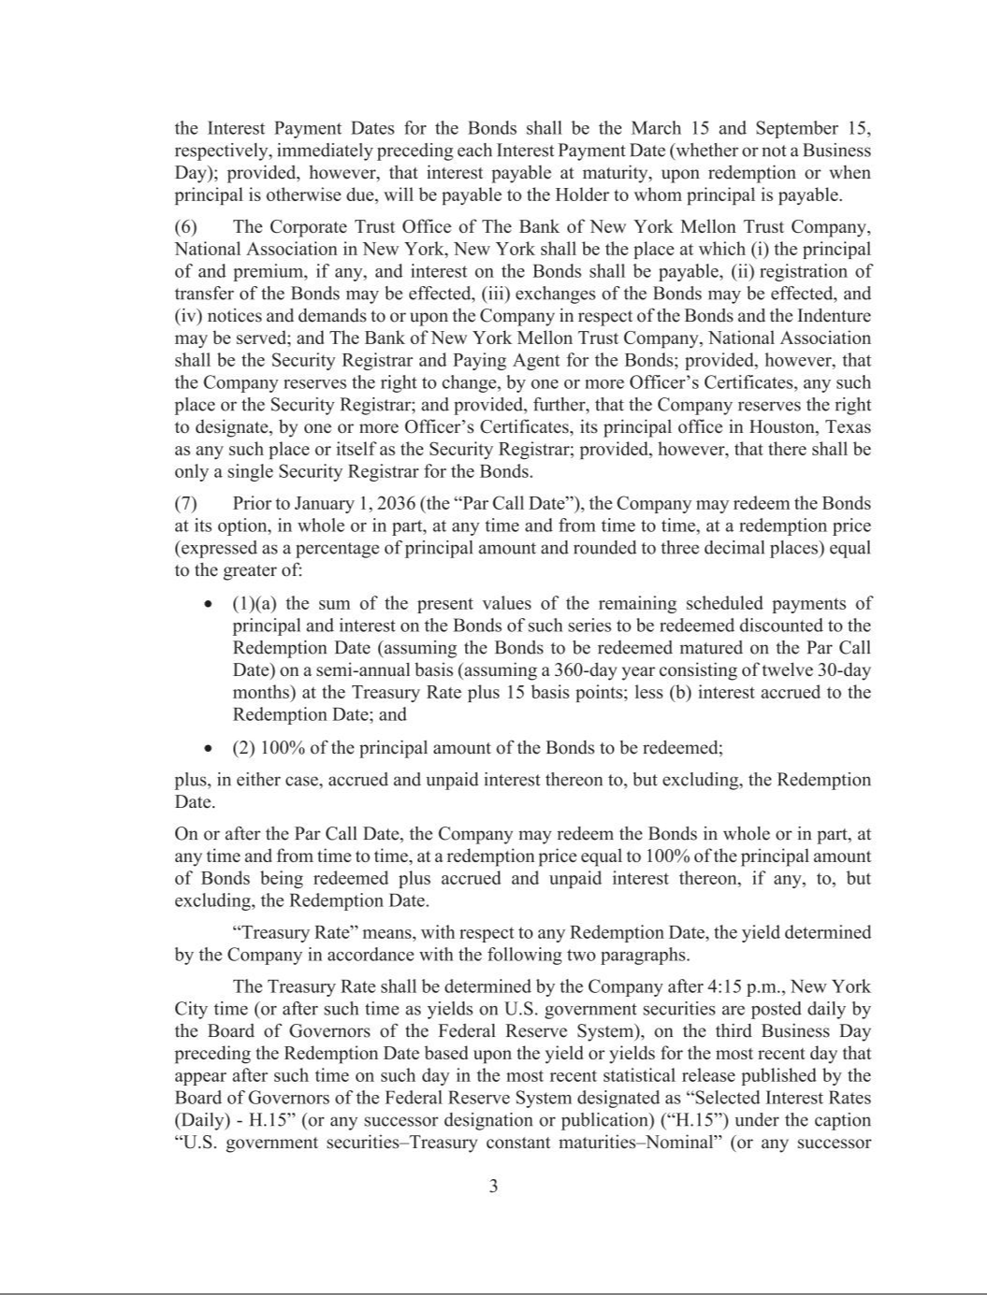

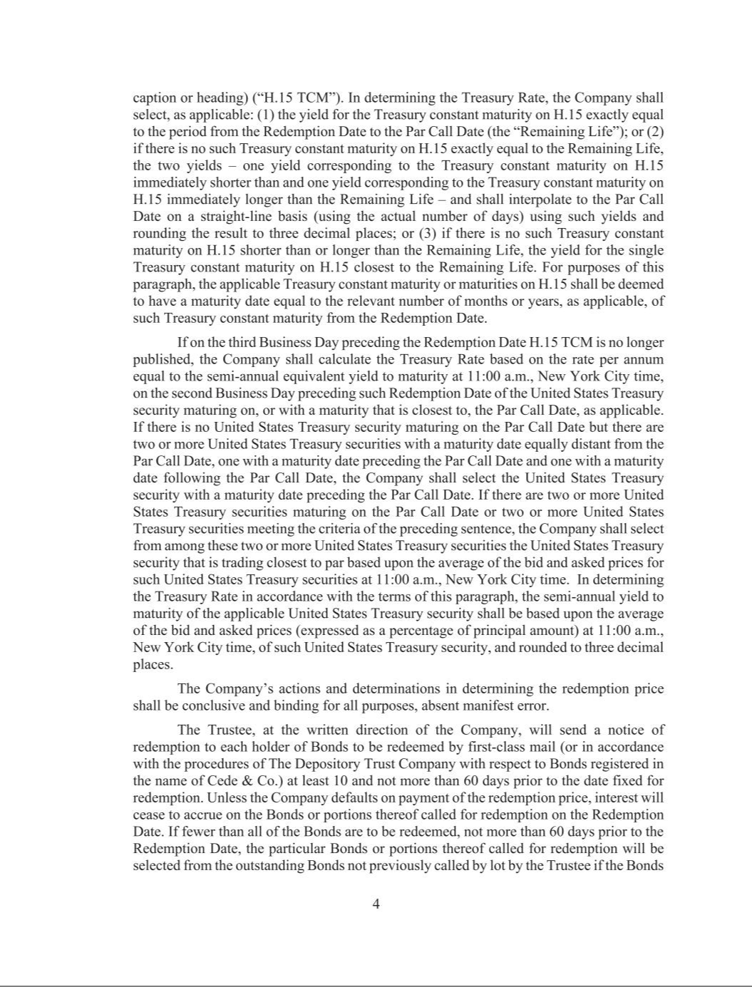

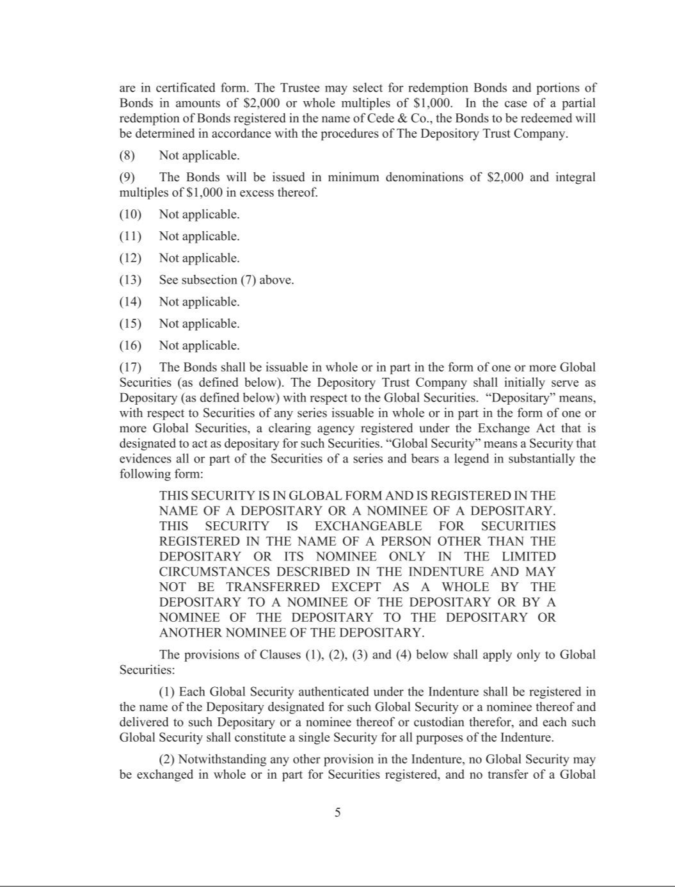

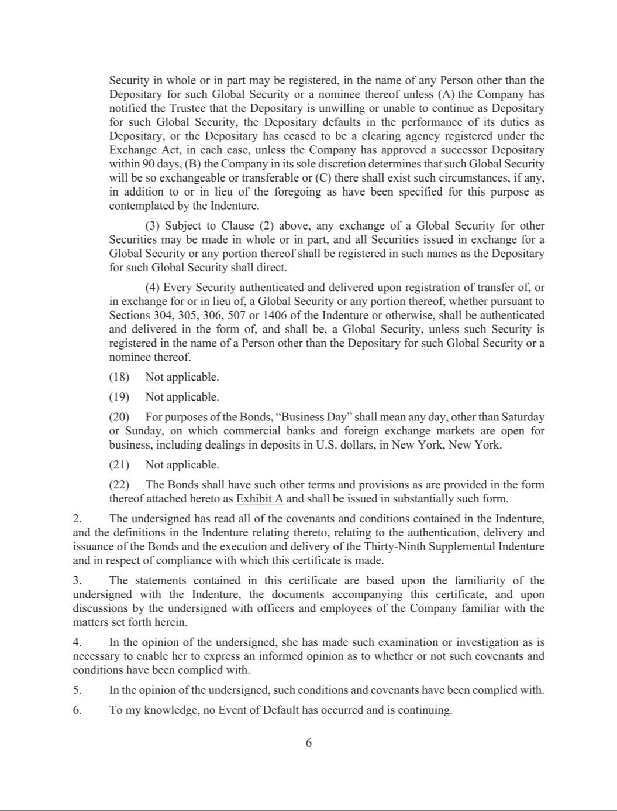

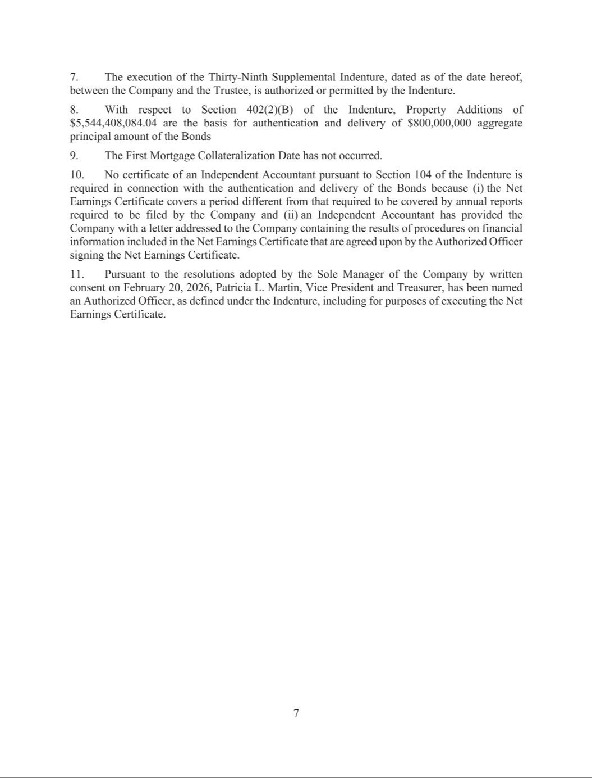

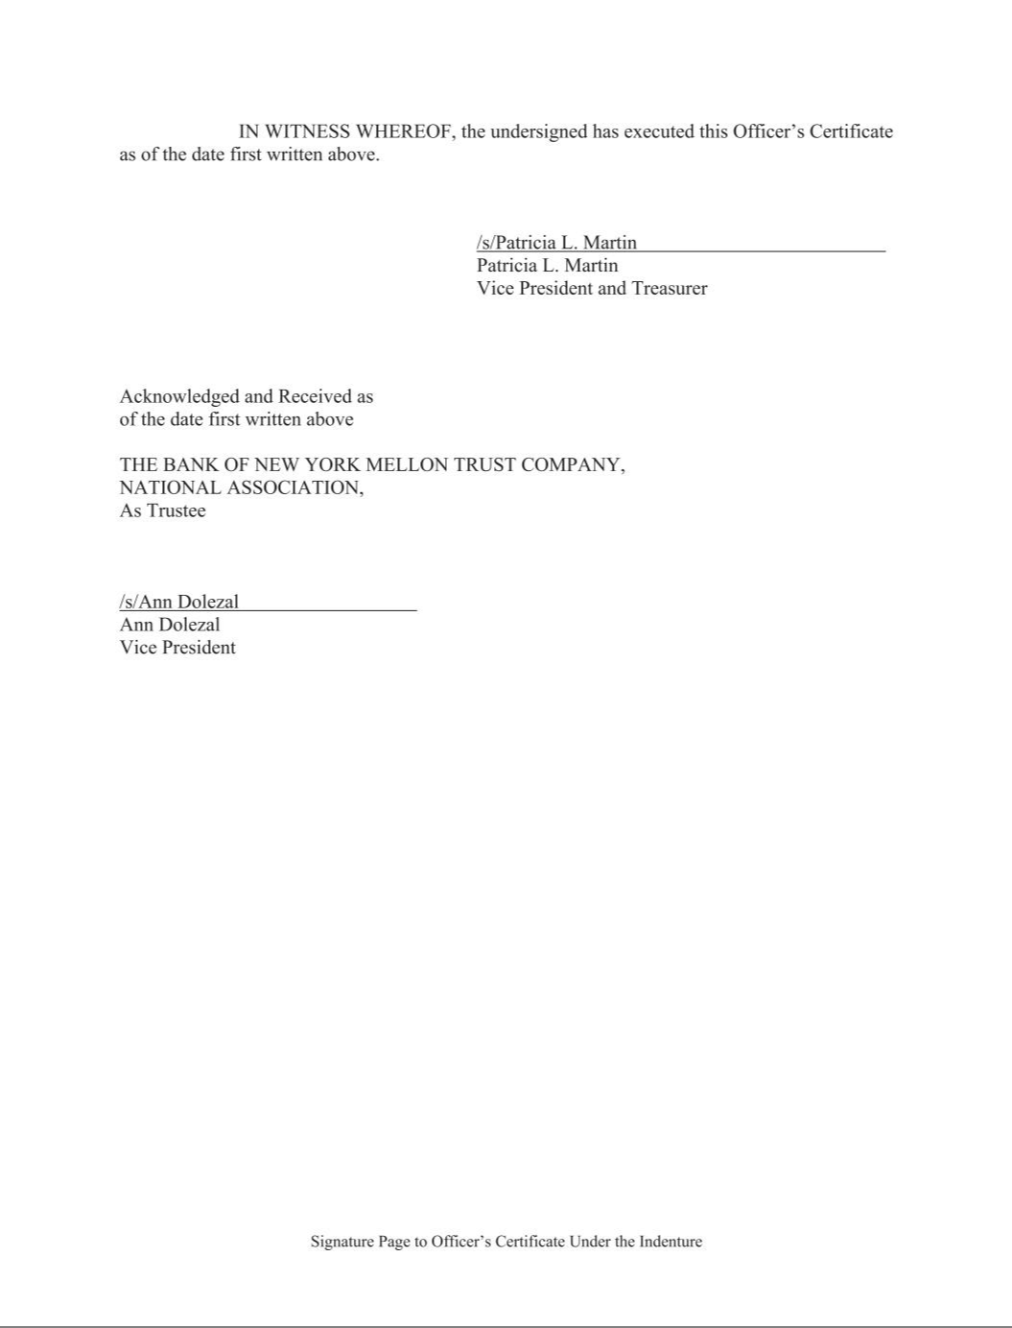



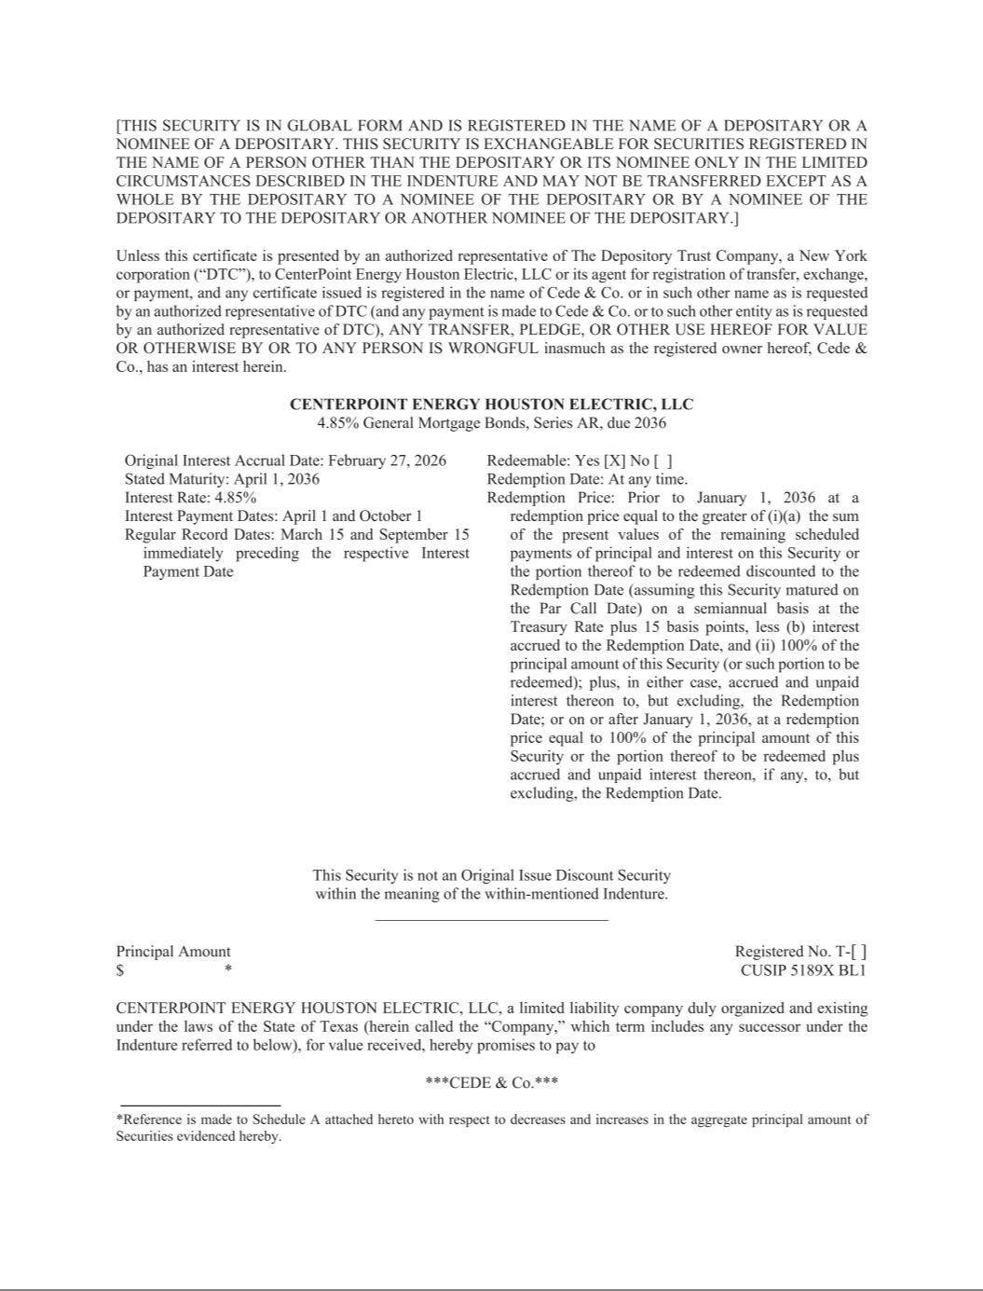

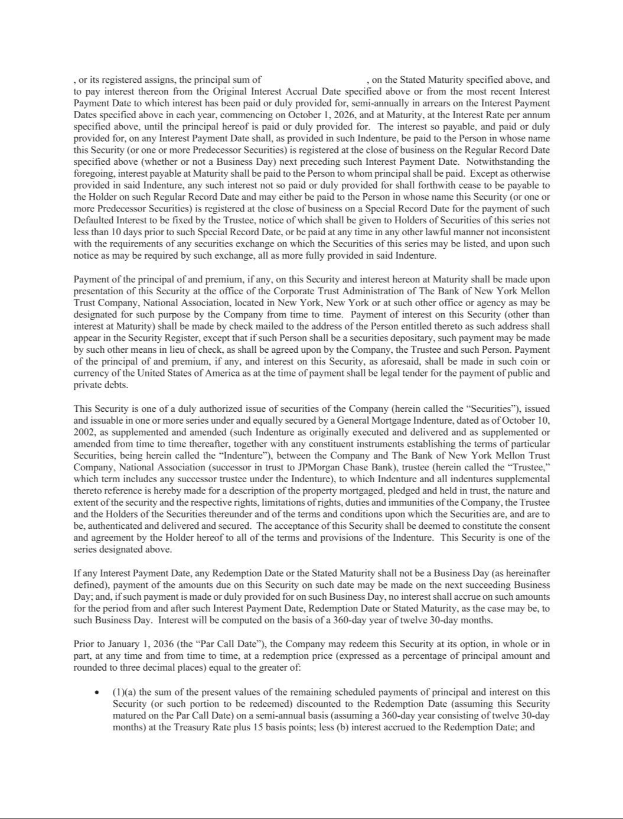

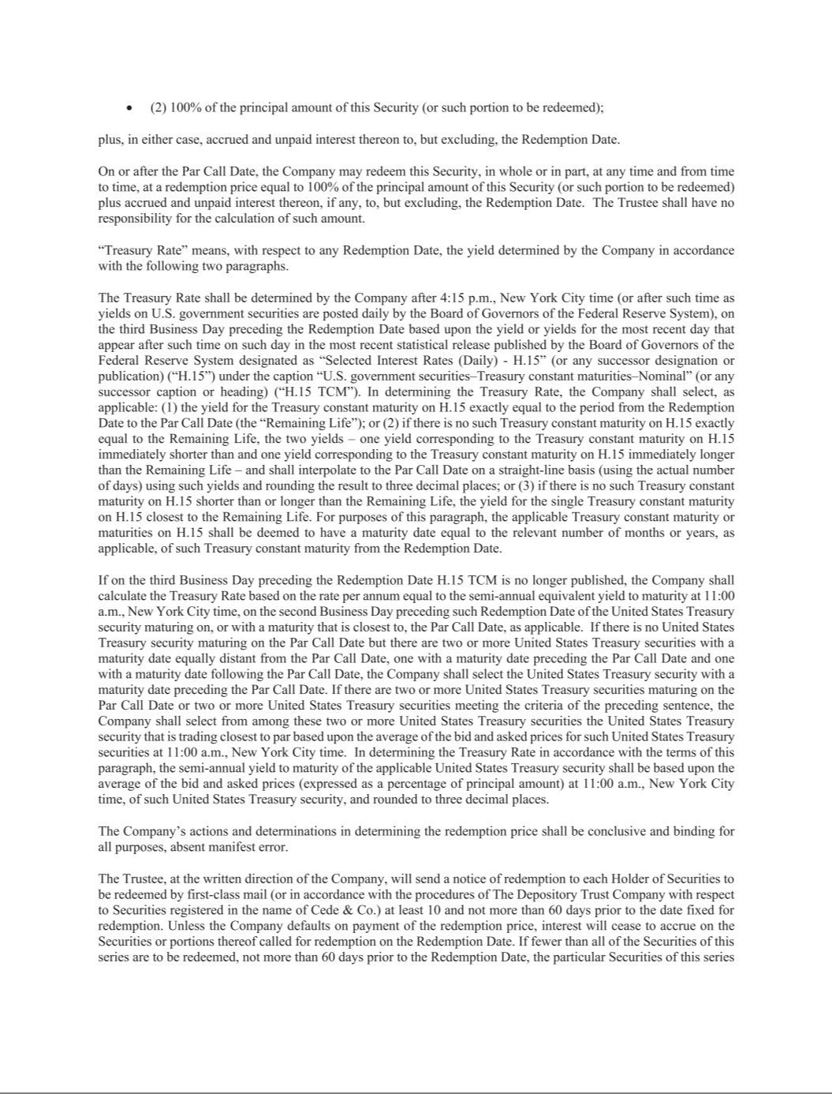

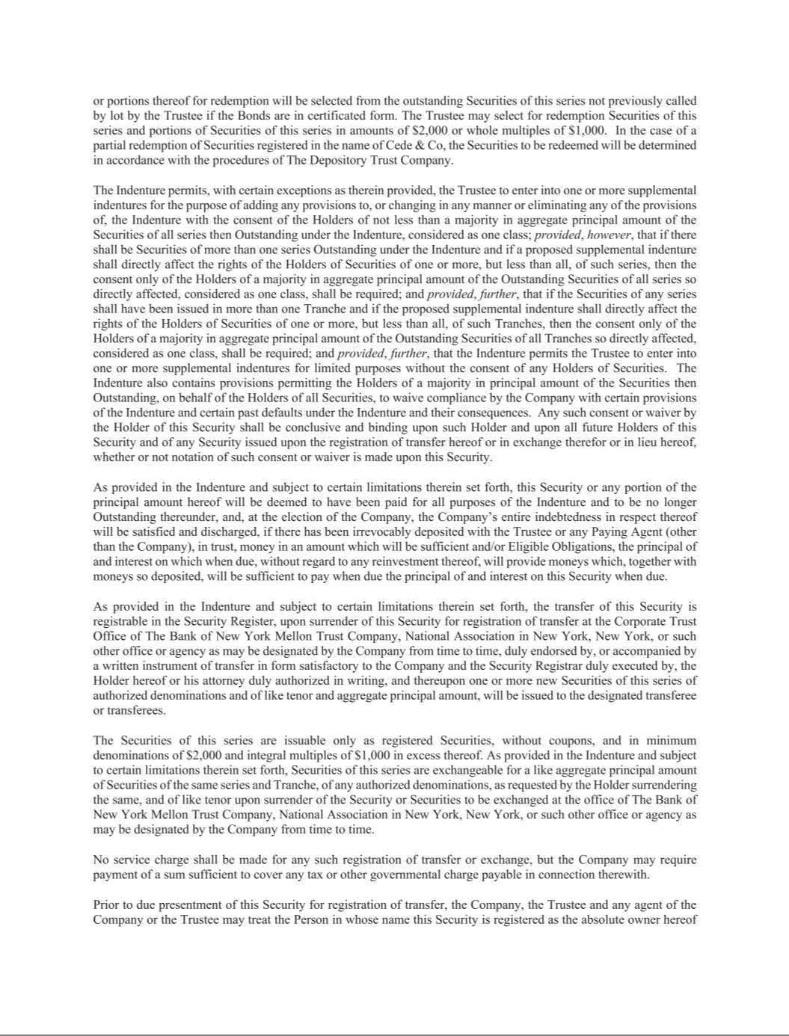

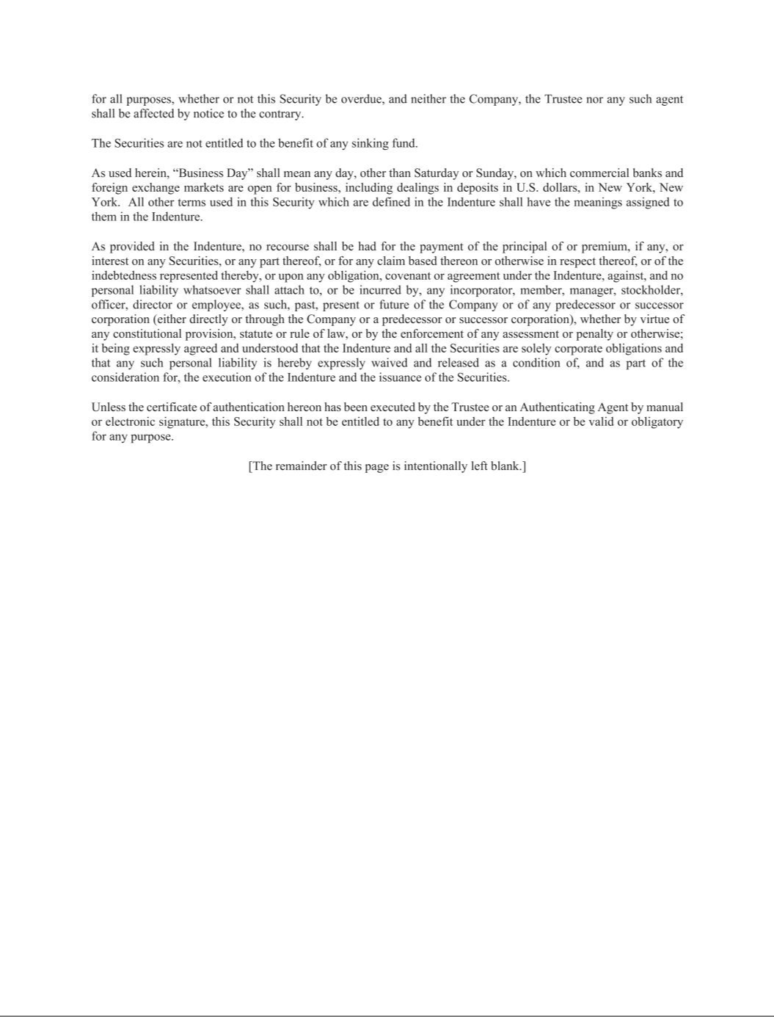

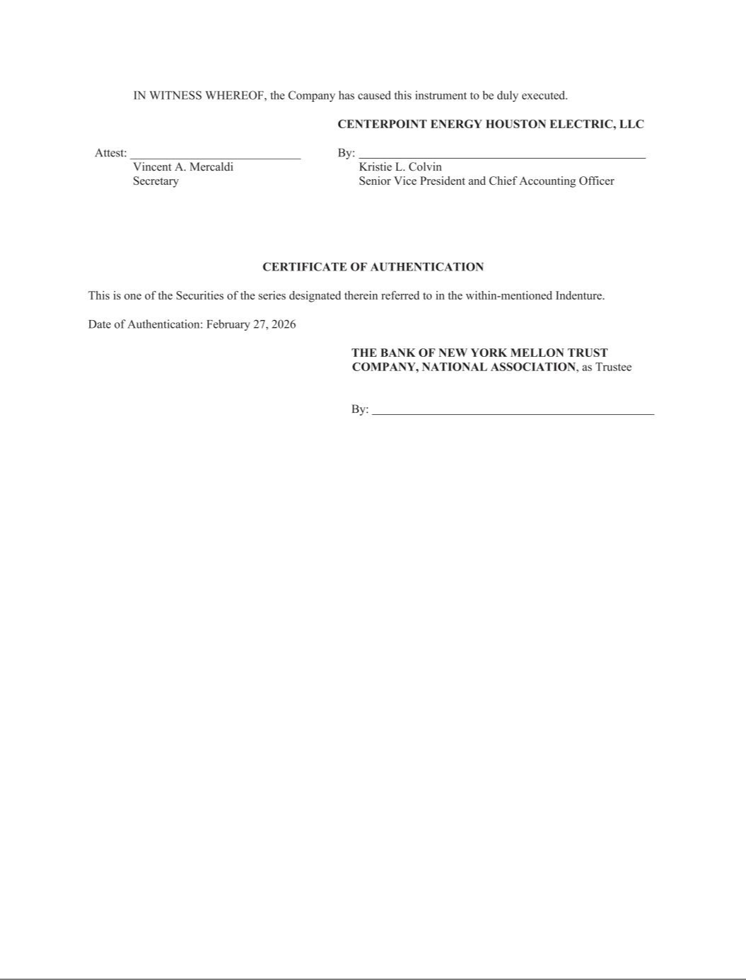

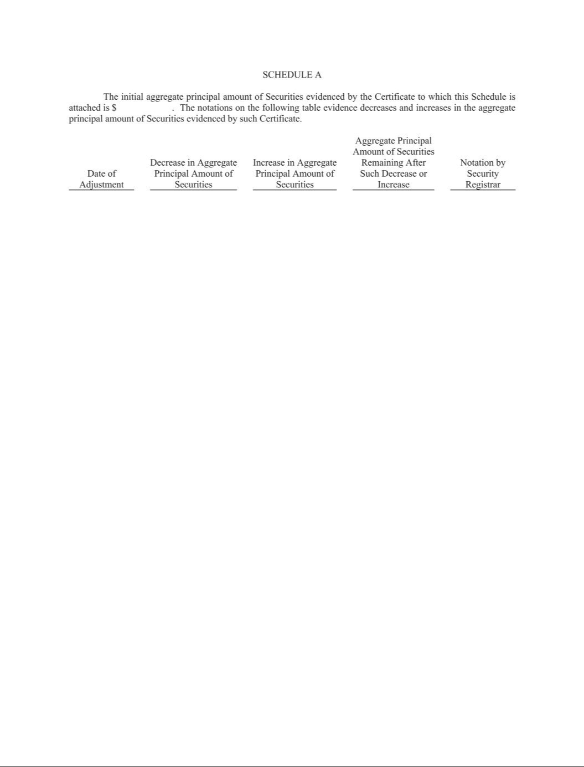

Exhibit 31.1.1

CERTIFICATIONS

I, Jason P. Wells, certify that:

- I have reviewed this quarterly report on Form 10-Q of CenterPoint Energy, Inc.;

- Based on my knowledge, this report does not contain any untrue statement of a material fact or omit to state a material fact necessary to make the statements made, in light of the circumstances under which such statements were made, not misleading with respect to the period covered by this report;

- Based on my knowledge, the financial statements, and other financial information included in this report, fairly present in all material respects the financial condition, results of operations and cash flows of the registrant as of, and for, the periods presented in this report;

- The registrant’s other certifying officer(s) and I are responsible for establishing and maintaining disclosure controls and procedures (as defined in Exchange Act Rules 13a-15(e) and

15d-15(e)) and internal control over financial reporting (as defined in Exchange Act Rules 13a-15(f) and 15d-15(f)) for the registrant and have:

- Designed such disclosure controls and procedures, or caused such disclosure controls and procedures to be designed under our supervision, to ensure that material information relating to the registrant, including its consolidated subsidiaries, is made known to us by others within those entities, particularly during the period in which this report is being prepared;

- Designed such internal control over financial reporting, or caused such internal control over financial reporting to be designed under our supervision, to provide reasonable assurance regarding the reliability of financial reporting and the preparation of financial statements for external purposes in accordance with generally accepted accounting principles;

- Evaluated the effectiveness of the registrant’s disclosure controls and procedures and presented in this report our conclusions about the effectiveness of the disclosure controls and procedures, as of the end of the period covered by this report based on such evaluation; and

- Disclosed in this report any change in the registrant’s internal control over financial reporting that occurred during the registrant’s most recent fiscal quarter (the registrant’s fourth fiscal quarter in the case of an annual report) that has materially affected, or is reasonably likely to materially affect, the registrant’s internal control over financial reporting; and

- The registrant’s other certifying officer(s) and I have disclosed, based on our most recent evaluation of internal control over financial reporting, to the registrant’s auditors and the audit committee of the registrant’s board of directors (or persons performing the equivalent functions):

- All significant deficiencies and material weaknesses in the design or operation of internal control over financial reporting which are reasonably likely to adversely affect the registrant’s ability to record, process, summarize and report financial information; and

- Any fraud, whether or not material, that involves management or other employees who have a significant role in the registrant’s internal control over financial reporting.

Date: April 23, 2026

/s/ Jason P. Wells

Jason P. Wells

President and Chief Executive Officer

Exhibit 31.1.2

CERTIFICATIONS

I, Jesus Soto, Jr., certify that:

- I have reviewed this quarterly report on Form 10-Q of CenterPoint Energy Houston Electric, LLC;

- Based on my knowledge, this report does not contain any untrue statement of a material fact or omit to state a material fact necessary to make the statements made, in light of the circumstances under which such statements were made, not misleading with respect to the period covered by this report;

- Based on my knowledge, the financial statements, and other financial information included in this report, fairly present in all material respects the financial condition, results of operations and cash flows of the registrant as of, and for, the periods presented in this report;

- The registrant’s other certifying officer(s) and I are responsible for establishing and maintaining disclosure controls and procedures (as defined in Exchange Act Rules 13a-15(e) and

15d-15(e)) and internal control over financial reporting (as defined in Exchange Act Rules 13a-15(f) and 15d-15(f)) for the registrant and have:

- Designed such disclosure controls and procedures, or caused such disclosure controls and procedures to be designed under our supervision, to ensure that material information relating to the registrant, including its consolidated subsidiaries, is made known to us by others within those entities, particularly during the period in which this report is being prepared;

- Designed such internal control over financial reporting, or caused such internal control over financial reporting to be designed under our supervision, to provide reasonable assurance regarding the reliability of financial reporting and the preparation of financial statements for external purposes in accordance with generally accepted accounting principles;

- Evaluated the effectiveness of the registrant’s disclosure controls and procedures and presented in this report our conclusions about the effectiveness of the disclosure controls and procedures, as of the end of the period covered by this report based on such evaluation; and

- Disclosed in this report any change in the registrant’s internal control over financial reporting that occurred during the registrant’s most recent fiscal quarter (the registrant’s fourth fiscal quarter in the case of an annual report) that has materially affected, or is reasonably likely to materially affect, the registrant’s internal control over financial reporting; and

- The registrant’s other certifying officer(s) and I have disclosed, based on our most recent evaluation of internal control over financial reporting, to the registrant’s auditors and the audit committee of the registrant’s board of directors (or persons performing the equivalent functions):

- All significant deficiencies and material weaknesses in the design or operation of internal control over financial reporting which are reasonably likely to adversely affect the registrant’s ability to record, process, summarize and report financial information; and

- Any fraud, whether or not material, that involves management or other employees who have a significant role in the registrant’s internal control over financial reporting.

Date: April 23, 2026

/s/ Jesus Soto, Jr.

Jesus Soto, Jr.

President and Chief Executive Officer

Exhibit 31.1.3

CERTIFICATIONS

I, Jesus Soto, Jr., certify that:

- I have reviewed this quarterly report on Form 10-Q of CenterPoint Energy Resources Corp.;

- Based on my knowledge, this report does not contain any untrue statement of a material fact or omit to state a material fact necessary to make the statements made, in light of the circumstances under which such statements were made, not misleading with respect to the period covered by this report;

- Based on my knowledge, the financial statements, and other financial information included in this report, fairly present in all material respects the financial condition, results of operations and cash flows of the registrant as of, and for, the periods presented in this report;

- The registrant's other certifying officer(s) and I are responsible for establishing and maintaining disclosure controls and procedures (as defined in Exchange Act Rules 13a-15(e) and

15d-15(e)) and internal control over financial reporting (as defined in Exchange Act Rules 13a-15(f) and 15d-15(f)) for the registrant and have:

- Designed such disclosure controls and procedures, or caused such disclosure controls and procedures to be designed under our supervision, to ensure that material information relating to the registrant, including its consolidated subsidiaries, is made known to us by others within those entities, particularly during the period in which this report is being prepared;

- Designed such internal control over financial reporting, or caused such internal control over financial reporting to be designed under our supervision, to provide reasonable assurance regarding the reliability of financial reporting and the preparation of financial statements for external purposes in accordance with generally accepted accounting principles;

- Evaluated the effectiveness of the registrant's disclosure controls and procedures and presented in this report our conclusions about the effectiveness of the disclosure controls and procedures, as of the end of the period covered by this report based on such evaluation; and

- Disclosed in this report any change in the registrant's internal control over financial reporting that occurred during the registrant's most recent fiscal quarter (the registrant's fourth fiscal quarter in the case of an annual report) that has materially affected, or is reasonably likely to materially affect, the registrant's internal control over financial reporting; and

- The registrant's other certifying officer(s) and I have disclosed, based on our most recent evaluation of internal control over financial reporting, to the registrant's auditors and the audit committee of the registrant's board of directors (or persons performing the equivalent functions):

- All significant deficiencies and material weaknesses in the design or operation of internal control over financial reporting which are reasonably likely to adversely affect the registrant's ability to record, process, summarize and report financial information; and

- Any fraud, whether or not material, that involves management or other employees who have a significant role in the registrant's internal control over financial reporting.

Date: April 23, 2026

/s/ Jesus Soto, Jr.

Jesus Soto, Jr.

President and Chief Executive Officer

Exhibit 31.2.1

CERTIFICATIONS

I, Christopher A. Foster, certify that:

- I have reviewed this quarterly report on Form 10-Q of CenterPoint Energy, Inc.;

- Based on my knowledge, this report does not contain any untrue statement of a material fact or omit to state a material fact necessary to make the statements made, in light of the circumstances under which such statements were made, not misleading with respect to the period covered by this report;

- Based on my knowledge, the financial statements, and other financial information included in this report, fairly present in all material respects the financial condition, results of operations and cash flows of the registrant as of, and for, the periods presented in this report;

- The registrant’s other certifying officer(s) and I are responsible for establishing and maintaining disclosure controls and procedures (as defined in Exchange Act Rules 13a-15(e) and

15d-15(e)) and internal control over financial reporting (as defined in Exchange Act Rules 13a-15(f) and 15d-15(f)) for the registrant and have:

- Designed such disclosure controls and procedures, or caused such disclosure controls and procedures to be designed under our supervision, to ensure that material information relating to the registrant, including its consolidated subsidiaries, is made known to us by others within those entities, particularly during the period in which this report is being prepared;

- Designed such internal control over financial reporting, or caused such internal control over financial reporting to be designed under our supervision, to provide reasonable assurance regarding the reliability of financial reporting and the preparation of financial statements for external purposes in accordance with generally accepted accounting principles;

- Evaluated the effectiveness of the registrant’s disclosure controls and procedures and presented in this report our conclusions about the effectiveness of the disclosure controls and procedures, as of the end of the period covered by this report based on such evaluation; and

- Disclosed in this report any change in the registrant’s internal control over financial reporting that occurred during the registrant’s most recent fiscal quarter (the registrant’s fourth fiscal quarter in the case of an annual report) that has materially affected, or is reasonably likely to materially affect, the registrant’s internal control over financial reporting; and

- The registrant’s other certifying officer(s) and I have disclosed, based on our most recent evaluation of internal control over financial reporting, to the registrant’s auditors and the audit committee of the registrant’s board of directors (or persons performing the equivalent functions):

- All significant deficiencies and material weaknesses in the design or operation of internal control over financial reporting which are reasonably likely to adversely affect the registrant’s ability to record, process, summarize and report financial information; and

- Any fraud, whether or not material, that involves management or other employees who have a significant role in the registrant’s internal control over financial reporting.

Date: April 23, 2026

/s/ Christopher A. Foster

Christopher A. Foster

Executive Vice President and Chief Financial Officer

Exhibit 31.2.2

CERTIFICATIONS

I, Christopher A. Foster, certify that:

- I have reviewed this quarterly report on Form 10-Q of CenterPoint Energy Houston Electric, LLC;

- Based on my knowledge, this report does not contain any untrue statement of a material fact or omit to state a material fact necessary to make the statements made, in light of the circumstances under which such statements were made, not misleading with respect to the period covered by this report;

- Based on my knowledge, the financial statements, and other financial information included in this report, fairly present in all material respects the financial condition, results of operations and cash flows of the registrant as of, and for, the periods presented in this report;

- The registrant’s other certifying officer(s) and I are responsible for establishing and maintaining disclosure controls and procedures (as defined in Exchange Act Rules 13a-15(e) and

15d-15(e)) and internal control over financial reporting (as defined in Exchange Act Rules 13a-15(f) and 15d-15(f)) for the registrant and have:

- Designed such disclosure controls and procedures, or caused such disclosure controls and procedures to be designed under our supervision, to ensure that material information relating to the registrant, including its consolidated subsidiaries, is made known to us by others within those entities, particularly during the period in which this report is being prepared;

- Designed such internal control over financial reporting, or caused such internal control over financial reporting to be designed under our supervision, to provide reasonable assurance regarding the reliability of financial reporting and the preparation of financial statements for external purposes in accordance with generally accepted accounting principles;

- Evaluated the effectiveness of the registrant’s disclosure controls and procedures and presented in this report our conclusions about the effectiveness of the disclosure controls and procedures, as of the end of the period covered by this report based on such evaluation; and

- Disclosed in this report any change in the registrant’s internal control over financial reporting that occurred during the registrant’s most recent fiscal quarter (the registrant’s fourth fiscal quarter in the case of an annual report) that has materially affected, or is reasonably likely to materially affect, the registrant’s internal control over financial reporting; and

- The registrant’s other certifying officer(s) and I have disclosed, based on our most recent evaluation of internal control over financial reporting, to the registrant’s auditors and the audit committee of the registrant’s board of directors (or persons performing the equivalent functions):

- All significant deficiencies and material weaknesses in the design or operation of internal control over financial reporting which are reasonably likely to adversely affect the registrant’s ability to record, process, summarize and report financial information; and

- Any fraud, whether or not material, that involves management or other employees who have a significant role in the registrant’s internal control over financial reporting.

Date: April 23, 2026

/s/ Christopher A. Foster

Christopher A. Foster

Executive Vice President and Chief Financial Officer

Exhibit 31.2.3

CERTIFICATIONS

I, Christopher A. Foster, certify that:

- I have reviewed this quarterly report on Form 10-Q of CenterPoint Energy Resources Corp.;

- Based on my knowledge, this report does not contain any untrue statement of a material fact or omit to state a material fact necessary to make the statements made, in light of the circumstances under which such statements were made, not misleading with respect to the period covered by this report;

- Based on my knowledge, the financial statements, and other financial information included in this report, fairly present in all material respects the financial condition, results of operations and cash flows of the registrant as of, and for, the periods presented in this report;

- The registrant's other certifying officer(s) and I are responsible for establishing and maintaining disclosure controls and procedures (as defined in Exchange Act Rules 13a-15(e) and

15d-15(e)) and internal control over financial reporting (as defined in Exchange Act Rules 13a-15(f) and 15d-15(f)) for the registrant and have:

- Designed such disclosure controls and procedures, or caused such disclosure controls and procedures to be designed under our supervision, to ensure that material information relating to the registrant, including its consolidated subsidiaries, is made known to us by others within those entities, particularly during the period in which this report is being prepared;

- Designed such internal control over financial reporting, or caused such internal control over financial reporting to be designed under our supervision, to provide reasonable assurance regarding the reliability of financial reporting and the preparation of financial statements for external purposes in accordance with generally accepted accounting principles;

- Evaluated the effectiveness of the registrant's disclosure controls and procedures and presented in this report our conclusions about the effectiveness of the disclosure controls and procedures, as of the end of the period covered by this report based on such evaluation; and

- Disclosed in this report any change in the registrant's internal control over financial reporting that occurred during the registrant's most recent fiscal quarter (the registrant's fourth fiscal quarter in the case of an annual report) that has materially affected, or is reasonably likely to materially affect, the registrant's internal control over financial reporting; and

- The registrant's other certifying officer(s) and I have disclosed, based on our most recent evaluation of internal control over financial reporting, to the registrant's auditors and the audit committee of the registrant's board of directors (or persons performing the equivalent functions):

- All significant deficiencies and material weaknesses in the design or operation of internal control over financial reporting which are reasonably likely to adversely affect the registrant's ability to record, process, summarize and report financial information; and

- Any fraud, whether or not material, that involves management or other employees who have a significant role in the registrant's internal control over financial reporting.

Date: April 23, 2026

/s/ Christopher A. Foster

Christopher A. Foster

Executive Vice President and Chief Financial Officer

Exhibit 32.1.1

CERTIFICATION PURSUANT TO

18 U.S.C. SECTION 1350,

AS ADOPTED PURSUANT TO SECTION 906

OF THE SARBANES-OXLEY ACT OF 2002

In connection with the Quarterly Report of CenterPoint Energy, Inc. (the “Company”) on Form 10-Q for the quarter ended March 31, 2026 (the “Report”), as filed with the Securities and Exchange Commission on the date hereof, I, Jason P. Wells, Chief Executive Officer, certify, pursuant to 18 U.S.C. Section 1350, as adopted pursuant to Section 906 of the Sarbanes-Oxley Act of 2002, to the best of my knowledge, that:

- The Report fully complies with the requirements of section 13(a) or 15(d) of the Securities Exchange Act of 1934, as amended; and

- The information contained in the Report fairly presents, in all material respects, the financial condition and results of operations of the Company.

/s/ Jason P. Wells

Jason P. Wells

President and Chief Executive Officer

April 23, 2026

Exhibit 32.1.2

CERTIFICATION PURSUANT TO

18 U.S.C. SECTION 1350,

AS ADOPTED PURSUANT TO SECTION 906

OF THE SARBANES-OXLEY ACT OF 2002

In connection with the Quarterly Report of CenterPoint Energy Houston Electric, LLC (the “Company”) on Form 10-Q for the quarter ended March 31, 2026 (the “Report”), as filed with the Securities and Exchange Commission on the date hereof, I, Jesus Soto, Jr., Chief Executive Officer, certify, pursuant to 18 U.S.C. Section 1350, as adopted pursuant to Section 906 of the Sarbanes-Oxley Act of 2002, to the best of my knowledge, that:

- The Report fully complies with the requirements of section 13(a) or 15(d) of the Securities Exchange Act of 1934, as amended; and

- The information contained in the Report fairly presents, in all material respects, the financial condition and results of operations of the Company.

/s/ Jesus Soto, Jr.

Jesus Soto, Jr.

President and Chief Executive Officer

April 23, 2026

Exhibit 32.1.3

CERTIFICATION PURSUANT TO

18 U.S.C. SECTION 1350,

AS ADOPTED PURSUANT TO SECTION 906

OF THE SARBANES-OXLEY ACT OF 2002

In connection with the Quarterly Report of CenterPoint Energy Resources Corp. (the “Company”) on Form 10-Q for the quarter ended March 31, 2026 (the “Report”), as filed with the Securities and Exchange Commission on the date hereof, I, Jesus Soto, Jr., Chief Executive Officer, certify, pursuant to 18 U.S.C. Section 1350, as adopted pursuant to Section 906 of the Sarbanes-Oxley Act of 2002, to the best of my knowledge, that:

- The Report fully complies with the requirements of section 13(a) or 15(d) of the Securities Exchange Act of 1934, as amended; and

- The information contained in the Report fairly presents, in all material respects, the financial condition and results of operations of the Company.

/s/ Jesus Soto, Jr.

Jesus Soto, Jr.

President and Chief Executive Officer

April 23, 2026

Exhibit 32.2.1

CERTIFICATION PURSUANT TO

18 U.S.C. SECTION 1350,

AS ADOPTED PURSUANT TO SECTION 906

OF THE SARBANES-OXLEY ACT OF 2002

In connection with the Quarterly Report of CenterPoint Energy, Inc. (the “Company”) on Form 10-Q for the quarter ended March 31, 2026 (the “Report”), as filed with the Securities and Exchange Commission on the date hereof, I, Christopher A. Foster, Chief Financial Officer, certify, pursuant to 18 U.S.C. Section 1350, as adopted pursuant to Section 906 of the Sarbanes-Oxley Act of 2002, to the best of my knowledge, that:

- The Report fully complies with the requirements of section 13(a) or 15(d) of the Securities Exchange Act of 1934, as amended; and

- The information contained in the Report fairly presents, in all material respects, the financial condition and results of operations of the Company.

/s/ Christopher A. Foster

Christopher A. Foster

Executive Vice President and Chief Financial Officer

April 23, 2026

Exhibit 32.2.2

CERTIFICATION PURSUANT TO

18 U.S.C. SECTION 1350,

AS ADOPTED PURSUANT TO SECTION 906

OF THE SARBANES-OXLEY ACT OF 2002

In connection with the Quarterly Report of CenterPoint Energy Houston Electric, LLC (the “Company”) on Form 10-Q for the quarter ended March 31, 2026 (the “Report”), as filed with the Securities and Exchange Commission on the date hereof, I, Christopher A. Foster, Chief Financial Officer, certify, pursuant to 18 U.S.C. Section 1350, as adopted pursuant to Section 906 of the Sarbanes-Oxley Act of 2002, to the best of my knowledge, that:

- The Report fully complies with the requirements of section 13(a) or 15(d) of the Securities Exchange Act of 1934, as amended; and

- The information contained in the Report fairly presents, in all material respects, the financial condition and results of operations of the Company.

/s/ Christopher A. Foster

Christopher A. Foster

Executive Vice President and Chief Financial Officer

April 23, 2026

Exhibit 32.2.3

CERTIFICATION PURSUANT TO

18 U.S.C. SECTION 1350,

AS ADOPTED PURSUANT TO SECTION 906

OF THE SARBANES-OXLEY ACT OF 2002

In connection with the Quarterly Report of CenterPoint Energy Resources Corp. (the “Company”) on Form 10-Q for the quarter ended March 31, 2026 (the “Report”), as filed with the Securities and Exchange Commission on the date hereof, I, Christopher A. Foster, Chief Financial Officer, certify, pursuant to 18 U.S.C. Section 1350, as adopted pursuant to Section 906 of the Sarbanes-Oxley Act of 2002, to the best of my knowledge, that:

- The Report fully complies with the requirements of section 13(a) or 15(d) of the Securities Exchange Act of 1934, as amended; and

- The information contained in the Report fairly presents, in all material respects, the financial condition and results of operations of the Company.

/s/ Christopher A. Foster

Christopher A. Foster

Executive Vice President and Chief Financial Officer

April 23, 2026

