UNITED STATES SECURITIES AND EXCHANGE COMMISSION

WASHINGTON, D.C. 20549

__________________

FORM 10-Q

(Mark One)

- QUARTERLY REPORT PURSUANT TO SECTION 13 OR 15(d) OF THE SECURITIES EXCHANGE ACT OF 1934

For the quarterly period ended March 31, 2025

OR

- TRANSITION REPORT PURSUANT TO SECTION 13 OR 15(d) OF THE SECURITIES EXCHANGE ACT OF 1934 FOR THE TRANSITION PERIOD FROM __________________ TO __________________

Commission file number 1-31447

CenterPoint Energy, Inc.

(Exact name of registrant as specified in its charter)

Texas |  |  | 74-0694415
(State or other jurisdiction of incorporation or organization) |  |  | (I.R.S. Employer Identification No.)
1111 Louisiana | Houston | Texas | 77002
(Address of Principal Executive Offices) |  |  | (Zip Code)
 |  | (713) 207-1111
 | Registrant's telephone number, including area code
 | Commission file number 1-3187
 | CenterPoint Energy Houston Electric, LLC
 | (Exact name of registrant as specified in its charter)
Texas |  |  | 22-3865106
(State or other jurisdiction of incorporation or organization) |  |  | (I.R.S. Employer Identification No.)
1111 Louisiana | Houston | Texas | 77002
(Address of Principal Executive Offices) |  |  | (Zip Code)
 |  | (713) 207-1111
 | Registrant's telephone number, including area code
 | Commission file number 1-13265
 | CenterPoint Energy Resources Corp.
 | (Exact name of registrant as specified in its charter)
Delaware |  |  | 76-0511406
(State or other jurisdiction of incorporation or organization) |  |  | (I.R.S. Employer Identification No.)
1111 Louisiana | Houston | Texas | 77002
(Address of Principal Executive Offices) |  |  | (Zip Code)
 |  | (713) 207-1111
 | Registrant's telephone number, including area code
 | Securities registered pursuant to Section 12(b) of the Act:

 | Registrant |  | Title of each class |  |  | Trading Symbol |  |  | Name of each exchange on which registered
CenterPoint Energy, Inc. |  |  | Common Stock, $0.01 par value |  |  |  | CNP |  |  | New York Stock Exchange
 |  |  |  |  |  |  |  |  |  | NYSE Texas
CenterPoint Energy Houston Electric, LLC |  |  | 6.95% General Mortgage Bonds due 2033 |  |  |  | n/a |  |  | New York Stock Exchange
CenterPoint Energy Resources Corp. |  |  | 6.625% Senior Notes due 2037 |  |  |  | n/a |  |  | New York Stock Exchange

Indicate by check mark whether the registrant: (1) has filed all reports required to be filed by Section 13 or 15(d) of the Securities Exchange Act of 1934 during the preceding 12 months (or for such shorter period that the registrant was required to file such reports), and (2) has been subject to such filing requirements for the past 90 days.

CenterPoint Energy, Inc. | Yes | ☑ | No | o
CenterPoint Energy Houston Electric, LLC | Yes | ☑ | No | o
CenterPoint Energy Resources Corp. | Yes | ☑ | No | o

Indicate by check mark whether the registrant has submitted electronically every Interactive Data File required to be submitted pursuant to Rule 405 of Regulation S-T (§232.405 of this chapter) during the preceding 12 months (or for such shorter period that the registrant was required to submit such files).

CenterPoint Energy, Inc. | Yes | ☑ | No | o
CenterPoint Energy Houston Electric, LLC | Yes | ☑ | No | o
CenterPoint Energy Resources Corp. | Yes | ☑ | No | o

Indicate by check mark whether the registrant is a large accelerated filer, an accelerated filer, a non-accelerated filer, a smaller reporting company or an emerging growth company. See definitions of “large accelerated filer,” “accelerated filer,” “smaller reporting company,” and “emerging growth company” in Rule 12b-2 of the Exchange Act.

 | Large accelerated filer | Accelerated filer | Non-accelerated filer | Smaller reporting | Emerging growth
 | Large accelerated filer | Accelerated filer | Non-accelerated filer | company | company
CenterPoint Energy, Inc. | ☑ | o | o | ☐ | ☐
CenterPoint Energy Houston Electric, LLC | o | o | ☑ | ☐ | ☐
CenterPoint Energy Resources Corp. | o | o | ☑ | ☐ | ☐

If an emerging growth company, indicate by check mark if the registrant has elected not to use the extended transition period for complying with any new or revised financial accounting standards provided pursuant to Section 13(a) of the Exchange Act. o

Indicate by check mark whether the registrant is a shell company (as defined in Rule 12b-2 of the Exchange Act).

CenterPoint Energy, Inc. | Yes | ☐ | No | ☑
CenterPoint Energy Houston Electric, LLC | Yes | ☐ | No | ☑
CenterPoint Energy Resources Corp. | Yes | ☐ | No | ☑

Indicate the number of shares outstanding of each of the issuers’ classes of common stock as of April 21, 2025:

CenterPoint Energy, Inc. | 652,728,398 | shares of common stock outstanding, excluding 166 shares held as treasury stock
CenterPoint Energy Houston Electric, LLC | 1,000 | common shares outstanding, all held by Utility Holding, LLC, a wholly-owned subsidiary of CenterPoint Energy, Inc.
CenterPoint Energy Resources Corp. | 1,000 | shares of common stock outstanding, all held by Utility Holding, LLC, a wholly-owned subsidiary of CenterPoint Energy, Inc.

CenterPoint Energy Houston Electric, LLC and CenterPoint Energy Resources Corp. meet the conditions set forth in General Instructions H(1)(a) and (b) of Form 10-Q and are therefore filing this form with the reduced disclosure format specified in General Instruction H(2) of Form 10-Q.

 |  |  |  |  |  |  |  |  |  |  |  |  |  |  |  |  |  |  |  | TABLE OF CONTENTS
PART I. | FINANCIAL INFORMATION
Item 1. |  | Financial Statements |  |  |  |  |  |  |  |  |  |  |  |  |  |  |  |  |  |  |  |  |  |  | 1
 |  | CenterPoint Energy, Inc. and Subsidiaries Financial Statements (Unaudited) |  |  |  |  |  |  |  |  |  |  |  |  |  |  |  |  |  |  |  |  |  |  | 1
 |  | CenterPoint Energy Houston Electric, LLC and Subsidiaries Financial Statements (Unaudited) |  |  |  |  |  |  |  |  |  |  |  |  |  |  |  |  |  |  |  |  |  |  | 7
 |  | CenterPoint Energy Resources Corp. and Subsidiaries Financial Statements (Unaudited) |  |  |  |  |  |  |  |  |  |  |  |  |  |  |  |  |  |  |  |  |  |  | 11
 |  | Combined Notes to Interim Condensed Financial Statements (Unaudited) |  |  |  |  |  |  |  |  |  |  |  |  |  |  |  |  |  |  |  |  |  |  | 17
 |  |  | (1) | Background and Basis of Presentation |  |  |  |  |  |  |  |  |  |  |  |  |  |  |  |  |  |  |  |  | 17
 |  |  | (2) | Accounting Policies and Recent Accounting Pronouncements |  |  |  |  |  |  |  |  |  |  |  |  |  |  |  |  |  |  |  |  | 18
 |  |  | (3) | Acquisition and Divestiture |  |  |  |  |  |  |  |  |  |  |  |  |  |  |  |  |  |  |  |  | 19
 |  |  | (4) | Revenue Recognition |  |  |  |  |  |  |  |  |  |  |  |  |  |  |  |  |  |  |  |  | 21
 |  |  | (5) | Employee Benefit Plans |  |  |  |  |  |  |  |  |  |  |  |  |  |  |  |  |  |  |  |  | 22
 |  |  | (6) | Regulatory Matters |  |  |  |  |  |  |  |  |  |  |  |  |  |  |  |  |  |  |  |  | 23
 |  |  | (7) | Fair Value Measurements |  |  |  |  |  |  |  |  |  |  |  |  |  |  |  |  |  |  |  |  | 27
 | (8) |  |  | Equity Securities and Indexed Debt Securities (ZENS) |  |  |  |  |  |  |  |  |  |  |  |  |  |  |  |  |  |  |  |  | 28
 |  |  | (9) | Short-term Borrowings and Long-term Debt |  |  |  |  |  |  |  |  |  |  |  |  |  |  |  |  |  |  |  |  | 29
 |  |  | (10) |  | Income Taxes |  |  |  |  |  |  |  |  |  |  |  |  |  |  |  |  |  |  |  | 31
 |  |  | (11) |  | Commitments and Contingencies |  |  |  |  |  |  |  |  |  |  |  |  |  |  |  |  |  |  |  | 31
 |  |  | (12) |  | Earnings Per Share |  |  |  |  |  |  |  |  |  |  |  |  |  |  |  |  |  |  |  | 38
 |  |  | (13) |  | Reportable Segments |  |  |  |  |  |  |  |  |  |  |  |  |  |  |  |  |  |  |  | 38
 |  |  | (14) |  | Related Party Transactions |  |  |  |  |  |  |  |  |  |  |  |  |  |  |  |  |  |  |  | 41
 |  |  | (15) |  | Equity |  |  |  |  |  |  |  |  |  |  |  |  |  |  |  |  |  |  |  | 42
 |  |  | (16) |  | Subsequent Events |  |  |  |  |  |  |  |  |  |  |  |  |  |  |  |  |  |  |  | 43
Item 2. |  | Management’s Discussion and Analysis of Financial Condition and Results of Operations |  |  |  |  |  |  |  |  |  |  |  |  |  |  |  |  |  |  |  |  |  |  | 45
 |  |  | Recent Events |  |  |  |  |  |  |  |  |  |  |  |  |  |  |  |  |  |  |  |  |  | 45
 |  |  | Consolidated Results of Operations |  |  |  |  |  |  |  |  |  |  |  |  |  |  |  |  |  |  |  |  |  | 46
 |  |  | Results of Operations by Reportable Segment |  |  |  |  |  |  |  |  |  |  |  |  |  |  |  |  |  |  |  |  |  | 47
 |  |  | Certain Factors Affecting Future Earnings |  |  |  |  |  |  |  |  |  |  |  |  |  |  |  |  |  |  |  |  |  | 54
 |  |  | Liquidity and Capital Resources |  |  |  |  |  |  |  |  |  |  |  |  |  |  |  |  |  |  |  |  |  | 55
Item 3. |  | Quantitative and Qualitative Disclosures about Market Risk |  |  |  |  |  |  |  |  |  |  |  |  |  |  |  |  |  |  |  |  |  |  | 68
Item 4. |  | Controls and Procedures |  |  |  |  |  |  |  |  |  |  |  |  |  |  |  |  |  |  |  |  |  |  | 69

PART II. | OTHER INFORMATION
Item 1. | Legal Proceedings |  |  |  |  | 69
Item 1A. | Risk Factors |  |  |  |  | 69
Item 5. | Other Information |  |  |  |  | 69
Item 6. | Exhibits |  |  |  |  | 69
 | Signatures |  |  |  |  | 73

i

 | GLOSSARY
AFUDC | Allowance for funds used during construction
ALJ | Administrative Law Judge
AMAs | Asset Management Agreement
Arevon | Arevon Energy, Inc., which was formed through the combination of Capital Dynamics, Inc.’s U.S. Clean Energy Infrastructure business
 | unit and Arevon Asset Management
ARO | Asset retirement obligation
ARP | Alternative revenue program
ASU | Accounting Standards Update
AT&T Common | AT&T Inc. common stock
ATM Forward Purchasers | Bank of America, N.A., Barclays Bank PLC, Citibank, N.A., Goldman Sachs & Co. LLC, JPMorgan Chase Bank, National
 | Association, Mizuho Markets Americas LLC, MUFG Securities EMEA plc and Royal Bank of Canada
ATM Forward Sellers | BofA Securities, Inc. Barclays Capital Inc., Citigroup Global Markets Inc., Goldman Sachs & Co. LLC, J.P. Morgan Securities LLC,
 | Mizuho Securities USA LLC, MUFG Securities Americas Inc. and RBC Capital Markets, LLC
ATM Managers | BofA Securities, Inc., Barclays Capital Inc., Citigroup Global Markets Inc., Goldman Sachs & Co. LLC, J.P. Morgan Securities LLC,
 | Mizuho Securities USA LLC, MUFG Securities Americas Inc. and RBC Capital Markets, LLC
Bcf | Billion cubic feet
Board | Board of Directors of CenterPoint Energy, Inc.
Bond Companies | Bond Company IV and Restoration Bond Company, each a wholly-owned, bankruptcy remote entity formed solely for the purpose of
 | purchasing and owning transition or system restoration property through the issuance of Securitization Bonds
Bond Company IV | CenterPoint Energy Transition Bond Company IV, LLC, a wholly-owned subsidiary of Houston Electric
BTA | Build Transfer Agreement
CAMT | Corporate Alternative Minimum Tax
Capital Dynamics | Capital Dynamics, Inc.
CCR | Coal Combustion Residuals
CECA | Clean Energy Cost Adjustment
CEIP | CenterPoint Energy Intrastate Pipelines, LLC, a wholly-owned subsidiary of CERC Corp.
CenterPoint Energy | CenterPoint Energy, Inc., and its subsidiaries
CEOH | Vectren Energy Delivery of Ohio, LLC, doing business as CenterPoint Energy Ohio, which converted its corporate structure from
 | Vectren Energy Delivery of Ohio, Inc. to an Ohio limited liability company on June 13, 2022, formerly a wholly-owned subsidiary of
 | Vectren, acquired by CERC on June 30, 2022
CERC | CERC Corp., together with its subsidiaries
CERC Corp. | CenterPoint Energy Resources Corp.
Charter Common | Charter Communications, Inc. common stock
CIP | Conservation Improvement Program
CODM | Chief Operating Decision Maker, who is each Registrant’s Chief Operating Executive
Common Stock | CenterPoint Energy, Inc. common stock, par value $0.01 per share
CPCN | Certificate of Public Convenience and Necessity
Credit Agreement | The Second Amended and Restated Credit Agreement dated as of December 6, 2022 among CenterPoint Energy, Inc., as borrower,
 | JPMorgan Chase Bank, N.A., as administrative agent, and the banks party thereto
CSIA | Compliance and System Improvement Adjustment
DCRF | Distribution Cost Recovery Factor
DOC | U.S. Department of Commerce
DRR | Distribution Replacement Rider
DSMA | Demand Side Management Adjustment
ECA | Environmental Cost Adjustment
EDIT | Excess deferred income taxes
EECRF | Energy Efficiency Cost Recovery Factor
EEFC | Energy Efficiency Funding Component
EEFR | Energy Efficiency Funding Rider
ELG | Effluent Limitation Guidelines
Energy Systems Group | Energy Systems Group, LLC, previously a wholly-owned subsidiary of Vectren

ii

 | GLOSSARY
EPA | Environmental Protection Agency
Equity Distribution Agreement | Equity Distribution Agreement, dated as of January 10, 2024, by and between CenterPoint Energy, the ATM Managers, the ATM
 | Forward Purchasers and the ATM Forward Sellers
Equity Purchase Agreement | Equity Purchase Agreement, dated as of May 21, 2023, by and between Vectren Energy Services and ESG Holdings Group
ERCOT | Electric Reliability Council of Texas
ESG Holdings Group | ESG Holdings Group, LLC, a Delaware limited liability company, and an affiliate of Oaktree Capital Management
Exchange Act | The Securities Exchange Act of 1934, as amended
February 2021 Winter Storm Event | The extreme and unprecedented winter weather event in February 2021 (Winter Storm Uri) that resulted in electricity generation supply
 | shortages, including in Texas, and natural gas supply shortages and increased wholesale prices of natural gas in the United States,
 | primarily due to prolonged freezing temperatures
FASB | Financial Accounting Standards Board
FERC | Federal Energy Regulatory Commission
Fitch | Fitch Ratings, Inc.
Form 10-Q | Quarterly Report on Form 10-Q
GAAP | Generally Accepted Accounting Principles
General Mortgage | General Mortgage Indenture, dated as of October 10, 2002, between Houston Electric and JPMorgan Chase Bank, as Trustee, as
 | supplemented
GHG | Greenhouse gases
GHRI | The Greater Houston Resiliency Initiative, which was initially announced by Houston Electric in August 2024 and includes targeted
 | actions to improve the resiliency of Houston Electric’s electric grid, as well as improve customer communications and community
 | partnerships
GRIP | Gas Reliability Infrastructure Program
GWh | Gigawatt-hours
Houston Electric | CenterPoint Energy Houston Electric, LLC and its subsidiaries
Hurricane Beryl | The powerful and destructive storm that made landfall in Texas on July 8, 2024 and caused widespread damage to Houston Electric’s
 | electric system
IDEM | Indiana Department of Environmental Management
Indiana Electric | Operations of SIGECO’s electric transmission and distribution services, and includes its power generating and wholesale power
 | operations
Indiana Gas | Indiana Gas Company, Inc., formerly a wholly-owned subsidiary of Vectren, acquired by CERC on June 30, 2022
Indiana North | Gas operations of Indiana Gas
Indiana South | Gas operations of SIGECO
Interim Condensed Financial Statements | Unaudited condensed consolidated interim financial statements and combined notes
IRA | Inflation Reduction Act of 2022
IRP | Integrated Resource Plan
IRS | Internal Revenue Service
IURC | Indiana Utility Regulatory Commission
KW | Kilowatts
LAMS Asset Purchase Agreement | Asset Purchase Agreement, dated as of February 19, 2024, by and among CERC Corp. and the LAMS Buyers
LAMS Buyers | Delta North Louisiana Gas Company, LLC (f/k/a Delta Utilities No. LA, LLC), a Delaware limited liability company, Delta South
 | Louisiana Gas Company, LLC (f/k/a Delta Utilities S. LA, LLC), a Delaware limited liability company, Delta Mississippi Gas
 | Company, LLC (f/k/a Delta Utilities MS, LLC), a Delaware limited liability company, and Delta Energy Resources, LLC (f/k/a Delta
 | Shared Services Co., LLC), a Delaware limited liability company
LDC | Local distribution company
Load Shed | Curtailing the amount of electricity a TDU can transmit and distribute to its customers
M&DOT | Mortgage and Deed of Trust, dated November 1, 1944, between Houston Lighting and Power Company and Chase Bank of Texas,
 | National Association (formerly, South Texas Commercial National Bank of Houston), as Trustee, as amended and supplemented
MDL | Multi-district litigation
May 2024 Storm Events | The sudden and destructive severe weather events in May 2024 that included hurricane-like winds and tornadoes and resulted in
 | widespread damage to Houston Electric’s electric delivery system

iii

 | GLOSSARY
MGP | Manufactured gas plant
MISO | Midcontinent Independent System Operator
Moody’s | Moody’s Investors Service, Inc.
MPUC | Minnesota Public Utilities Commission
MW | Megawatt
NERC | North American Electric Reliability Corporation
NRG | NRG Energy, Inc.
NYSE | New York Stock Exchange
Oriden | Oriden LLC
Origis | Origis Energy USA Inc.
OUCC | Indiana Office of Utility Consumer Counselor
PFD | Proposal for decision
Posey Solar | Posey Solar, LLC, a special purpose entity
Posey Solar Merger Agreement | Agreement and Plan of Merger, dated as of March 7, 2025, among SIGECO and Posey Solar
PPA | Power purchase agreement
PRPs | Potentially responsible parties
PTCs | Production Tax Credits
PUCO | Public Utilities Commission of Ohio
PUCT | Public Utility Commission of Texas
Railroad Commission | Railroad Commission of Texas
RCRA | Resource Conservation and Recovery Act of 1976
Registrants | CenterPoint Energy, Inc., CenterPoint Energy Houston Electric, LLC and CenterPoint Energy Resources Corp., collectively
REP | Retail electric provider
ROE | Return on equity
ROU | Right of use
S&P | S&P Global Ratings
SEC | Securities and Exchange Commission
Securitization Bonds | Transition and system restoration bonds issued by the Bond Companies and SIGECO Securitization Bonds issued by the SIGECO
 | Securitization Subsidiary
SIGECO | Southern Indiana Gas and Electric Company, a wholly-owned subsidiary of Vectren
SIGECO Securitization Subsidiary | SIGECO Securitization I, LLC, a direct, wholly-owned subsidiary of SIGECO
SOFR | Secured Overnight Financing Rate
SRC | Sales Reconciliation Component
SRP | The transmission and distribution system resiliency plan filed by Houston Electric with the PUCT on January 31, 2025, which proposes
 | investing approximately $5.75 billion over a three-year period for transmission and distribution infrastructure, information technology
 | and cybersecurity assets and event response capability
TBD | To be determined
TCA | Texas Consumer Association
TCOS | Transmission Cost of Service
TCRF | Transmission Cost Recovery Factor
TDSIC | Transmission, Distribution and Storage System Improvement Charge
TDU | Transmission and distribution utility
TEEEF | Assets leased or costs incurred as “temporary emergency electric energy facilities” under the Public Utility Regulatory Act Section
 | 39.918, also referred to as temporary generation
Transition Services Agreement | Transition Services Agreement, dated as of March 31, 2025, by and among CenterPoint Energy Resources Corp., Delta North
 | Louisiana Gas Company, LLC, Delta South Louisiana Gas Company, LLC, Delta Mississippi Gas Company, LLC, and Delta Energy
 | Resources, LLC
Utility Holding | Utility Holding, LLC, a wholly-owned subsidiary of CenterPoint Energy
Vectren | Vectren, LLC, which converted its corporate structure from Vectren Corporation to a limited liability company on June 30, 2022, a
 | wholly-owned subsidiary of CenterPoint Energy as of February 1, 2019
Vectren Energy Services | Vectren Energy Services Corporation, an Indiana corporation and a wholly-owned subsidiary of CenterPoint Energy
VIE | Variable interest entity

iv

Vistra Energy Corp.

VRP

WBD Common

Winter Storm Elliott

ZENS

ZENS-Related Securities

2024 Form 10-K

GLOSSARY

Texas-based energy company focused on the competitive energy and power generation markets

Voluntary Remediation Program
Warner Bros. Discovery, Inc. Series A common stock

From December 21 to 26, 2022, a historic extratropical cyclone created winter storm conditions, including blizzards, high winds, snowfall and record cold temperatures across the majority of the United States and parts of Canada
2.0% Zero-Premium Exchangeable Subordinated Notes due 2029

As of March 31, 2025 and December 31, 2024, consisted of AT&T Common, Charter Common and WBD Common
Annual Report on Form 10-K for the fiscal year ended December 31, 2024 as filed with the SEC on February 20, 2025

v

CAUTIONARY STATEMENT REGARDING FORWARD-LOOKING INFORMATION

From time to time the Registrants make statements concerning their expectations, beliefs, plans, objectives, goals, strategies, future events or performance and underlying assumptions and other statements that are not historical facts. These statements are “forward-looking statements” within the meaning of the Private Securities Litigation Reform Act of 1995. Actual results may differ materially from those expressed or implied by these statements. You can generally identify forward-looking statements by the words “anticipate,” “believe,” “continue,” “could,” “estimate,” “expect,” “forecast,” “goal,” “intend,” “may,” “objective,” “plan,” “potential,” “predict,” “projection,” “should,” “target,” “will” or other similar words.

The Registrants have based their forward-looking statements on management’s beliefs and assumptions based on information reasonably available to management at the time the statements are made. The Registrants caution you that assumptions, beliefs, expectations, intentions and projections about future events may and often do vary materially from actual results. Therefore, the Registrants cannot assure you that actual results will not differ materially from those expressed or implied by the Registrants’ forward-looking statements. In this combined Form 10-Q, unless context requires otherwise, the terms “our,” “we” and “us” are used as abbreviated references to CenterPoint Energy, Inc. together with its consolidated subsidiaries, including Houston Electric, CERC and SIGECO.

The following are some of the factors that could cause actual results to differ from those expressed or implied by the Registrants’ forward-looking statements and apply to all Registrants unless otherwise indicated:

- The business strategies and strategic initiatives, restructurings, joint ventures and acquisitions or dispositions of assets or businesses involving us or our industry, including the ability to successfully complete such strategies, initiatives, transactions or plans on the timelines we expect or at all, such as the completed sale of our Louisiana and Mississippi natural gas LDC businesses, which we cannot assure will have the anticipated benefits to us;
- industrial, commercial and residential growth in our service territories and changes in market demand, including in relation to the expansion of data centers, energy export facilities, including hydrogen facilities, electrification of industrial processes and transport and logistics, as well as the effects of energy efficiency measures and demographic patterns;
- our ability to fund and invest planned capital and the timely recovery of our investments, including the timing of and amounts sought for those related to Indiana Electric’s generation transition plan as part of its IRPs and Houston Electric’s GHRI and SRP;
- our ability to successfully construct, operate, repair and maintain electric generating facilities, natural gas facilities, TEEEF and electric transmission facilities, including complying with applicable environmental standards and the implementation of a well-balanced energy and resource mix, as appropriate;
- timely and appropriate rate actions that allow and authorize timely recovery of costs and a reasonable return on investment, including the timing of and amounts sought for recovery of Houston Electric’s TEEEF leases and restoration costs relating to, among other things, the May 2024 Storm Events and Hurricane Beryl, and requested or favorable adjustments to rates and approval of other requested items as part of base rate proceedings or interim rate mechanisms;
- our ability to obtain approval for Houston Electric’s proposal to release its 15 large 27 MW to 32 MW TEEEF units to the San Antonio area, reduce its TEEEF fleet capacity and reduce rates to reflect the removal of the 15 large TEEEF units from Houston Electric’s TEEEF fleet, as well as complete one or more other future transactions involving the TEEEF units on acceptable terms and conditions within the anticipated timeframe;
- economic conditions in regional and national markets, including potential for recession, changes to inflation and interest rates, and their effect on sales, prices and costs;

- weather variations and other natural phenomena, including the impact of severe weather events on operations, capital, legislation and/or regulations, such as seen in connection with the February 2021 Winter Storm Event, the May 2024 Storm Events and Hurricane Beryl;
- volatility in the markets for natural gas as a result of, among other factors, tariffs, legislation, bans, retaliatory trade measures taken against the United States or related governmental action, as well as armed conflicts, including the conflict in the Middle East and any broader related conflict, and the conflict in Ukraine, and the related sanctions on certain Russian entities;
- non-payment for our services due to financial distress of our customers and the ability of our customers, including REPs, to satisfy their obligations to CenterPoint Energy, Houston Electric, and CERC, and the negative impact on such ability related to adverse economic conditions and severe weather events;
- public health threats, and their effect on our operations, business and financial condition, our industries and the communities we serve, U.S. and world financial markets and supply chains, potential regulatory actions and changes in customer and stakeholder behavior relating thereto;
- federal, state and local legislative, executive and regulatory actions or developments affecting various aspects of our businesses, including, among others, any actions resulting from the May 2024 Storm Events and/or Hurricane Beryl,

vi

energy deregulation or re-regulation, pipeline integrity and safety and changes in regulation and legislation pertaining to trade, health care, finance and actions regarding the rates charged by our regulated businesses;
- our ability to timely execute Houston Electric’s GHRI and SRP;
- disruptions to the global supply chain, including as a result of volatility in commodity prices, trade agreements, changes in trade relationships, geopolitical and economic uncertainty, regulatory and policy instability, severe weather events, tariffs, bans, retaliatory trade measures, legislation and governmental action impacting the supply chain, that could prevent CenterPoint Energy from securing the resources needed to, among other things, fully execute on the GHRI and SRP, its 10-year capital plan or achieve its net zero and GHG emissions reduction goals;

- the availability of, prices for and our ability to procure materials, supplies or services and scarcity of and changes in labor for current and future projects, including those relating to our GHRI and SRP and those arising from our capital plan, and operations and maintenance costs, including our ability to control such costs;
- our ability to timely obtain and maintain necessary licenses and permits from local, federal and other regulatory authorities on acceptable terms and resolve third-party challenges to such licenses or permits as applicable;
- direct or indirect effects on our facilities, resources, operations, reputation and financial condition resulting from terrorism, cyberattacks or intrusions, data security breaches or other attempts to disrupt our businesses or the businesses of third parties, or other catastrophic events such as fires, earthquakes, explosions, leaks, floods, droughts, hurricanes, tornadoes, derecho events, ice storms and other severe weather events, terrorism, wildfires, pandemic health events, geopolitical conflict or other occurrences;
- risks relating to potential wildfires, including damages to our network and losses in excess of insurance liability coverage;

- tax legislation, including the effects of or changes to or the repeal of the IRA (which includes but is not limited to any potential changes to tax rates, CAMT imposed, tax credits and/or interest deductibility), as well as any changes in tax laws under the current or future administrations, and uncertainties involving state commissions’ and local municipalities’ regulatory requirements and determinations regarding the treatment of EDIT and our rates;
- our ability to mitigate weather impacts through normalization or rate mechanisms, and the effectiveness of such mechanisms;

- actions by credit rating agencies, including any potential downgrades to credit ratings;

- matters affecting regulatory approval, legislative or executive actions, construction, implementation of necessary technology or other issues with respect to major capital projects that result in delays or cancellation or in costs that cannot be recouped in rates;
- local, state and federal legislative, executive and regulatory actions or developments relating to the environment, including, among others, those related to global climate risk, air emissions, GHG emissions, carbon emissions, wastewater discharges and the handling and disposal of CCR that could impact operations, cost recovery of generation plant costs and related assets, and CenterPoint Energy’s net zero and GHG emissions reduction goals;
- the impact of unplanned facility outages or other closures;

- the sufficiency of our insurance coverage, including availability, cost, coverage and terms and ability to recover claims;

- impacts from CenterPoint Energy’s pension and postretirement benefit plans, such as the investment performance and increases to net periodic costs as a result of plan settlements and changes in assumptions, including discount rates;
- changes in interest rates and their impact on costs of borrowing and the valuation of CenterPoint Energy’s pension benefit obligation;

- commercial bank and financial market conditions, including disruptions in the banking industry, our access to capital, the cost of such capital, the results of our financing and refinancing efforts, including availability of funds in the capital markets, and impacts on our vendors, customers and suppliers;
- inability of various counterparties to meet their obligations to us;

- the extent and effectiveness of our risk management activities;

- timely and appropriate regulatory actions, which include actions allowing requested securitization, for any hurricanes or other severe weather events, such as the May 2024 Storm Events and Hurricane Beryl, or natural disasters or other amounts sought for recovery of costs, including stranded coal-fired generation asset costs;
- our ability to attract, effectively transition, motivate and retain management and key employees and maintain good labor relations;

- changes in technology, particularly with respect to efficient battery storage or the emergence or growth of new, developing or alternative sources of generation, and their adoption by consumers, and our ability to anticipate and adapt to technological changes;
- our success in timely adopting, developing and deploying artificial intelligence;

- the impact of climate risk and alternate energy sources on the demand for natural gas and electricity generated or transmitted by us;

- the timing and outcome of any audits, disputes and other proceedings related to taxes;

- the recording of impairment charges;

vii

- political and economic developments and actions, including energy and environmental policies under the current administration;

- CenterPoint Energy’s ability to execute on its strategy, initiatives, targets and goals, including its net zero and GHG emissions reduction goals and its operations and maintenance expenditure goals;
- the outcome of litigation, including litigation related to the February 2021 Winter Storm Event and Hurricane Beryl;

- the effect of changes in and application of accounting standards and pronouncements; and

- other factors discussed in “Risk Factors” in Part I, Item 1A of the Registrants’ combined 2024 Form 10-K, which are incorporated herein by reference, Part II, Item 1A of this combined Form 10-Q, and in other reports that the Registrants file from time to time with the SEC.

You should not place undue reliance on forward-looking statements. Each forward-looking statement speaks only as of the date of the particular statement, and the Registrants undertake no obligation to update or revise any forward-looking statements. Investors should note that the Registrants announce material financial and other information in SEC filings, press releases and public conference calls. Based on guidance from the SEC, the Registrants may use the Investors section of CenterPoint Energy’s website (http://www.centerpointenergy.com) to communicate with investors about the Registrants. It is possible that the financial and other information posted there could be deemed to be material information. The information on CenterPoint Energy’s website is not part of this combined Form 10-Q.

viii

Table of Contents

PART I. FINANCIAL INFORMATION

Item 1. FINANCIAL STATEMENTS

 | CENTERPOINT ENERGY, INC. AND SUBSIDIARIES
 | CONDENSED STATEMENTS OF CONSOLIDATED INCOME
 | (Unaudited)
 |  | Three Months Ended March 31,
 |  | 2025 |  |  | 2024
 |  | (in millions, except per share amounts)
Revenues:
Utility revenues | $ |  | 2,906 |  | $ | 2,607
Non-utility revenues |  |  | 14 |  |  | 13
Total |  |  | 2,920 |  |  | 2,620
Expenses:
Utility natural gas, fuel and purchased power |  |  | 1,006 |  |  | 787
Non-utility cost of revenues, including natural gas |  |  | 1 |  |  | 1
Operation and maintenance |  |  | 747 |  |  | 709
Depreciation and amortization |  |  | 363 |  |  | 363
Taxes other than income taxes |  |  | 154 |  |  | 144
Total |  |  | 2,271 |  |  | 2,004
Operating Income |  |  | 649 |  |  | 616
Other Income (Expense):
Loss on sale |  |  | (43) |  |  | —
Gain (loss) on equity securities |  |  | 79 |  |  | (83)
Gain (loss) on indexed debt securities |  |  | (79) |  |  | 85
Interest expense and other finance charges |  |  | (234) |  |  | (198)
Interest expense on Securitization Bonds |  |  | (4) |  |  | (6)
Other income, net |  |  | 10 |  |  | 14
Total |  |  | (271) |  |  | (188)
Income Before Income Taxes |  |  | 378 |  |  | 428
Income tax expense |  |  | 81 |  |  | 78
Net Income |  | $ | 297 |  | $ | 350
Basic Earnings Per Common Share | $ |  | 0.45 |  | $ | 0.55
Diluted Earnings Per Common Share |  | $ | 0.45 |  | $ | 0.55
Weighted Average Common Shares Outstanding, Basic |  |  | 652 |  |  | 632
Weighted Average Common Shares Outstanding, Diluted |  |  | 653 |  |  | 634

See Combined Notes to Interim Condensed Financial Statements

1

Table of Contents

CENTERPOINT ENERGY, INC. AND SUBSIDIARIES

CONDENSED STATEMENTS OF CONSOLIDATED COMPREHENSIVE INCOME

(Unaudited)

 | Three Months Ended March 31,
 | 2025 |  |  | 2024
 |  | (in millions)
Net income | $ | 297 |  | $ | 350
Other comprehensive income (loss):
Adjustment to pension and other postretirement plans (net of tax of $-0-, and $-0-) |  | — |  |  | (1)
Net deferred gain from cash flow hedges (net of tax of $-0-, and $-0-) |  | — |  |  | 3
Total |  | — |  |  | 2
Comprehensive income | $ | 297 |  | $ | 352

See Combined Notes to Interim Condensed Financial Statements

2

Table of Contents

CENTERPOINT ENERGY, INC. AND SUBSIDIARIES

CONDENSED CONSOLIDATED BALANCE SHEETS

(Unaudited)

 | March 31, 2025 |  |  |  | December 31, 2024
 |  | (in millions)
ASSETS
Current Assets:
Cash and cash equivalents ($29 and $21 related to VIEs, respectively) | $ | 1,254 |  | $ | 24
Investment in equity securities |  | 640 |  |  | 561
Accounts receivable ($2 and $2 related to VIEs, respectively), less allowance for credit losses of $30 and $28, respectively |  | 869 |  |  | 717
Accrued unbilled revenues ($2 and $2 related to VIEs, respectively), less allowance for credit losses of $1 and $2, respectively |  | 403 |  |  | 521
Natural gas and coal inventory |  | 88 |  |  | 173
Materials and supplies |  | 520 |  |  | 541
Taxes receivable |  | 81 |  |  | 121
Current assets held for sale |  | — |  |  | 1,361
Regulatory assets |  | 168 |  |  | 239
Prepaid expenses and other current assets ($2 and $2 related to VIEs, respectively) |  | 113 |  |  | 123
Total current assets |  | 4,136 |  |  | 4,381
Property, Plant and Equipment, Net:
Property, plant and equipment |  | 43,868 |  |  | 42,667
Less: accumulated depreciation and amortization |  | 10,768 |  |  | 10,578
Property, plant and equipment, net |  | 33,100 |  |  | 32,089
Other Assets:
Goodwill |  | 3,943 |  |  | 3,943
Regulatory assets ($309 and $313 related to VIEs, respectively) |  | 3,086 |  |  | 3,108
Other non-current assets |  | 221 |  |  | 247
Total other assets |  | 7,250 |  |  | 7,298
Total Assets | $ | 44,486 |  | $ | 43,768

See Combined Notes to Interim Condensed Financial Statements

3

Table of Contents

CENTERPOINT ENERGY, INC. AND SUBSIDIARIES

CONDENSED CONSOLIDATED BALANCE SHEETS – (continued)

(Unaudited)

 | March 31, 2025 |  |  | December 31, 2024
 | (in millions, except par value and shares)
LIABILITIES AND SHAREHOLDERS’ EQUITY
Current Liabilities:
Short-term borrowings | $ | 500 |  | $ | 500
Current portion of VIE Securitization Bonds long-term debt |  | 13 |  |  | 13
Indexed debt, net |  | 2 |  |  | 2
Current portion of other long-term debt |  | 1,310 |  |  | 51
Indexed debt securities derivative |  | 698 |  |  | 619
Accounts payable |  | 1,042 |  |  | 1,320
Taxes accrued |  | 202 |  |  | 329
Interest accrued |  | 235 |  |  | 274
Dividends accrued |  | — |  |  | 143
Customer deposits |  | 94 |  |  | 93
Current liabilities held for sale |  | — |  |  | 176
Other current liabilities |  | 345 |  |  | 525
Total current liabilities |  | 4,441 |  |  | 4,045
Other Liabilities:
Deferred income taxes, net |  | 4,477 |  |  | 4,389
Benefit obligations |  | 491 |  |  | 550
Regulatory liabilities |  | 3,001 |  |  | 2,999
Other non-current liabilities |  | 759 |  |  | 722
Total other liabilities |  | 8,728 |  |  | 8,660
Long-term Debt, Net:
VIE Securitization Bonds, net |  | 308 |  |  | 308
Other long-term debt, net |  | 20,054 |  |  | 20,089
Total long-term debt, net |  | 20,362 |  |  | 20,397
Commitments and Contingencies (Note 11)
Shareholders’ Equity:
Common stock, $0.01 par value, 1,000,000,000 shares authorized, 652,726,754 shares and 651,727,276 shares outstanding, respectively |  | 6 |  |  | 6
Additional paid-in capital |  | 9,097 |  |  | 9,105
Retained earnings |  | 1,869 |  |  | 1,572
Accumulated other comprehensive loss |  | (17) |  |  | (17)
Total shareholders’ equity |  | 10,955 |  |  | 10,666
Total Liabilities and Shareholders’ Equity | $ | 44,486 |  | $ | 43,768

See Combined Notes to Interim Condensed Financial Statements

4

Table of Contents

CENTERPOINT ENERGY, INC. AND SUBSIDIARIES

CONDENSED STATEMENTS OF CONSOLIDATED CASH FLOWS

(Unaudited)

 | Three Months Ended March 31,
 | 2025 |  |  | 2024
 |  | (in millions)
Cash Flows from Operating Activities:
Net income | $ | 297 |  | $ | 350
Adjustments to reconcile net income to net cash provided by operating activities:
Depreciation and amortization |  | 363 |  |  | 363
Deferred income taxes |  | 45 |  |  | 193
Loss on sale |  | 43 |  |  | —
Loss (gain) on equity securities |  | (79) |  |  | 83
Loss (gain) on indexed debt securities |  | 79 |  |  | (85)
Pension contributions |  | (63) |  |  | (2)
Changes in other assets and liabilities:
Accounts receivable and unbilled revenues, net |  | (125) |  |  | 72
Inventory |  | 110 |  |  | 93
Taxes receivable |  | 40 |  |  | (110)
Accounts payable |  | (216) |  |  | (70)
Current regulatory assets and liabilities |  | 64 |  |  | (97)
Non-current regulatory assets and liabilities |  | 1 |  |  | (48)
Other current assets and liabilities |  | (244) |  |  | (224)
Other non-current assets and liabilities |  | 94 |  |  | 40
Other operating activities, net |  | 1 |  |  | (20)
Net cash provided by operating activities |  | 410 |  |  | 538
Cash Flows from Investing Activities:
Capital expenditures |  | (1,038) |  |  | (845)
Payment for asset acquisition |  | (357) |  |  | —
Proceeds from divestiture |  | 1,219 |  |  | —
Other investing activities, net |  | (58) |  |  | 1
Net cash used in investing activities |  | (234) |  |  | (844)
Cash Flows from Financing Activities:
Decrease in short-term borrowings, net |  | (3) |  |  | (4)
Proceeds from commercial paper, net |  | 569 |  |  | 157
Proceeds from long-term debt and term loans, net |  | 665 |  |  | 398
Payments of long-term debt and term loans, including make-whole premiums |  | (11) |  |  | (22)
Payment of debt issuance costs |  | (8) |  |  | (3)
Payment of dividends on Common Stock |  | (143) |  |  | (126)
Proceeds from issuance of Common Stock, net |  | — |  |  | 3
Other financing activities, net |  | (16) |  |  | (27)
Net cash provided by financing activities |  | 1,053 |  |  | 376
Net Increase in Cash, Cash Equivalents and Restricted Cash |  | 1,229 |  |  | 70
Cash, Cash Equivalents and Restricted Cash at Beginning of Period |  | 30 |  |  | 109
Cash, Cash Equivalents and Restricted Cash at End of Period | $ | 1,259 |  | $ | 179
Supplemental Disclosure of Cash Flow Information
Cash paid for interest, net of capitalized interest | $ | 290 |  | $ | 228
Refunds received for income taxes, net |  | (3) |  |  | (12)
Supplemental Disclosure of Non-cash Transactions
Accounts payable related to capital expenditures | $ | 334 |  | $ | 195
ROU assets obtained in exchange for lease liabilities |  | 35 |  |  | —

See Combined Notes to Interim Condensed Financial Statements

5

Table of Contents

CENTERPOINT ENERGY, INC. AND SUBSIDIARIES

CONDENSED STATEMENTS OF CONSOLIDATED CHANGES IN EQUITY

(Unaudited)

 |  |  | Three Months Ended March 31,
 | 2025 |  |  |  |  |  | 2024
 | Shares |  |  | Amount |  |  | Shares |  |  | Amount
 | (in millions of dollars and shares, except authorized shares and par
 |  |  |  | value)
Common Stock, $0.01 par value; authorized 1,000,000,000 shares
Balance, beginning of period | 652 |  | $ | 6 |  |  | 631 |  | $ | 6
Issuances related to benefit and investment plans | — |  |  | — |  |  | 2 |  |  | —
Balance, end of period | 652 |  |  | 6 |  |  | 633 |  |  | 6
Additional Paid-in-Capital
Balance, beginning of period |  |  |  | 9,105 |  |  |  |  |  | 8,604
Issuances of Common Stock, net of issuance costs |  |  |  | — |  |  |  |  |  | 3
Issuances related to benefit and investment plans |  |  |  | (8) |  |  |  |  |  | (24)
Balance, end of period |  |  |  | 9,097 |  |  |  |  |  | 8,583
Retained Earnings
Balance, beginning of period |  |  |  | 1,572 |  |  |  |  |  | 1,092
Net income |  |  |  | 297 |  |  |  |  |  | 350
Balance, end of period |  |  |  | 1,869 |  |  |  |  |  | 1,442
Accumulated Other Comprehensive Loss
Balance, beginning of period |  |  |  | (17) |  |  |  |  |  | (35)
Other comprehensive income |  |  |  | — |  |  |  |  |  | 2
Balance, end of period |  |  |  | (17) |  |  |  |  |  | (33)
Total Shareholders’ Equity |  |  | $ | 10,955 |  |  |  |  | $ | 9,998

See Combined Notes to Interim Condensed Financial Statements

6

Table of Contents

CENTERPOINT ENERGY HOUSTON ELECTRIC, LLC AND SUBSIDIARIES (AN INDIRECT, WHOLLY-OWNED SUBSIDIARY OF CENTERPOINT ENERGY, INC.) CONDENSED STATEMENTS OF CONSOLIDATED INCOME (Unaudited)

 | Three Months Ended March 31,
 | 2025 |  |  | 2024
 |  | (in millions)
Revenues | $ | 884 |  | $ | 901
Expenses:
Operation and maintenance |  | 448 |  |  | 437
Depreciation and amortization |  | 179 |  |  | 199
Taxes other than income taxes |  | 75 |  |  | 75
Total |  | 702 |  |  | 711
Operating Income |  | 182 |  |  | 190
Other Income (Expense):
Interest expense and other finance charges |  | (86) |  |  | (76)
Interest expense on Securitization Bonds |  | — |  |  | (1)
Other income, net |  | 8 |  |  | 11
Total |  | (78) |  |  | (66)
Income Before Income Taxes |  | 104 |  |  | 124
Income tax expense |  | 20 |  |  | 25
Net Income | $ | 84 |  | $ | 99

See Combined Notes to Interim Condensed Financial Statements

7

Table of Contents

CENTERPOINT ENERGY HOUSTON ELECTRIC, LLC AND SUBSIDIARIES

(AN INDIRECT, WHOLLY-OWNED SUBSIDIARY OF CENTERPOINT ENERGY, INC.)

CONDENSED CONSOLIDATED BALANCE SHEETS

(Unaudited)

 |  | March 31, 2025 |  |  |  |  | December 31, 2024
 |  |  | (in millions)
ASSETS
Current Assets:
Cash and cash equivalents ($14 and $14 related to VIEs, respectively) |  | $ | 17 |  |  | $ | 14
Accounts and notes receivable, less allowance for credit losses of $2 and $2, respectively |  |  | 290 |  |  |  | 307
Accounts and notes receivable–affiliated companies |  |  | 161 |  |  |  | 371
Accrued unbilled revenues |  |  | 126 |  |  |  | 137
Materials and supplies |  |  | 366 |  |  |  | 392
Prepaid expenses and other current assets |  |  | 23 |  |  |  | 44
Total current assets |  |  | 983 |  |  |  | 1,265
Property, Plant and Equipment, Net:
Property, plant and equipment |  |  | 22,256 |  |  |  | 21,750
Less: accumulated depreciation and amortization |  |  | 4,724 |  |  |  | 4,628
Property, plant and equipment, net |  |  | 17,532 |  |  |  | 17,122
Other Assets:
Regulatory assets |  |  | 1,346 |  |  |  | 1,284
Other non-current assets |  |  | 37 |  |  |  | 41
Total other assets |  |  | 1,383 |  |  |  | 1,325
Total Assets |  | $ | 19,898 |  |  | $ | 19,712
LIABILITIES AND MEMBER’S EQUITY
Current Liabilities:
Short-term borrowings |  | $ | 500 |  |  | $ | 500
Accounts payable |  |  | 518 |  |  |  | 681
Accounts and notes payable–affiliated companies |  |  | 93 |  |  |  | 119
Taxes accrued |  |  | 96 |  |  |  | 189
Interest accrued |  |  | 115 |  |  |  | 108
Other current liabilities |  |  | 121 |  |  |  | 144
Total current liabilities |  |  | 1,443 |  |  |  | 1,741
Other Liabilities:
Deferred income taxes, net |  |  | 1,519 |  |  |  | 1,502
Benefit obligations |  |  | 31 |  |  |  | 32
Regulatory liabilities |  |  | 846 |  |  |  | 861
Other non-current liabilities |  |  | 87 |  |  |  | 95
Total other liabilities |  |  | 2,483 |  |  |  | 2,490
Long-Term Debt, Net |  |  | 8,819 |  |  |  | 8,322
Commitments and Contingencies (Note 11)
Member’s Equity:
Common stock |  |  | — |  |  |  | —
Additional paid-in capital |  |  | 5,589 |  |  |  | 5,589
Retained earnings |  |  | 1,565 |  |  |  | 1,571
Accumulated other comprehensive loss |  |  | (1) |  |  |  | (1)
Total member’s equity |  |  | 7,153 |  |  |  | 7,159
Total Liabilities and Member’s Equity |  | $ | 19,898 |  |  | $ | 19,712

See Combined Notes to Interim Condensed Financial Statements

8

Table of Contents

CENTERPOINT ENERGY HOUSTON ELECTRIC, LLC AND SUBSIDIARIES

(AN INDIRECT, WHOLLY-OWNED SUBSIDIARY OF CENTERPOINT ENERGY, INC.)

CONDENSED STATEMENTS OF CONSOLIDATED CASH FLOWS

(Unaudited)

 | Three Months Ended March 31,
 | 2025 |  |  | 2024
 |  | (in millions)
Cash Flows from Operating Activities:
Net income | $ | 84 |  | $ | 99
Adjustments to reconcile net income to net cash provided by operating activities:
Depreciation and amortization |  | 179 |  |  | 199
Deferred income taxes |  | 11 |  |  | (11)
Changes in other assets and liabilities:
Accounts receivable and unbilled revenues, net |  | 28 |  |  | 51
Accounts receivable/payable–affiliated companies |  | (25) |  |  | (15)
Inventory |  | 26 |  |  | (1)
Accounts payable |  | (132) |  |  | 25
Taxes receivable |  | — |  |  | 33
Current regulatory assets and liabilities |  | (2) |  |  | —
Non-current regulatory assets and liabilities |  | (72) |  |  | (79)
Other current assets and liabilities |  | (86) |  |  | (79)
Other non-current assets and liabilities |  | (1) |  |  | 23
Other operating activities, net |  | (2) |  |  | (4)
Net cash provided by operating activities |  | 8 |  |  | 241
Cash Flows from Investing Activities:
Capital expenditures |  | (603) |  |  | (461)
Decrease (increase) in notes receivable–affiliated companies |  | 209 |  |  | (335)
Other investing activities, net |  | (15) |  |  | 1
Net cash used in investing activities |  | (409) |  |  | (795)
Cash Flows from Financing Activities:
Proceeds from long-term debt and term loan, net |  | 500 |  |  | 398
Dividend to parent |  | (90) |  |  | (36)
Contribution from parent |  | — |  |  | 230
Payment of debt issuance costs |  | (5) |  |  | (3)
Other financing activities, net |  | (1) |  |  | (2)
Net cash provided by financing activities |  | 404 |  |  | 587
Net Increase in Cash, Cash Equivalents and Restricted Cash |  | 3 |  |  | 33
Cash, Cash Equivalents and Restricted Cash at Beginning of Period |  | 14 |  |  | 89
Cash, Cash Equivalents and Restricted Cash at End of Period | $ | 17 |  | $ | 122
Supplemental Disclosure of Cash Flow Information
Cash paid for interest, net of capitalized interest | $ | 90 |  | $ | 59
Supplemental Disclosure of Non-cash Transactions
Accounts payable related to capital expenditures | $ | 286 |  | $ | 149

See Combined Notes to Interim Condensed Financial Statements

9

Table of Contents

CENTERPOINT ENERGY HOUSTON ELECTRIC, LLC AND SUBSIDIARIES

(AN INDIRECT, WHOLLY-OWNED SUBSIDIARY OF CENTERPOINT ENERGY, INC.)

CONDENSED STATEMENTS OF CONSOLIDATED CHANGES IN EQUITY

(Unaudited)

 |  |  | Three Months Ended March 31,
 | 2025 |  |  |  | 2024
 | Shares |  |  | Amount |  | Shares |  |  | Amount
 |  | (in millions, except share amounts)
Common Stock
Balance, beginning of period | 1,000 | $ |  | — | 1,000 |  |  | $ | —
Balance, end of period | 1,000 |  |  | — |  | 1,000 |  |  | —
Additional Paid-in-Capital
Balance, beginning of period |  |  |  | 5,589 |  |  |  |  | 4,745
Contribution from parent |  |  |  | — |  |  |  |  | 230
Balance, end of period |  |  |  | 5,589 |  |  |  |  | 4,975
Retained Earnings
Balance, beginning of period |  |  |  | 1,571 |  |  |  |  | 1,364
Net income |  |  |  | 84 |  |  |  |  | 99
Dividend to parent |  |  |  | (90) |  |  |  |  | (36)
Balance, end of period |  |  |  | 1,565 |  |  |  |  | 1,427
Accumulated Other Comprehensive Loss
Balance, beginning of period |  |  |  | (1) |  |  |  |  | —
Balance, end of period |  |  |  | (1) |  |  |  |  | —
Total Member’s Equity |  |  | $ | 7,153 |  |  |  | $ | 6,402

See Combined Notes to Interim Condensed Financial Statements

10

Table of Contents

CENTERPOINT ENERGY RESOURCES CORP. AND SUBSIDIARIES (AN INDIRECT, WHOLLY-OWNED SUBSIDIARY OF CENTERPOINT ENERGY, INC.) CONDENSED STATEMENTS OF CONSOLIDATED INCOME (Unaudited)

 | Three Months Ended March 31,
 | 2025 |  |  | 2024
 |  | (in millions)
Revenues:
Utility revenues | $ | 1,776 |  | $ | 1,500
Non-utility revenues |  | 12 |  |  | 12
Total |  | 1,788 |  |  | 1,512
Expenses:
Utility natural gas |  | 909 |  |  | 724
Non-utility cost of revenues, including natural gas |  | 1 |  |  | 1
Operation and maintenance |  | 256 |  |  | 226
Depreciation and amortization |  | 142 |  |  | 127
Taxes other than income taxes |  | 73 |  |  | 64
Total |  | 1,381 |  |  | 1,142
Operating Income |  | 407 |  |  | 370
Other Income (Expense):
Gain on sale |  | 52 |  |  | —
Interest expense and other finance charges |  | (56) |  |  | (49)
Other income, net |  | 2 |  |  | 3
Total |  | (2) |  |  | (46)
Income Before Income Taxes |  | 405 |  |  | 324
Income tax expense |  | 100 |  |  | 60
Net Income | $ | 305 |  | $ | 264

See Combined Notes to Interim Condensed Financial Statements

11

Table of Contents

CENTERPOINT ENERGY RESOURCES CORP. AND SUBSIDIARIES (AN INDIRECT, WHOLLY-OWNED SUBSIDIARY OF CENTERPOINT ENERGY, INC.) CONDENSED STATEMENTS OF CONSOLIDATED COMPREHENSIVE INCOME (Unaudited)

 | Three Months Ended March 31,
 | 2025 |  |  | 2024
 |  | (in millions)
Net income | $ | 305 |  | $ | 264
Other comprehensive income (loss):
Adjustment to pension and other postretirement plans (net of tax of $-0- and $-0-) |  | — |  |  | (1)
Total |  | — |  |  | (1)
Comprehensive income | $ | 305 |  | $ | 263

See Combined Notes to Interim Condensed Financial Statements

12

Table of Contents

CENTERPOINT ENERGY RESOURCES CORP. AND SUBSIDIARIES

(AN INDIRECT, WHOLLY-OWNED SUBSIDIARY OF CENTERPOINT ENERGY, INC.)

CONDENSED CONSOLIDATED BALANCE SHEETS

(Unaudited)

 | March 31, 2025 |  |  |  | December 31, 2024
 |  | (in millions)
ASSETS
Current Assets:
Cash and cash equivalents | $ | 1 |  | $ | 2
Accounts receivable, less allowance for credit losses of $25 and $24, respectively |  | 506 |  |  | 349
Accrued unbilled revenues, less allowance for credit losses of $1and $2, respectively |  | 230 |  |  | 338
Accounts and notes receivable–affiliated companies |  | 1,226 |  |  | 6
Materials and supplies |  | 108 |  |  | 105
Natural gas inventory |  | 57 |  |  | 137
Taxes receivable |  | — |  |  | 46
Current assets held for sale |  | — |  |  | 1,266
Regulatory assets |  | 155 |  |  | 238
Prepaid expenses and other current assets |  | 34 |  |  | 50
Total current assets |  | 2,317 |  |  | 2,537
Property, Plant and Equipment, Net:
Property, plant and equipment |  | 15,788 |  |  | 15,552
Less: accumulated depreciation and amortization |  | 4,216 |  |  | 4,146
Property, plant and equipment, net |  | 11,572 |  |  | 11,406
Other Assets:
Goodwill |  | 1,461 |  |  | 1,461
Regulatory assets |  | 829 |  |  | 903
Other non-current assets |  | 65 |  |  | 118
Total other assets |  | 2,355 |  |  | 2,482
Total Assets | $ | 16,244 |  | $ | 16,425

See Combined Notes to Interim Condensed Financial Statements

13

Table of Contents

CENTERPOINT ENERGY RESOURCES CORP. AND SUBSIDIARIES

(AN INDIRECT, WHOLLY-OWNED SUBSIDIARY OF CENTERPOINT ENERGY, INC.)

CONDENSED CONSOLIDATED BALANCE SHEETS – (continued)

(Unaudited)

 | March 31, 2025 |  |  |  | December 31, 2024
 |  | (in millions)
LIABILITIES AND STOCKHOLDER’S EQUITY
Current Liabilities:
Current portion of long-term debt | $ | 502 |  | $ | 10
Accounts payable |  | 376 |  |  | 405
Accounts payable–affiliated companies |  | 80 |  |  | 101
Taxes accrued |  | 159 |  |  | 150
Interest accrued |  | 47 |  |  | 82
Customer deposits |  | 83 |  |  | 81
Current liabilities held for sale |  | — |  |  | 176
Other current liabilities |  | 153 |  |  | 255
Total current liabilities |  | 1,400 |  |  | 1,260
Other Liabilities:
Deferred income taxes, net |  | 1,429 |  |  | 1,370
Benefit obligations |  | 62 |  |  | 63
Regulatory liabilities |  | 1,904 |  |  | 1,887
Other non-current liabilities |  | 407 |  |  | 403
Total other liabilities |  | 3,802 |  |  | 3,723
Long-Term Debt, Net |  | 4,566 |  |  | 5,174
Commitments and Contingencies (Note 11)
Stockholder’s Equity:
Common stock |  | — |  |  | —
Additional paid-in capital |  | 4,519 |  |  | 4,519
Retained earnings |  | 1,940 |  |  | 1,732
Accumulated other comprehensive income |  | 17 |  |  | 17
Total stockholder’s equity |  | 6,476 |  |  | 6,268
Total Liabilities and Stockholder’s Equity | $ | 16,244 |  | $ | 16,425

See Combined Notes to Interim Condensed Financial Statements

14

Table of Contents

CENTERPOINT ENERGY RESOURCES CORP. AND SUBSIDIARIES

(AN INDIRECT, WHOLLY-OWNED SUBSIDIARY OF CENTERPOINT ENERGY, INC.)

CONDENSED STATEMENTS OF CONSOLIDATED CASH FLOWS

(Unaudited)

 | Three Months Ended March 31,
 | 2025 |  |  | 2024
 |  | (in millions)
Cash Flows from Operating Activities:
Net income | $ | 305 |  | $ | 264
Adjustments to reconcile net income to net cash provided by operating activities:
Depreciation and amortization |  | 142 |  |  | 127
Deferred income taxes |  | 26 |  |  | 106
Gain on sale |  | (52) |  |  | —
Changes in other assets and liabilities:
Accounts receivable and unbilled revenues, net |  | (139) |  |  | 21
Accounts receivable/payable–affiliated companies |  | (19) |  |  | 18
Inventory |  | 82 |  |  | 82
Taxes receivable |  | 46 |  |  | (36)
Accounts payable |  | (24) |  |  | (81)
Current regulatory assets and liabilities |  | 78 |  |  | (94)
Non-current regulatory assets and liabilities |  | 75 |  |  | 25
Other current assets and liabilities |  | (20) |  |  | (53)
Other non-current assets and liabilities |  | 78 |  |  | 12
Other operating activities, net |  | — |  |  | (13)
Net cash provided by operating activities |  | 578 |  |  | 378
Cash Flows from Investing Activities:
Capital expenditures |  | (311) |  |  | (303)
Decrease (increase) in notes receivable–affiliated companies |  | (1,222) |  |  | 1
Proceeds from divestiture |  | 1,219 |  |  | —
Other investing activities, net |  | (46) |  |  | 13
Net cash used in investing activities |  | (360) |  |  | (289)
Cash Flows from Financing Activities:
Decrease in short-term borrowings, net |  | (3) |  |  | (4)
Proceeds from (payments of) commercial paper, net |  | (107) |  |  | 48
Payments of long-term debt and term loan |  | (10) |  |  | —
Dividends to parent |  | (97) |  |  | (115)
Other financing activities, net |  | (2) |  |  | (2)
Net cash used in financing activities |  | (219) |  |  | (73)
Net Increase in Cash, Cash Equivalents and Restricted Cash |  | (1) |  |  | 16
Cash, Cash Equivalents and Restricted Cash at Beginning of Period |  | 2 |  |  | 1
Cash, Cash Equivalents and Restricted Cash at End of Period | $ | 1 |  | $ | 17
Supplemental Disclosure of Cash Flow Information
Cash paid for interest, net of capitalized interest | $ | 90 |  | $ | 76
Supplemental Disclosure of Non-cash Transactions
Accounts payable related to capital expenditures | $ | 80 |  | $ | 59

See Combined Notes to Interim Condensed Financial Statements

15

Table of Contents

CENTERPOINT ENERGY RESOURCES CORP. AND SUBSIDIARIES

(AN INDIRECT, WHOLLY-OWNED SUBSIDIARY OF CENTERPOINT ENERGY, INC.)

CONDENSED STATEMENTS OF CONSOLIDATED CHANGES IN EQUITY

(Unaudited)

 |  |  | Three Months Ended March 31,
 | 2025 |  |  |  | 2024
 | Shares |  |  | Amount |  | Shares |  |  | Amount
 |  | (in millions, except share amounts)
Common Stock
Balance, beginning of period | 1,000 | $ |  | — | 1,000 |  |  | $ | —
Balance, end of period | 1,000 |  |  | — |  | 1,000 |  |  | —
Additional Paid-in-Capital
Balance, beginning of period |  |  |  | 4,519 |  |  |  |  | 4,229
Balance, end of period |  |  |  | 4,519 |  |  |  |  | 4,229
Retained Earnings
Balance, beginning of period |  |  |  | 1,732 |  |  |  |  | 1,634
Net income |  |  |  | 305 |  |  |  |  | 264
Dividend to parent |  |  |  | (97) |  |  |  |  | (115)
Balance, end of period |  |  |  | 1,940 |  |  |  |  | 1,783
Accumulated Other Comprehensive Income
Balance, beginning of period |  |  |  | 17 |  |  |  |  | 16
Other comprehensive loss |  |  |  | — |  |  |  |  | (1)
Balance, end of period |  |  |  | 17 |  |  |  |  | 15
Total Stockholder’s Equity |  |  | $ | 6,476 |  |  |  | $ | 6,027

See Combined Notes to Interim Condensed Financial Statements

16

Table of Contents

CENTERPOINT ENERGY, INC. AND SUBSIDIARIES

CENTERPOINT ENERGY HOUSTON ELECTRIC, LLC AND SUBSIDIARIES

CENTERPOINT ENERGY RESOURCES CORP. AND SUBSIDIARIES

COMBINED NOTES TO INTERIM CONDENSED FINANCIAL STATEMENTS

(1) Background and Basis of Presentation

General. This combined Form 10-Q is filed separately by three registrants: CenterPoint Energy, Inc., CenterPoint Energy Houston Electric, LLC and CenterPoint Energy Resources Corp. Information contained herein relating to any individual registrant is filed by such registrant solely on its own behalf. Each registrant makes no representation as to information relating exclusively to the other Registrants or the subsidiaries of CenterPoint Energy, Inc. other than itself or its subsidiaries.

Except as discussed in Note 9, no registrant has an obligation in respect of any other Registrant’s debt securities, and holders of such debt securities should not consider the financial resources or results of operations of any Registrant other than the obligor in making a decision with respect to such securities.

Basis of Presentation. Included in this combined Form 10-Q are the Interim Condensed Financial Statements of the Registrants. The Interim Condensed Financial Statements, which omit certain financial statement disclosures, are unaudited and should be read with the Registrants’ financial statements included in the Registrants’ combined 2024 Form 10-K. The Combined Notes to Interim Condensed Financial Statements apply to all Registrants and specific references to Houston Electric and CERC herein also pertain to CenterPoint Energy, unless otherwise indicated. The Interim Condensed Financial Statements reflect all normal and recurring adjustments that are, in the opinion of management, necessary to present fairly the financial position, results of operations and cash flows for the respective periods. Amounts reported in the Condensed Statements of Consolidated Income are not necessarily indicative of amounts expected for a full-year period due to the effects of, among other things, (a) seasonal fluctuations in demand for energy, (b) changes in energy commodity prices and the impact of tariffs, (c) timing of maintenance and other expenditures and (d) acquisitions and dispositions of businesses, assets and other interests.

Background. CenterPoint Energy is a public utility holding company. CenterPoint Energy’s operating subsidiaries own and operate electric transmission, distribution and generation facilities and natural gas distribution systems.

As of March 31, 2025, CenterPoint Energy’s operating subsidiaries were as follows:

- Houston Electric owns and operates electric transmission and distribution facilities in the Texas Gulf Coast area that includes the city of Houston;

- CERC Corp. (i) directly owns and operates natural gas distribution systems in Minnesota and Texas, (ii) indirectly, through Indiana Gas and CEOH, owns and operates natural gas distribution systems in Indiana and Ohio, respectively, and (iii) owns and operates permanent pipeline connections through interconnects with various interstate and intrastate pipeline companies through CEIP; and

- SIGECO provides energy delivery services to electric and natural gas customers located in and near Evansville in southwestern Indiana and owns and operates electric generation assets to serve its electric customers and optimizes those assets in the wholesale power market.

As of March 31, 2025, CenterPoint Energy’s reportable segments were Electric, Natural Gas, and Corporate and Other. Houston Electric and CERC each consist of a single reportable segment.

For a description of CenterPoint Energy’s reportable segments, see Note 13.

On March 7, 2025, SIGECO acquired 100% of the equity interests in Posey Solar, which was constructing a 191 MW solar array in Posey County, Indiana, for approximately $357 million. On March 31, 2025, CenterPoint Energy, through its subsidiary CERC Corp., completed the sale of its Louisiana and Mississippi natural gas LDC businesses for approximately $1.2 billion, subject to adjustment as set forth in the LAMS Asset Purchase Agreement, including adjustments based on net working capital, regulatory assets and liabilities and capital expenditures at closing. For additional information related to both transactions, see Note 3.

Principles of Consolidation. The accompanying Interim Condensed Financial Statements have been prepared in conformity with GAAP. The accounts of the Registrants and their wholly-owned and majority-owned and controlled subsidiaries are included in the Interim Condensed Financial Statements. All intercompany transactions and balances are eliminated in

17

Table of Contents

consolidation; however, intercompany profits have not been eliminated when such amounts are probable of recovery under the affiliates’ rate regulation process.

As of March 31, 2025, CenterPoint Energy, Houston Electric and SIGECO had VIEs including Bond Company IV and the SIGECO Securitization Subsidiary, which are consolidated. The consolidated VIEs are wholly-owned, bankruptcy-remote, special purpose entities that were formed solely for the purpose of securitizing transition property or facilitating the securitization financing of qualified costs. CenterPoint Energy, through SIGECO, has a controlling financial interest in the SIGECO Securitization Subsidiary and is the VIE’s primary beneficiary. For further information, see Note 6. Houston Electric has a controlling financial interest in Bond Company IV and is the VIE’s primary beneficiary. Creditors of CenterPoint Energy, Houston Electric and SIGECO have no recourse to any assets or revenues of Bond Company IV or the SIGECO Securitization Subsidiary, as applicable. The Securitization Bonds issued by these VIEs are payable only from and secured by transition or securitization property, as applicable, and the bondholders have no recourse to the general credit of CenterPoint Energy, Houston Electric or SIGECO.

The preparation of the Registrants’ financial statements in conformity with GAAP requires management to make estimates and assumptions that affect the reported amounts of assets and liabilities, disclosure of contingent assets and liabilities at the date of the financial statements, and the reported amounts of revenues and expenses during the reporting period. Actual results could differ from those estimates.

(2) Accounting Policies and Recent Accounting Pronouncements

There have been no material changes in our significant accounting policies from those described in our combined 2024 Form 10-K, except discussed below.

Cash and Cash Equivalents and Restricted Cash

The table below provides a reconciliation of cash, cash equivalents and restricted cash reported in the Condensed Consolidated Balance Sheets to the amount reported in the Condensed Statements of Consolidated Cash Flows:

 |  |  |  |  | March 31, 2025 |  |  |  |  |  |  |  | December 31, 2024
 | CenterPoint Energy |  |  |  | Houston Electric |  |  | CERC |  | CenterPoint Energy |  |  |  | Houston Electric |  |  | CERC
 |  | (3) |  |  |  |  |  |  |  |  |  |  |  |  |  |  | CERC
 |  |  |  |  |  |  |  | (in millions)
Cash and cash equivalents (1) | $ | 1,254 |  | $ | 17 |  | $ | 1 |  | $ | 24 |  | $ | 14 |  | $ | 2
Restricted cash included in Prepaid expenses and other current assets (2) |  | 5 |  |  | — |  |  | — |  |  | 6 |  |  | — |  |  | —
Total cash, cash equivalents and restricted cash shown in Condensed | $ | 1,259 |  | $ | 17 |  | $ | 1 |  | $ | 30 |  | $ | 14 |  | $ | 2
Statements of Consolidated Cash Flows | $ | 1,259 |  | $ | 17 |  | $ | 1 |  | $ | 30 |  | $ | 14 |  | $ | 2

- Cash and cash equivalents related to VIEs as of March 31, 2025 and December 31, 2024 included $29 million and $21 million, respectively, at CenterPoint Energy and $14 million and $14 million, respectively, at Houston Electric.
- Restricted cash primarily related to accounts established by CenterPoint Energy in connection with the issuance of the Securitization Bonds to collateralize the Securitization Bonds that were issued in these financing transactions. These restricted cash accounts are not available for withdrawal until the maturity of the Securitization Bonds.
- Cash and cash equivalents at CenterPoint Energy as of March 31, 2025 primarily related to proceeds from the sale of CERC Corp.’s Louisiana and Mississippi natural gas LDC businesses, which proceeds were invested in the CenterPoint Energy money pool. See Note 3 and Note 14 for additional detail.

Recent Accounting Pronouncements

In December 2023, the FASB issued ASU 2023-09, Income Taxes (Topic 740): Improvements to Income Tax Disclosures (“ASU 2023-09”). This ASU enhances the transparency of income tax disclosures related to rate reconciliation and income taxes. ASU 2023-09 is effective for annual periods beginning after December 15, 2024. Early adoption is permitted. The Registrants are currently evaluating the impact of this ASU on their respective consolidated financial statements.

In November 2024, the FASB issued ASU 2024-03, Income Statement—Reporting Comprehensive Income (Topic 220): Expense Disaggregation Disclosures (“ASU 2024-03”). This ASU improves disclosure of a public business entity’s expense by requiring disaggregated disclosure of expenses in commonly presented expense captions. ASU 2024-03 is effective for annual

18

Table of Contents

periods beginning after December 15, 2026, and for interim periods beginning after December 15, 2027. Early adoption is permitted. The Registrants are currently evaluating the impact of this ASU on their respective consolidated financial statements.

Management believes that all other recently adopted and recently issued accounting standards that are not yet effective will not have a material impact on the Registrants’ financial position, results of operations or cash flows upon adoption.

(3) Acquisition and Divestiture (CenterPoint Energy and CERC)

Divestiture of Louisiana and Mississippi Natural Gas Businesses. On February 19, 2024, CERC Corp. entered into the LAMS Asset Purchase Agreement, pursuant to which CERC Corp. agreed to sell its Louisiana and Mississippi natural gas LDC businesses. The purchase price for the Louisiana and Mississippi natural gas LDC businesses was $1.2 billion, subject to adjustment as set forth in the LAMS Asset Purchase Agreement, including adjustments based on net working capital, regulatory assets and liabilities and capital expenditures at closing. The transaction closed on March 31, 2025. As of the closing date, the businesses included approximately 12,000 miles of main pipeline in Louisiana and Mississippi serving approximately 380,000 customers. The Louisiana and Mississippi natural gas LDC businesses are reflected in CenterPoint Energy’s Natural Gas reportable segment and CERC’s single reportable segment, as applicable.

The sale was considered an asset sale for tax purposes, requiring net deferred tax liabilities to be excluded from held for sale balances. The deferred taxes associated with the businesses were recognized as a deferred income tax benefit by CenterPoint Energy and CERC upon closing of the sale in 2025.

Although the Louisiana and Mississippi natural gas LDC businesses met the held for sale criteria as of December 31, 2024, their disposals did not represent a strategic shift for CenterPoint Energy or CERC, as both retain significant operations in, and continue to invest in, their natural gas businesses. Therefore, the assets and liabilities, as well as the related income and expenses, associated with these transactions were not reflected as discontinued operations on CenterPoint Energy’s or CERC’s Condensed Consolidated Balance Sheets and Condensed Statements of Consolidated Income, as applicable. Since the depreciation on the Louisiana and Mississippi natural gas LDC businesses’ assets continued to be reflected in revenues through customer rates until the closing of the transaction and has since been reflected in the carryover basis of the rate-regulated assets after the sale, CenterPoint Energy and CERC continued to record depreciation on those assets through the closing of the transaction. The Registrants record assets and liabilities held for sale at the lower of their carrying value or their estimated fair value less cost to sell.

19

Table of Contents

CenterPoint Energy and CERC recognized a loss of $43 million and a gain of $52 million, respectively, net of transaction costs of $21 million, in connection with the closing of the disposition of the Louisiana and Mississippi natural gas LDC businesses during the three months ended March 31, 2025. Goodwill of $217 million and $122 million was allocated to the Louisiana and Mississippi natural gas LDC businesses by CenterPoint Energy and CERC, respectively, at the time the held for sale criteria was met and such amount was subsequently derecognized following the completion of the sale on March 31, 2025. As of March 31, 2025, CenterPoint Energy and CERC had a receivable of $12 million for working capital and other customary adjustments set forth in the LAMS Asset Purchase Agreement, and a gain or loss on sale in future periods may be incurred by CenterPoint Energy and CERC for differences between the estimated receivable as of March 31, 2025 and the actual amount of the payment.

As a result of the sale of the Louisiana and Mississippi natural gas LDC businesses, there were no assets or liabilities classified as held for sale as of March 31, 2025. The assets and liabilities of the Louisiana and Mississippi natural gas LDC businesses classified as held for sale in CenterPoint Energy’s and CERC’s Condensed Consolidated Balance Sheets, as applicable, as of December 31, 2024 included the following:

 |  | December 31, 2024
 |  | CenterPoint Energy |  |  | CERC
 |  | (in millions)
Receivables, net | $ | 27 |  | $ | 27
Accrued unbilled revenues |  | 26 |  |  | 26
Natural gas inventory |  | 13 |  |  | 13
Materials and supplies |  | 5 |  |  | 5
Property, plant and equipment, net |  | 1,052 |  |  | 1,052
Goodwill |  | 217 |  |  | 122
Regulatory assets |  | 15 |  |  | 15
Other |  | 6 |  |  | 6
Total current assets held for sale | $ | 1,361 |  | $ | 1,266
Short-term borrowings | $ | 3 |  | $ | 3
Accounts payable |  | 44 |  |  | 44
Customer deposits |  | 14 |  |  | 14
Regulatory liabilities |  | 31 |  |  | 31
Other |  | 84 |  |  | 84
Total current liabilities held for sale | $ | 176 |  | $ | 176

The pre-tax income for the Louisiana and Mississippi natural gas LDC businesses, excluding interest and corporate allocations, included in CenterPoint Energy’s and CERC’s Condensed Statements of Consolidated Income is as follows:

 | Three Months Ended March 31,
 | 2025 |  | 2024
 |  | (in millions)
Income Before Income Taxes | $ | 48 | $ | 41

Effective on the date of the closing of the disposition of the Louisiana and Mississippi natural gas LDC businesses, CERC entered into the Transition Services Agreement, whereby CERC agreed to provide certain transition services, including accounting, customer operations, procurement, and technology functions for a term of up to 24 months. Subject to the conditions in the Transition Services Agreement, the LAMS Buyers may terminate these support services with 60 days prior written notice.

CenterPoint Energy’s and CERC’s Condensed Consolidated Balance Sheets included a receivable due from the LAMS Buyers for reimbursement of one-time setup costs in the amount of $7.5 million as of March 31, 2025.

Acquisition of Posey Solar. On March 7, 2025, SIGECO acquired 100% of the equity interests in Posey Solar, which was constructing a 191 MW solar array in Posey County, Indiana, for approximately $357 million. The purchase represents an asset acquisition. The lease obligations related to Posey Solar were approximately $35 million at the time of acquisition. The purchase was subject to terms and conditions in an order approved by the IURC on September 6, 2023, allowing Indiana Electric to recover project costs, net of PTCs, in rate base rather than a levelized rate, through base rates or the CECA mechanism, depending on which provides more timely recovery.

20

Table of Contents

(4) Revenue Recognition

The following tables disaggregate revenues by reportable segment and major source:

CenterPoint Energy

 |  |  |  |  | Three Months Ended March 31, 2025
 | Electric |  |  |  | Natural Gas |  |  | Corporate |  |  | Total
 | Electric |  |  |  |  |  |  | and Other |  |  | Total
 |  |  |  |  | (in millions)
Revenue from contracts with customers | $ | 1,072 |  | $ | 1,883 |  | $ | 1 |  | $ | 2,956
Other (1) |  | (6) |  |  | (30) |  |  | 1 |  |  | (35)
Eliminations |  | — |  |  | (1) |  |  | — |  |  | (1)
Total revenues | $ | 1,066 |  | $ | 1,852 |  | $ | 2 |  | $ | 2,920
 |  |  |  |  | Three Months Ended March 31, 2024
 | Electric |  |  |  | Natural Gas |  |  | Corporate |  |  | Total
 | Electric |  |  |  |  |  |  | and Other |  |  | Total
 |  |  |  |  | (in millions)
Revenue from contracts with customers | $ | 1,052 |  | $ | 1,541 |  | $ | 1 |  | $ | 2,594
Other (1) |  | (3) |  |  | 29 |  |  | — |  |  | 26
Total revenues | $ | 1,049 |  | $ | 1,570 |  | $ | 1 |  | $ | 2,620

(1) Primarily consists of income from ARPs and leases.

Houston Electric

Revenue from contracts with customers

Other (1)

Total revenues

(1) Primarily consists of income from ARPs and leases.

CERC

Revenue from contracts with customers

Other (1)

Total revenues

Three Months Ended March 31,

 | 2025 |  |  | 2024
 | (in millions)
$ | 892 |  | $ | 910
 | (8) |  |  | (9)
$ | 884 |  | $ | 901

Three Months Ended March 31,

 | 2025 |  |  | 2024
 | (in millions)
$ | 1,819 |  | $ | 1,485
 | (31) |  |  | 27
$ | 1,788 |  | $ | 1,512

(1) Primarily consists of income from ARPs and leases.

21

Table of Contents

The opening and closing balances of accounts receivable and accrued unbilled revenues from contracts with customers are as follows:

CenterPoint Energy

 |  | Accounts Receivable (1) |  |  | Accrued Unbilled Revenues
 |  | (in millions)
Opening balance as of December 31, 2024 | $ | 666 |  | $ | 521
Closing balance as of March 31, 2025 |  | 779 |  |  | 403
Increase (decrease) | $ | 113 |  | $ | (118)

- Excludes balances related to customer or vendor cost reimbursements and insurance that are not attributable to revenues from contracts with customers as well as receivables associated with the sale of CERC Corp.’s Louisiana and Mississippi natural gas LDC businesses.

Houston Electric

 |  | Accounts Receivable (1) |  |  | Accrued Unbilled Revenues
 |  | (in millions)
Opening balance as of December 31, 2024 | $ | 284 |  | $ | 137
Closing balance as of March 31, 2025 |  | 264 |  |  | 126
Decrease | $ | (20) |  | $ | (11)

(1) Excludes balances related to customer or vendor cost reimbursements and insurance that are not attributable to revenues from contracts with customers.

CERC

 |  | Accounts Receivable (1) |  |  | Accrued Unbilled Revenues
 |  | (in millions)
Opening balance as of December 31, 2024 | $ | 326 |  | $ | 338
Closing balance as of March 31, 2025 |  | 457 |  |  | 230
Increase (decrease) | $ | 131 |  | $ | (108)

  - Excludes balances related to customer or vendor cost reimbursements and insurance that are not attributable to revenues from contracts with customers as well as receivables associated with the sale of CERC Corp.’s Louisiana and Mississippi natural gas LDC businesses.

- Employee Benefit Plans

The Registrants’ net periodic cost, before considering amounts subject to overhead allocations for capital expenditure projects or for amounts subject to deferral for regulatory purposes, includes the following components relating to pension and postretirement benefits:

Pension Benefits (CenterPoint Energy)

 | Three Months Ended March 31,
 | 2025 |  |  | 2024
 |  | (in millions)
Service cost (1) | $ | 6 |  | $ | 6
Interest cost (2) |  | 20 |  |  | 19
Expected return on plan assets (2) |  | (20) |  |  | (19)
Amortization of net loss (2) |  | 7 |  |  | 7
Net periodic cost | $ | 13 |  | $ | 13

22

Table of Contents

- Included in Operation and maintenance expense in CenterPoint Energy’s Condensed Statements of Consolidated Income, net of amounts capitalized and regulatory deferrals.

- Included in Other income, net in CenterPoint Energy’s Condensed Statements of Consolidated Income, net of regulatory deferrals.

Postretirement Benefits

 |  |  |  |  |  |  |  | Three Months Ended March 31,
 |  |  |  |  | 2025 |  |  |  |  |  |  |  |  | 2024
 | CenterPoint Energy |  |  |  | Houston Electric |  |  | CERC |  | CenterPoint Energy |  |  |  | Houston Electric |  |  | CERC
 |  |  |  |  |  |  |  | (in millions)
Interest cost (1) | $ | 3 |  | $ | 1 |  | $ | 1 |  | $ | 3 |  | $ | 1 |  | $ | 1
Expected return on plan assets (1) |  | (1) |  |  | (1) |  |  | — |  |  | (1) |  |  | (1) |  |  | —
Amortization of prior service cost (credit) (1) |  | (1) |  |  | (1) |  |  | 1 |  |  | (1) |  |  | (1) |  |  | 1
Amortization of net loss (1) |  | (2) |  |  | (1) |  |  | (1) |  |  | (2) |  |  | (1) |  |  | (1)
Net periodic cost (benefit) | $ | (1) |  | $ | (2) |  | $ | 1 |  | $ | (1) |  | $ | (2) |  | $ | 1

(1) Included in Other income, net in each of the Registrants’ respective Condensed Statements of Consolidated Income, net of regulatory deferrals.

The table below reflects the expected contributions to be made to the pension and postretirement benefit plans during 2025:

 |  | CenterPoint Energy |  | Houston Electric | CERC
 |  |  |  | (in millions)
Expected contributions to pension plans | $ | 112 | $ | — $ | —
Expected contributions to postretirement benefit plans |  | 9 |  | 1 | 5

The table below reflects the contributions made to the pension and postretirement benefit plans during the periods presented:

Three Months Ended March 31, 2025

CenterPoint Energy Houston Electric CERC

(in millions)

Pension plans | $ | 63 | $ | — | $ | —
Postretirement benefit plans |  | 3 |  | — |  | 2

(6) Regulatory Matters

Equity Return

The Registrants are at times allowed by a regulator to defer an equity return as part of the recoverable carrying costs of a regulatory asset. A deferred equity return is capitalized for rate-making purposes, but it is not included in the Registrant’s regulatory assets on its Condensed Consolidated Balance Sheets. The allowed equity return is recognized in the Condensed Statements of Consolidated Income as it is recovered in rates. The recoverable allowed equity return not yet recognized by the Registrants is as follows:

 |  |  |  | March 31, 2025 |  |  |  |  |  | December 31, 2024
 | CenterPoint Energy |  | Houston Electric (2) |  | CERC (3) |  |  | CenterPoint Energy |  | Houston Electric (2) |  |  | CERC (3)
 |  | (1) |  |  | CERC (3) |  |  |  | (1) |  |  |  | CERC (3)
 |  |  |  |  |  | (in millions)
Unrecognized equity return | $ | 276 | $ | 114 | $ | 97 |  | $ | 251 | $ | 94 | $ | 92

- In addition to the amounts described in (2) and (3) below, represents CenterPoint Energy’s allowed equity return on post in-service carrying cost generally associated with investments at

SIGECO.

- Represents Houston Electric’s allowed equity return on certain storm restoration balances.

23

Table of Contents

- Represents CERC’s allowed equity return on post in-service carrying cost associated with certain distribution facilities replacement expenditures in Texas and Indiana Gas. The table below reflects the amount of allowed equity return recognized by each Registrant in its Condensed Statements of Consolidated Income:

 |  |  |  |  |  | Three Months Ended March 31,
 |  |  |  | 2025 |  |  |  |  |  |  | 2024
 | CenterPoint Energy |  |  | Houston Electric |  | CERC |  | CenterPoint Energy |  |  | Houston Electric |  | CERC
 |  |  |  |  |  | (in millions)
Allowed equity return recognized | $ | 2 | $ | 1 | $ | 1 |  | $ | 9 | $ | 8 | $ | 1

February 2021 Winter Storm Event

In February 2021, certain of the Registrants’ jurisdictions experienced an extreme and unprecedented winter weather event that resulted in prolonged freezing temperatures, which impacted their businesses. The February 2021 Winter Storm Event impacted wholesale prices of CenterPoint Energy’s and CERC’s natural gas purchases and their ability to serve customers in their Natural Gas service territories, including due to the reduction in available natural gas capacity and impacts to CenterPoint Energy’s and CERC’s natural gas supply portfolio activities, and the effects of weather on their systems and their ability to transport natural gas, among other things. The overall natural gas market, including the markets from which CenterPoint Energy and CERC sourced a significant portion of their natural gas for their operations, experienced significant impacts caused by the February 2021 Winter Storm Event, resulting in extraordinary increases in the cost of natural gas purchased by CenterPoint Energy and CERC of approximately $2 billion. CenterPoint Energy and CERC have completed recovery of natural gas costs in Mississippi, Indiana, Louisiana and Texas, and continue to recover the natural gas cost in Minnesota. As of March 31, 2025, CenterPoint Energy and CERC had each recorded current regulatory assets of $67 million and non-current regulatory assets of $44 million associated with the February 2021 Winter Storm Event. As of December 31, 2024, CenterPoint Energy and CERC had each recorded current regulatory assets of $67 million and non-current regulatory assets of $67 million associated with the February 2021 Winter Storm Event.

As of March 31, 2025 and December 31, 2024, as authorized by the PUCT, both CenterPoint Energy and Houston Electric had each recorded a regulatory asset of $8 million for bad debt expenses resulting from REPs’ default on their obligation to pay delivery charges to Houston Electric net of collateral. Additionally, both CenterPoint Energy and Houston Electric had each recorded a regulatory asset of $19 million and $19 million as of March 31, 2025 and December 31, 2024, respectively, and requested reimbursement of costs associated with the February 2021 Winter Storm Event in Houston Electric’s rate case, which was filed on March 6, 2024. A final order approving a settlement agreement related to the Houston Electric rate case was issued by the PUCT on March 13, 2025. All regulatory assets and liabilities at issue in this proceeding will be amortized over five years beginning on the date rates take effect, April 28, 2025.

See Note 11(d) for further information regarding litigation related to the February 2021 Winter Storm Event.

Texas Public Securitization

The Texas Natural Gas Securitization Finance Corporation issued customer rate relief bonds in March 2023, and on March 23, 2023, CenterPoint Energy and CERC, collectively, received approximately $1.1 billion in cash proceeds from the issuance and sale of the state’s customer rate relief bonds. As CenterPoint Energy and CERC have no future financial obligations for the repayment of the state’s customer rate relief bonds, the customer rate relief bonds are not recorded on CenterPoint Energy’s or CERC’s balance sheets. The $1.1 billion in cash proceeds from the state’s customer rate relief bonds is considered to be a government grant. The state’s customer rate relief bonds are backed in part by customer rate relief property, including customer rate relief charges, which are non-bypassable uniform monthly volumetric charges to be paid by all existing and future sales customers as a component of each regulated utility’s gas cost, separate from their base rate. CERC only acts as a collection agent, whose duties include management, servicing and administration of a portion of the customer rate relief property which is associated with the customer rate relief charge imposed on customers of CERC under the guidance and direction from the Railroad Commission. The Texas Natural Gas Securitization Finance Corporation, and not CenterPoint Energy or CERC, is the owner of the customer rate relief property. The assets of the Texas Natural Gas Securitization Finance Corporation are not available to pay creditors of CenterPoint Energy, CERC, or their affiliates. While the customer rate relief charges will be included by CERC in their monthly billings, the billing amount is established by the Railroad Commission. CERC will remit all customer rate relief charges collected to the financing entity set up by the Railroad Commission. Therefore, the collection and

24

Table of Contents

servicing of customer rate relief charges have no impact on the respective Condensed Statements of Consolidated Income of CenterPoint Energy or CERC.

Indiana Electric Securitization of Generation Retirements (CenterPoint Energy)

On January 4, 2023, the IURC issued an order in accordance with Indiana Senate Enrolled Act 386 authorizing the issuance of up to $350 million in securitization bonds to securitize qualified

costs associated with the retirements of Indiana Electric’s A.B. Brown coal-fired generation facilities. The SIGECO Securitization Subsidiary issued $341 million aggregate principal amount of the SIGECO Securitization Bonds on June 29, 2023 and used a portion of the net proceeds from the issuance of the SIGECO Securitization Bonds to purchase the securitization property from SIGECO. No gain or loss was recognized.

The SIGECO Securitization Bonds are secured by the securitization property, which includes the right to recover, through non-bypassable securitization charges payable by SIGECO’s retail electric customers, the qualified costs of SIGECO authorized by the IURC order. The SIGECO Securitization Subsidiary, and not SIGECO, is the owner of the securitization property, and the assets of the SIGECO Securitization Subsidiary are not available to pay the creditors of SIGECO or its affiliates, other than the SIGECO Securitization Subsidiary. SIGECO has no payment obligations with respect to the SIGECO Securitization Bonds except to remit collections of securitization charges as set forth in a servicing agreement between SIGECO and the SIGECO Securitization Subsidiary. The non-bypassable securitization charges are subject to a true-up mechanism.

Houston Electric TEEEF

Pursuant to legislation passed in 2021, Houston Electric entered into two leases for TEEEF (temporary generation). Houston Electric defers costs associated with the short-term and long-term leases that are probable of recovery and would otherwise be charged to expense in a regulatory asset, including allowed debt returns, and determined that such regulatory assets remain probable of recovery as of March 31, 2025. Expenses associated with the short-term lease, including carrying costs, totaled $87 million and $89 million as of March 31, 2025 and December 31, 2024, respectively. Expenses associated with the long-term lease, including variable costs associated with the operation and maintenance of the TEEEF, depreciation expense on the right of use asset and carrying costs, are deferred to a regulatory asset as a recoverable cost under the 2021 Texas legislation and totaled $165 million and $158 million as of March 31, 2025 and December 31, 2024, respectively.

Right of use finance lease assets, such as assets acquired under the long-term leases, are evaluated for impairment under the long-lived asset impairment model by assessing if a capital disallowance from a regulator is probable through monitoring the outcome of rate cases and other proceedings. Houston Electric continues to monitor the ongoing proceedings and did not record any impairments or disallowances on its right of use assets or TEEEF regulatory assets in the three months ended March 31, 2025 or March 31, 2024.

Effective January 1, 2023, all temporary generation assets were leased under the long-term lease agreement. The long-term lease agreement includes up to 505 MW of TEEEF, all of which was delivered as of December 31, 2022, triggering lease commencement at delivery, with an initial term ending in 2029 for all TEEEF leases. The remaining finance lease liability associated with the commenced long-term TEEEF agreement was not significant as of March 31, 2025 and December 31, 2024 and relates to removal costs that will be incurred at the end of the lease term. As of March 31, 2025, Houston Electric had secured a first lien on the assets leased under the prepayment agreement, except for assets with lease payments totaling $75 million, which is being held in an escrow account, not controlled by Houston Electric, and the funds will be released either pro rata each month or when a first lien can be secured by Houston Electric on such assets.

On September 11, 2024, the TCA filed a complaint with the PUCT requesting that the PUCT modify its rulings with respect to its prior decisions related to the TEEEF filings made in 2022 and 2023. Specifically, the TCA requested that the PUCT end cost recovery and return on investment on all the large up to 32 MW and 5 MW TEEEF units approved in docket 53442. On October 2, 2024, Houston Electric filed a response to the TCA complaint and requested that the complaint be dismissed due to the principles of res judicata and collateral estoppel. On October 8, 2024, the TCA supplemented its complaint and on October 9, 2024, PUCT staff filed a statement of position stating that Houston Electric’s response provided a strong argument for dismissal of the complaint, but also stating that it would be prudent to have a thorough legal argument from the TCA. On October 10, 2024, the PUCT issued Order No. 2 finding the TCA complaint insufficient and requiring supplemental information or amendment from the TCA by October 24, 2024; the TCA filed supplemental information on October 24, 2024. On November 14, 2024, the PUCT issued Order No. 4 denying the motion to reconsider and extending a deadline. On December 16, 2024, the PUCT issued Order No. 5 granting waiver of the requirement for informal disposition and soliciting PUCT staff recommendation by January 16, 2025. On January 16, 2025, the PUCT staff filed a supplemental recommendation recommending that the TCA had not met its requirement to first present its complaint to the City of Houston prior to presenting it to the PUCT. On February 26, 2025, the TCA filed its complaint with the City of Houston. On April 1, 2025, the TCA filed

25

Table of Contents

the response from the City of Houston dated March 12, 2025, which stated the matter is closed and the City of Houston does not have the authority to re-visit these dockets. The City of Houston also stated that the TCA may appeal to the PUCT and then district court.

On December 19, 2024, Houston Electric announced a proposal to release its 15 large 27 MW to 32 MW TEEEF units to the San Antonio area prior to the summer of 2025. The proposal is intended to help ERCOT address a potential energy shortfall and Load Shed risk and to provide additional electric generation capacity to support growing energy demand in the greater San Antonio region. Under the proposal, Houston Electric would not receive revenue or profit from ERCOT and would also not charge Houston-area customers for these TEEEF units for the period when they are in San Antonio serving ERCOT, which is currently expected to be for a period of up to two years. Houston Electric would anticipate receiving revenues from one or more future transactions after the period the units are utilized to temporarily serve an energy need in the San Antonio area, and would therefore plan to continue to not charge customers for these units for any future periods. On April 18, 2025, a proposal was filed with the PUCT, seeking approval of the aforementioned release to ERCOT, a corresponding reduction to TEEEF fleet capacity and a rate reduction to reflect the removal of the 15 large TEEEF units from Houston Electric’s TEEEF fleet. The proposal is subject to the negotiation and execution of definitive documentation among the relevant parties, as well as being subject to the approval of ERCOT and other stakeholders. It is not certain that mutually agreeable definitive documentation will be entered into at all or that all approvals will be obtained.

May 2024 Storm Events

Houston Electric’s electric delivery system suffered significant damage as a result of the May 2024 Storm Events. As is common with electric utilities serving coastal regions, the poles, towers, wires, street lights and pole-mounted equipment that comprise Houston Electric’s transmission and distribution system are not covered by property insurance. Houston Electric is deferring the related system restoration costs as management believes it is probable that such costs will be recovered through the regulatory process. The ultimate recovery of the costs (or a portion thereof) is expected to be sought through the issuance and sale of non-recourse securitization bonds for distribution-related costs and the TCOS capital mechanism for transmission-related costs. However, neither the amount nor timing of the recovery is certain.

On November 8, 2024, Houston Electric filed an Application for Determination of System Restoration Costs with the PUCT to determine the reasonableness and necessity of approximately $502 million of costs (including estimated case processing expenses and carrying costs) incurred or expected to be incurred to restore service following the May 2024 Storm Events. On March 19, 2025, Houston Electric filed a settlement agreement with the PUCT, under which Houston Electric would be entitled to recover a total of $396 million in distribution-related costs relating to the May 2024 Storm Events, along with carrying costs from the date those costs were incurred until system restoration bonds are issued. The settlement agreement also provided for the recovery of $29 million in transmission-related costs related to the May 2024 Storm Events that will be eligible for recovery through existing mechanisms established to recover transmission costs. Houston Electric agreed to defer $17.5 million of its distribution-related costs to the Hurricane Beryl cost determination proceeding and further agreed to an overall $10 million reduction in costs as part of the settlement agreement. The settlement agreement is scheduled to be considered at the PUCT open meeting on April 24, 2025. On January 24, 2025, Houston Electric filed a request for a Financing Order for the distribution costs included in the November 8, 2024 Application for Determination of System Restoration Costs. On April 23, 2025, Houston Electric filed a settlement agreement with the PUCT, under which Houston Electric would be entitled to securitize the approved distribution-related costs. The settlement agreement is expected to be considered at a future PUCT open meeting. Neither the amount nor timing of the recovery of the system restoration costs is certain.

Hurricane Beryl and Subsequent Storm Events

In 2024 and early 2025, Houston Electric’s service territory was damaged as a result of Hurricane Beryl and certain other significant storms. Houston Electric is deferring the related system restoration costs as management believes it is probable that such costs will be recovered through the regulatory process. As of March 31, 2025, Houston Electric had recorded system restoration costs, including carrying costs, related to Hurricane Beryl and certain other significant storms of $1.2 billion. The ultimate recovery of the system restoration costs (or a portion thereof) is expected to be sought through the issuance and sale of non-recourse securitization bonds for distribution-related costs. However, neither the amount nor timing of the recovery of the system restoration costs is certain.

26

Table of Contents

(7) Fair Value Measurements

Assets and liabilities that are recorded at fair value in the Registrants’ Condensed Consolidated Balance Sheets are categorized based upon the level of judgment associated with the inputs used to measure their value. Hierarchical levels, as defined below and directly related to the amount of subjectivity associated with the inputs to fair valuations of these assets and liabilities, are as follows:

Level 1: Inputs are unadjusted quoted prices in active markets for identical assets or liabilities at the measurement date. The types of assets carried at Level 1 fair value generally are exchange-traded derivatives and equity securities.

Level 2: Inputs, other than quoted prices included in Level 1, are observable for the asset or liability, either directly or indirectly. Level 2 inputs include quoted prices for similar instruments in active markets and inputs other than quoted prices that are observable for the asset or liability. Fair value assets and liabilities that are generally included in this category are derivatives with fair values based on inputs from actively quoted markets. A market approach is utilized to value the Registrants’ Level 2 interest rate derivative assets or liabilities and natural gas derivative assets or liabilities. CenterPoint Energy’s Level 2 indexed debt securities derivative is valued using an option model and a discounted cash flow model, which uses projected dividends on the ZENS-Related Securities and a discount rate as observable inputs.

Level 3: Inputs are unobservable for the asset or liability, and include situations where there is little, if any, market activity for the asset or liability. Unobservable inputs reflect the Registrants’ judgments about the assumptions market participants would use in pricing the asset or liability since limited market data exists. The Registrants develop these inputs based on the best information available, including the Registrants’ own data.

The Registrants determine the appropriate level for each financial asset and liability on a quarterly basis and recognize transfers between levels at the end of the reporting period. As of March 31, 2025 and December 31, 2024, the Registrants did not have any assets or liabilities classified as Level 3.

The following tables present information about the Registrants’ assets and liabilities measured at fair value on a recurring basis as of March 31, 2025 and December 31, 2024 and indicate the fair value hierarchy of the valuation techniques utilized by the Registrants to determine such fair value.

CenterPoint Energy

 |  |  |  |  | March 31, 2025 |  |  |  |  |  |  |  |  |  |  |  | December 31, 2024
 |  | Level 1 |  |  | Level 2 |  | Level 3 |  |  | Total |  |  |  | Level 1 |  |  | Level 2 |  | Level 3 |  |  |  | Total
Assets |  |  |  |  |  |  |  |  |  |  | (in millions)
Equity securities | $ | 640 |  | $ | — |  | $ | — |  | $ | 640 |  | $ | 561 |  | $ | — |  | $ | — |  | $ | 561
Investments, including money market funds (1) |  | 21 |  |  | — |  |  | — |  |  | 21 |  |  | 22 |  |  | — |  |  | — |  |  | 22
Interest rate derivatives (1) |  | — |  |  | 1 |  |  | — |  |  | 1 |  |  | — |  |  | — |  |  | — |  |  | —
Natural gas derivatives (1) |  | — |  |  | 10 |  |  | — |  |  | 10 |  |  | — |  |  | 1 |  |  | — |  |  | 1
Total assets | $ | 661 |  | $ | 11 |  | $ | — |  | $ | 672 |  | $ | 583 |  | $ | 1 |  | $ | — |  | $ | 584
Liabilities
Indexed debt securities derivative | $ | — |  | $ | 698 |  | $ | — |  | $ | 698 |  | $ | — |  | $ | 619 |  | $ | — |  | $ | 619
Natural gas derivatives (2) |  | — |  |  | — |  |  | — |  |  | — |  |  | — |  |  | 3 |  |  | — |  |  | 3
Total liabilities | $ | — |  | $ | 698 |  | $ | — |  | $ | 698 |  | $ | — |  | $ | 622 |  | $ | — |  | $ | 622

Houston Electric

 |  |  |  | March 31, 2025 |  |  |  |  |  |  |  |  |  |  |  |  | December 31, 2024
 | Level 1 |  |  | Level 2 |  |  | Level 3 |  |  |  | Total |  |  | Level 1 |  |  | Level 2 |  |  | Level 3 |  |  | Total
Assets |  |  |  |  |  |  |  |  |  |  | (in millions)
Investments, including money market funds (1) | $ | 4 |  | $ | — |  | $ | — |  | $ | 4 |  | $ | 5 |  | $ | — |  | $ | — |  | $ | 5
Interest rate derivatives (1) |  | — |  |  | 1 |  |  | — |  |  | 1 |  |  | — |  |  | — |  |  | — |  |  | —
Total assets | $ | 4 |  | $ | 1 |  | $ | — |  | $ | 5 |  | $ | 5 |  | $ | — |  | $ | — |  | $ | 5

27

Table of Contents

CERC

 |  |  |  | March 31, 2025 |  |  |  |  |  |  |  |  |  |  |  |  | December 31, 2024
 | Level 1 |  |  | Level 2 |  |  | Level 3 |  |  |  | Total |  |  | Level 1 |  |  | Level 2 |  |  | Level 3 |  |  | Total
Assets |  |  |  |  |  |  |  |  |  |  | (in millions)
Investments, including money market funds (1) | $ | 16 |  | $ | — |  | $ | — |  | $ | 16 |  | $ | 15 |  | $ | — |  | $ | — |  | $ | 15
Natural gas derivatives (1) |  | — |  |  | 9 |  |  | — |  |  | 9 |  |  | — |  |  | 1 |  |  | — |  |  | 1
Total assets | $ | 16 |  | $ | 9 |  | $ | — |  | $ | 25 |  | $ | 15 |  | $ | 1 |  | $ | — |  | $ | 16
Liabilities
Natural gas derivatives (2) | $ | — |  | $ | — |  | $ | — |  | $ | — |  | $ | — |  | $ | 2 |  | $ | — |  | $ | 2
Total liabilities | $ | — |  | $ | — |  | $ | — |  | $ | — |  | $ | — |  | $ | 2 |  | $ | — |  | $ | 2

- Included in Prepaid expenses and other current assets in the respective Condensed Consolidated Balance Sheets.

- Included in Other current liabilities in the respective Condensed Consolidated Balance Sheets.

Estimated Fair Value of Financial Instruments

The fair values of cash and cash equivalents, investments in equity securities measured at fair value and short-term borrowings under AMAs are estimated to be approximately equivalent to carrying amounts and have been excluded from the table below. The carrying amounts of non-trading derivative assets and liabilities and CenterPoint Energy’s ZENS indexed debt securities derivative are stated at fair value and are excluded from the table below. The fair value of each debt instrument is determined by multiplying the principal amount of each debt instrument by a combination of historical trading prices and comparable issue data. These liabilities, which are not measured at fair value in the Registrants’ Condensed Consolidated Balance Sheets, but for which the fair value is disclosed, would be classified as Level 2 in the fair value hierarchy.

 |  |  |  |  | March 31, 2025 |  |  |  |  |  | December 31, 2024
 |  | CenterPoint Energy |  |  | Houston Electric | CERC |  |  | CenterPoint Energy |  |  | Houston Electric |  | CERC
 |  |  | (1) |  | Houston Electric | CERC |  |  |  | (1) |  | Houston Electric |  | CERC
Long-term debt, including current maturities |  |  |  |  |  |  | (in millions)
 | Carrying amount | $ | 22,185 | $ | 9,319 | $ | 5,068 |  | $ | 20,961 | $ | 8,822 | $ | 5,184
 | Fair value |  | 21,085 |  | 8,351 |  | 4,985 |  |  | 19,597 |  | 7,746 |  | 5,032

  - Includes Securitization Bonds, as applicable.

- Equity Securities and Indexed Debt Securities (ZENS) (CenterPoint Energy)

(a) Equity Securities

Gains and losses on equity securities, net of transaction costs, are recorded in Gain (loss) on equity securities in CenterPoint Energy’s Condensed Statements of Consolidated Income. The following table presents unrealized gains (losses), net on equity securities owned by CenterPoint Energy for each period presented:

 | Three Months Ended March 31,
 | 2025 |  |  | 2024
 |  | (in millions)
AT&T Common | $ | 56 |  | $ | 9
Charter Common |  | 23 |  |  | (85)
WBD Common |  | — |  |  | (7)
Total gains (losses) on equity securities, net | $ | 79 |  | $ | (83)

28

Table of Contents

CenterPoint Energy and its subsidiaries hold shares of certain securities detailed in the table below, which are classified as trading securities. Shares of AT&T Common, Charter Common and WBD Common are expected to be held to facilitate CenterPoint Energy’s ability to meet its obligation under the ZENS. The following table presents information on CenterPoint Energy’s equity securities for each period presented:

 | Shares Held |  |  |  |  |  | Carrying Value
 | March 31, 2025 |  |  | December 31, 2024 |  |  | March 31, 2025 |  |  | December 31, 2024
 |  |  |  |  |  |  | (in millions)
AT&T Common | 10,212,945 |  |  | 10,212,945 |  | $ | 289 |  | $ | 233
Charter Common | 872,503 |  |  | 872,503 |  |  | 322 |  |  | 299
WBD Common | 2,470,685 |  |  | 2,470,685 |  |  | 26 |  |  | 26
Other |  |  |  |  |  |  | 3 |  |  | 3
Total |  |  |  |  |  | $ | 640 |  | $ | 561

(b) ZENS

In September 1999, CenterPoint Energy issued ZENS having an original principal amount of $1.0 billion, of which $828 million remained outstanding as of March 31, 2025. Each ZENS is exchangeable at the holder’s option at any time for an amount of cash equal to 95% of the market value of the reference shares attributable to such note. The number and identity of the reference shares attributable to each ZENS are adjusted for certain corporate events. CenterPoint Energy’s reference shares for each ZENS consisted of the following:

 | March 31, 2025 | December 31, 2024
 | (in shares)
AT&T Common | 0.7185 | 0.7185
Charter Common | 0.061382 | 0.061382
WBD Common | 0.173817 | 0.173817

CenterPoint Energy pays interest on the ZENS at an annual rate of 2% plus the amount of any quarterly cash dividends paid in respect of the reference shares attributable to the ZENS. The principal amount of the ZENS is subject to increases or decreases to the extent that the annual yield from interest and cash dividends on the reference shares attributable to the ZENS is less than or more than 2.309%. The adjusted principal amount is defined in the ZENS instrument as “contingent principal.” As of March 31, 2025, the ZENS, having an original principal amount of $828 million and a contingent principal amount of $7 million, were outstanding and were exchangeable, at the option of the holders, for cash equal to 95% of the market value of the reference shares attributable to the ZENS.

(9) Short-term Borrowings and Long-term Debt

Debt Issuances. On January 31, 2025, SIGECO issued $165 million aggregate principal amount of 5.69% First Mortgage Bonds, Series 2025A, Tranche A due 2055. Total proceeds, net of transaction expenses and fees, were approximately $164 million, which was used for the acquisition of Posey Solar. See Note 3 for additional detail.

In February 2025, Houston Electric issued $500 million aggregate principal amount of 4.80% General Mortgage Bonds, Series AP, due 2030. Total proceeds, net of transaction expenses and fees, were approximately $495 million, which was used for general limited liability company purposes, including capital expenditures and working capital purposes.

Debt Repurchases. In March 2025, CERC, through its wholly-owned subsidiary Indiana Gas, repurchased $10 million aggregate principal amount of 6.36% Medium Term Notes, Series F, due 2028 at a redemption price equal to 104.8% of the principal amount of the notes to be redeemed plus accrued and unpaid interest thereon to, but excluding, the redemption date.

29

Table of Contents

Credit Facilities. On January 29, 2025, CenterPoint Energy, Houston Electric, CERC and SIGECO each entered into extension agreements to, among other things, extend the maturity date of the lenders’ commitments under each of their respective credit agreements by one year, from December 6, 2027 to December 6, 2028. The Registrants had the following revolving credit facilities as of March 31, 2025:

 |  |  |  |  |  |  |  |  | Financial |  | Debt for
 |  |  |  |  |  |  |  |  | Financial |  | Borrowed Money
 |  |  |  |  |  |  |  |  | Covenant Limit |  | to Capital
 |  |  |  |  |  |  |  |  | on Debt for |  | Ratio as of
Registrant |  | Execution |  |  | Size of |  | Draw Rate of |  | Borrowed Money |  | March 31, 2025 |  | Termination Date
 |  | Date |  |  | Facility |  | SOFR plus (1) |  | to Capital Ratio |  | (2) |  | Termination Date
 |  |  |  |  | (in millions)
CenterPoint Energy |  | December 6, 2022 |  | $ | 2,400 | 1.500% |  |  | 65.0% | (3) | 60.2% |  | December 6, 2028
CenterPoint Energy (4) |  | December 6, 2022 |  |  | 250 | 1.125% |  |  | 65.0% |  | 46.2% |  | December 6, 2028
Houston Electric |  | December 6, 2022 |  |  | 300 | 1.250% |  |  | 67.5% | (3) | 54.7% |  | December 6, 2028
CERC |  | December 6, 2022 |  |  | 1,050 | 1.125% |  |  | 65.0% |  | 40.1% |  | December 6, 2028
Total |  |  |  | $ | 4,000

- Based on credit ratings as of March 31, 2025.

- As defined in the revolving credit facility agreements, excluding Securitization Bonds.

- For CenterPoint Energy and Houston Electric, the financial covenant limit will temporarily increase to 70% if Houston Electric experiences damage from a natural disaster in its service territory and CenterPoint Energy certifies to the administrative agent that Houston Electric has incurred system restoration costs reasonably likely to exceed $100 million in a consecutive 12-month period, all or part of which Houston Electric intends to seek to recover through securitization financing. Such temporary increase in the financial covenant would be in effect from the date CenterPoint Energy delivers its certification until the earliest to occur of (i) the completion of the securitization financing, (ii) the first anniversary of CenterPoint Energy’s certification or (iii) the revocation of such certification.
- This credit facility was issued by SIGECO.

The Registrants, as well as the subsidiaries of CenterPoint Energy discussed above, were in compliance with all financial debt covenants as of March 31, 2025.

The table below reflects the utilization of the Registrants’ respective revolving credit facilities:

 |  |  |  |  |  | March 31, 2025 |  |  |  |  |  |  |  |  |  | December 31, 2024
Registrant |  | Loans |  |  | Letters |  |  |  | Commercial | Weighted Average |  |  | Loans |  |  | Letters |  |  | Commercial | Weighted Average
 |  | Loans |  |  | of Credit |  |  |  | Paper | Interest Rate |  |  |  |  |  | of Credit |  |  | Paper | Interest Rate
 |  |  |  |  |  |  |  |  | (in millions, except weighted average interest rate)
CenterPoint Energy (1) |  | $ | — |  | $ | — |  | $ | 1,058 | 4.58 % $ |  |  | — |  | $ | — |  | $ | 382 | 4.59 %
CenterPoint Energy (2) |  |  | — |  |  | — |  |  | — | — % |  |  | — |  |  | — |  |  | — | — %
Houston Electric |  |  | — |  |  | — |  |  | — | — % |  |  | — |  |  | — |  |  | — | — %
CERC (1) |  |  | — |  |  | — |  |  | 492 | 4.57 % |  |  | — |  |  | — |  |  | 599 | 4.62 %
Total |  | $ | — |  | $ | — |  | $ | 1,550 |  |  | $ | — |  | $ | — |  | $ | 981

- CenterPoint Energy’s and CERC’s outstanding commercial paper generally have maturities of up to 60 days and 30 days, respectively, and are backstopped by the respective issuer’s long-term revolving credit facility. As of March 31, 2025, CenterPoint Energy and CERC had outstanding balances of $1.3 billion and $492 million, respectively, in commercial paper included in the current portion of long-term debt, as management expects to utilize current assets to repay these obligations.
- This credit facility was issued by SIGECO.

Liens. As of March 31, 2025, Houston Electric’s assets were subject to liens securing approximately $9 billion of general mortgage bonds outstanding under the General Mortgage, including approximately $68 million held in trust to secure pollution control bonds that mature in 2028 for which CenterPoint Energy is obligated. The general mortgage bonds that are held in trust to secure pollution control bonds are not reflected in Houston Electric’s consolidated financial statements because of the

30

Table of Contents

contingent nature of the obligations. Houston Electric may issue additional general mortgage bonds on the basis of retired bonds, 70% of property additions or cash deposited with the trustee. As of March 31, 2025, approximately $4.6 billion of additional general mortgage bonds could be issued on the basis of retired bonds and 70% of property additions. No first mortgage bonds are outstanding under the M&DOT, and Houston Electric is contractually obligated to not issue any additional first mortgage bonds under the M&DOT and is undertaking actions to release the lien of the M&DOT and terminate the M&DOT.

As of March 31, 2025, SIGECO had approximately $1.1 billion aggregate principal amount of first mortgage bonds outstanding. Generally, all of SIGECO’s real and tangible property is subject to the lien of SIGECO’s mortgage indenture which was amended and restated effective as of January 1, 2023. As of March 31, 2025, SIGECO was permitted to issue additional bonds under its mortgage indenture up to 70% of then currently unfunded property additions and approximately $899 million of additional first mortgage bonds could be issued on this basis.

- Income Taxes

The Registrants reported the following effective tax rates:

Three Months Ended March 31,

 | 2025 |  |  | 2024
CenterPoint Energy (1) |  | 21 % |  | 18 %
Houston Electric (2) |  | 19 % |  | 20 %
CERC (3) |  | 25 % |  | 19 %

- CenterPoint Energy’s higher effective tax rate for the three months ended March 31, 2025 compared to the three months ended March 31, 2024 was primarily driven by the impact of the non-deductible goodwill associated with the sale of the Louisiana and Mississippi natural gas LDC businesses. For additional detail, see Note 3.
- Houston Electric’s lower effective tax rate for the three months ended March 31, 2025 compared to the three months ended March 31, 2024 was primarily driven by a decrease in state income taxes.
- CERC’s higher effective tax rate for the three months ended March 31, 2025 compared to the three months ended March 31, 2024 was primarily driven by the impact of the non-deductible goodwill associated with the sale of the Louisiana and Mississippi natural gas LDC businesses on March 31, 2025 and the absence of impacts associated with the state deferred tax remeasurement and valuation allowance related to the Louisiana and Mississippi natural gas LDC businesses recorded in 2024 upon classification as held for sale. For additional detail, see Note 3.

CenterPoint Energy reported a net uncertain tax liability, inclusive of interest and penalties, of $32 million as of March 31, 2025. The Registrants believe that it is reasonably possible that the Registrants will recognize a $10 million tax benefit, including penalties and interest, in the next 12 months as a result of a lapse of statutes on older exposures, a tax settlement, and/or a resolution of open audits.

Tax Audits and Settlements. Tax years through 2022 have been audited and settled with the IRS for CenterPoint Energy. For tax years 2023, 2024 and 2025, the Registrants are participants in the IRS’s Compliance Assurance Process.

(11) Commitments and Contingencies

(a) Purchase Obligations (CenterPoint Energy and CERC)

Commitments include minimum purchase obligations related to CenterPoint Energy’s and CERC’s Natural Gas reportable segment and CenterPoint Energy’s Electric reportable segment. Contracts with minimum payment obligations have various quantity requirements and durations and are not classified as non-trading derivative assets and liabilities in CenterPoint Energy’s and CERC’s Condensed Consolidated Balance Sheets as of March 31, 2025 and December 31, 2024 because these contracts meet an exception as “normal purchases contracts” or do not meet the definition of a derivative. Natural gas and coal supply commitments also include transportation contracts that do not meet the definition of a derivative.

31

Table of Contents

As of March 31, 2025, CenterPoint Energy and CERC had the following undiscounted minimum purchase obligations:

 |  |  |  |  | CenterPoint Energy |  |  |  |  |  | CERC
 | Natural Gas Supply |  |  |  | Electric Supply (1) |  |  | Other (2) |  |  | Natural Gas Supply
 |  |  |  |  | (in millions)
Remainder of 2025 | $ | 426 |  | $ | 63 |  | $ | 77 |  | $ | 423
2026 |  | 601 |  |  | 113 |  |  | 107 |  |  | 597
2027 |  | 519 |  |  | 130 |  |  | 26 |  |  | 515
2028 |  | 472 |  |  | 88 |  |  | 10 |  |  | 468
2029 |  | 452 |  |  | 94 |  |  | 3 |  |  | 448
Thereafter |  | 1,648 |  |  | 1,349 |  |  | 171 |  |  | 1,620
Total | $ | 4,118 |  | $ | 1,837 |  | $ | 394 |  | $ | 4,071

- Related to PPAs with commitments ranging from 15 years to 25 years.

- Related primarily to technology hardware and software agreements.

Excluded from the table above are estimates for cash outlays from other PPAs through Indiana Electric that do not have minimum thresholds but require payment when energy is generated by the provider. Costs arising from certain of these commitments are pass-through costs, generally collected dollar-for-dollar from retail customers through regulator-approved cost recovery mechanisms.

(b) AMAs (CenterPoint Energy and CERC)

CenterPoint Energy’s and CERC’s Natural Gas businesses continue to utilize AMAs associated with their utility distribution service in Indiana, Minnesota and Texas. The AMAs have varying terms, the longest of which expires in 2029. Pursuant to the provisions of the agreements, CenterPoint Energy’s and CERC’s Natural Gas businesses either sell natural gas to the asset manager and agree to repurchase an equivalent amount of natural gas throughout the year at the same cost, or simply purchase their full natural gas requirements at each delivery point from the asset manager. Generally, AMAs are contracts between CenterPoint Energy’s and CERC’s Natural Gas businesses and an asset manager that are intended to transfer the working capital obligation and maximize the utilization of the assets. In these agreements, CenterPoint Energy’s and CERC’s Natural Gas businesses agree to release transportation and storage capacity to other parties to manage natural gas storage, supply and delivery arrangements for CenterPoint Energy’s and CERC’s Natural Gas businesses and to use the released capacity for other purposes when it is not needed for CenterPoint Energy’s and CERC’s Natural Gas businesses. CenterPoint Energy’s and CERC’s Natural Gas businesses may receive compensation from the asset manager through payments made over the life of the AMAs. CenterPoint Energy’s and CERC’s Natural Gas businesses have an obligation to purchase their winter storage requirements that have been released to the asset manager under these AMAs. Amounts outstanding under these AMAs as of March 31, 2025 and December 31, 2024 were not material.

(c) Guarantees (CenterPoint Energy)

CenterPoint Energy recognizes guarantee obligations at fair value. CenterPoint Energy discloses parent company guarantees of a subsidiary’s obligation when that guarantee results in the exposure of a material obligation of the parent company even if the probability of fulfilling such obligation is considered remote.

On May 21, 2023, CenterPoint Energy, through Vectren Energy Services, entered into the Equity Purchase Agreement to sell Energy Systems Group. The sale closed on June 30, 2023.

In the normal course of business prior to the consummation of the transaction on June 30, 2023, CenterPoint Energy, primarily through Vectren, issued parent company level guarantees supporting Energy Systems Group’s obligations. When Energy Systems Group was wholly-owned by CenterPoint Energy, these guarantees did not represent incremental consolidated obligations, but rather, these guarantees represented guarantees of Energy Systems Group’s obligations to allow it to conduct business without posting other forms of assurance. For those obligations where potential exposure can be estimated, management estimated the maximum exposure under these guarantees to be approximately $461 million as of March 31, 2025 and expects the exposure to decrease pro rata. This exposure primarily relates to energy savings guarantees on federal energy savings performance contracts. Other parent company level guarantees, certain of which do not contain a cap on potential liability, were issued prior to the sale of Energy Systems Group in support of federal operations and maintenance projects for which a maximum exposure cannot be estimated based on the nature of the projects.

32

Table of Contents

Under the terms of the Equity Purchase Agreement, ESG Holdings Group must generally use reasonable best efforts to replace existing CenterPoint Energy guarantees with credit support provided by a party other than CenterPoint Energy as of and after the closing of the transaction. The Equity Purchase Agreement also requires certain protections to be provided for any damages incurred by CenterPoint Energy in relation to these guarantees not released by closing. No additional guarantees were provided by CenterPoint Energy in favor of Energy Systems Group subsequent to the closing of the sale on June 30, 2023.

While there can be no assurance that performance under any of these parent company guarantees will not be required in the future, CenterPoint Energy considers the likelihood of a material amount being incurred to be remote. CenterPoint Energy believes that, from Energy Systems Group’s inception in 1994 to the closing of the sale of Energy Systems Group on June 30, 2023, Energy Systems Group had a history of generally meeting its performance obligations and energy savings guarantees and its installed products operated effectively. CenterPoint Energy recorded no amounts on its Condensed Consolidated Balance Sheets as of March 31, 2025 and December 31, 2024 related to its obligation under the outstanding guarantees.

- Legal, Environmental and Other Matters Legal Matters

Litigation Related to Hurricane Beryl. Various federal, state and local governmental and regulatory agencies and other entities, such as the Texas Governor’s office, the Texas legislature and the PUCT, have called for or are conducting inquiries and investigations into Hurricane Beryl, the efforts made by Houston Electric to prepare for, and respond to, this event, including the electric service outage issues, and the procurement of TEEEF. Moreover, additional governmental and regulatory agencies and other entities may conduct such inquiries and investigations, as well. There are significant uncertainties around these inquiries and investigations and potential results and consequences, including with respect to our recovery of costs incurred as a result of Hurricane Beryl and whether any financial penalties will be assessed or changes to Houston Electric’s system, service territories, operations and/or regulatory treatment will result therefrom. Further, on January 22, 2025, a putative shareholder of CenterPoint Energy, Donel Davidson, filed a derivative petition in Harris County District Court, Texas, alleging breach of fiduciary duty and unjust enrichment on behalf of CenterPoint Energy against certain of its current and former directors and officers citing, in part, the topics of these inquiries and investigations. The action seeks to recover damages and other relief from the defendants on behalf of CenterPoint Energy. The action has been removed to the Texas Business Courts, and defendants’ deadline to respond to the petition is May 12, 2025. Additionally, on February 12, 2025, a second putative shareholder of CenterPoint Energy made a demand on the Board to investigate the same basic allegations raised in the derivative petition filed by Donel Davidson.

CenterPoint Energy and Houston Electric are subject to current and potential future litigation and claims arising out of Hurricane Beryl, which litigation and claims could include allegations of, among other things, personal injury, property damage, various economic losses in connection with loss of power, unlawful business practices, and others. As of March 31, 2025, three putative class actions had been filed against CenterPoint Energy and/or Houston Electric in the District Courts of Harris County, Texas, on behalf of individuals or entities who claim losses due to power outages lasting at least 48 hours as a result of Hurricane Beryl, such actions consisting of the following proposed classes: (1) all restaurants in Harris County, Galveston County, and Montgomery County; (2) all residential customers; and (3) all health, wellness, medical and beauty facilities in Harris County. These putative classes assert claims and theories of negligence, gross negligence, nuisance, fraud, and/or violation of Houston Electric’s tariff for retail delivery service, and each seeks damages in excess of $100 million for, among other things, business interruption, property damage and loss, cost of repair, loss of use and market value, lost income, nuisance, extreme mental anguish and/or punitive damages. In addition, as of March 31, 2025, two individual actions had been filed in Harris County District Courts asserting claims of negligence, negligence per se and/or gross negligence against CenterPoint Energy, CenterPoint Energy Service Company, LLC and/or Houston Electric. The plaintiffs in these actions allege personal injury and/or property damage from downed power lines and seek damages in excess of $1 million. CenterPoint Energy, CenterPoint Energy Service Company, LLC and Houston Electric intend to vigorously defend themselves against the lawsuits. CenterPoint Energy and its subsidiaries have general and excess liability insurance policies that provide coverage for third party bodily injury and property damage claims. Given the nature of some allegations, it is possible that the insurers could dispute coverage for some types of claims or damages that may be alleged by plaintiffs, and CenterPoint Energy has received from two insurers denials of indemnity coverage in the putative class actions based on the failure to supply exclusion. Those insurers have also reserved their rights with respect to coverage in those actions. CenterPoint Energy and Houston Electric intend to continue to pursue all available insurance coverage for all of these matters. To date, there have not been demands, quantification, disclosure or discovery of damages by any party to any of the above legal matters that are sufficient to enable CenterPoint Energy and its subsidiaries to estimate exposure. Given that, as well as the preliminary nature of the proceedings, the numerosity of parties and complexity of issues involved, and the uncertainties of litigation. CenterPoint Energy and its

33

Table of Contents

subsidiaries are unable to predict the outcome or consequences of any of the foregoing matters or to estimate a range of potential losses. For more information regarding Hurricane Beryl, see Note 6.

Litigation Related to the February 2021 Winter Storm Event. Various legal proceedings are still pending against numerous entities with respect to the February 2021 Winter Storm Event, including against CenterPoint Energy, Utility Holding, Houston Electric, and CERC. Like other Texas energy companies and TDUs, CenterPoint Energy and Houston Electric have become involved in certain investigations, litigation and other regulatory and legal proceedings regarding their efforts to restore power during the storm and their compliance with NERC, ERCOT and PUCT rules and directives. Additionally, like other natural gas market participants, CERC has been named in litigation alleging gas market manipulation.

CenterPoint Energy, Utility Holding, and Houston Electric, along with hundreds of other defendants (including ERCOT, power generation companies, other TDUs, natural gas producers, REPs, and other entities) received claims and lawsuits filed by plaintiffs alleging wrongful death, personal injury, property damage and other injuries and damages. As of March 31, 2025, there were approximately 220 pending lawsuits that are consolidated in Texas state court in Harris County, Texas, as part of the MDL proceeding related to the February 2021 Winter Storm Event, and CenterPoint Energy and Houston Electric, along with numerous other entities, have been named as defendants in approximately 155 of those lawsuits. One of the lawsuits in the MDL is a putative class action on behalf of everyone who received electric power via the ERCOT grid and sustained a power outage between February 10, 2021 and February 28, 2021. Additionally, Utility Holding is currently named as a defendant in one lawsuit in which CenterPoint Energy and Houston Electric are also named as defendants.

The judge overseeing the MDL issued an initial case management order and stayed all proceedings and discovery. Per the case management order, the judge entertained dispositive motions in five representative or “bellwether” cases and, in late January 2023, issued rulings on them. The judge ruled that ERCOT has sovereign immunity as a governmental entity and dismissed the suits against it. In a subsequent opinion in an unrelated matter, the Texas Supreme Court held that ERCOT is entitled to sovereign immunity. This ruling will apply to claims against ERCOT in the MDL. The MDL judge also dismissed all claims against the natural gas defendants (which list of natural gas defendants incorrectly included Utility Holding) and the REP defendants and some causes of action against the other defendants. CenterPoint Energy expects that the claims against Utility Holding will ultimately be dismissed in light of the judge’s initial rulings. As to the TDU and generator defendants, the judge dismissed some causes of action but denied the motions to dismiss claims for negligence, gross negligence, and nuisance, which denial the TDU defendants and generator defendants asked the courts of appeals to overturn. On April 2, 2024, a three-judge panel of the Court of Appeals for the Fourteenth District of Texas issued an opinion in the TDU mandamus proceeding, granting in part and denying in part the TDUs’ mandamus request. In its opinion, the panel granted the TDUs’ mandamus request relating to the TDUs’ motion to dismiss the plaintiffs’ claims for (1) negligence, (2) negligent nuisance and (3) strict liability nuisance and ordered those claims be dismissed. The panel denied the TDUs’ mandamus request relating to the TDUs’ motion to dismiss the plaintiffs’ gross negligence and intentional nuisance claims. On May 22, 2024, the TDUs filed a mandamus petition with the Supreme Court of Texas, seeking dismissal of the remaining claims. The Supreme Court of Texas subsequently asked for briefing on the merits and heard oral arguments on the TDUs’ mandamus petition on February 19, 2025.

In the generator mandamus proceeding that was pending in the Court of Appeals for the First District of Texas, a three-judge panel granted the generators’ mandamus request and ordered dismissal of all claims asserted against the generators’ defendants. The plaintiffs asked the entire First Court of Appeals to rehear the panel’s decision. On November 26, 2024, the First Court of Appeals denied that motion. The plaintiffs filed a petition for writ of mandamus with the Supreme Court of Texas on January 31, 2025. The Supreme Court of Texas requested a response to the plaintiffs’ mandamus petition and set a May 21, 2025 deadline for that response.

The MDL judge allowed defendants (including Houston Electric) to file several additional motions on preliminary legal issues. These motions included the TDUs’ motion to dismiss under Chapter 150 of the Texas Civil Practice and Remedies Code, which was filed in one of the bellwether cases and argued that all of plaintiffs’ claims should be dismissed because the plaintiffs did not include a sufficient certificate by a qualified engineer with their petition as required by Texas law, as well as a motion to deny class certification in the putative class action. On November 13, 2024, the MDL Court granted the TDUs’ motion to dismiss under Chapter 150, and on December 3, 2024, the plaintiffs filed a notice of appeal of that ruling. On March 3, 2025, the plaintiffs filed their appellate brief regarding the MDL judge’s dismissal of their claims under Chapter 150, and the deadline for the TDUs’ response brief is May 23, 2025. On January 8, 2025, the MDL Court denied class certification in the putative class action. Following issuance of the order denying class certification, a new lawsuit was filed on behalf of approximately 140 plaintiffs in Harris County District Court against hundreds of defendants, including CenterPoint Energy and Houston Electric, and that case was transferred to the MDL on January 23, 2025. In addition, plaintiffs filed a notice of appeal of the denial of class certification on January 27, 2025. Aside from addressing certain additional preliminary legal issues, the cases remain stayed in the MDL Court. CenterPoint Energy, Utility Holding, and Houston Electric intend to vigorously defend themselves against the claims raised.

34

Table of Contents

CenterPoint Energy and Houston Electric have also responded to inquiries from the Texas Attorney General and the Galveston County District Attorney’s Office, and various other regulatory and governmental entities also conducted inquiries, investigations and other reviews of the February 2021 Winter Storm Event and the efforts made by various entities to prepare for, and respond to, the event, including the electric generation shortfall issues.

In February 2023, twelve lawsuits were filed in state district court in Harris County and Tom Green County, Texas, against dozens of gas market participants in Texas, including natural gas producers, processors, pipelines, marketers, sellers, traders, gas utilities, and financial institutions. Plaintiffs named CERC as a defendant, along with “CenterPoint Energy Services, Inc.,” incorrectly identifying it as CERC’s parent company (CenterPoint Energy previously divested CenterPoint Energy Services, Inc.). One lawsuit filed in Harris County is a putative class action on behalf of two classes of electric and natural gas customers (those who experienced a loss of electricity and/or natural gas, and those who were charged securitization-related surcharges on a utility bill or were otherwise charged higher rates for electricity and/or gas during the February 2021 Winter Storm Event), potentially including millions of class members. Two other lawsuits (one filed in Harris County and one in Tom Green County) were brought by an entity that purports to be an assignee of the claims of tens of thousands of persons and entities. These, and nine other similar lawsuits filed in Harris County, generally allege that the defendants engaged in gas market manipulation and price gouging, including by intentionally withholding, suppressing, or diverting supplies of natural gas in connection with the February 2021 Winter Storm Event, Winter Storm Elliott, and other severe weather conditions, and through financial market manipulation. Plaintiffs allege that this manipulation impacted gas supply and prices as well as the market, supply, and price of electricity in Texas and caused blackouts and other damage. Plaintiffs assert claims for tortious interference with existing contract, private nuisance, and unjust enrichment, and allege a broad array of injuries and damages, including personal injury, property damage, and harm from certain costs being securitized and passed on to ratepayers. The lawsuits do not specify the amount of damages sought, but seek broad categories of actual, compensatory, statutory, consequential, economic, and punitive damages; restitution and disgorgement; pre- and post-judgment interest; costs and attorneys’ fees; and other relief. All twelve lawsuits have been tagged for transfer to the existing MDL proceeding referenced above, but only three of the cases have been served against the defendants, including CERC. These gas market cases are in addition to the 220 cases noted above regarding electric market issues.

On February 2, 2024, CERC filed pleas to the jurisdiction in the three cases in which it was served; CERC also partially joined the other defendants’ motions to dismiss and additional pleas to the jurisdiction. On April 2, 2024, plaintiffs in the three served cases filed amended petitions rather than responding to pleas to the jurisdiction and motions to dismiss. Among other changes, plaintiffs in these three cases dismissed CenterPoint Energy Services, Inc., but maintained the same three causes of action as to the remaining defendants. CERC has vigorously defended itself against the claims raised, including filing updated pleas to the jurisdiction on May 17, 2024 in response to plaintiffs’ amended petitions and intends to continue to do so. On August 12, 2024, plaintiffs in the putative class action filed a motion for leave to amend to add additional plaintiffs/class representatives. Defendants opposed this motion on September 20, 2024. On September 23, 2024, the MDL judge heard oral argument on CERC’s plea to the jurisdiction and defendants’ motions to dismiss and other pleas to the jurisdiction. On November 7, 2024 and November 11, 2024, the MDL judge granted defendants’ motion to dismiss and CERC’s plea to the jurisdiction in all three cases. As a result of these rulings, all claims against CERC were dismissed with prejudice. Plaintiffs have appealed these rulings, and the appeals have been assigned to the Court of Appeals for the First District of Texas. On December 4, 2024, the MDL judge denied as moot a plaintiff’s motion for leave to amend to add additional plaintiffs/class representatives in the putative class action case. On January 17, 2025, the plaintiffs in the putative class action case filed an unopposed motion to dismiss their appeal, which the Court of Appeals granted on February 4, 2025. The Plaintiff in the remaining two cases filed its opening briefs on March 28, 2025. Defendants’ response briefs are due on May 28, 2025.

To date, there have not been demands, quantification, disclosure or discovery of damages by any party to any of the above legal matters that are sufficient to enable CenterPoint Energy and its subsidiaries to estimate exposure. Given that, as well as the preliminary nature of the proceedings, the numerosity of parties and complexity of issues involved, and the uncertainties of litigation, CenterPoint Energy and its subsidiaries are unable to predict the outcome or consequences of any of the foregoing matters or to estimate a range of potential losses. CenterPoint Energy and its subsidiaries have general and excess liability insurance policies that provide coverage for third party bodily injury and property damage claims. As CenterPoint Energy previously noted, given the nature of certain of the plaintiffs’ allegations, insurance coverage may not be available other than for third party bodily injury and property damage claims caused by an accident, and one of CenterPoint Energy’s insurers has reserved its rights with respect to coverage for plaintiffs’ intentional nuisance claims as well as plaintiffs’ claims in the gas market cases. CenterPoint Energy and its subsidiaries intend to continue to pursue all available insurance coverage for all of these matters.

Jefferson Parish. Several parishes and the State of Louisiana filed 42 suits under Louisiana’s State and Local Coastal Resources Management Act against hundreds of oil and gas companies seeking compensatory damages for contamination and erosion of the Louisiana coastline allegedly caused by historical oil and gas operations. One of the defendants in one of the

35

Table of Contents

lawsuits (filed in 2013 only by the Parish of Jefferson) is Primary Fuels, Inc., a predecessor company of CenterPoint Energy, which operated in Louisiana from 1983-1989. All 42 suits were removed to Louisiana federal courts twice and were stayed for several years pending the district courts’ consideration of various motions to remand and multiple appeals of remand orders. Several cases involving other parishes that had been remanded to Louisiana state court have begun to resume proceedings in state court. To date, two of the 42 suits have substantially progressed in state court. The first case, Cameron Parish v. Auster Oil & Gas, Inc., et al., settled shortly before trial on confidential terms. The second case, Plaquemines Parish v. Rozel Operating Co., et. al, was tried against one defendant, Chevron Corporation. On April 4, 2025, the jury returned a verdict of $744.6 million. Chevron has stated it intends to appeal. As of March 31, 2025, the federal district court had not ruled on Jefferson Parish’s motion to remand to state court the lawsuit which includes Primary Fuels, Inc. among the defendants.

Because of the procedurally preliminary nature of the proceedings in the case in which Primary Fuels, Inc. is a defendant, lack of information about both the scope of and damages for Jefferson Parish’s claim against Primary Fuels, Inc., the numerosity of parties and complexity of issues involved, and the uncertainties of litigation, CenterPoint Energy and its subsidiaries are unable to predict the outcome or consequences of this matter or to estimate a range of potential losses. CenterPoint Energy intends to continue to vigorously defend itself against the claims raised and pursue any and all available insurance coverage.

Environmental Matters

MGP Sites. CenterPoint Energy, CERC and their predecessors, including predecessors of Vectren, operated MGPs in the past. The costs CenterPoint Energy or CERC, as applicable, expect to incur to fulfill their respective obligations are estimated by management using assumptions based on actual costs incurred, the timing of expected future payments and inflation factors, among others. While CenterPoint Energy and CERC have recorded obligations for all costs which are probable and estimable, including amounts they are presently obligated to incur in connection with activities at these sites, it is possible that future events may require remedial activities which are not presently foreseen, and those costs may not be subject to PRP or insurance recovery.

- Minnesota MGPs (CenterPoint Energy and CERC). With respect to certain Minnesota MGP sites, CenterPoint Energy and CERC have completed state-ordered remediation and continue state-ordered monitoring and water treatment. CenterPoint Energy and CERC recorded a liability as reflected in the table below for continued monitoring and any future remediation required by regulators in Minnesota.

- Indiana MGPs (CenterPoint Energy and CERC). In the Indiana Gas service territory, the existence, location and certain general characteristics of 26 gas manufacturing and storage sites have been identified for which CenterPoint Energy and CERC may have some remedial responsibility. A remedial investigation/feasibility study was completed at one of the sites under an agreed upon order between Indiana Gas and the IDEM, and a Record of Decision was issued by the IDEM in January 2000. The remaining sites have been submitted to the IDEM’s VRP. CenterPoint Energy has also identified its involvement in five manufactured gas plant sites in SIGECO’s service territory, all of which are currently enrolled in the IDEM’s VRP. CenterPoint Energy is currently conducting some level of remedial activities, including groundwater monitoring at certain sites.

- Other MGPs (CenterPoint Energy and CERC). In addition to the Minnesota and Indiana sites, the EPA and other regulators have investigated MGP sites that were owned or operated by CenterPoint Energy or CERC or may have been owned by one of their former affiliates.

Total costs that may be incurred in connection with addressing these sites cannot be determined at this time. The estimated accrued costs are limited to CenterPoint Energy’s and CERC’s share of the remediation efforts and are therefore net of exposures of other PRPs. The estimated range of possible remediation costs for the sites for which CenterPoint Energy and CERC believe they may have responsibility was based on remediation continuing for the minimum time frame given in the table below:

 |  | March 31, 2025
 |  | CenterPoint Energy |  | CERC
 |  | (in millions, except years)
Amount accrued for remediation | $ | 13 | $ | 11
Minimum estimated remediation costs |  | 8 |  | 7
Maximum estimated remediation costs |  | 48 |  | 41
Minimum years of remediation |  | 5 |  | 5
Maximum years of remediation |  | 50 |  | 50

36

Table of Contents

The cost estimates are based on studies of a site or industry average costs for remediation of sites of similar size. The actual remediation costs will depend on the number of sites to be remediated, the participation of other PRPs, if any, and the remediation methods used.

CenterPoint Energy and CERC do not expect the ultimate outcome of these matters to have a material adverse effect on the financial condition, results of operations or cash flows of either CenterPoint Energy or CERC.

Asbestos. Some facilities owned by the Registrants or their predecessors contain or have contained asbestos insulation and other asbestos-containing materials. The Registrants are from time to time named, along with numerous others, as defendants in lawsuits filed by a number of individuals who claim injury due to exposure to asbestos, and the Registrants anticipate that additional claims may be asserted in the future. Although their ultimate outcome cannot be predicted at this time, the Registrants do not expect these matters, either individually or in the aggregate, to have a material adverse effect on their financial condition, results of operations or cash flows.

CCR Rule (CenterPoint Energy). In April 2015, the EPA finalized its CCR Rule, which regulates ash as non-hazardous material under the RCRA. The final rule allows beneficial reuse of ash, and a portion of the ash generated by Indiana Electric’s generating plants will continue to be reused.

Indiana Electric has three ash ponds, two at the F.B. Culley facility (Culley East and Culley West) and one at the A.B. Brown facility. Under the CCR Rule, Indiana Electric is required to perform integrity assessments, including ground water monitoring, at its F.B. Culley and A.B. Brown generating stations. Pursuant to the CCR Rule, both the Culley East and A.B. Brown facilities were taken out of service in a timely manner per the commitments made to the EPA in the extension requests filed for both ponds. On April 24, 2019, Indiana Electric received an order from the IURC approving recovery in rates of costs associated with the closure of the Culley West pond, which has already completed closure activities. On August 14, 2019, Indiana Electric filed its petition with the IURC for recovery of costs associated with the closure of the A.B. Brown ash pond, which would include costs associated with the excavation and recycling of ponded ash. This petition was subsequently approved by the IURC on May 13, 2020. On October 28, 2020, the IURC approved Indiana Electric’s ECA proceeding, which included the initiation of recovery of the federally mandated project costs.

On November 1, 2022, Indiana Electric filed for a CPCN to recover federally mandated costs associated with closure of the Culley East Pond, its third and final ash pond. Indiana Electric sought accounting and ratemaking relief for the project, and on June 8, 2023, Indiana Electric filed a revised CPCN for recovery of the federally mandated ash pond costs. On February 7, 2024 the IURC approved the federally mandated costs, both incurred and projected, of $52 million in capital costs, plus an estimated $133,000 in annual operation and maintenance expenses, for recovery through the ECA. Following approval of its most recent rate case, this project is now being recovered through base rates.

As of March 31, 2025, CenterPoint Energy had recorded an approximate $130 million ARO, which represents the discounted value of future cash flow estimates to close the ponds at A.B. Brown and F.B. Culley. This estimate is subject to change due to the contractual arrangements; continued assessments of the ash, closure methods, and the timing of closure; implications of Indiana Electric’s generation transition plan; changing environmental regulations; and proceeds received from the settlements in previously settled insurance proceedings. In addition to these AROs, Indiana Electric also anticipates equipment purchases of between $60 million and $80 million to complete the A.B. Brown closure project.

On April 25, 2024, the EPA released its final Hazardous and Solid Waste Management System; Disposal of Coal Combustion Residuals from Electric Utilities; Legacy CCR Surface Impoundments rule (CCR Legacy Rule), which was published in the Federal Register in May 2024. The CCR Legacy Rule requires companies to investigate previously closed impoundments that were used historically for ash disposal or locations which have had ash placed on them in amounts set forth in the CCR Legacy Rule. The Registrants have completed their preliminary review of potential sites that will require further investigation under the CCR Legacy Rule and identified certain sites in Indiana for further evaluation. During 2024, Indiana Electric recorded an approximate $11 million ARO with a corresponding increase of $11 million to Property, plant and equipment for amounts recoverable for electric generation stations that are currently in service. These estimates reflect the discounted value of future estimated capping costs for an area of historic ash placement at F.B. Culley. Indiana Electric will continue to refine the assumptions, engineering analyses and resulting cost estimates associated with this ARO and such refinement could materially impact the amount of the estimated ARO.

Clean Water Act Permitting of Groundwater and Power Plant Discharges. In April 2020, the U.S. Supreme Court issued an opinion providing that indirect discharges via groundwater or other non-point sources are subject to permitting and liability under the Clean Water Act when they are the functional equivalent of a direct discharge. On November 27, 2023, the EPA

37

Table of Contents

published draft guidance regarding the application of the “functional equivalent” analysis as related to permitting of certain discharges through groundwater to surface waters. The Registrants do not currently anticipate impacts from this guidance, but groundwater monitoring continues under the CCR Rule.

In 2015, the EPA finalized revisions to the existing steam electric wastewater discharge standards which set more stringent wastewater discharge limits and effectively prohibited further wet disposal of coal ash in ash ponds. In February 2019, the IURC approved Indiana Electric’s Effluent Limitation Guidelines Compliance Plan for its F.B. Culley Generating Station, which was completed in compliance with the requirements of the Effluent Limitation Guidelines. On April 25, 2024, the EPA released its final Supplemental Effluent Limitation Guidelines and Standards for the Steam Electric Generating Point Source Category. The Registrants currently anticipate that they will be in compliance with the Supplemental ELG Guidelines at the Culley facility due to previous wastewater treatment upgrades.

Other Environmental. From time to time, the Registrants identify the presence of environmental contaminants during operations or on property where their predecessors have conducted operations. Other such sites involving contaminants may be identified in the future. The Registrants have and expect to continue to remediate any identified sites consistent with state and federal legal obligations. From time to time, the Registrants have received notices, and may receive notices in the future, from regulatory authorities or others regarding status as a PRP in connection with sites found to require remediation due to the presence of environmental contaminants. In addition, the Registrants have been, or may be, named from time to time as defendants in litigation related to such sites. Although the ultimate outcome of such matters cannot be predicted at this time, the Registrants do not expect these matters, either individually or in the aggregate, to have a material adverse effect on their financial condition, results of operations or cash flows.

Other Proceedings

The Registrants are involved in other legal, environmental, tax and regulatory proceedings before various courts, regulatory commissions and governmental agencies regarding matters arising in the ordinary course of business. From time to time, the Registrants are also defendants in legal proceedings with respect to claims brought by various plaintiffs against broad groups of participants in the energy industry. Some of these proceedings involve substantial amounts. The Registrants regularly analyze current information and, as necessary, provide accruals for probable and reasonably estimable liabilities on the eventual disposition of these matters. The Registrants do not expect the disposition of these matters to have a material adverse effect on the Registrants’ financial condition, results of operations or cash flows.

- Earnings Per Share (CenterPoint Energy)

The following table reconciles numerators and denominators of CenterPoint Energy’s basic and diluted earnings per common share:

 | Three Months Ended March 31,
 | 2025 |  |  | 2024
 | (in millions, except per share and share amounts)
Numerator:
Net income | $ | 297 |  | $ | 350
Denominator:
Weighted average common shares outstanding – basic |  | 652,161,000 |  |  | 632,228,000
Restricted stock |  | 1,158,000 |  |  | 1,742,000
Weighted average common shares outstanding – diluted |  | 653,319,000 |  |  | 633,970,000
Earnings Per Common Share:
Basic | $ | 0.45 |  | $ | 0.55
Diluted | $ | 0.45 |  | $ | 0.55

(13) Reportable Segments

The Registrants’ determination of reportable segments considers the strategic operating units under which the CODM manages sales, allocates resources and assesses performance of various products and services to wholesale or retail customers in differing regulatory environments.

38

Table of Contents

As of March 31, 2025, reportable segments by Registrant and information about each Registrant’s CODM were as follows:

CenterPoint Energy

- CenterPoint Energy’s Electric reportable segment consists of electric transmission and distribution services in the Texas Gulf Coast area in the ERCOT region and electric transmission and distribution services primarily to southwestern Indiana and includes power generation and wholesale power operations in the MISO region.

- CenterPoint Energy’s Natural Gas reportable segment consists of (i) intrastate natural gas sales to, and natural gas transportation and distribution for residential, commercial, and industrial customers in Indiana, Minnesota, Ohio and Texas; and (ii) permanent pipeline connections through interconnects with various interstate and intrastate pipeline companies through CEIP.

- CenterPoint Energy’s Corporate and Other category consists of corporate support operations that support all of CenterPoint Energy’s business operations. CenterPoint Energy’s Corporate and Other also includes office buildings and other real estate used for business operations.

CenterPoint Energy’s CODM, the President and Chief Executive Officer, evaluates performance for all of its reportable segments based on segment net income. The CODM uses segment net income to allocate resources as part of the budgeting and forecasting process as well as during periodic budget-to-actual reviews.

Houston Electric

- Houston Electric’s single reportable segment consists of electric transmission services to transmission service customers in the ERCOT region and distribution services to REPs serving the Texas Gulf Coast area that includes the city of Houston.

Houston Electric’s CODM, the President and Chief Executive Officer, evaluates performance for its single reportable segment based on segment net income. The CODM uses segment net income to allocate resources as part of the budgeting and forecasting process as well as during periodic budget-to-actual reviews.

CERC

- CERC’s single reportable segment following the Restructuring and prior to the closing of the sale of the Louisiana and Mississippi natural gas LDC businesses on March 31, 2025 consisted of (i) intrastate natural gas sales to, and natural gas transportation and distribution for, residential, commercial, and industrial customers in Indiana, Louisiana, Minnesota, Mississippi, Ohio and Texas; and (ii) permanent pipeline connections through interconnects with various interstate and intrastate pipeline companies through CEIP.

CERC’s CODM, the President and Chief Executive Officer, evaluates performance for its single reportable segment based on segment net income. The CODM uses segment net income to allocate resources as part of the budgeting and forecasting process as well as during periodic budget-to-actual reviews.

Expenditures for long-lived assets include property, plant and equipment. Intersegment sales are eliminated in consolidation, except as described in Note 4.

Financial data for reportable segments is as follows:

39

Table of Contents

CenterPoint Energy

 |  |  |  |  |  |  |  | Three Months Ended March 31, 2025
 | Electric |  |  |  | Natural Gas |  | Corporate and Other |  |  |  | Total Reportable |  |  | Eliminations |  |  | Total
 | Electric |  |  |  |  |  |  |  |  |  | Segments |  |  |  |  |  | Total
 |  |  |  |  |  |  |  | (in millions)
Revenues from external customers | $ | 1,066 |  | $ | 1,852 |  | $ | 2 |  | $ | 2,920 |  | $ | — |  | $ | 2,920
Intersegment revenues |  | — |  |  | 1 |  |  | — |  |  | 1 |  |  | (1) |  |  | —
Utility natural gas, fuel and purchased power |  | 74 |  |  | 933 |  |  | — |  |  | 1,007 |  |  | (1) |  |  | 1,006
Non-utility cost of revenues, including natural gas |  | — |  |  | 1 |  |  | — |  |  | 1 |  |  | — |  |  | 1
Operation and maintenance expenses |  | 484 |  |  | 265 |  |  | (2) |  |  | 747 |  |  | — |  |  | 747
Depreciation and amortization |  | 210 |  |  | 147 |  |  | 6 |  |  | 363 |  |  | — |  |  | 363
Taxes other than income taxes |  | 78 |  |  | 74 |  |  | 2 |  |  | 154 |  |  | — |  |  | 154
Interest expense |  | 101 |  |  | 59 |  |  | 85 |  |  | 245 |  |  | (7) |  |  | 238
Income tax expense (benefit) |  | 25 |  |  | 105 |  |  | (49) |  |  | 81 |  |  | — |  |  | 81
Interest income (1) |  | (4) |  |  | (2) |  |  | (7) |  |  | (13) |  |  | 7 |  |  | (6)
Other expense (income), net (2) |  | (10) |  |  | 43 |  |  | 6 |  |  | 39 |  |  | — |  |  | 39
Net income (loss) | $ | 108 |  | $ | 228 |  | $ | (39) |  | $ | 297 |  | $ | — |  | $ | 297
 |  |  |  |  |  |  |  | Three Months Ended March 31, 2024
 | Electric |  |  |  | Natural Gas |  | Corporate and Other |  |  |  | Total Reportable |  |  | Eliminations |  |  | Total
 | Electric |  |  |  |  |  |  |  |  |  | Segments |  |  |  |  |  | Total
 |  |  |  |  |  |  |  | (in millions)
Revenues from external customers | $ | 1,049 |  | $ | 1,570 |  | $ | 1 |  | $ | 2,620 |  | $ | — |  | $ | 2,620
Utility natural gas, fuel and purchased power |  | 43 |  |  | 744 |  |  | — |  |  | 787 |  |  | — |  |  | 787
Non-utility cost of revenues, including natural gas |  | — |  |  | 1 |  |  | — |  |  | 1 |  |  | — |  |  | 1
Operation and maintenance expenses |  | 475 |  |  | 234 |  |  | — |  |  | 709 |  |  | — |  |  | 709
Depreciation and amortization |  | 226 |  |  | 132 |  |  | 5 |  |  | 363 |  |  | — |  |  | 363
Taxes other than income taxes |  | 78 |  |  | 65 |  |  | 1 |  |  | 144 |  |  | — |  |  | 144
Interest expense |  | 91 |  |  | 51 |  |  | 69 |  |  | 211 |  |  | (7) |  |  | 204
Income tax expense (benefit) |  | 31 |  |  | 63 |  |  | (16) |  |  | 78 |  |  | — |  |  | 78
Interest income (1) |  | (5) |  |  | — |  |  | (2) |  |  | (7) |  |  | 7 |  |  | —
Other income, net (2) |  | (11) |  |  | (3) |  |  | (2) |  |  | (16) |  |  | — |  |  | (16)
Net income (loss) | $ | 121 |  | $ | 283 |  | $ | (54) |  | $ | 350 |  | $ | — |  | $ | 350

- Interest income from Securitization Bonds of less than $1 million and $1 million for the three months ended March 31, 2025 and 2024, respectively, is included in Other income (expense), net on CenterPoint Energy’s Statements of Consolidated Income.
- Other income (expense), net primarily includes AFUDC equity, non-service cost for pension and postretirement benefits, Gain (loss) on equity securities, Gain (loss) on indexed debt securities and Loss on sale.

 |  | Expenditures for Long-lived Assets
 |  | Three Months Ended March 31,
 | 2025 |  |  |  | 2024
 |  | (in millions)
Electric | $ | 971 |  | $ | 507
Natural Gas |  | 363 |  |  | 303
Corporate and Other, net of eliminations |  | 6 |  |  | 1
Consolidated | $ | 1,340 |  | $ | 811

40

Table of Contents

 |  | Total Assets
 | March 31, 2025 |  |  |  | December 31, 2024
 |  | (in millions)
Electric | $ | 24,605 |  | $ | 23,936
Natural Gas |  | 18,299 |  |  | 18,583
Corporate and Other, net of eliminations (1) |  | 1,582 |  |  | 1,249
Consolidated | $ | 44,486 |  | $ | 43,768

(1) Total assets included pension and other postemployment-related regulatory assets of $378 million and $384 million as of March 31, 2025 and December 31, 2024, respectively.

Houston Electric

Houston Electric consists of a single reportable segment. For financial data related to income and expenses for the single reportable segment, see Houston Electric’s Statements of Consolidated Income. For financial data related to segment total assets, see Houston Electric’s Consolidated Balance Sheets. Financial data related to interest income and expenditures for long-lived assets is as follows:

 | Three Months Ended March 31,
 | 2025 |  | 2024
 |  | (in millions)
Interest income (1) | $ | 2 | $ | 4
Expenditures for long-lived assets |  | 579 |  | 453

(1) Reflected in Other income, net on Houston Electric’s Statements of Consolidated Income.

CERC

CERC consists of a single reportable segment. For financial data related to income and expenses for the single reportable segment, see CERC’s Statements of Consolidated Income. For financial data related to segment total assets, see CERC’s Consolidated Balance Sheets. Financial data related to interest income and expenditures for long-lived assets is as follows:

 | Three Months Ended March 31,
 | 2025 |  | 2024
 |  | (in millions)
Interest income (1) | $ | 1 | $ | —
Expenditures for long-lived assets |  | 291 |  | 292

  - Reflected in Other income, net on CERC’s Statements of Consolidated Income.

- Related Party Transactions (Houston Electric and CERC)

Houston Electric and CERC participate in CenterPoint Energy’s money pool through which they can borrow or invest on a short-term basis. Funding needs are aggregated and external borrowing

or investing is based on the net cash position. The net funding requirements of the CenterPoint Energy money pool are expected to be met with borrowings under CenterPoint Energy’s revolving credit facility or the sale of CenterPoint Energy’s commercial paper.

The table below summarizes CenterPoint Energy money pool activity:

 |  | March 31, 2025 |  |  |  |  | December 31, 2024
 |  | Houston Electric |  | CERC (2) |  |  | Houston Electric |  | CERC
 |  |  |  | (in millions, except interest rates)
Money pool investments (1) | $ | 159 | $ | 1,222 |  | $ | 368 | $ | —
Weighted average interest rate |  | 4.64 % |  | 4.64 % |  |  | 4.65 % |  | — %

- Included in Accounts and notes receivable–affiliated companies in Houston Electric’s and CERC’s respective Condensed Consolidated Balance Sheets as of March 31, 2025 and December 31, 2024, as applicable.
- Includes the proceeds from the sale of CERC Corp.’s Louisiana and Mississippi natural gas LDC businesses.

41

Table of Contents

Houston Electric and CERC affiliate-related transactions were as follows:

 |  |  |  | Three Months Ended March 31,
 |  | 2025 |  |  |  |  | 2024
 | Houston Electric |  |  | CERC |  | Houston Electric |  |  | CERC
 |  |  |  | (in millions)
Interest income, net (1) | $ | 2 | $ | 1 |  | $ | 3 | $ | —

- Interest income is included in Other income, net and interest expense is included in Interest expense and other finance charges on Houston Electric’s and CERC’s respective Statements of Consolidated Income.

CenterPoint Energy provides some corporate services to Houston Electric and CERC. The costs of services have been charged directly to Houston Electric and CERC using methods that management believes are reasonable. These methods include usage rates, dedicated asset assignment and proportionate corporate formulas based on operating expenses, assets, gross margin, employees and a composite of assets, gross margin and employees. Houston Electric provides certain services to CERC. These services are billed at actual cost, either directly or as an allocation and include fleet services, shop services, geographic services, surveying and right-of-way services, radio communications, data circuit management and field operations. Additionally, CERC provides certain services to Houston Electric. These services are billed at actual cost, either directly or as an allocation and include line locating and other miscellaneous services. These charges are not necessarily indicative of what would have been incurred had Houston Electric and CERC not been affiliates.

The table below presents amounts charged for these services, which are included primarily in Operation and maintenance expenses on Houston Electric’s and CERC’s respective Condensed Statements of Consolidated Income:

 |  |  |  | Three Months Ended March 31,
 |  | 2025 |  |  |  |  | 2024
 | Houston Electric |  |  | CERC |  | Houston Electric |  |  | CERC
 |  |  |  | (in millions)
Corporate service charges | $ | 43 | $ | 55 |  | $ | 35 | $ | 51
Net affiliate service charges (billings) |  | (1) |  | 1 |  |  | (1) |  | 1

The table below presents transactions among Houston Electric, CERC and their parent, Utility Holding:

 |  |  |  | Three Months Ended March 31,
 |  | 2025 |  |  |  |  | 2024
 | Houston Electric |  |  | CERC |  | Houston Electric |  |  | CERC
 |  |  |  | (in millions)
Cash dividends paid to parent | $ | 90 | $ | 97 |  | $ | 36 | $ | 115
Cash contribution from parent |  | — |  | — |  |  | 230 |  | —

(15) Equity

Dividends Declared and Paid (CenterPoint Energy)

CenterPoint Energy’s dividends declared and dividends paid are presented below:

 |  | Dividends Declared Per Share |  |  |  |  |  | Dividends Paid Per Share
 | Three Months Ended March 31, |  |  |  |  |  | Three Months Ended March 31,
 | 2025 | 2024 |  |  |  |  | 2025 |  |  | 2024
Common Stock | $ | — |  | $ | — |  | $ | 0.220 |  | $ | 0.200

42

Table of Contents

Common Stock (CenterPoint Energy)

(a) Equity Distribution Agreement

On January 10, 2024, CenterPoint Energy entered into an Equity Distribution Agreement with certain financial institutions with respect to the offering and sale from time to time of shares of Common Stock, having an aggregate gross sales price of up to $500 million. Sales of Common Stock may be made by any method permitted by applicable law and deemed to be an “at the market offering” as defined in Rule 415 of the Securities Act of 1933, as amended. CenterPoint Energy has also entered into forward sales agreements pursuant to master forward confirmations. The offer and sale of Common Stock under the Equity Distribution Agreement will terminate upon the earliest of (1) the sale of all Common Stock subject to the Equity Distribution Agreement, (2) termination of the Equity Distribution Agreement, or (3) May 17, 2026.

As of March 31, 2025, CenterPoint Energy had $250 million of remaining capacity available under the at-the-market program, excluding any forward sales executed in April 2025. See Note 16 for additional details regarding forward sales under the Equity Distribution Agreement.

Accumulated Other Comprehensive Income (Loss) (CenterPoint Energy and CERC)

Changes in accumulated comprehensive income (loss) are as follows:

 |  |  |  |  | Three Months Ended March 31,
 |  | 2025 |  |  |  |  |  | 2024
 |  | CenterPoint Energy |  |  | CERC |  |  | CenterPoint Energy |  |  | CERC
 |  |  |  |  | (in millions)
Beginning Balance | $ | (17) |  | $ | 17 |  | $ | (35) |  | $ | 16
Other comprehensive income (loss) before reclassifications:
Remeasurement of pension and other postretirement plans |  | — |  |  | — |  |  | (2) |  |  | —
Net deferred gain from cash flow hedges |  | — |  |  | — |  |  | 3 |  |  | —
Amounts reclassified from accumulated other comprehensive income (loss):
Actuarial losses (gain) (1) |  | — |  |  | — |  |  | 1 |  |  | (1)
Other comprehensive income (loss) |  | — |  |  | — |  |  | 2 |  |  | (1)
Ending Balance | $ | (17) |  | $ | 17 |  | $ | (33) |  | $ | 15

  - Amounts are included in the computation of net periodic cost and are reflected in Other income, net in each of the Registrants’ respective Condensed Statements of Consolidated Income.

- Subsequent Events

Equity Distribution Agreement (CenterPoint Energy)

43

Table of Contents

In April 2025, CenterPoint Energy entered into forward sale agreements pursuant to the Equity Distribution Agreement with counterparties relating to 3,277,764 shares and 680,902 shares of Common Stock at an initial forward price of $36.29 and $36.72, respectively. On a settlement date or dates, if CenterPoint Energy elects to physically settle the forward sale agreements, CenterPoint Energy will issue shares of Common Stock to the counterparties at the then-applicable forward sale price. The forward price used to determine amounts due at settlement is calculated based on a floating interest rate factor equal to the overnight bank funding rate less a spread of 75 basis points, and will be subject to decrease on certain dates specified in the forward sale agreements by specified amounts related to expected dividends on the shares of the Common Stock during the term of the forward sale agreements. If the overnight bank funding rate is less than or more than the spread on any day, the interest rate factor will result in a reduction or an increase, respectively, of the forward sale price. CenterPoint Energy may settle the forward sale agreements at any time on or prior to the maturity date of May 14, 2026. As initial pricing terms were based on market prices for Common Stock, no amounts were recorded at the execution of the forward agreements. CenterPoint Energy will receive proceeds when settlement occurs and will record the proceeds in equity. Assuming physical settlement of the April 2025 forward sale agreements, at April 7, 2025, CenterPoint Energy had $105 million of available capacity remaining under the at-the-market program.

Dividends Declared (CenterPoint Energy)

Equity Instrument |  | Declaration Date |  | Record Date |  | Payment Date |  |  | Per Share
Common Stock |  | April 16, 2025 |  | May 15, 2025 |  | June 12, 2025 |  | $ | 0.2200

44

Table of Contents

Item 2. MANAGEMENT’S DISCUSSION AND ANALYSIS OF FINANCIAL CONDITION AND RESULTS OF OPERATIONS OF CENTERPOINT ENERGY, INC. AND SUBSIDIARIES

The following combined discussion and analysis should be read in combination with the Interim Condensed Financial Statements contained in this combined Form 10-Q and the Registrants’ combined 2024 Form 10-K. When discussing CenterPoint Energy’s consolidated financial information, it includes the results of Houston Electric and CERC, which, along with CenterPoint Energy, are collectively referred to as the Registrants. Unless the context indicates otherwise, specific references to Houston Electric and CERC also pertain to CenterPoint Energy. In this combined Form 10-Q, the terms “our,” “we” and “us” are used as abbreviated references to CenterPoint Energy, Inc. together with its consolidated subsidiaries, including Houston Electric and CERC, unless otherwise stated. No Registrant makes any representations as to the information related solely to CenterPoint Energy or the subsidiaries of CenterPoint Energy other than itself.

RECENT EVENTS

Equity Distribution Agreement. In April 2025, CenterPoint Energy entered into forward sale agreements with counterparties relating to 3,277,764 shares and 680,902 shares of Common Stock at an initial forward price of $36.29 and $36.72, respectively. For additional information, see Note 15 and Note 16 to the Interim Condensed Financial Statements.

Divestiture of Louisiana and Mississippi Natural Gas Businesses. On March 31, 2025, CenterPoint Energy, through its subsidiary CERC Corp., completed the sale of its Louisiana and Mississippi natural gas LDC businesses for approximately $1.2 billion, subject to adjustment as set forth in the LAMS Asset Purchase Agreement, including adjustments based on net working capital, regulatory assets and liabilities and capital expenditures at closing. For information about this transaction, see Note 3 to the Interim Condensed Financial Statements.

Acquisition of Posey Solar. On March 7, 2025, SIGECO acquired 100% of the equity interests in Posey Solar, which was constructing a 191 MW solar array in Posey County, Indiana, for approximately $357 million. For information about this transaction, see Note 3 to the Interim Condensed Financial Statements.

Regulatory Proceedings. For further information, see Note 6 to the Interim Condensed Financial Statements. For information related to our pending and completed regulatory proceedings to date in 2025, see “Liquidity and Capital Resources —Regulatory Matters” below.

Debt Transactions. For information about debt transactions to date in 2025, see Note 9 to the Interim Condensed Financial Statements.

45

Table of Contents

CENTERPOINT ENERGY CONSOLIDATED RESULTS OF OPERATIONS

For information regarding factors that may affect the future results of our consolidated operations, see “Risk Factors” in Part I, Item 1A of the Registrants’ combined 2024 Form 10-K.

Net income for the three months ended March 31, 2025 and 2024 was as follows:

 |  |  |  | Three Months Ended March 31,
 | 2025 |  |  |  | 2024 |  |  | Favorable (Unfavorable)
 |  |  |  |  | (in millions)
Electric | $ | 108 |  | $ | 121 |  | $ | (13)
Natural Gas |  | 228 |  |  | 283 |  |  | (55)
Total Utility Operations |  | 336 |  |  | 404 |  |  | (68)
Corporate and Other (1) |  | (39) |  |  | (54) |  |  | 15
Total CenterPoint Energy | $ | 297 |  | $ | 350 |  | $ | (53)

(1) Includes unallocated corporate costs, interest income and interest expense and intercompany eliminations.

Three months ended March 31, 2025 compared to three months ended March 31, 2024

Net income decreased $53 million primarily due to the following items:

- a decrease in net income of $13 million for the Electric reportable segment, as further discussed below;

- a decrease in net income of $55 million for the Natural Gas reportable segment, as further discussed below; and

- an increase in net income of $15 million for Corporate and Other, primarily due to the favorable impact of accrued income tax benefits offset in other segments. This increase was partially offset by $14 million associated with increased borrowing costs.

Income Tax Expense. For a discussion of effective tax rate per period, see Note 10 to the Interim Condensed Financial Statements.

46

Table of Contents

CENTERPOINT ENERGY’S RESULTS OF OPERATIONS BY REPORTABLE SEGMENT

CenterPoint Energy’s CODM views net income as the measure of profit or loss for the reportable segments. Segment results include inter-segment interest income and expense, which may result in inter-segment profit and loss.

The following discussion of CenterPoint Energy’s results of operations is separated into two reportable segments, Electric and Natural Gas.

Electric (CenterPoint Energy)

For information regarding factors that may affect the future results of operations of CenterPoint Energy’s Electric reportable segment, see “Risk Factors — Risk Factors Affecting Operations — Electric Generation, Transmission and Distribution,” “— Risk Factors Affecting Regulatory, Environmental and Legal Risks,” “— Risk Factors Affecting Financial, Economic and Market Risks,” “— Risk Factors Affecting Safety and Security Risks” and “— General and Other Risks” in Part I, Item 1A of the Registrants’ combined 2024 Form 10-K.

The following table provides summary data of CenterPoint Energy’s Electric reportable segment:

 |  |  |  | Three Months Ended March 31,
 | 2025 |  |  |  | 2024 |  |  | Favorable (Unfavorable)
 |  | (in millions, except operating statistics)
Revenues | $ | 1,066 |  | $ | 1,049 |  | $ | 17
Expenses:
Utility natural gas, fuel and purchased power |  | 74 |  |  | 43 |  |  | (31)
Operation and maintenance |  | 484 |  |  | 475 |  |  | (9)
Depreciation and amortization |  | 210 |  |  | 226 |  |  | 16
Taxes other than income taxes |  | 78 |  |  | 78 |  |  | —
Total expenses |  | 846 |  |  | 822 |  |  | (24)
Operating Income |  | 220 |  |  | 227 |  |  | (7)
Other Income (Expense):
Interest expense and other finance charges |  | (101) |  |  | (91) |  |  | (10)
Other income, net |  | 14 |  |  | 16 |  |  | (2)
Income Before Income Taxes |  | 133 |  |  | 152 |  |  | (19)
Income tax expense |  | 25 |  |  | 31 |  |  | 6
Net Income | $ | 108 |  | $ | 121 |  | $ | (13)
Throughput (in GWh):
Residential |  | 6,643 |  |  | 5,963 |  |  | 11 %
Total |  | 24,749 |  |  | 23,063 |  |  | 7 %
Weather (percentage of normal weather for service area):
Cooling degree days |  | 138 % |  |  | 104 % |  |  | 34 %
Heating degree days |  | 105 % |  |  | 91 % |  |  | 14 %
Number of metered customers at end of period:
Residential |  | 2,651,381 |  |  | 2,604,026 |  |  | 2 %
Total |  | 2,983,906 |  |  | 2,932,702 |  |  | 2 %

47

Table of Contents

The following table provides variance explanations for the three months ended March 31, 2025 compared to the three months ended March 31, 2024 by major income statement caption for

CenterPoint Energy’s Electric reportable segment:

 |  |  | Favorable (Unfavorable)
 |  |  | (in millions)
Revenues
Transmission Revenues, including TCOS and TCRF, inclusive of costs billed by transmission providers, partially offset in operation and maintenance below |  | $ | (10)
Customer rates and the impact of the change in rate design |  |  | 16
Customer growth |  |  | 7
Cost of fuel and purchased power, offset in utility natural gas, fuel and purchased power below |  |  | 31
Energy efficiency, offset in operation and maintenance below |  |  | (3)
Miscellaneous revenues, including service connections and off-system sales |  |  | (8)
Equity return, related to the annual true-up of transition charges for amounts over or under collected in prior periods |  |  | (8)
Weather, efficiency improvements and other usage impacts |  |  | 24
Bond Companies and SIGECO Securitization Subsidiary, offset in other line items below |  |  | (32)
Total |  | $ | 17
Utility natural gas, fuel and purchased power
Cost of purchased power, offset in revenues above |  | $ | (27)
Cost of fuel, including coal, natural gas, and fuel oil, offset in revenues above |  |  | (4)
Total |  | $ | (31)
Operation and maintenance
Transmission costs billed by transmission providers, offset in revenues above |  | $ | 6
Contract services |  |  | 2
Corporate support services |  |  | (9)
Labor and benefits |  |  | (1)
Bond Companies and SIGECO Securitization Subsidiary, offset in other line items |  |  | 1
Energy efficiency, offset in revenues above |  |  | (1)
All other operation and maintenance expense, including materials and supplies and insurance |  |  | (7)
Total |  | $ | (9)
Depreciation and amortization
Ongoing additions to plant-in-service |  | $ | (15)
Bond Companies and SIGECO Securitization Subsidiary, offset in other line items |  |  | 31
Total |  | $ | 16
Interest expense and other finance charges
Changes in outstanding debt |  | $ | (19)
Other, primarily AFUDC and impacts of regulatory deferrals |  |  | 8
Bond Companies and SIGECO Securitization Subsidiary, offset in other line items above |  |  | 1
Total |  | $ | (10)
Other income, net
Other income, including AFUDC - Equity |  | $ | (1)
Bond Companies and SIGECO Securitization Subsidiary, offset in other line items above |  |  | (1)
Total |  | $ | (2)

Income Tax Expense. For a discussion of effective tax rate per period by Registrant, see Note 10 to the Interim Condensed Financial Statements.

48

Table of Contents

Natural Gas (CenterPoint Energy)

For information regarding factors that may affect the future results of operations of CenterPoint Energy’s Natural Gas reportable segment, see “Risk Factors — Risk Factors Affecting Operations

— Natural Gas,” “— Risk Factors Affecting Regulatory, Environmental and Legal Risks,” “— Risk Factors Affecting Financial, Economic and Market Risks,” “— Risk Factors Affecting Safety and Security Risks” and “— General and Other Risks” in Part I, Item 1A of the Registrants’ combined 2024 Form 10-K.

The following table provides summary data of CenterPoint Energy’s Natural Gas reportable segment:

 |  |  |  | Three Months Ended March 31,
 | 2025 |  |  |  | 2024 |  |  | Favorable (Unfavorable)
 |  | (in millions, except operating statistics)
Revenues | $ | 1,853 |  | $ | 1,570 | $ |  | 283
Expenses:
Utility natural gas and fuel |  | 933 |  |  | 744 |  |  | (189)
Non-utility cost of revenues, including natural gas |  | 1 |  |  | 1 |  |  | —
Operation and maintenance |  | 265 |  |  | 234 |  |  | (31)
Depreciation and amortization |  | 147 |  |  | 132 |  |  | (15)
Taxes other than income taxes |  | 74 |  |  | 65 |  |  | (9)
Total expenses |  | 1,420 |  |  | 1,176 |  |  | (244)
Operating Income |  | 433 |  |  | 394 |  |  | 39
Other Income (Expense):
Loss on sale |  | (43) |  |  | — |  |  | (43)
Interest expense and other finance charges |  | (59) |  |  | (51) |  |  | (8)
Other income, net |  | 2 |  |  | 3 |  |  | (1)
Income Before Income Taxes |  | 333 |  |  | 346 |  |  | (13)
Income tax expense |  | 105 |  |  | 63 |  |  | (42)
Net Income | $ | 228 |  | $ | 283 |  | $ | (55)
Throughput (in Bcf):
Residential |  | 118 |  |  | 74 |  |  | 59 %
Commercial and Industrial |  | 149 |  |  | 101 |  |  | 48 %
Total |  | 267 |  |  | 175 |  |  | 53 %
Weather (percentage of 10-year average for service area):
Heating degree days |  | 99 % |  |  | 82 % |  |  | 17 %
Number of metered customers at end of period:
Residential |  | 4,079,888 |  |  | 4,026,029 |  |  | 1 %
Commercial and Industrial |  | 306,075 |  |  | 303,018 |  |  | 1 %
Total |  | 4,385,963 |  |  | 4,329,047 |  |  | 1 %

49

Table of Contents

The following table provides variance explanations for the three months ended March 31, 2025 compared to the three months ended March 31, 2024 by major income statement caption for

CenterPoint Energy’s Natural Gas reportable segment:

 |  |  | Favorable (Unfavorable)
 |  |  | (in millions)
Revenues
Cost of natural gas, offset in utility natural gas and fuel below |  | $ | 189
Energy efficiency and other pass-through, offset in operation and maintenance below |  |  | 17
Gross receipts tax, offset in taxes other than income taxes below |  |  | 6
Non-volumetric and miscellaneous revenue |  |  | 2
Weather and usage |  |  | 23
Customer growth |  |  | 4
Non-utility revenues |  |  | 3
Customer rates and impact of the change in rate design |  |  | 39
Total |  | $ | 283
Utility natural gas and fuel
Cost of natural gas, offset in revenues above |  | $ | (189)
Total |  | $ | (189)
Operation and maintenance
All other operations and maintenance expense, including bad debt expense |  | $ | (5)
Contract services |  |  | (2)
Labor and benefits |  |  | (5)
Corporate support services |  |  | (2)
Energy efficiency and other pass-through, offset in revenues above |  |  | (17)
Total |  | $ | (31)
Depreciation and amortization
Ongoing additions to plant-in-service |  | $ | (15)
Total |  | $ | (15)
Taxes other than income taxes
Gross receipts tax, offset in revenues above |  | $ | (6)
Incremental capital projects placed in service, and the impact of updated property tax rates |  |  | (3)
Total |  | $ | (9)
Loss on sale
Loss on sale of Louisiana and Mississippi natural gas LDC businesses |  | $ | (43)
Total |  | $ | (43)
Interest expense and other finance charges
Other, primarily AFUDC and impacts of regulatory deferrals |  | $ | (1)
Changes in outstanding debt |  |  | (7)
Total |  | $ | (8)
Other income, net
Other income, including AFUDC - Equity |  | $ | (1)
Total |  | $ | (1)

Income Tax Expense. For a discussion of effective tax rate per period by Registrant, see Note 10 to the Interim Condensed Financial Statements.

50

Table of Contents

HOUSTON ELECTRIC CONSOLIDATED RESULTS OF OPERATIONS

Houston Electric’s CODM views net income as the measure of profit or loss for its single reportable segment. Houston Electric’s results of operations are affected by seasonal fluctuations in the demand for electricity. Houston Electric’s results of operations are also affected by, among other things, the actions of various governmental authorities having jurisdiction over rates Houston Electric charges, debt service costs, income tax expense, Houston Electric’s ability to collect receivables from REPs and Houston Electric’s ability to recover its regulatory assets. For more information regarding factors that may affect the future results of operations of Houston Electric’s business, see “Risk Factors — Risk Factors Affecting Operations — Electric Generation, Transmission and Distribution,” “— Risk Factors Affecting Regulatory, Environmental and Legal Risks,” “— Risk Factors Affecting Financial, Economic and Market Risks,” “— Risk Factors Affecting Safety and Security Risks” and “— General and Other Risks” in Part I, Item 1A of the Registrants’ combined 2024 Form 10-K and in Part II, Item 1A of this combined Form 10-Q.

The following table provides summary data of Houston Electric’s single reportable segment:

 |  |  |  | Three Months Ended March 31,
 | 2025 |  |  |  | 2024 |  |  | Favorable (Unfavorable)
 |  | (in millions, except operating statistics)
Revenues:
TDU | $ | 884 |  | $ | 868 |  | $ | 16
Bond Companies |  | — |  |  | 33 |  |  | (33)
Total revenues |  | 884 |  |  | 901 |  |  | (17)
Expenses:
Operation and maintenance, excluding Bond Companies |  | 448 |  |  | 437 |  |  | (11)
Depreciation and amortization, excluding Bond Companies |  | 179 |  |  | 167 |  |  | (12)
Taxes other than income taxes |  | 75 |  |  | 75 |  |  | —
Bond Companies |  | — |  |  | 32 |  |  | 32
Total expenses |  | 702 |  |  | 711 |  |  | 9
Operating Income |  | 182 |  |  | 190 |  |  | (8)
Other Income (Expense):
Interest expense and other finance charges |  | (86) |  |  | (76) |  |  | (10)
Interest expense on Securitization Bonds |  | — |  |  | (1) |  |  | 1
Other income, net |  | 8 |  |  | 11 |  |  | (3)
Income Before Income Taxes |  | 104 |  |  | 124 |  |  | (20)
Income tax expense |  | 20 |  |  | 25 |  |  | 5
Net Income | $ | 84 |  | $ | 99 |  | $ | (15)
Throughput (in GWh):
Residential |  | 6,274 |  |  | 5,624 |  |  | 12 %
Total |  | 23,802 |  |  | 22,005 |  |  | 8 %
Weather (percentage of 10-year average for service area):
Cooling degree days |  | 137 % |  |  | 104 % |  |  | 33 %
Heating degree days |  | 106 % |  |  | 92 % |  |  | 14 %
Number of metered customers at end of period:
Residential |  | 2,517,224 |  |  | 2,470,925 |  |  | 2 %
Total |  | 2,830,184 |  |  | 2,780,362 |  |  | 2 %

51

The following table provides variance explanations for the three months ended March 31, 2025 compared to the three months ended March 31, 2024 by major income statement caption for

Houston Electric:

 |  |  | Favorable (Unfavorable)
 |  |  | (in millions)
Revenues
Transmission Revenues, including TCOS and TCRF, inclusive of costs billed by transmission providers, partially offset in operation and maintenance below |  | $ | (10)
Customer rates and the impact of the change in rate design |  |  | 14
Customer growth |  |  | 5
Energy efficiency, partially offset in operations and maintenance below |  |  | 1
Miscellaneous revenues |  |  | (2)
Equity return, related to the annual true-up of transition charges for amounts over or under collected in prior periods |  |  | (8)
Weather, efficiency improvements and other usage impacts |  |  | 16
Bond Companies, offset in other line items below |  |  | (33)
Total |  | $ | (17)
Operation and maintenance, excluding Bond Companies
Transmission costs billed by transmission providers, offset in revenues above |  | $ | 6
Contract services |  |  | —
All other operation and maintenance expense, including materials and supplies and insurance |  |  | (7)
Corporate support services |  |  | (8)
Energy efficiency, offset in revenues above |  |  | (1)
Labor and benefits |  |  | (1)
Total |  | $ | (11)
Depreciation and amortization, excluding Bond Companies
Ongoing additions to plant-in-service |  | $ | (12)
Total |  | $ | (12)
Bond Companies expense
Operations and maintenance and depreciation expense, offset in revenues above |  | $ | 32
Total |  | $ | 32
Interest expense and other finance charges
Changes in outstanding debt |  | $ | (18)
Other, primarily AFUDC and impacts of regulatory deferrals |  |  | 8
Total |  | $ | (10)
Interest expense on Securitization Bonds
Lower outstanding principal balance, offset in revenues above |  | $ | 1
Total |  | $ | 1
Other income, net
Other income, including AFUDC - Equity |  | $ | (3)
Total |  | $ | (3)

Income Tax Expense. For a discussion of effective tax rate per period, see Note 10 to the Interim Condensed Financial Statements.

52

Table of Contents

CERC CONSOLIDATED RESULTS OF OPERATIONS

CERC’s CODM views net income as the measure of profit or loss for its single reportable segment. CERC’s results of operations are affected by seasonal fluctuations in the demand for natural gas. CERC’s results of operations are also affected by, among other things, the actions of various federal, state and local governmental authorities having jurisdiction over rates CERC charges, debt service costs and income tax expense, CERC’s ability to collect receivables from customers and CERC’s ability to recover its regulatory assets. For more information regarding factors that may affect the future results of operations for CERC’s business, see “Risk Factors — Risk Factors Affecting Operations — Natural Gas,” “— Risk Factors Affecting Regulatory, Environmental and Legal Risks,” “— Risk Factors Affecting Financial, Economic and Market Risks,” “— Risk Factors Affecting Safety and Security Risks” and “— General and Other Risks” in Part I, Item 1A of the Registrants’ combined 2024 Form 10-K.

 |  |  |  | Three Months Ended March 31,
 | 2025 |  |  |  | 2024 |  |  | Favorable (Unfavorable)
 |  | (in millions, except operating statistics)
Revenues | $ | 1,788 |  | $ | 1,512 | $ |  | 276
Expenses:
Utility natural gas |  | 909 |  |  | 724 |  |  | (185)
Non-utility cost of revenues, including natural gas |  | 1 |  |  | 1 |  |  | —
Operation and maintenance |  | 256 |  |  | 226 |  |  | (30)
Depreciation and amortization |  | 142 |  |  | 127 |  |  | (15)
Taxes other than income taxes |  | 73 |  |  | 64 |  |  | (9)
Total expenses |  | 1,381 |  |  | 1,142 |  |  | (239)
Operating Income |  | 407 |  |  | 370 |  |  | 37
Other Income (Expense):
Gain on sale |  | 52 |  |  | — |  |  | 52
Interest expense and other finance charges |  | (56) |  |  | (49) |  |  | (7)
Other income, net |  | 2 |  |  | 3 |  |  | (1)
Income Before Income Taxes |  | 405 |  |  | 324 |  |  | 81
Income tax expense |  | 100 |  |  | 60 |  |  | (40)
Net Income | $ | 305 |  | $ | 264 |  | $ | 41
Throughput (in Bcf):
Residential |  | 115 |  |  | 71 |  |  | 62 %
Commercial and Industrial |  | 136 |  |  | 93 |  |  | 46 %
Total |  | 251 |  |  | 164 |  |  | 53 %
Weather (percentage of 10-year average for service area):
Heating degree days |  | 99 % |  |  | 82 % |  |  | 17 %
Number of metered customers at end of period:
Residential |  | 3,974,567 |  |  | 3,921,286 |  |  | 1 %
Commercial and Industrial |  | 295,417 |  |  | 292,398 |  |  | 1 %
Total |  | 4,269,984 |  |  | 4,213,684 |  |  | 1 %

53

Table of Contents

The following table provides variance explanations for the three months ended March 31, 2025 compared to the three months ended March 31, 2024 by major income statement caption for

CERC:

 |  |  | Favorable (Unfavorable)
 |  |  | (in millions)
Revenues
Cost of natural gas, offset in utility natural gas below |  | $ | 185
Energy efficiency and other pass-through, offset in operation and maintenance below |  |  | 17
Gross receipts tax, offset in taxes other than income taxes below |  |  | 6
Non-volumetric and miscellaneous revenue |  |  | 2
Weather and usage |  |  | 23
Customer growth |  |  | 4
Non-utility revenues |  |  | 3
Customer rates |  |  | 36
Total |  | $ | 276
Utility natural gas
Cost of natural gas, offset in revenues above |  | $ | (185)
Total |  | $ | (185)
Operation and maintenance
All other operations and maintenance expense, including bad debt expense |  | $ | (4)
Contract services |  |  | (3)
Labor and benefits |  |  | (4)
Corporate support services |  |  | (2)
Energy efficiency and other pass-through, offset in revenues above |  | $ | (17)
Total |  | $ | (30)
Depreciation and amortization
Ongoing additions to plant-in-service |  | $ | (15)
Total |  | $ | (15)
Taxes other than income taxes
Gross receipts tax, offset in revenues above |  | $ | (6)
Incremental capital projects placed in service, and the impact of updated property tax rates |  |  | (3)
Total |  | $ | (9)
Gain on sale
Gain on sale of Louisiana and Mississippi natural gas LDC businesses |  | $ | 52
Total |  | $ | 52
Interest expense and other finance charges
Other, primarily AFUDC and impacts of regulatory deferrals |  | $ | (1)
Changes in outstanding debt |  |  | (6)
Total |  | $ | (7)
Other income, net
Other income, including AFUDC - Equity |  | $ | (1)
Total |  | $ | (1)

Income Tax Expense. For a discussion of effective tax rate per period, see Note 10 to the Interim Condensed Financial Statements.

CERTAIN FACTORS AFFECTING FUTURE EARNINGS

For information on other developments, factors and trends that may impact the Registrants’ future earnings, see “Management’s Discussion and Analysis of Financial Condition and Results of Operations — Certain Factors Affecting Future Earnings” in Item 7 of Part II and “Risk Factors” in Part I, Item 1A of the Registrants’ combined 2024 Form 10-K, and “Cautionary Statement Regarding Forward-Looking Information” in this combined Form 10-Q.

54

Table of Contents

LIQUIDITY AND CAPITAL RESOURCES

Cash Flows

The following table summarizes the Registrants’ cash flows by category during the three months ended March 31, 2025 and 2024:

 |  |  |  |  |  | Three Months Ended March 31,
 |  |  |  | 2025 |  |  |  |  |  |  | 2024
 | CenterPoint Energy |  |  | Houston Electric |  | CERC |  | CenterPoint Energy |  |  | Houston Electric |  | CERC
 |  |  |  |  |  | (in millions)
Cash provided by (used in):
Operating activities | $ | 410 | $ | 8 | $ | 578 |  | $ | 538 | $ | 241 | $ | 378
Investing activities |  | (234) |  | (409) |  | (360) |  |  | (844) |  | (795) |  | (289)
Financing activities |  | 1,053 |  | 404 |  | (219) |  |  | 376 |  | 587 |  | (73)

Operating Activities. The following items contributed to increased (decreased) net cash provided by operating activities for the three months ended March 31, 2025 compared to the three months ended March 31, 2024:

 | CenterPoint Energy |  |  |  | Houston |  |  | CERC
 | CenterPoint Energy |  |  |  | Electric |  |  | CERC
 |  |  |  |  | (in millions)
Changes in net income after adjusting for non-cash items | $ | (156) |  | $ | (13) |  | $ | (76)
Changes in working capital |  | (196) |  |  | (203) |  |  | (25)
Changes in current regulatory assets and liabilities |  | 161 |  |  | (2) |  |  | 172
Changes in non-current regulatory assets and liabilities |  | 49 |  |  | 7 |  |  | 50
Higher pension contribution |  | (61) |  |  | — |  |  | —
Other |  | 75 |  |  | (22) |  |  | 79
 | $ | (128) |  | $ | (233) |  | $ | 200

Investing Activities. The following items contributed to (increased) decreased net cash used in investing activities for the three months ended March 31, 2025 compared to the three months ended

March 31, 2024:

 |  | CenterPoint Energy |  |  | Houston |  |  | CERC
 |  |  |  |  | Electric |  |  | CERC
 |  |  |  |  | (in millions)
Payment for asset acquisition | $ | (357) |  | $ | — |  | $ | —
Net change in capital expenditures | $ | (193) |  | $ | (142) |  | $ | (8)
Net change in notes receivable from affiliated companies |  | — |  |  | 544 |  |  | (1,223)
Proceeds from divestiture |  | 1,219 |  |  | — |  |  | 1,219
Other |  | (59) |  |  | (16) |  |  | (59)
 | $ | 610 |  | $ | 386 |  | $ | (71)

55

Table of Contents

Financing Activities. The following items contributed to (increased) decreased net cash provided by (used in) financing activities for the three months ended March 31, 2025 compared to the three months ended March 31, 2024:

 | CenterPoint Energy |  |  |  | Houston |  |  | CERC
 | CenterPoint Energy |  |  |  | Electric |  |  | CERC
 |  |  |  |  | (in millions)
Net changes in commercial paper outstanding | $ | 412 |  | $ | — |  | $ | (155)
Net changes in proceeds from issuances of Common Stock |  | (3) |  |  | — |  |  | —
Net changes in long-term debt and term loans outstanding, excluding commercial paper |  | 278 |  |  | 102 |  |  | (10)
Net changes in debt issuance costs |  | (5) |  |  | (2) |  |  | —
Net changes in short-term borrowings |  | 1 |  |  | — |  |  | 1
Increased payment of Common Stock dividends |  | (17) |  |  | — |  |  | —
Change in contribution from parent |  | — |  |  | (230) |  |  | —
Change in dividend to parent |  | — |  |  | (54) |  |  | 18
Other |  | 11 |  |  | 1 |  |  | —
 | $ | 677 |  | $ | (183) |  | $ | (146)

Future Sources and Uses of Cash

The liquidity and capital requirements of the Registrants are affected primarily by results of operations, capital expenditures, storm restoration costs, debt service requirements, tax payments, working capital needs and various regulatory actions. Capital expenditures (other than expenditures associated with the May 2024 Storm Events and Hurricane Beryl) are expected to be used for investment in infrastructure. These capital expenditures are anticipated to enhance reliability and safety, increase resiliency and expand our systems through value-added projects. In addition to dividend payments on CenterPoint Energy’s Common Stock and interest payments on debt, the Registrants’ principal anticipated cash requirements for the remainder of 2025 include the following:

 |  | CenterPoint Energy |  | Houston |  | CERC
 |  | CenterPoint Energy |  | Electric |  | CERC
 |  |  |  | (in millions)
Estimated capital expenditures (1) | $ | 3,764 | $ | 2,139 | $ | 1,080
Estimated restoration costs associated with May 2024 Storm Events (2) |  | 32 |  | 32 |  | —
Scheduled principal payments on Securitization Bonds |  | 13 |  | — |  | —
Expected contributions to pension plans and other post-retirement plans |  | 55 |  | 1 |  | 3

- Excludes expenditures for the restoration costs associated with the May 2024 Storm Events.

- Represents cash requirements associated with the estimated storm restoration costs for the remainder of 2025.

The Registrants expect that anticipated cash needs for the remainder of 2025 will be met with available cash flow from operations, as well as cash flows from financing (such as incremental bond issuances including securitization, borrowings under credit facilities, commercial paper issuances or other sources) and investing activities (such as proceeds from divestitures). Such activities may include the issuance of securities in the capital markets as well as proceeds from divestitures. The issuance of securities in the capital markets and borrowings under additional credit facilities and term loans may not, however, be available on acceptable terms. The Registrants may also, from time to time, redeem, repurchase or otherwise acquire their outstanding debt securities through open market purchases, tender offers or pursuant to the terms of such securities.

For more information regarding the May 2024 Storm Events and Hurricane Beryl, see Note 6 to the Interim Condensed Financial Statements.

Off-Balance Sheet Arrangements

Other than Houston Electric’s general mortgage bonds issued as collateral for tax-exempt long-term debt of CenterPoint Energy as discussed in Note 9 and guarantees as discussed in Note 11(c) to the Interim Condensed Financial Statements, the Registrants have no off-balance sheet arrangements.

56

Table of Contents

Regulatory Matters

Houston Electric TEEEF

For information about Houston Electric’s TEEEF, see Note 6 to the Interim Condensed Financial Statements.

Hurricane Beryl

For additional information about Hurricane Beryl, see Note 6 to the Interim Condensed Financial Statements.

May 2024 Storm Events

For additional information about the May 2024 Storm Events, see Note 6 to the Interim Condensed Financial Statements.

Indiana Electric CPCN (CenterPoint Energy)

BTAs

On February 7, 2023, Indiana Electric filed a CPCN with the IURC to approve an amended BTA to purchase the 191 MW Posey Solar project. With the passage of the IRA, Indiana Electric can now pursue PTCs for solar projects. Indiana Electric requested that project costs, net of PTCs, be recovered in rate base rather than a levelized rate, through base rates or the CECA mechanism, depending on which provides more timely recovery. On September 6, 2023, the IURC issued an order approving the CPCN. On March 7, 2025, SIGECO completed the acquisition of Posey Solar from Arevon for a purchase price of approximately $357 million. Subsequent to the acquisition, and pursuant to the Posey Solar Merger Agreement, Posey Solar was merged into SIGECO. The Posey Solar project is expected to be placed in service in the second quarter of 2025 and recovered through base rates. For further information, see Note 3 to the Interim Condensed Financial Statements.

On January 10, 2023, Indiana Electric filed a CPCN with the IURC to acquire a wind energy generating facility with installed capacity of 200 MWs through a BTA, consistent with its 2019/2020 IRP that calls for up to 300 MWs of wind generation. The wind project is located in MISO’s Central Region. Indiana Electric received approval from the IURC to recover the costs of the wind facility via the CECA mechanism, which is expected to be placed in service by the end of 2026. On June 6, 2023, the IURC issued an order approving the CPCN, thereby authorizing Indiana Electric to purchase the wind generating facility. However, as of the date of the filing of this combined Form 10-Q, Indiana Electric has not entered into any definitive agreement relating to this wind energy generating facility, and it is not certain that a definitive agreement will be entered into at all.

PPAs

Indiana Electric sought approval in February 2021 for a 100 MW solar PPA with Clenera LLC in Warrick County, Indiana. The request accounted for increased cost of debt related to this PPA, which provides equivalent equity return to offset imputed debt during the 25-year life of the PPA. In October 2021, the IURC approved the Warrick County solar PPA but denied the request to preemptively offset imputed debt in the PPA cost. Due to rising project costs caused by inflation and supply chain issues affecting the energy industry, Clenera LLC and Indiana Electric were compelled to renegotiate terms of the agreement to increase the PPA price. On January 17, 2023, Indiana Electric filed a request with the IURC to amend the previously approved PPA with certain modifications. Revised purchase power costs are requested to be recovered through the fuel adjustment clause proceedings over the term of the amended PPA. On May 30, 2023, the IURC approved the Warrick County solar amended PPA; however, due to MISO interconnection study delays and estimated interconnection cost increases, Indiana Electric and Clenera LLC have entered into discussions regarding the future of the project, which is expected to result in the termination of the PPA.

On August 25, 2021, Indiana Electric filed with the IURC seeking approval to purchase 185 MW of solar power, under a 15-year PPA, from Oriden, which is developing a solar project in Vermillion County, Indiana, and 150 MW of solar power, under a 20-year PPA, from Origis, which is developing a solar project in Knox County, Indiana. On May 4, 2022, the IURC issued an order approving Indiana Electric to enter into both PPAs. In March 2022, when the results of the MISO interconnection study were completed, Origis advised Indiana Electric that the costs to construct the solar project in Knox County, Indiana had increased. The increase was largely driven by escalating commodity and supply chain costs impacting manufacturers worldwide. In August 2022, Indiana Electric and Origis entered into an amended PPA, which reiterated the terms contained in the 2021 PPA with certain modifications. On February 22, 2023, the IURC approved the Knox County solar amended PPA; however, due to MISO interconnection delays, the project in-service date will be delayed from 2024 to 2026. On January 17, 2023, Indiana Electric filed a request with the IURC to amend the previously approved PPA with Oriden with

57

Table of Contents

certain modifications. Revised purchase power costs were approved to be recovered through the fuel adjustment clause proceedings over the term of the amended PPA with Oriden. On May 30, 2023, the IURC approved the Vermillion County solar amended PPA; however, due to MISO interconnection study delays, the developer disclosed the project in-service date would be delayed to 2028. As of March 31, 2025, Indiana Electric and Oriden had entered into additional discussions regarding the future of the solar project in Vermillion County, Indiana, which is expected to result in the termination of the PPA.

On May 1, 2024, Indiana Electric filed with the IURC seeking approval to purchase 147 MW of wind power under a 25-year PPA with an affiliate of NextEra Energy, Inc., which is developing a wind project in Knox County, Illinois. On November 6, 2024, the IURC approved the Knox County wind PPA, which provided for the recovery of the purchase power costs through the fuel adjustment clause proceedings over the term of the PPA. The facility is targeted to be in operation in early 2026.

On April 14, 2025, Indiana Electric filed with the IURC seeking approval to purchase 170 MW of wind power under a 25-year PPA with an affiliate of NextEra Energy, Inc., which is developing a wind project in Tama County, Iowa. The facility is targeted to be in operation by the fourth quarter of 2025. Indiana Electric expects a decision from the IURC in the fourth quarter of 2025. If Indiana Electric’s request is approved, the power purchase costs will be recovered through the fuel adjustment clause proceedings over the term of the PPA.

Natural Gas Combustion Turbines

On June 17, 2021, Indiana Electric filed a CPCN with the IURC seeking approval to construct two natural gas combustion turbines to replace portions of its existing coal-fired generation fleet. On June 28, 2022, the IURC approved the CPCN. The estimated $334 million turbine facility is being constructed at the previous site of the A.B. Brown power plant in Posey County, Indiana and is expected to provide a combined output of 460 MW. Indiana Electric received approval for depreciation expense and post in-service carrying costs to be deferred in a regulatory asset until the date Indiana Electric’s base rates include a return on and recovery of depreciation expense on the facility. A new approximately 23.5 mile pipeline is constructed and operated by Texas Gas Transmission, LLC to supply natural gas to the turbine facility. FERC granted a certificate to construct the pipeline on October 20, 2022. On January 7, 2025, the United States Court of Appeals for the D.C. Circuit affirmed the FERC’s order granting the certificate. Indiana Electric granted its contractor a full notice to proceed to construct the turbines on December 9, 2022. It is expected that 230 MW of the facility will be operational in the second quarter of 2025, and, due to a transformer manufacturing issue, that the remaining 230 MW of the facility will be operational in the third quarter of 2025. On February 6, 2025, the EPC contractor for Indiana Electric’s proposed natural gas combustion turbines provided a notice to Indiana Electric that the EPC contractor was identifying the impacts of the proposed tariffs on the project and intended to seek an equitable adjustment to the contract price for the project. Indiana Electric received approval from the IURC on February 3, 2025, to recover for each combustion turbine by adjusting base rates as they are placed in service.

Texas Legislation (CenterPoint Energy, Houston Electric and CERC)

The Registrants will monitor the 89th Texas Legislature for legislation that may impact their businesses.

Solar Panel Issues (CenterPoint Energy)

CenterPoint Energy’s current and future solar projects have been impacted by delays and/or increased costs. The potential delays and inflationary cost pressures communicated from the developers of our solar projects have been primarily due to (i) unavailability of solar panels and other uncertainties related to DOC antidumping and countervailing duties investigation(s), (ii) the December 2021 Uyghur Forced Labor Prevention Act on solar modules and other products manufactured in China’s Xinjiang Uyghur Autonomous Region and (iii) persistent general global supply chain and labor availability issues. On May 15, 2024, based on a petition filed by the American Alliance for Solar Manufacturing Trade Committee, the DOC announced the initiation of antidumping and countervailing duty investigations of silicon photovoltaic cells from Cambodia, Malaysia, Thailand, and Vietnam. On October 1, 2024, the DOC’s preliminary countervailing duty determination affirmed the petition and established preliminary duty rates. Subsequently, on November 29, 2024, the DOC announced its preliminary affirmative determination in the antidumping investigation and established preliminary dumping rates. On April 21, 2025, the DOC announced its final affirmative determinations in the antidumping and countervailing duty investigations, determining that imports of silicon photovoltaic cells from the aforementioned countries are being dumped into the U.S. market and receiving countervailable subsidies. The International Trade Commission (the “ITC”) has until June 2, 2025 to make its final injury determination. If the ITC makes an affirmative country-specific final injury determination, the DOC will impose certain duty rates on imports of silicon photovoltaic cells from the aforementioned countries. Furthermore, in 2025, the U.S. government has announced and, in certain cases, rescinded, multiple tariffs on several foreign jurisdictions and imports into the United States. Increased tariffs by the United States have led, and may continue to lead, to the imposition of retaliatory tariffs or other measures taken by foreign jurisdictions, which may in turn lead to additional tariffs imposed or measures taken by the United States. These tariffs, as well as new legislation, tariffs, bans, retaliatory trade measures or related governmental action, have

58

Table of Contents

already, and may continue to, further negatively impact the supply of solar panels. In addition to supply reductions, these or similar duties, legislation, tariffs, bans and other measures have and may in the future also put upward pressure on prices of these solar energy products, which may reduce our ability to acquire these items in a timely and cost-efficient manner. These impacts have resulted, and may continue to result in, cost increases for certain projects, and such impacts may require that we seek additional regulatory review and approvals. Additionally, significant changes to project costs and schedules as a result of these factors could impact the viability of the projects. For more information regarding potential delays, cancellations and supply chain disruptions, see “Risk Factors” in Part I, Item 1A of the Registrants’ combined 2024 Form 10-K.

Transmission and Distribution System Resiliency Plan (CenterPoint Energy and Houston Electric)

Following feedback from customers, external experts and other stakeholders, including elected officials and local agencies, Houston Electric filed a revised SRP with the PUCT on January 31, 2025 for review and approval. The SRP proposes to invest approximately $5.75 billion over a three-year period from 2026 to 2028 for transmission and distribution infrastructure, information technology and cybersecurity assets and event response capability. This plan proposes 39 resiliency-enhancing measures and a microgrid pilot program to be implemented over the three-year period. The SRP has an estimated capital cost of approximately $5.54 billion and an estimated operations and maintenance expense of approximately $211 million. Approximately $2.17 billion of such cost is for transmission-related investments, and approximately $3.58 billion is for distribution-related investments. Intervenor testimony was filed on April 8, 2025, and PUCT staff testimony was filed on April 15, 2025. All parties have agreed to mediation led by the State Office of Administrative Hearings on April 29, 2025. Houston Electric’s rebuttal is due by May 1, 2025. A hearing on the merits is scheduled for May 12, 2025 through May 14, 2025 and a decision from the PUCT is anticipated in the third quarter of 2025.

Rate Change Applications

The Registrants are routinely involved in rate change applications before state regulatory authorities. Those applications include general rate cases, where the entire cost of service of the utility is assessed and reset. In addition, Registrants are periodically involved in proceedings to adjust its capital tracking mechanisms (e.g., CSIA, DCRF, DRR, GRIP, TCOS, ECA, CECA and TDSIC), its decoupling mechanism (e.g., decoupling and SRC), and its energy efficiency cost trackers (e.g., CIP, DSMA, EECRF, EEFC and EEFR).

Minnesota Gas Rate Case. On November 1, 2023, CERC filed an application with the MPUC requesting an adjustment to delivery charges in 2024 and 2025 for the natural gas business in Minnesota. The requested increase is approximately 6.5% or $85 million for 2024 and an additional approximately 3.7% or $52 million for 2025. The need for a rate change is primarily driven by continuing investment in the safety and reliability of the natural gas system, including new Intelis natural gas meters that feature an integrated safety shutoff valve, changes to depreciation rates that better reflect the actual life and salvage characteristics of assets, and changes in other costs to serve customers. The request reflects a proposed 10.3% ROE on a 52.5% equity ratio. Interim rates for 2024 of $69 million, subject to refund, were implemented as of January 1, 2024. A request for interim rates of $33 million for 2025 was filed on September 30, 2024, approved at the December 3, 2024 hearing and approved by an order issued December 20, 2024. A unanimous settlement agreement was filed on November 25, 2024. The settlement provided for an increase of $60.8 million for 2024 and an additional $42.7 million for 2025. The parties agreed to an overall cost of capital of 7.07% for 2024 and 2025. The ALJ filed a report on February 13, 2025 recommending that the MPUC approve the settlement agreement. As required by the December 20, 2024 order, the difference between 2024 interim rates and the settled amount of $60.8 million was refunded to customers in March 2025. Exceptions to the ALJ report were filed on April 18, 2025. The anticipated decision date of the rate case is July 1, 2025.

Houston Electric Rate Case. On March 6, 2024, Houston Electric filed an application with the PUCT requesting authority to change rates and charges for electric transmission and distribution service. The requested increase was approximately $17 million (1%) for retail customers and $43 million (6.6%) for wholesale transmission service, excluding TCRF and rate case expenses. The need for a rate increase was primarily driven by continuing investment that has been made to support customer growth and to bolster the safety and reliability of Houston Electric’s transmission and distribution system. The request reflected a proposed 10.4% ROE and a 45% equity ratio. Errata testimony was filed to correct minor errors included in the initial filing which reduced the requested increase to $56 million compared to then-current rates. Houston Electric reached a settlement agreement with certain parties and submitted the agreement to the PUCT on January 29, 2025. The settlement reflects a $47 million reduction in annual revenues and a 9.65% ROE and a weighted average cost of capital of 6.606% based upon an as-filed 4.29% cost of debt, an agreed ROE of 9.65% and an agreed regulatory capital structure of 56.75% long-term debt and 43.25% equity. A final order approving the settlement agreement was issued by the PUCT on March 13, 2025.

Ohio Gas Rate Case. CEOH filed its Application and Standard Filing Requirement in October 2024 and the related testimony in November 2024. The filing seeks a revenue requirement increase of approximately $100 million based on a requested return on equity of 10.4% and an equity percentage of 45.87%. The need for a rate increase was primarily driven by

59

Table of Contents

continuing investment in the safety and reliability of the natural gas system. A final order is expected no sooner than the first quarter of 2026.

60

Table of Contents

The table below reflects significant applications pending or completed since the Registrants’ combined 2024 Form 10-K was filed with the SEC through the date of the filing of this combined

Form 10-Q:

 | Annual Increase |  | Filing
Mechanism |  | (Decrease) (1) | Filing | Effective Date | Approval Date | Additional Information
Mechanism |  | (in millions) | Date | Effective Date | Approval Date | Additional Information
 |  |  |  |  | CenterPoint Energy and Houston Electric (PUCT)
Rate Case | $ | (47) | March 2024 | April 2025 | March 2025 | See discussion above under Houston Electric Rate Case.
TCOS | $ | 64 | February 2025 | TBD | TBD | Based on the net change in invested capital since its last base rate proceeding of approximately $614 million for the period
 |  |  |  |  |  | January 1, 2024 through December 31, 2024.
DCRF | $ | 123 | February 2025 | TBD | TBD | Based on the net change in distribution invested capital since its last base rate proceeding of approximately $1 billion for the
 |  |  |  |  |  | period January 1, 2024 through December 31, 2024, for an incremental revenue increase of $123 million adjusted for load
 |  |  |  |  |  | growth.
TEEEF | $ | (24) | April 2025 | TBD | TBD | Seeks approval of: (1) a proposal to release Houston Electric’s 15 large 32 MW TEEEF units to ERCOT and CPS Energy
 |  |  |  |  |  | beginning on or around May 1, 2025 to address a potential shortfall and Load Shed risk and provide support to the San Antonio
region; (2) a corresponding reduction to the capacity of the Houston Electric TEEEF fleet; and (3) a reduction and update to Houston Electric’s rider TEEEF rate to reflect the removal of the 15 large 32 MW TEEEF units from Houston Electric’s TEEEF
fleet. Houston Electric will make no revenue or profit from ERCOT for the time period when the 15 large 32 MW TEEEF units are in the San Antonio area being dispatched by ERCOT.

CenterPoint Energy and CERC - Beaumont/East Texas, South Texas, Houston and Texas Coast (Railroad Commission)

Tax Act Rider | $ | 20 | August 2024 | TBD | TBD | Resulting from the Texas Gas Rate Case, the first Tax Act Rider Calculation was filed on August 1, 2024 pursuant to Docket
 |  |  |  |  |  | No. OS-23-00015513 to recover the effects of the Inflation Reduction Act (“Tax Act 2022”) and certain other tax-related costs
 |  |  |  |  |  | for rates to become effective January 1, 2025. These effects include the return on the CAMT deferred tax asset (“DTA”)
 |  |  |  |  |  | resulting from the Tax Act 2022, income tax credits resulting from the Tax Act 2022, and the return on the increment or
 |  |  |  |  |  | decrement in the NOL DTA included in rate base and in the standard service base revenue requirement approved in the Texas
 |  |  |  |  |  | Gas Rate Case. CERC believes its filing is consistent with the Tax Act Rider tariff approved in Docket No. OS-23-00015513.
 |  |  |  |  |  | On October 1, 2024, certain parties filed comments disputing the application. Briefings were filed with an ALJ in November
 |  |  |  |  |  | 2024. A hearing on the merits was held on February 21, 2025 and continued on March 21, 2025. On March 21, 2025, a
 |  |  |  |  |  | Unanimous Settlement Agreement was filed. On April 11, 2025, a Proposal for Decision (PFD) was issued. The Railroad
 |  |  |  |  |  | Commission is scheduled to consider the PFD at the May 13, 2025 open meeting.
GRIP | $ | 71 | February 2025 | TBD | TBD | Based on net change in invested capital of $446 million.
 |  |  |  |  | CenterPoint Energy and CERC - Minnesota (MPUC)
Rate Case | $ | 136 | November 2023 | TBD | TBD | See discussion above under Minnesota Gas Rate Case.
 |  |  |  |  | CenterPoint Energy - Indiana South - Gas (IURC)
CSIA | $ | 2 | April 2025 | TBD | TBD | Requested an increase of $11.6 million to rate base, which reflects approximately $1.5 million annual increase in current
 |  |  |  |  |  | revenues, of which 80% is included in the mechanism and 20% is deferred until the next rate case. The mechanism also includes
 |  |  |  |  |  | a change in (over)/under recovery variance of $1.9 million. The OUCC will file testimony on June 3, 2025. Indiana South
 |  |  |  |  |  | rebuttal is due June 17, 2025. The hearing is scheduled for June 30, 2025.
 |  |  |  |  | CenterPoint Energy and CERC - Indiana North - Gas (IURC)
CSIA | $ | 9 | April 2025 | TBD | TBD | Requested an increase of $94.9 million to rate base, which reflects approximately $8.6 million annual increase in current
 |  |  |  |  |  | revenues, of which 80% is included in the mechanism and 20% is deferred until the next rate case. The mechanism also includes
 |  |  |  |  |  | a change in (over)/under recovery variance of $5 million. The OUCC will file testimony on June 3, 2025. Indiana North rebuttal
 |  |  |  |  |  | is due June 17, 2025. The hearing is scheduled for June 30, 2025.
 |  |  |  |  | CenterPoint Energy and CERC - Ohio - Gas (PUCO)
Rate Case | $ | 100 | October 2024 | TBD | TBD | See discussion above under Ohio Gas Rate Case.

- Represents proposed increases (decreases) when effective date and/or approval date is not yet determined. Approved rates could differ materially from proposed rates.

61

Table of Contents

Tariffs

In 2025, the U.S. government has announced and, in certain cases, rescinded, multiple tariffs on several foreign jurisdictions and imports into the United States. For example, in March 2025, the U.S. government imposed a 25% tariff on steel imports, and in April 2025, the U.S. government announced a baseline tariff of 10% on products imported from all countries and an additional individualized reciprocal tariff on the countries with which the United States has the largest trade deficits, including China. Increased tariffs by the United States have led, and may continue to lead, to the imposition of retaliatory tariffs or other measures taken by foreign jurisdictions, which may in turn lead to additional tariffs imposed or measures taken by the United States. Additionally, the announcement and rescission of tariffs on foreign jurisdictions has increased uncertainty regarding the ultimate effect of the tariffs on economic conditions. Current uncertainties about tariffs and their effects on trading relationships may affect the Registrants’ ability to access the capital markets, contribute to inflation in the markets in which the Registrants operate, increase commodity cost volatility, impact availability of goods and materials, or otherwise negatively impact the global supply chain. The Registrants are continuing to monitor the economic effects of such announcements and developments, as well as the Registrants’ ability to mitigate their related impacts, but costs and other effects associated with the tariffs remain uncertain.

Greenhouse Gas and Climate-Related Regulation and Compliance (CenterPoint Energy)

There has been increasing attention at the local, state and international levels to the issue of climate risk. There has been a recent shift, however, in climate policy at the federal level in the United States. On January 20, 2025, President Trump signed an executive order to withdraw the United States from the Paris Agreement, which will take effect on January 27, 2026. Additionally, in January 2025, President Trump signed a series of executive orders that, among other things, (i) call upon the EPA to submit a report on the continuing applicability of its endangerment finding for GHGs under the Clean Air Act and issue guidance on the “social cost of carbon” to consider whether such metric should be eliminated, (ii) direct federal executive departments and agencies to initiate a regulatory freeze for certain rules that have not taken effect, pending review by the newly appointed agency head, (iii) temporarily halt certain federal government agencies from issuing approvals, permits and loans for wind projects pending the completion of certain assessments and reviews and (iv) pause the disbursement of funds appropriated through the IRA and the Infrastructure Investments and Jobs Act. In response to the series of executive orders, on March 12, 2025, the EPA announced 31 regulatory actions, including the reconsideration of certain regulations and standards under the Clean Air Act and other air-related rules such as the 2009 endangerment finding authorizing the EPA to regulate GHG emissions under the Clean Air Act, the mandatory GHG Reporting Program, GHG emissions limits for the oil and gas sector adopted by the prior administration, and the rules regulating GHG emissions from new gas-fired combustion turbines and existing coal, oil and gas-fired steam generating units. On March 14, 2025, President Trump signed a Joint Resolution of Disapproval under the Congressional Review Act to prohibit the IRA’s waste methane emissions charge rules, which were finalized in November 2024, from taking effect.

On March 6, 2024, the SEC adopted final rules that require the Registrants to disclose certain climate-related information in registration statements and annual reports. Litigation challenging the rules was filed by multiple parties in multiple jurisdictions, which was consolidated and assigned to the U.S. Court of Appeals for the Eighth Circuit. On April 4, 2024, the SEC announced it was voluntarily delaying the implementation of the climate disclosure rules while the U.S. Court of Appeals considered the litigation, and on March 27, 2025, the SEC voted to end the defense of the rules in the litigation.

CenterPoint Energy’s net zero emissions goals are aligned with Indiana Electric’s generation transition plan and are expected to position Indiana Electric to comply with anticipated future regulatory requirements related to GHG emissions reductions. Houston Electric, in contrast to some electric utilities including Indiana Electric, does not generate electricity, other than through TEEEF, and thus is not directly exposed to the risk of high capital costs and regulatory uncertainties that face electric utilities that burn fossil fuels to generate electricity. Nevertheless, Houston Electric’s and Indiana Electric’s revenues could be adversely affected to the extent any resulting regulatory action has the effect of reducing consumption of electricity by ultimate consumers within their respective service territories. Likewise, incentives to conserve energy or to use energy sources other than natural gas could result in a decrease in demand for the Registrants’ services. For example, Minnesota has enacted the Natural Gas Innovation Act that seeks to provide customers with access to renewable energy resources and innovative technologies, with the goal of reducing GHG emissions. Further, certain local government bodies have introduced or are considering requirements and/or incentives to reduce energy consumption by certain specified dates. For example, Minneapolis has adopted carbon emission reduction goals in an effort to decrease reliance on natural gas. Additionally, cities in Minnesota within CenterPoint Energy’s Natural Gas operational footprint are considering initiatives to eliminate natural gas use in buildings and focus on electrification. Also, Minnesota cities may consider seeking legislative authority for the ability to enact voluntary enhanced energy standards for all development projects. These initiatives could have a significant impact on CenterPoint Energy and its operations, and this impact could increase if other cities and jurisdictions in its service area enact similar initiatives. Further, our third-party suppliers, vendors and partners may also be impacted by climate-related laws and regulations, which could impact CenterPoint Energy’s business by, among other things, causing permitting and construction

62

Table of Contents

delays, project cancellations or increased project costs passed on to CenterPoint Energy. Conversely, regulatory actions that effectively promote the consumption of natural gas because of its lower emissions characteristics relative to other fossil fuels would be expected to benefit CenterPoint Energy and CERC and their natural gas-related businesses. At this time, however, we cannot quantify the magnitude of the impacts from possible new regulatory actions related to GHG emissions, either positive or negative, on the Registrants’ businesses.

Compliance costs and other effects associated with climate risk, reductions in GHG emissions and obtaining renewable energy sources remain uncertain. Although the amount of compliance costs remains uncertain, any new climate-related regulation or legislation will likely result in an increase in compliance costs. While the requirements of a federal or state rule remain uncertain, CenterPoint Energy will continue to monitor regulatory activity regarding GHG emission standards that may affect its business. Currently, CenterPoint Energy does not purchase carbon credits. In connection with its net zero and GHG emissions reduction goals, CenterPoint Energy expects to purchase carbon credits in the future; however, CenterPoint Energy does not currently expect the number of credits, or cost for those credits, to be material.

Climate Risk Trends and Uncertainties

Recent changes in the U.S. presidential administration and significant expected increases in electric demand, as announced by organizations such as ERCOT and MISO, have shifted the energy landscape in the United States. Since taking office, President Trump has issued a series of executive orders and presidential memoranda that seek to increase investment in fossil fuel infrastructure, including by directing all heads of federal agencies to identify and begin the processes to suspend, revise or rescind all agency actions that are determined to be unduly burdensome on the identification, development or use of domestic energy resources, with particular attention to oil, natural gas, hydropower, biofuels, critical mineral and nuclear energy resources. This shift in federal domestic energy policy has resulted in uncertainty with respect to the scope and speed of future renewable generation infrastructure development and the role that existing renewable generation will play in support of the U.S. energy grid. The long-term impacts of this domestic energy policy shift are uncertain, including with respect to impacts on the regulatory framework relating to the development of, and consequently the availability of, alternative energy sources (such as private solar, microturbines, fuel cells, energy-efficient buildings and energy storage devices). Additionally, it is unclear whether, and if so how, the new domestic energy policy, including the potential suspension, revision or rescission of regulations restricting emissions (including methane emissions), will affect consumers’ and companies’ energy use, adoption of alternative energy sources or decisions to expand their facilities, including natural gas facilities.

Nevertheless, as alternative energy technologies become a more cost-competitive option over time, whether through cost effectiveness or government incentives and subsidies, certain customers may choose to meet their own energy needs and subsequently decrease usage of the Registrants’ systems and services, which may result in, among other things, Indiana Electric’s generating facilities becoming less competitive and economical. Further, continued evolution of investor sentiment related to the use of fossil fuels has had, and may continue to have, significant impacts on CenterPoint Energy’s electric generation and natural gas businesses. For example, because Indiana Electric currently relies on coal for a portion of its generating capacity, certain financial institutions choose not to participate in CenterPoint Energy’s financing arrangements. Conversely, demand for the Registrants’ services may increase as a result of customer adoption of alternative energy sources and responses to climate risk. For example, the expected expansion of energy export facilities, including hydrogen facilities, and electrification of industrial processes and transport and logistics, among others, in our service territories could lead to an increase in demand for electricity, resulting in increased usage of CenterPoint Energy’s systems and services. Any negative opinions with respect to CenterPoint Energy’s environmental practices or its ability to meet the challenges posed by climate risk formed by regulators, customers, investors, legislators or other stakeholders could harm its reputation.

Indiana Electric’s 2019/2020 IRP identified a preferred portfolio that retires 730 MW of coal-fired generation facilities and replaces these resources with a mix of generating resources composed primarily of renewables, including solar, wind, and solar with storage, supported by dispatchable natural gas combustion turbines including a pipeline to serve such natural gas generation. Indiana Electric continues to execute on its 2019/2020 IRP and has received initial approvals for 626 MWs of the 700-1,000 MWs of solar generation and 200 MWs of the 300 MWs of wind generation identified within Indiana Electric’s 2019/2020 IRP through a combination of BTAs and PPAs. Additionally, as reflected in its 10-year capital plan announced in September 2021, CenterPoint Energy anticipates spending over $3 billion in energy investments and enablement, which may be used to support, among other things, renewable energy generation. CenterPoint Energy believes its planned investments in renewable energy generation, natural-gas fired electric generating units and corresponding planned reductions in its GHG emissions support efforts to provide its customers with lower-cost, lower-emissions energy options while supporting the Company’s GHG emissions reduction goals. Indiana Electric’s 2022/2023 IRP, which was submitted to the IURC in May 2023, was conducted to identify an appropriate generation resource portfolio to satisfy the needs of its customers and comply with environmental regulations. The proposed preferred portfolio under the 2022/2023 IRP was the second evolution to the generation transition plan to move away from coal-fired generation to a more cost-effective and lower-emission portfolio of resources. Indiana Electric’s 2022/2023 IRP proposed preferred portfolio called for the conversion of its last remaining coal

63

Table of Contents

unit, F.B. Culley Unit 3, to natural gas and to add a significant amount of additional renewable resources through 2033. Indiana Electric has since received approval for a PPA for 147 MWs of wind generation consistent with the preferred portfolio identified in the 2022/2023 IRP. Additionally, in February 2025, Indiana Electric launched its 2025 IRP process to set its long-term strategy for electric generation and power needs for its customers. The conversion of F.B. Culley Unit 3 to natural gas has been paused and will be reevaluated in the 2025 IRP process. For more information regarding CenterPoint Energy’s net zero and GHG emissions reduction goals and the risks associated with them, see “Risk Factors — Risk Factors Affecting Regulatory, Environmental and Legal Risks — CenterPoint Energy is subject to operational and financial risks...” in Part I, Item 1A of the Registrants’ combined 2024 Form 10-K.

To the extent climate risk result in warmer temperatures in the Registrants’ service territories, financial results from the Registrants’ businesses could be adversely impacted. For example, CenterPoint Energy’s and CERC’s Natural Gas could be adversely affected through lower natural gas sales. On the other hand, warmer temperatures in CenterPoint Energy’s and Houston Electric’s electric service territory may increase revenues from transmission and distribution and generation through increased demand for electricity used for cooling. Another possible result of climate risk is more frequent and more severe weather events, such as hurricanes, tornadoes, floods, microbursts, severe winter weather conditions, including ice storms, wildfires, thunderstorms, high winds, hail, derecho events, or extreme temperatures, including such storms as the February 2021 Winter Storm Event, the May 2024 Storm Events and Hurricane Beryl. Since many of the Registrants’ facilities are located along or near the Texas Gulf Coast, increased or more severe weather events could increase costs to repair damaged facilities and restore service to customers. CenterPoint Energy’s current 10-year capital plan includes capital expenditures to maintain reliability and safety and increase resiliency of its systems as climate risk may result in more frequent significant weather events. To the extent adverse weather conditions affect the Registrants’ suppliers, results from their energy delivery businesses may suffer. For example, in Texas, the February 2021 Winter Storm Event caused an electricity generation shortage that was severely disruptive to Houston Electric’s service territory and the wholesale generation market and also caused a reduction in available natural gas capacity. Additionally, the May 2024 Storm Events and Hurricane Beryl caused significant damage to Houston Electric’s electric delivery system and resulted in electric service interruptions peaking at an estimated 922,000 customers and more than 2.1 million customers, respectively. When the Registrants cannot deliver electricity or natural gas to customers, or customers cannot receive services, the Registrants’ financial results can be impacted by lost revenues, and they generally must seek approval from regulators to recover restoration costs. To the extent the Registrants are unable to recover those costs, or if higher rates resulting from recovery of such costs result in reduced demand for services, the Registrants’ future financial results may be adversely impacted. Further, as the intensity and frequency of significant weather events continues, it may impact our ability to secure cost-efficient insurance.

Other Matters

Credit Facilities

The Registrants may draw on their respective revolving credit facilities from time to time to provide funds used for general corporate and limited liability company purposes, including to backstop CenterPoint Energy’s and CERC’s commercial paper programs. The facilities may also be utilized to obtain letters of credit. For further details related to the Registrants’ revolving credit facilities, see Note 9 to the Interim Condensed Financial Statements.

Based on the consolidated debt to capitalization covenant in the Registrants’ revolving credit facilities, the Registrants would have been permitted to utilize the full capacity of such revolving credit facilities, which aggregated approximately $4.0 billion as of March 31, 2025. As of April 21, 2025, the Registrants had the following revolving credit facilities and utilization of such facilities:

 |  |  |  |  |  | Amount Utilized as of April 21, 2025
Registrant |  |  | Size of Facility |  |  | Loans |  |  | Letters of Credit |  |  | Commercial Paper |  | Weighted Average |  | Termination Date
 |  |  |  |  |  |  |  |  |  |  |  | Commercial Paper |  | Interest Rate |  | Termination Date
 |  |  |  |  |  | (in millions)
CenterPoint Energy |  | $ | 2,400 |  | $ | — |  | $ | — |  | $ | 315 | 4.57% |  |  | December 6, 2028
CenterPoint Energy (1) |  |  | 250 |  |  | — |  |  | — |  |  | — |  | —% |  | December 6, 2028
Houston Electric |  |  | 300 |  |  | — |  |  | — |  |  | — |  | —% |  | December 6, 2028
CERC |  |  | 1,050 |  |  | — |  |  | — |  |  | 80 | 4.56% |  |  | December 6, 2028
Total |  | $ | 4,000 |  | $ | — |  | $ | — |  | $ | 395

(1) This credit facility was issued by SIGECO.

The borrowers are currently in compliance with the various business and financial covenants in the four revolving credit facilities.

64

Table of Contents

Debt Transactions

For detailed information about the Registrants’ debt transactions to date in 2025, see Note 9 to the Interim Condensed Financial Statements.

Securities Registered with the SEC

On May 17, 2023, the Registrants filed a joint shelf registration statement with the SEC registering indeterminate principal amounts of Houston Electric’s general mortgage bonds, CERC Corp.’s senior debt securities and CenterPoint Energy’s senior debt securities and junior subordinated debt securities and an indeterminate number of shares of Common Stock, shares of preferred stock, depositary shares, as well as stock purchase contracts and equity units. The joint shelf registration statement will expire on May 17, 2026. For information related to the Registrants’ debt issuances in 2025, see Note 9 to the Interim Condensed Financial Statements.

Additionally, for information related to shares of Common Stock sold pursuant to the Equity Distribution Agreement in 2025, see Note 15 and Note 16 to the Interim Condensed Financial Statements.

Temporary Investments

As of April 21, 2025, the Registrants had no temporary investments.

Money Pool

The Registrants participate in a money pool through which they and certain of their subsidiaries can borrow or invest on a short-term basis. Funding needs are aggregated and external borrowing or investing is based on the net cash position. The net funding requirements of the CenterPoint Energy money pool are expected to be met with borrowings under CenterPoint Energy’s revolving credit facility or the sale of CenterPoint Energy’s commercial paper.

The table below summarizes CenterPoint Energy money pool activity by Registrant as of April 21, 2025:

 | Weighted Average Interest Rate |  |  | Houston Electric |  | CERC (1)
 |  |  |  | (in millions)
Money pool investments (borrowings) | 4.62% |  | $ | (94) | $ | 920

(1) Includes a portion of the proceeds from the sale of CERC Corp.’s Louisiana and Mississippi natural gas LDC businesses.

Impact on Liquidity of a Downgrade in Credit Ratings

The interest rate on borrowings under the credit facilities is based on each respective borrower’s credit ratings. As of April 21, 2025, Moody’s, S&P and Fitch had assigned the following credit ratings to the borrowers:

 |  |  |  |  | Moody’s |  |  |  |  | S&P |  |  |  |  | Fitch
Registrant |  | Borrower/Instrument |  | Rating |  |  | Outlook (1) |  | Rating |  |  | Outlook (2) |  | Rating |  |  | Outlook (3)
CenterPoint Energy |  | CenterPoint Energy Senior Unsecured Debt |  | Baa2 |  |  | Negative |  | BBB |  |  | Negative |  | BBB |  |  | Negative
CenterPoint Energy |  | Vectren Corp. Issuer Rating |  | n/a |  |  | Negative |  | BBB+ |  |  | Negative |  | n/a |  |  | n/a
CenterPoint Energy |  | SIGECO Senior Secured Debt |  | A1 |  |  | Stable |  | A |  |  | Negative |  | n/a |  |  | n/a
Houston Electric |  | Houston Electric Senior Secured Debt |  | A2 |  |  | Negative |  | A |  |  | Negative |  | A |  |  | Negative
CERC |  | CERC Corp. Senior Unsecured Debt |  | A3 |  |  | Stable |  | BBB+ |  |  | Negative |  | A- |  |  | Negative
CERC |  | Indiana Gas Senior Unsecured Debt |  | n/a |  |  | n/a |  | BBB+ |  |  | Negative |  | n/a |  |  | n/a

- A Moody’s rating outlook is an opinion regarding the likely direction of an issuer’s rating over the medium term.

- An S&P outlook assesses the potential direction of a long-term credit rating over the intermediate to longer term.

- A Fitch rating outlook indicates the direction a rating is likely to move over a one- to two-year period.

The Registrants cannot assure that the ratings set forth above will remain in effect for any given period of time or that one or more of these ratings will not be lowered or withdrawn entirely by a rating agency. The Registrants note that these credit

65

Table of Contents

ratings are included for informational purposes and are not recommendations to buy, sell or hold the Registrants’ securities and may be revised or withdrawn at any time by the rating agency. Each rating should be evaluated independently of any other rating. Any future reduction or withdrawal of one or more of the Registrants’ credit ratings could have a material adverse impact on the Registrants’ ability to obtain short- and long-term financing, the cost of such financings and the execution of the Registrants’ commercial strategies.

A decline in credit ratings could increase borrowing costs under the Registrants’ revolving credit facilities. If the Registrants’ credit ratings had been downgraded one notch by S&P and Moody’s from the ratings that existed as of March 31, 2025, the impact on the borrowing costs under the four revolving credit facilities would have been insignificant. A decline in credit ratings would also increase the interest rate on long-term debt to be issued in the capital markets and could negatively impact the Registrants’ ability to complete capital market transactions and to access the commercial paper market. Additionally, a decline in credit ratings could increase cash collateral requirements and reduce earnings of CenterPoint Energy’s and CERC’s Natural Gas reportable segments.

Pipeline tariffs and contracts typically provide that if the credit ratings of a shipper or the shipper’s guarantor drop below a threshold level, which is generally investment grade ratings from both Moody’s and S&P, cash or other collateral may be demanded from the shipper in an amount equal to the sum of three months’ charges for pipeline services plus the unrecouped cost of any lateral built for such shipper. If the credit ratings of CERC Corp. decline below the applicable threshold levels, CERC might need to provide cash or other collateral of up to $314 million as of March 31, 2025. The amount of collateral will depend on seasonal variations in transportation levels.

ZENS and Securities Related to ZENS (CenterPoint Energy)

If CenterPoint Energy’s creditworthiness were to drop such that ZENS holders thought CenterPoint Energy’s liquidity was adversely affected or the market for the ZENS were to become illiquid, some ZENS holders might decide to exchange their ZENS for cash. Funds for the payment of cash upon exchange could be obtained from the sale of the shares of ZENS-Related Securities that CenterPoint Energy owns or from other sources. CenterPoint Energy owns shares of ZENS-Related Securities equal to approximately 100% of the reference shares used to calculate its obligation to the holders of the ZENS. ZENS exchanges result in a cash outflow because tax deferrals related to the ZENS and shares of ZENS-Related Securities would typically cease when ZENS are exchanged or otherwise retired and shares of ZENS-Related Securities are sold. The ultimate tax liability related to the ZENS and ZENS-Related Securities continues to increase by the amount of the tax benefit realized each year, and there could be a significant cash outflow when the taxes are paid as a result of the retirement or exchange of the ZENS. If all ZENS had been exchanged for cash on March 31, 2025, deferred taxes of approximately $806 million would have been payable in 2025. If all the ZENS-Related Securities had been sold on March 31, 2025, capital gains taxes of approximately $99 million would have been payable in 2025 based on 2025 tax rates in effect. For additional information about ZENS, see Note 8 to the Interim Condensed Financial Statements.

Cross Defaults

Under the Registrants’ respective revolving credit facilities, a payment default on, or a non-payment default, event or condition that permits acceleration of, any indebtedness for borrowed money and certain other specified types of obligations (including guarantees) exceeding $125 million by the borrower or any of their respective significant subsidiaries will cause a default under such borrower’s respective credit facility or term loan agreement. Under SIGECO’s revolving credit facility, a payment default on, or a non-payment default, event or condition that permits acceleration of, any indebtedness for borrowed money and certain other specific types of obligations (including guarantees) exceeding $75 million by SIGECO or any of its significant subsidiaries will cause a default under SIGECO’s credit facility. A default by CenterPoint Energy would not trigger a default under its subsidiaries’ debt instruments or revolving credit facilities.

Possible Acquisitions, Divestitures and Joint Ventures

From time to time, the Registrants consider the acquisition or the disposition of assets or businesses or possible joint ventures, strategic initiatives or other joint ownership arrangements with respect to assets or businesses. Any determination to take action in this regard will be based on market conditions and opportunities existing at the time, and accordingly, the timing, size or success of any efforts and the associated potential capital commitments are unpredictable. The Registrants may seek to fund all or part of any such efforts with proceeds from debt and/or equity issuances. Debt or equity financing may not, however, be available to the Registrants at that time due to a variety of events, including, among others, maintenance of our credit ratings, industry conditions, general economic conditions, market conditions and market perceptions. CenterPoint Energy has increased its planned capital expenditures in its Electric and Natural Gas businesses multiple times over the recent years to support rate base growth and may continue to do so in the future. The Registrants may continue to explore asset sales as a means to

66

Table of Contents

efficiently finance a portion of its increased capital expenditures in the future, subject to the considerations listed above. For further information, see Note 3 to the Interim Condensed Financial Statements.

On February 19, 2024, CenterPoint Energy, through its subsidiary CERC Corp., entered into the LAMS Asset Purchase Agreement to sell its Louisiana and Mississippi natural gas LDC businesses for approximately $1.2 billion, subject to adjustment as set forth in the LAMS Asset Purchase Agreement, including adjustments based on net working capital, regulatory assets and liabilities and capital expenditures at closing. The transaction closed on March 31, 2025. On March 7, 2025, SIGECO acquired 100% of the equity interests in Posey Solar, which is constructing a 191 MW solar array in Posey County, Indiana, for approximately $357 million. For further information, see Note 3 to the Interim Condensed Financial Statements.

Collection of Receivables from REPs (CenterPoint Energy and Houston Electric)

Houston Electric’s receivables from the distribution of electricity are collected from REPs that supply the electricity Houston Electric distributes to their customers. Before conducting business, a REP must register with the PUCT and must meet certain financial qualifications. Nevertheless, adverse economic conditions, weather events such as the February 2021 Winter Storm Event, structural problems in the market served by ERCOT or financial difficulties of one or more REPs could impair the ability of these REPs to pay for Houston Electric’s services or could cause them to delay such payments. Houston Electric depends on these REPs to remit payments on a timely basis, and any delay or default in payment by REPs could adversely affect Houston Electric’s cash flows. In the event of a REP default, Houston Electric’s tariff provides a number of remedies, including the option for Houston Electric to request that the PUCT suspend or revoke the certification of the REP. Applicable regulatory provisions require that customers be shifted to another REP or a provider of last resort if a REP cannot make timely payments. However, Houston Electric remains at risk for payments related to services provided prior to the shift to the replacement REP or the provider of last resort. If a REP were unable to meet its obligations, it could consider, among various options, restructuring under the bankruptcy laws, in which event such REP might seek to avoid honoring its obligations and claims might be made against Houston Electric involving payments it had received from such REP. If a REP were to file for bankruptcy, Houston Electric may not be successful in recovering accrued receivables owed by such REP that are unpaid as of the date the REP filed for bankruptcy. However, PUCT regulations authorize utilities, such as Houston Electric, to defer bad debts resulting from defaults by REPs for recovery in future rate cases, subject to a review of reasonableness and necessity.

Other Factors that Could Affect Cash Requirements

In addition to the above factors, the Registrants’ liquidity and capital resources could also be negatively affected by:

- cash collateral requirements that could exist in connection with certain contracts, including weather hedging arrangements, and natural gas purchases, natural gas price and natural gas storage activities of CenterPoint Energy’s and CERC’s Natural Gas reportable segment;
- acceleration of payment dates on certain gas supply contracts, under certain circumstances, as a result of increased natural gas prices, and concentration of natural gas suppliers (CenterPoint Energy and CERC);
- increased costs related to the acquisition of natural gas (CenterPoint Energy and CERC);

- increased costs of certain goods, materials or services due to tariffs or trade restrictions imposed by the U.S. government, the imposition of retaliatory tariffs or other measures, and any effect on trading relationships between the United States and other countries;
- increases in interest expense in connection with debt refinancings and borrowings under credit facilities or term loans or the use of alternative sources of financings, including financings due to the May 2024 Storm Events and Hurricane Beryl;

- various legislative, executive or regulatory actions at the federal, state and local levels, including such actions in response to the May 2024 Storm Events and Hurricane Beryl;

- incremental collateral, if any, that may be required due to regulation of derivatives (CenterPoint Energy);

- the ability of REPs, including REP affiliates of NRG and Vistra Energy Corp., to satisfy their obligations to CenterPoint Energy and Houston Electric;

- slower customer payments and increased write-offs of receivables due to higher natural gas prices, changing economic conditions, public health threats or severe weather events, such as the May 2024 Storm Events and Hurricane Beryl (CenterPoint Energy and CERC);
- the satisfaction of any obligations pursuant to guarantees;

- the outcome of litigation, including litigation related to the February 2021 Winter Storm Event and Hurricane Beryl;

- contributions to pension and postretirement benefit plans;

- recovery of any losses under applicable insurance policies;

- restoration costs and revenue losses resulting from future natural disasters such as hurricanes or other severe weather events and the timing of and amounts sought for recovery of such restoration costs; and

67

Table of Contents

- various other risks identified in “Risk Factors” in Part I, Item 1A of the Registrants’ combined 2024 Form 10-K, which are incorporated herein by reference, in Part II, Item 1A of this combined Form 10-Q, and in other reports that the Registrants file from time to time with the SEC.

Certain Contractual Limits on Our Ability to Issue Securities and Borrow Money

Certain provisions in certain note purchase agreements relating to debt issued by CERC have the effect of restricting the amount of secured debt issued by CERC and debt issued by subsidiaries of CERC Corp. Additionally, Houston Electric and SIGECO are limited in the amount of mortgage bonds they can issue by the General Mortgage and SIGECO’s mortgage indenture, respectively. For information about the total debt to capitalization financial covenants in the Registrants’ and SIGECO’s revolving credit facilities, see Note 9 to the Interim Condensed Financial Statements.

CRITICAL ACCOUNTING POLICIES

A critical accounting policy is one that is both important to the presentation of the Registrants’ financial condition and results of operations and requires management to make difficult, subjective or complex accounting estimates. An accounting estimate is an approximation made by management of a financial statement element, item or account in the financial statements. Accounting estimates in the Registrants’ historical consolidated financial statements measure the effects of past business transactions or events, or the present status of an asset or liability. The accounting estimates described below require the Registrants to make assumptions about matters that are highly uncertain at the time the estimate is made. Additionally, different estimates that the Registrants could have used or changes in an accounting estimate that are reasonably likely to occur could have a material impact on the presentation of their financial condition, results of operations or cash flows. The circumstances that make these judgments difficult, subjective and/or complex have to do with the need to make estimates about the effect of matters that are inherently uncertain. Estimates and assumptions about future events and their effects cannot be predicted with certainty. The Registrants base their estimates on historical experience and on various other assumptions that they believe to be reasonable under the circumstances, the results of which form the basis for making judgments. These estimates may change as new events occur, as more experience is acquired, as additional information is obtained and as the Registrants’ operating environment changes. Our critical accounting policies that we deemed the most material in nature were reported in our combined 2024 Form 10-K. There has been no material changes with regard to these critical accounting policies.

Item 3. QUANTITATIVE AND QUALITATIVE DISCLOSURES ABOUT MARKET RISK

Houston Electric and CERC meet the conditions specified in General Instruction H(1)(a) and (b) to Form 10-Q and are therefore permitted to use the reduced disclosure format for wholly-owned subsidiaries of reporting companies. Accordingly, Houston Electric and CERC have omitted from this report the information called for by Item 3 (Quantitative and Qualitative Disclosures About Market Risk) of Part I of the Form 10-Q.

Information regarding the Registrants’ quantitative and qualitative disclosures about market risk are disclosed in Part II, Item 7A of our combined 2024 Form 10-K. Except as described below, there have been no material changes in those disclosures.

Interest Rate Risk (CenterPoint Energy)

As of March 31, 2025, the Registrants had outstanding long-term debt and lease obligations and CenterPoint Energy had obligations under its ZENS that subject them to the risk of loss associated with movements in market interest rates. The Registrants seek to manage interest rate exposure by monitoring the effects of changes in market interest rates and using a combination of fixed and variable rate debt. Additionally, interest rate swaps are used to mitigate interest rate exposure when deemed appropriate.

CenterPoint Energy’s floating rate obligations aggregated $2.1 billion and $1.5 billion as of March 31, 2025 and December 31, 2024, respectively. If the floating interest rates were to increase by 100 basis points from March 31, 2025 rates, CenterPoint Energy’s combined interest expense would increase by approximately $21 million annually.

As of March 31, 2025 and December 31, 2024, CenterPoint Energy had outstanding fixed-rate debt (excluding indexed debt securities) aggregating $20.3 billion and $19.7 billion, respectively, in principal amount and having a fair value of $19.2 billion and $18.4 billion, respectively. Because these instruments are fixed-rate, they do not expose CenterPoint Energy to the risk of loss in earnings due to changes in market interest rates. However, the fair value of these instruments would increase by approximately $792 million if interest rates were to decline by 10% from levels at March 31, 2025. In general, such an increase in fair value would impact earnings and cash flows only if CenterPoint Energy were to reacquire all or a portion of these instruments in the open market prior to their maturity.

68

Table of Contents

The ZENS obligation is bifurcated into a debt component and a derivative component. The debt component of $2 million as of March 31, 2025 was a fixed-rate obligation and, therefore, did not expose CenterPoint Energy to the risk of loss in earnings due to changes in market interest rates. However, the fair value of the debt component would increase by less than $1 million if interest rates were to decline by 10% from levels at March 31, 2025. Changes in the fair value of the derivative component, a $698 million recorded liability at March 31, 2025, are recorded in CenterPoint Energy’s Condensed Statements of Consolidated Income and, therefore, it is exposed to changes in the fair value of the derivative component as a result of changes in the underlying risk-free interest rate. If the risk-free interest rate were to increase by 10% from March 31, 2025 levels, the fair value of the derivative component liability would decrease by $1 million, which would be recorded as a gain on indexed debt securities in CenterPoint Energy’s Condensed Statements of Consolidated Income.

Item 4. CONTROLS AND PROCEDURES

In accordance with Exchange Act Rules 13a-15 and 15d-15, the Registrants carried out separate evaluations, under the supervision and with the participation of each company’s management, including the principal executive officer and principal financial officer, of the effectiveness of the disclosure controls and procedures as of the end of the period covered by this report. Based on those evaluations, the principal executive officer and principal financial officer, in each case, concluded that the disclosure controls and procedures were effective as of March 31, 2025 to provide assurance that information required to be disclosed in the reports filed or submitted under the Exchange Act is recorded, processed, summarized and reported within the time periods specified in the SEC’s rules and forms and such information is accumulated and communicated to management, including the principal executive officer and principal financial officer, as appropriate to allow timely decisions regarding disclosure.

There has been no change in the Registrants’ internal controls over financial reporting that occurred during the three months ended March 31, 2025 that has materially affected, or is reasonably likely to materially affect, the Registrants’ internal controls over financial reporting.

PART II. OTHER INFORMATION

Item 1. LEGAL PROCEEDINGS

For a description of material legal and regulatory proceedings, including environmental legal proceedings that involve a governmental authority as a party and that the Registrants reasonably believe would result in $1,000,000 or more of monetary sanctions, exclusive of interest and costs, under federal, state and local laws that have been enacted or adopted regulating the discharge of materials into the environment or primarily for the purpose of protecting the environment, affecting the Registrants, see Note 11(d) to the Interim Condensed Financial Statements and “Management’s Discussion and Analysis of Financial Condition and Results of Operations — Liquidity and Capital Resources — Future Sources and Uses of Cash” and “— Regulatory Matters,” each of which is incorporated herein by reference. See also “Business — Regulation” and “— Environmental Matters” in Part I, Item 1 and “Legal Proceedings” in Part I, Item 3 of the Registrants’ combined 2024 Form 10-K.

Item 1A. RISK FACTORS

There have been no material changes from the risk factors disclosed in the Registrants’ combined 2024 Form 10-K.

Item 5. OTHER INFORMATION

Rule 10b5-1 Trading Arrangements

During the three months ended March 31, 2025, no director or officer of CenterPoint Energy, Houston Electric or CERC adopted or terminated a “Rule 10b5-1 trading arrangement” or “non-Rule 10b5-1 trading arrangement,” as each term is defined in Item 408 of Regulation S-K.

Item 6. EXHIBITS

Exhibits filed herewith are designated by a cross (†); all exhibits not so designated are incorporated by reference to a prior filing as indicated. Agreements included as exhibits are included only to provide information to investors regarding their terms. The agreements listed below may contain representations, warranties and other provisions that were made, among other things, to provide the parties thereto with specified rights and obligations and to allocate risk among them, and such agreements should not be relied upon as constituting or providing any factual disclosures about the Registrants, any other persons, any state of affairs or other matters.

69

Table of Contents

Pursuant to Item 601(b)(4)(iii)(A) of Regulation S-K, the Registrants have not filed as exhibits to this combined Form 10-Q certain long-term debt instruments, including indentures, under which the total amount of securities authorized does not exceed 10% of the total assets of the Registrants and its subsidiaries on a consolidated basis. The Registrants hereby agree to furnish a copy of any such instrument to the SEC upon request.

Exhibit |  |  |  |  |  |  |  |  |  |  |  |  |  |  |  |  |  |  |  |  |  |  |  |  |  |  |  |  |  |  |  |  | Report or Registration |  | SEC File or |  | Exhibit
 |  |  |  |  |  |  |  | Description |  |  |  |  |  |  |  |  |  |  |  |  |  |  |  |  |  |  |  |  |  |  |  |  |  |  | Registration |  |  |  | CenterPoint Energy |  | Houston Electric |  | CERC
Number |  |  |  |  |  |  |  |  |  |  |  |  |  |  |  |  |  |  |  |  |  |  |  |  |  |  |  |  |  |  |  |  | Statement |  | Number |  | Reference |  |  |  |  |  | CERC
2.1* |  |  | Asset Purchase Agreement, dated February 19, 2024, among |  |  |  |  |  |  |  |  |  |  |  |  |  |  |  |  |  |  |  |  |  |  |  |  |  |  |  |  |  | CenterPoint Energy’s Form 8-K |  | 1-31447 |  | 1.1 |  | x |  |  |  | x
 |  |  | CenterPoint Energy Resources Corp. and Delta Utilities No. |  |  |  |  |  |  |  |  |  |  |  |  |  |  |  |  |  |  |  |  |  |  |  |  |  |  |  |  |  | dated February 19, 2024
 |  |  | LA, LLC, Delta Utilities S. LA, LLC, Delta Utilities MS,
 |  |  | LLC, and Delta Shared Services Co., LLC
3.1 |  |  | Restated Articles of Incorporation of CenterPoint Energy |  |  |  |  |  |  |  |  |  |  |  |  |  |  |  |  |  |  |  |  |  |  |  |  |  |  |  |  |  | CenterPoint Energy’s Form 8-K |  | 1-31447 |  | 3.2 |  | x
 |  |  |  |  |  |  |  |  |  |  |  |  |  |  |  |  |  |  |  |  |  |  |  |  |  |  |  |  |  |  |  |  | dated July 24, 2008
3.2 |  |  | Restated Certificate of Formation of Houston Electric |  |  |  |  |  |  |  |  |  |  |  |  |  |  |  |  |  |  |  |  |  |  |  |  |  |  |  |  |  | Houston Electric’s Form 10-Q for |  | 1-3187 |  | 3.1 |  |  |  | x
 |  |  |  |  |  |  |  |  |  |  |  |  |  |  |  |  |  |  |  |  |  |  |  |  |  |  |  |  |  |  |  |  | the quarter ended June 30, 2011
3.3 |  |  | Certificate of Incorporation of RERC Corp. |  |  |  |  |  |  |  |  |  |  |  |  |  |  |  |  |  |  |  |  |  |  |  |  |  |  |  |  |  | CERC Form 10-K for the year |  | 1-13265 |  | 3(a)(1) |  |  |  |  |  | x
 |  |  |  |  |  |  |  |  |  |  |  |  |  |  |  |  |  |  |  |  |  |  |  |  |  |  |  |  |  |  |  |  | ended December 31, 1997
3.4 |  |  | Certificate of Amendment changing the name to Reliant |  |  |  |  |  |  |  |  |  |  |  |  |  |  |  |  |  |  |  |  |  |  |  |  |  |  |  |  |  | CERC Form 10-K for the year |  | 1-13265 |  | 3(a)(3) |  |  |  |  |  | x
 |  |  | Energy Resources Corp. |  |  |  |  |  |  |  |  |  |  |  |  |  |  |  |  |  |  |  |  |  |  |  |  |  |  |  |  |  | ended December 31, 1998
3.5 |  |  | Certificate of Amendment changing the name to CenterPoint |  |  |  |  |  |  |  |  |  |  |  |  |  |  |  |  |  |  |  |  |  |  |  |  |  |  |  |  |  | CERC Form 10-Q for the quarter |  | 1-13265 |  | 3(a)(4) |  |  |  |  |  | x
 |  |  | Energy Resources Corp. |  |  |  |  |  |  |  |  |  |  |  |  |  |  |  |  |  |  |  |  |  |  |  |  |  |  |  |  |  | ended June 30, 2003
3.6 |  |  | Fourth Amended and Restated Bylaws of CenterPoint Energy |  |  |  |  |  |  |  |  |  |  |  |  |  |  |  |  |  |  |  |  |  |  |  |  |  |  |  |  |  | CenterPoint Energy’s Form 10-K |  | 1-31447 |  | 3(h) |  | x
 |  |  |  |  |  |  |  |  |  |  |  |  |  |  |  |  |  |  |  |  |  |  |  |  |  |  |  |  |  |  |  |  | for the year ended December 31,
 |  |  |  |  |  |  |  |  |  |  |  |  |  |  |  |  |  |  |  |  |  |  |  |  |  |  |  |  |  |  |  |  | 2023
3.7 |  |  | Amended and Restated Limited Liability Company |  |  |  |  |  |  |  |  |  |  |  |  |  |  |  |  |  |  |  |  |  |  |  |  |  |  |  |  |  | Houston Electric’s Form 10-Q for |  | 1-3187 |  | 3.2 |  |  |  | x
 |  |  | Agreement of Houston Electric |  |  |  |  |  |  |  |  |  |  |  |  |  |  |  |  |  |  |  |  |  |  |  |  |  |  |  |  |  | the quarter ended June 30, 2011
3.8 |  |  | Bylaws of RERC Corp. |  |  |  |  |  |  |  |  |  |  |  |  |  |  |  |  |  |  |  |  |  |  |  |  |  |  |  |  |  | CERC Form 10-K for the year |  | 1-13265 |  | 3(b) |  |  |  |  |  | x
 |  |  |  |  |  |  |  |  |  |  |  |  |  |  |  |  |  |  |  |  |  |  |  |  |  |  |  |  |  |  |  |  | ended December 31, 1997
3.9 |  |  | Statement of Resolutions Deleting Shares Designated Series |  |  |  |  |  |  |  |  |  |  |  |  |  |  |  |  |  |  |  |  |  |  |  |  |  |  |  |  |  | CenterPoint Energy’s Form 10-K |  | 1-31447 |  | 3(c) |  | x
 |  |  | A Preferred Stock of CenterPoint Energy |  |  |  |  |  |  |  |  |  |  |  |  |  |  |  |  |  |  |  |  |  |  |  |  |  |  |  |  |  | for the year ended December 31,
 |  |  |  |  |  |  |  |  |  |  |  |  |  |  |  |  |  |  |  |  |  |  |  |  |  |  |  |  |  |  |  |  | 2011
4.1 |  |  | General Mortgage Indenture, dated as of October 10, 2002, |  |  |  |  |  |  |  |  |  |  |  |  |  |  |  |  |  |  |  |  |  |  |  |  |  |  |  |  |  | Houston Electric’s Form 10-Q for |  | 1-3187 |  | 4(j)(1) |  |  |  | x
 |  |  | between Houston Electric and The Bank of New York Mellon |  |  |  |  |  |  |  |  |  |  |  |  |  |  |  |  |  |  |  |  |  |  |  |  |  |  |  |  |  | the quarter ended September 30,
 |  |  | Trust Company, National Association (successor in trust to |  |  |  |  |  |  |  |  |  |  |  |  |  |  |  |  |  |  |  |  |  |  |  |  |  |  |  |  |  | 2002
 |  |  | JPMorgan Chase Bank)
4.2 |  |  | Ninth Supplemental Indenture, dated as of November 12, |  |  |  |  |  |  |  |  |  |  |  |  |  |  |  |  |  |  |  |  |  |  |  |  |  |  |  |  |  | CenterPoint Energy’s Form 10-K |  | 1-31447 |  | 4(e)(10) |  |  |  | x
 |  |  | 2002, to Exhibit 4.2 |  |  |  |  |  |  |  |  |  |  |  |  |  |  |  |  |  |  |  |  |  |  |  |  |  |  |  |  |  | for the year ended December 31,
 |  |  |  |  |  |  |  |  |  |  |  |  |  |  |  |  |  |  |  |  |  |  |  |  |  |  |  |  |  |  |  |  | 2002)
4.3 |  |  | Twentieth Supplemental Indenture, dated as of December 9, |  |  |  |  |  |  |  |  |  |  |  |  |  |  |  |  |  |  |  |  |  |  |  |  |  |  |  |  |  | Houston Electric’s Form 8-K dated |  | 1-3187 |  | 4.2 |  |  |  | x
 |  |  | 2008, to Exhibit 4.2 |  |  |  |  |  |  |  |  |  |  |  |  |  |  |  |  |  |  |  |  |  |  |  |  |  |  |  |  |  | January 6, 2009
4.4 |  |  | Thirty-Seventh Supplemental Indenture, dated as of February |  |  |  |  |  |  |  |  |  |  |  |  |  |  |  |  |  |  |  |  |  |  |  |  |  |  |  |  |  | Houston Electric’s Form 8-K dated |  | 1-3187 |  | 4.4 |  |  |  | x
 |  |  | 27, 2025, to Exhibit 4.1 |  |  |  |  |  |  |  |  |  |  |  |  |  |  |  |  |  |  |  |  |  |  |  |  |  |  |  |  |  | February 26, 2024
†4.5 |  |  | Officer’s Certificate, dated as of February 27, 2025 |  |  |  |  |  |  |  |  |  |  |  |  |  |  |  |  |  |  |  |  |  |  |  |  |  |  |  |  |  |  |  |  |  |  |  |  |  | x
4.6 |  |  | Fourth Supplemental Indenture dated as of January 31, 2025, |  |  |  |  |  |  |  |  |  |  |  |  |  |  |  |  |  |  |  |  |  |  |  |  |  |  |  |  |  | CenterPoint Energy’s Form 10-K |  | 1-31447 |  | 4(g)(5) |  | x
 |  |  | between Southern Indiana Gas and Electric Company and |  |  |  |  |  |  |  |  |  |  |  |  |  |  |  |  |  |  |  |  |  |  |  |  |  |  |  |  |  | for the year ended December 31,
 |  |  | Deutsche Bank Trust Company Americas, as Trustee |  |  |  |  |  |  |  |  |  |  |  |  |  |  |  |  |  |  |  |  |  |  |  |  |  |  |  |  |  | 2024

70

Table of Contents

Exhibit |  |  |  |  |  |  |  |  |  |  |  |  |  |  |  |  |  |  |  |  |  |  |  |  | Report or Registration |  | SEC File or |  | Exhibit
 |  |  |  |  |  | Description |  |  |  |  |  |  |  |  |  |  |  |  |  |  |  |  |  |  |  |  | Registration |  |  |  | CenterPoint Energy |  | Houston Electric |  | CERC
Number |  |  |  |  |  |  |  |  |  |  |  |  |  |  |  |  |  |  |  |  |  |  |  |  | Statement |  | Number |  | Reference |  |  |  |  |  | CERC
10.1 |  |  | Extension Agreement to Second Amended and Restated |  |  |  |  |  |  |  |  |  |  |  |  |  |  |  |  |  |  |  |  |  | CenterPoint Energy’s Form 8-K |  | 1-31447 |  | 10.1 |  | x
 |  |  | Credit Agreement, dated as of January 29, 2025 among |  |  |  |  |  |  |  |  |  |  |  |  |  |  |  |  |  |  |  |  |  | dated January 29, 2025
 |  |  | CenterPoint Energy, Inc., JPMorgan Chase Bank, N.A., |  |  |  |  |  |  |  |  |  |  | as
 |  |  | administrative agent, and the banks party thereto
10.2 |  |  | Extension Agreement to Second Amended and Restated |  |  |  |  |  |  |  |  |  |  |  |  |  |  |  |  |  |  |  |  |  | CenterPoint Energy’s Form 8-K |  | 1-31447 |  | 10.2 |  |  |  | x
 |  |  | Credit Agreement, dated as of January 29, 2025 among |  |  |  |  |  |  |  |  |  |  |  |  |  |  |  |  |  |  |  |  |  | dated January 29, 2025
 |  |  | CenterPoint Energy Houston Electric, LLC, Mizuho Bank,
 |  |  | Ltd., as administrative agent, and the banks party thereto
10.3 |  |  | Extension Agreement to Second Amended and Restated |  |  |  |  |  |  |  |  |  |  |  |  |  |  |  |  |  |  |  |  |  | CenterPoint Energy’s Form 8-K |  | 1-31447 |  | 10.3 |  |  |  |  |  | x
 |  |  | Credit Agreement, dated as of January 29, 2025 among |  |  |  |  |  |  |  |  |  |  |  |  |  |  |  |  |  |  |  |  |  | dated January 29, 2025
 |  |  | CenterPoint Energy Resources Corp., Wells Fargo Bank,
 |  |  | National Association, as administrative agent, and the banks
 |  |  | party thereto
10.4 |  |  | Extension Agreement to Credit Agreement, dated as of |  |  |  |  |  |  |  |  |  |  |  |  |  |  |  |  |  |  |  |  |  | CenterPoint Energy’s Form 8-K |  | 1-31447 |  | 10.4 |  | x
 |  |  |  |  |  |  |  |  |  |  |  |  |  |  |  |  |  |  |  |  |  |  |  |  | dated January 29, 2025
 |  |  | January 29, 2025 among Southern Indiana Gas and Electric
 |  |  | Company, Wells Fargo Bank, National Association, as
 |  |  | administrative agent, and the banks party thereto
10.5 |  |  | Second Amendment to Amended and Restated CenterPoint |  |  |  |  |  |  |  |  |  |  |  |  |  |  |  |  |  |  |  |  |  | CenterPoint Energy’s Form 10-K |  | 1-31447 |  | 10(m)(2) |  | x
 |  |  | Energy Stock Plan for Outside Directors, dated as of |  |  |  |  |  |  |  |  |  |  |  |  |  |  |  |  |  |  |  |  |  | for the year ended December 31,
 |  |  | February 14, 2025 |  |  |  |  |  |  |  |  |  |  |  |  |  |  |  |  |  |  |  |  |  | 2024
†31.1.1 |  |  | Rule 13a-14(a)/15d-14(a) Certification of Jason P. Wells |  |  |  |  |  |  |  |  |  |  |  |  |  |  |  |  |  |  |  |  |  |  |  |  |  |  |  | x
†31.1.2 |  |  | Rule 13a-14(a)/15d-14(a) Certification of Darin M. Carroll |  |  |  |  |  |  |  |  |  |  |  |  |  |  |  |  |  |  |  |  |  |  |  |  |  |  |  |  |  | x
†31.1.3 |  |  | Rule 13a-14(a)/15d-14(a) Certification of Richard C. Leger |  |  |  |  |  |  |  |  |  |  |  |  |  |  |  |  |  |  |  |  |  |  |  |  |  |  |  |  |  |  |  | x
†31.2.1 |  |  | Rule 13a-14(a)/15d-14(a) Certification of Christopher A. |  |  |  |  |  |  |  |  |  |  |  |  |  |  |  |  |  |  |  |  |  |  |  |  |  |  |  | x
 |  |  | Foster
†31.2.2 |  |  | Rule 13a-14(a)/15d-14(a) Certification of Christopher A. |  |  |  |  |  |  |  |  |  |  |  |  |  |  |  |  |  |  |  |  |  |  |  |  |  |  |  |  |  | x
 |  |  | Foster
†31.2.3 |  |  | Rule 13a-14(a)/15d-14(a) Certification of Christopher A. |  |  |  |  |  |  |  |  |  |  |  |  |  |  |  |  |  |  |  |  |  |  |  |  |  |  |  |  |  |  |  | x
 |  |  | Foster
†32.1.1 |  |  | Section 1350 Certification of Jason P. Wells |  |  |  |  |  |  |  |  |  |  |  |  |  |  |  |  |  |  |  |  |  |  |  |  |  |  |  | x
†32.1.2 |  |  | Section 1350 Certification of Darin M. Carroll |  |  |  |  |  |  |  |  |  |  |  |  |  |  |  |  |  |  |  |  |  |  |  |  |  |  |  |  |  | x
†32.1.3 |  |  | Section 1350 Certification of Richard C. Leger |  |  |  |  |  |  |  |  |  |  |  |  |  |  |  |  |  |  |  |  |  |  |  |  |  |  |  |  |  |  |  | x
†32.2.1 |  |  | Section 1350 Certification of Christopher A. Foster |  |  |  |  |  |  |  |  |  |  |  |  |  |  |  |  |  |  |  |  |  |  |  |  |  |  |  | x
†32.2.2 |  |  | Section 1350 Certification of Christopher A. Foster |  |  |  |  |  |  |  |  |  |  |  |  |  |  |  |  |  |  |  |  |  |  |  |  |  |  |  |  |  | x
†32.2.3 |  |  | Section 1350 Certification of Christopher A. Foster |  |  |  |  |  |  |  |  |  |  |  |  |  |  |  |  |  |  |  |  |  |  |  |  |  |  |  |  |  |  |  | x
†101.INS |  |  | Inline XBRL Instance Document - the instance document |  |  |  |  |  |  |  |  |  |  |  |  |  |  |  |  |  |  |  |  |  |  |  |  |  |  |  | x |  | x |  | x
 |  |  | does not appear in the Interactive Data File because its XBRL
 |  |  | tags are embedded within the Inline XBRL document
†101.SCH |  |  | Inline XBRL Taxonomy Extension Schema Document |  |  |  |  |  |  |  |  |  |  |  |  |  |  |  |  |  |  |  |  |  |  |  |  |  |  |  | x |  | x |  | x
†101.CAL |  |  | Inline XBRL Taxonomy Extension Calculation Linkbase |  |  |  |  |  |  |  |  |  |  |  |  |  |  |  |  |  |  |  |  |  |  |  |  |  |  |  | x |  | x |  | x
 |  |  | Document
†101.DEF |  |  | Inline XBRL Taxonomy Extension Definition Linkbase |  |  |  |  |  |  |  |  |  |  |  |  |  |  |  |  |  |  |  |  |  |  |  |  |  |  |  | x |  | x |  | x
 |  |  | Document
†101.LAB |  |  | Inline XBRL Taxonomy Extension Labels Linkbase |  |  |  |  |  |  |  |  |  |  |  |  |  |  |  |  |  |  |  |  |  |  |  |  |  |  |  | x |  | x |  | x
 |  |  | Document

71

Table of Contents

Exhibit |  |  |  | Report or Registration |  | SEC File or |  | Exhibit
 |  | Description |  |  |  | Registration |  |  |  | CenterPoint Energy |  | Houston Electric |  | CERC
Number |  |  |  | Statement |  | Number |  | Reference |  |  |  |  |  | CERC
†101.PRE |  | Inline XBRL Taxonomy Extension Presentation Linkbase |  |  |  |  |  |  |  | x |  | x |  | x
 |  | Document
†104 |  | Cover Page Interactive Data File (formatted as Inline XBRL |  |  |  |  |  |  |  | x |  | x |  | x
 |  | and contained in Exhibit 101)

- Schedules to this agreement have been omitted pursuant to Items 601(a)(5) and 601(b)(2) of Regulation S-K. A copy of any omitted schedules will be furnished supplementally to the SEC upon request; provided, however, that the parties may request confidential treatment pursuant to Rule 24b-2 of the Exchange Act for any document so furnished.

72

Table of Contents

SIGNATURES

Pursuant to the requirements of the Securities Exchange Act of 1934, each registrant has duly caused this report to be signed on its behalf by the undersigned thereunto duly authorized.

CENTERPOINT ENERGY, INC.

CENTERPOINT ENERGY HOUSTON ELECTRIC, LLC

CENTERPOINT ENERGY RESOURCES CORP.

By: | /s/ Kristie L. Colvin
 | Kristie L. Colvin
 | Senior Vice President and Chief Accounting Officer
 | (Duly Authorized Officer and Principal Accounting Officer)

Date: April 24, 2025

73

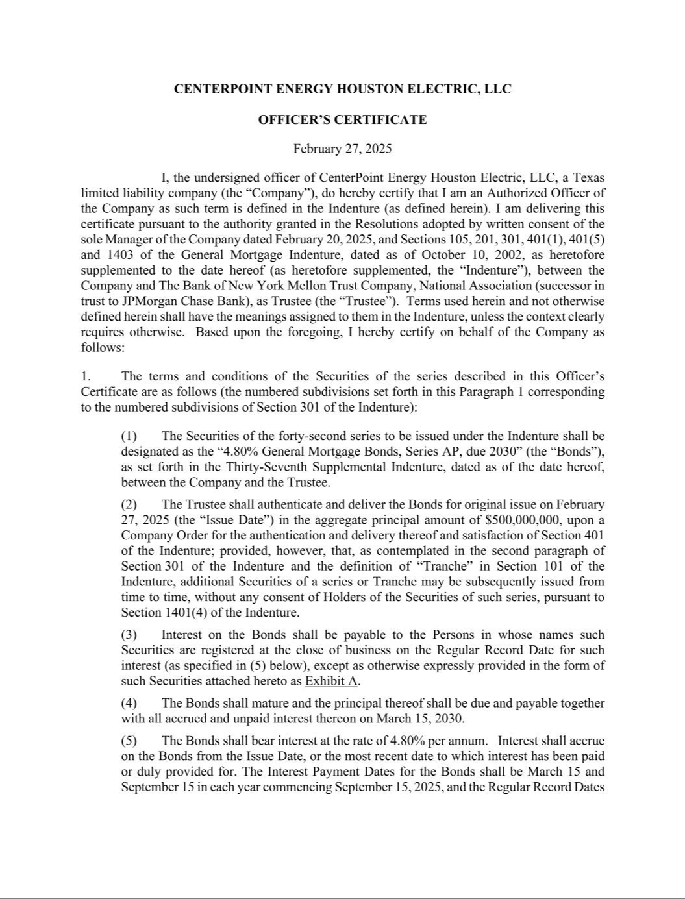

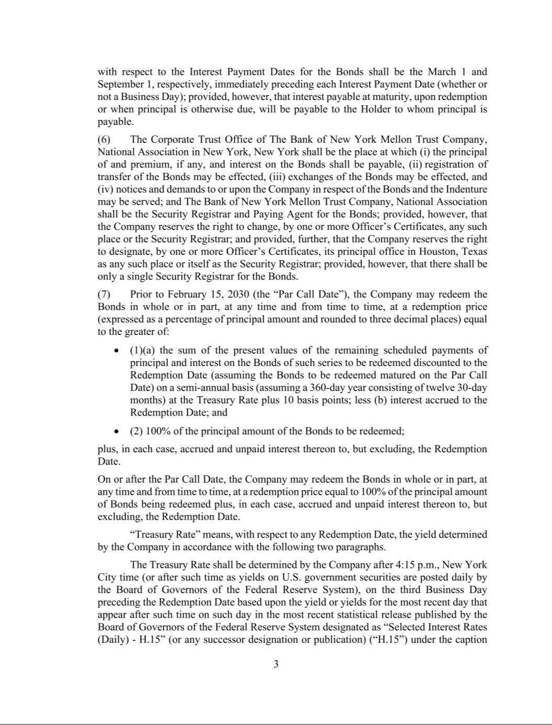

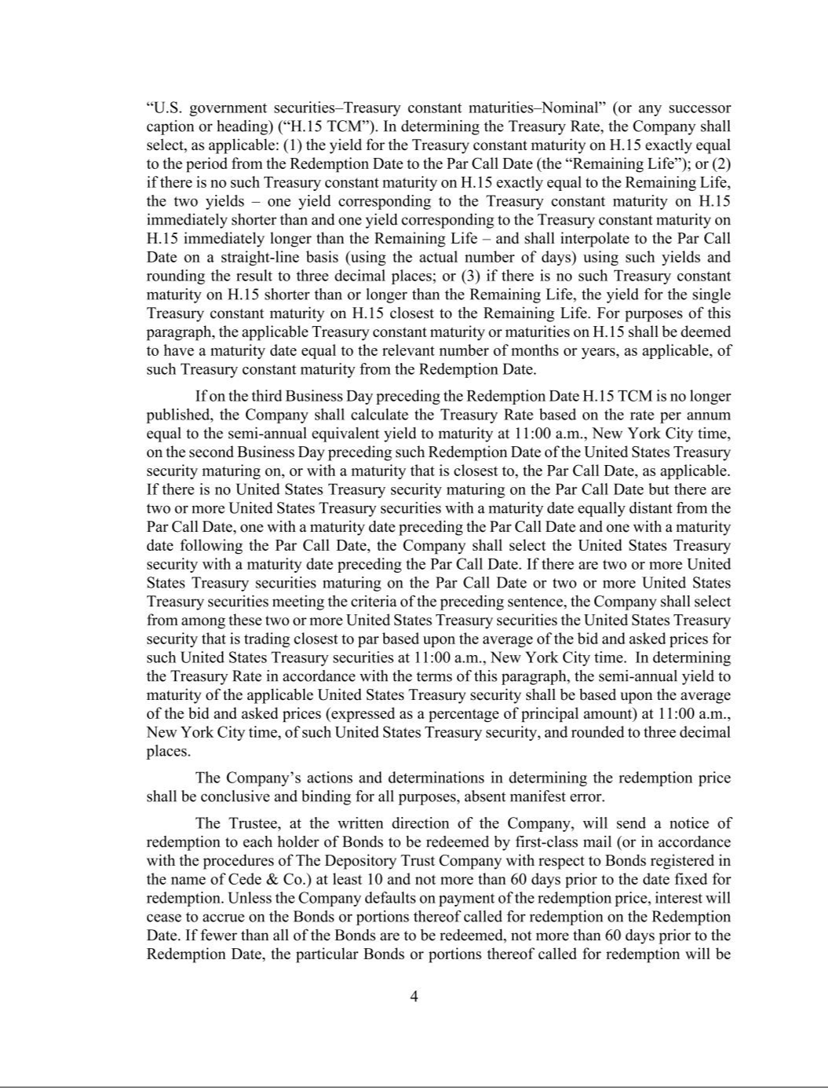

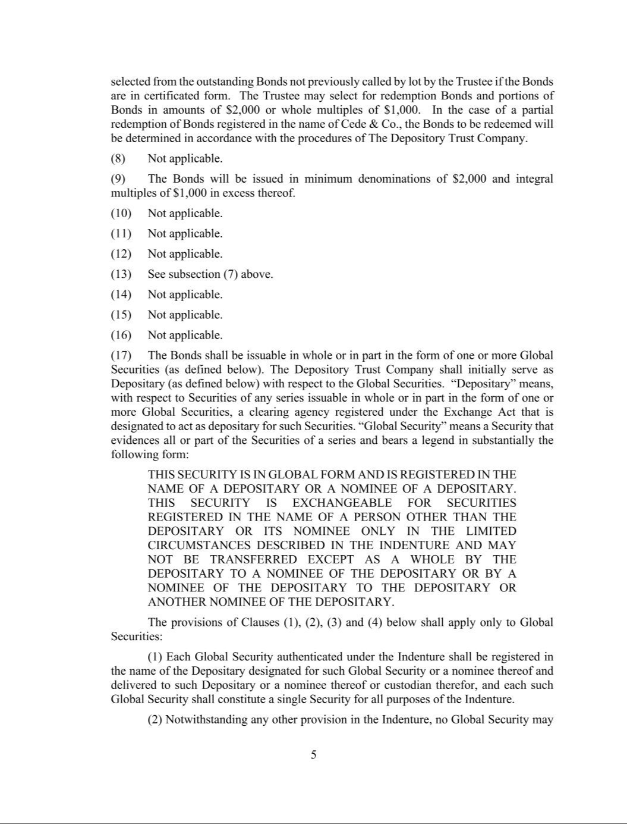

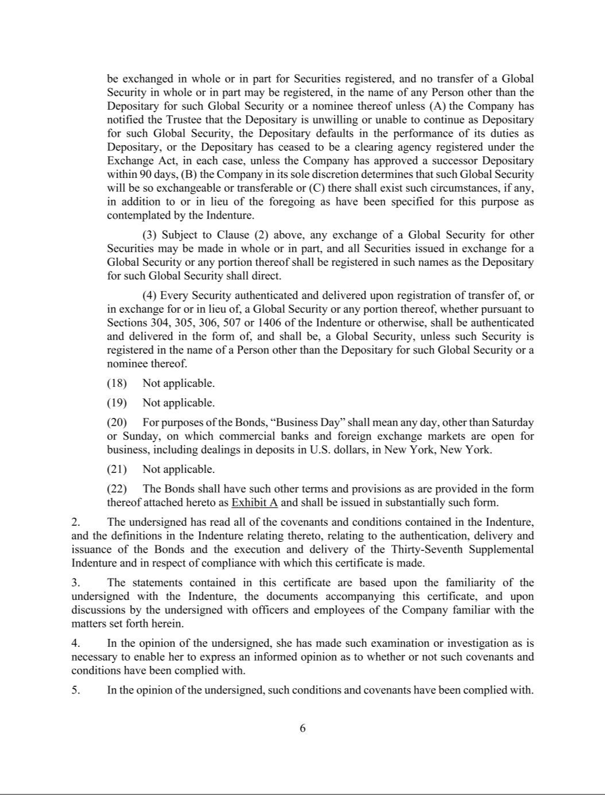

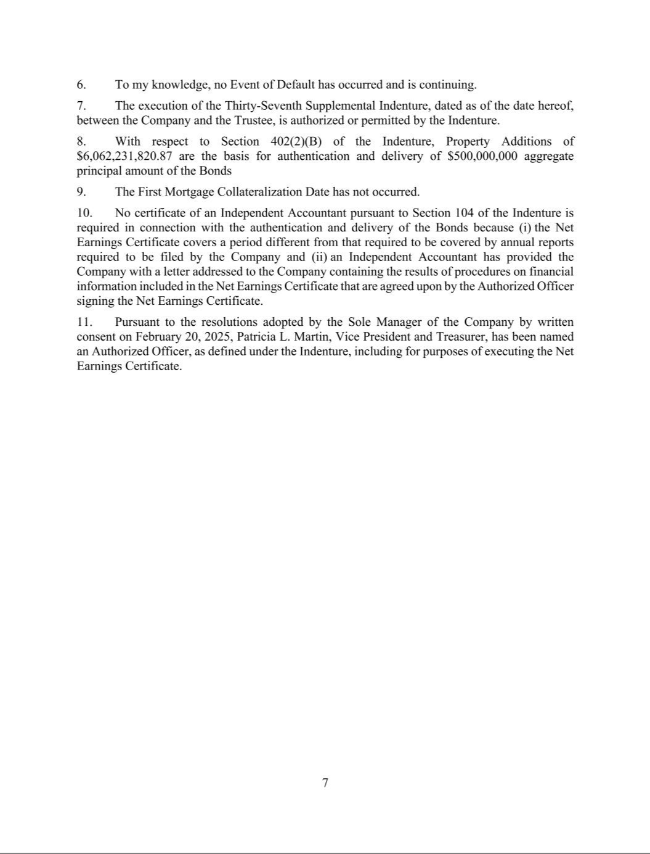

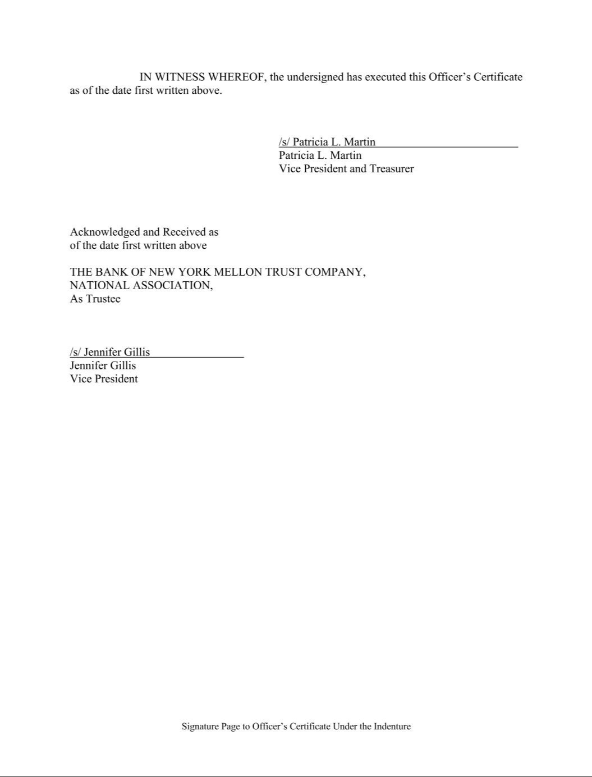



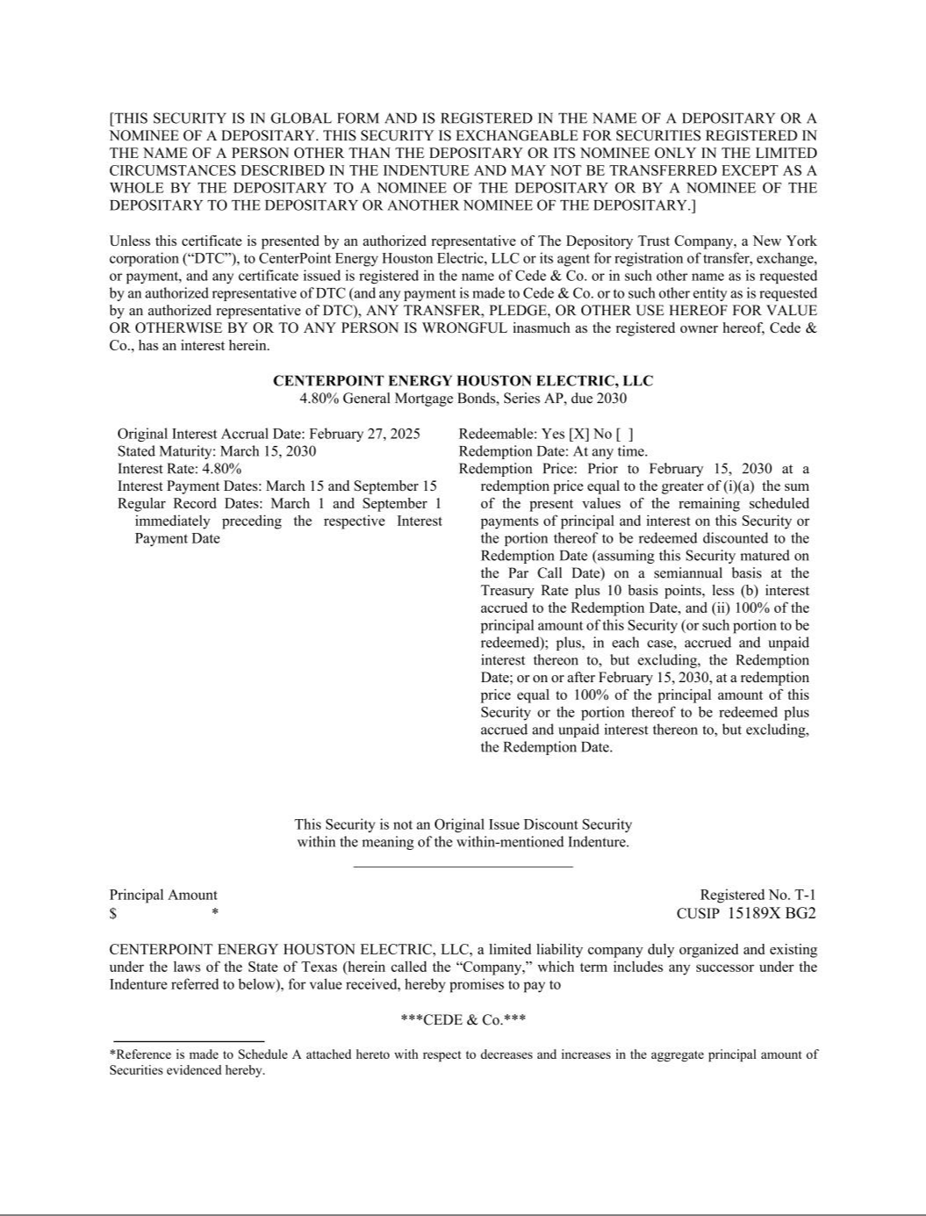

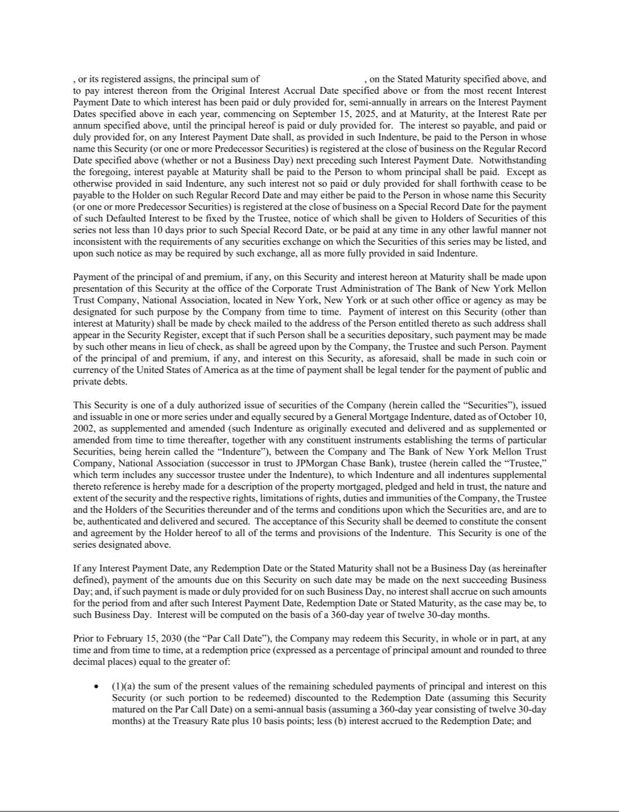

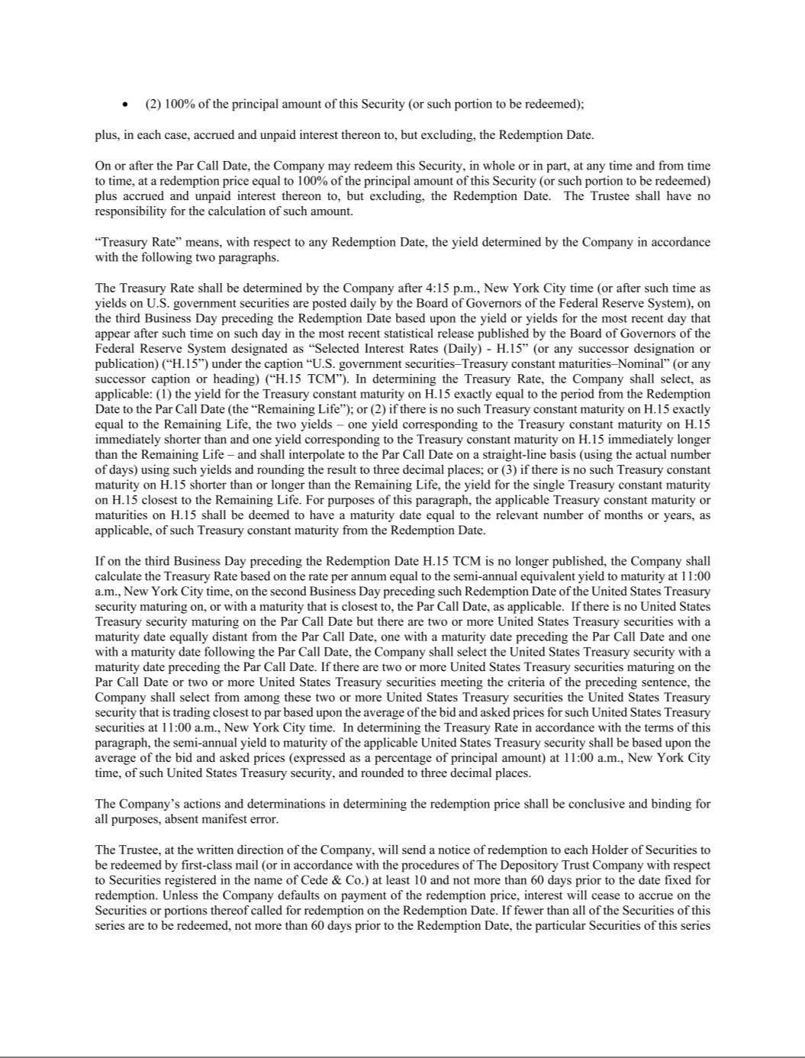

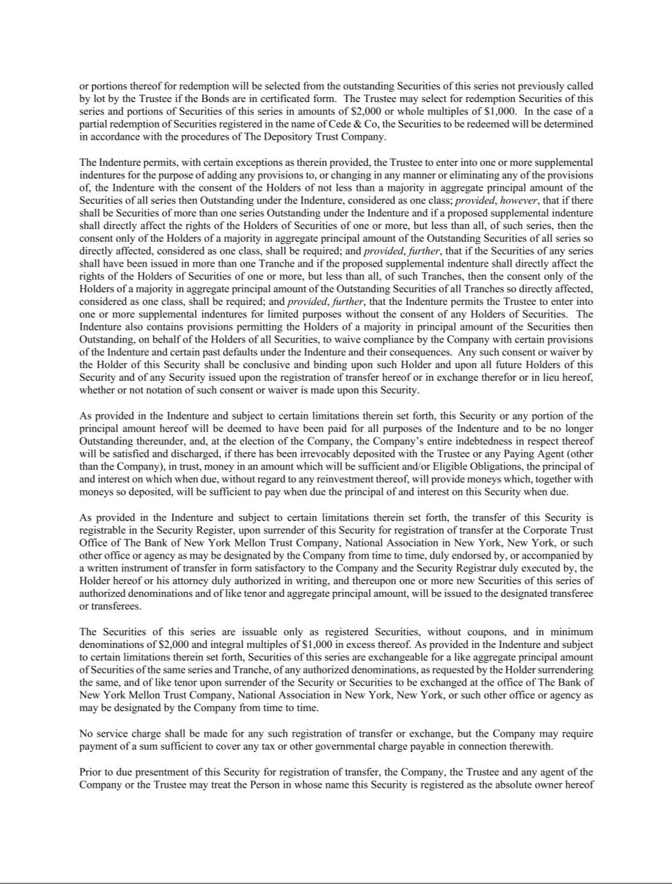

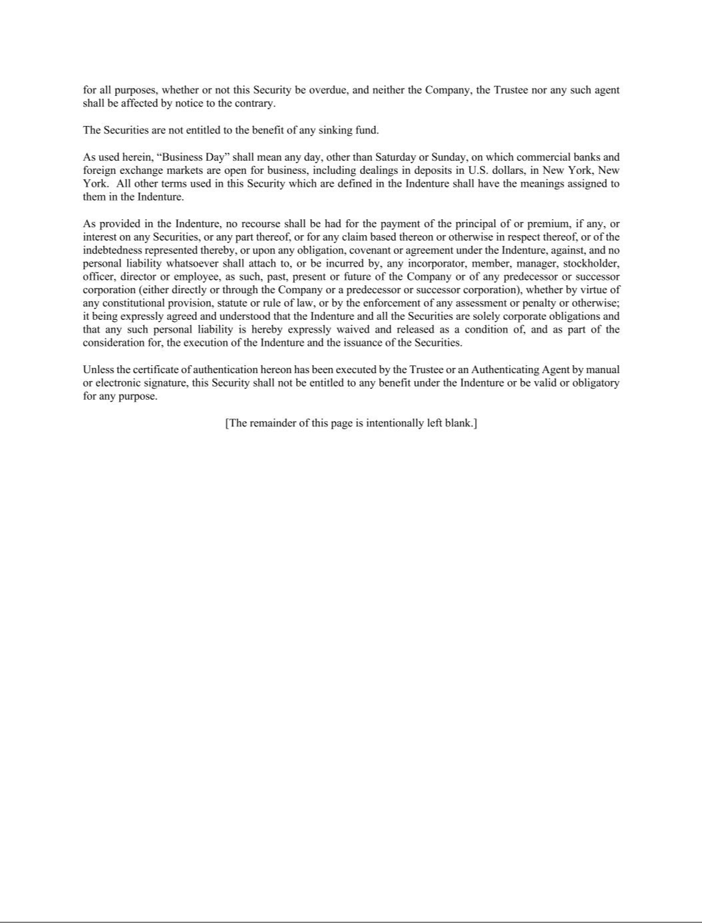

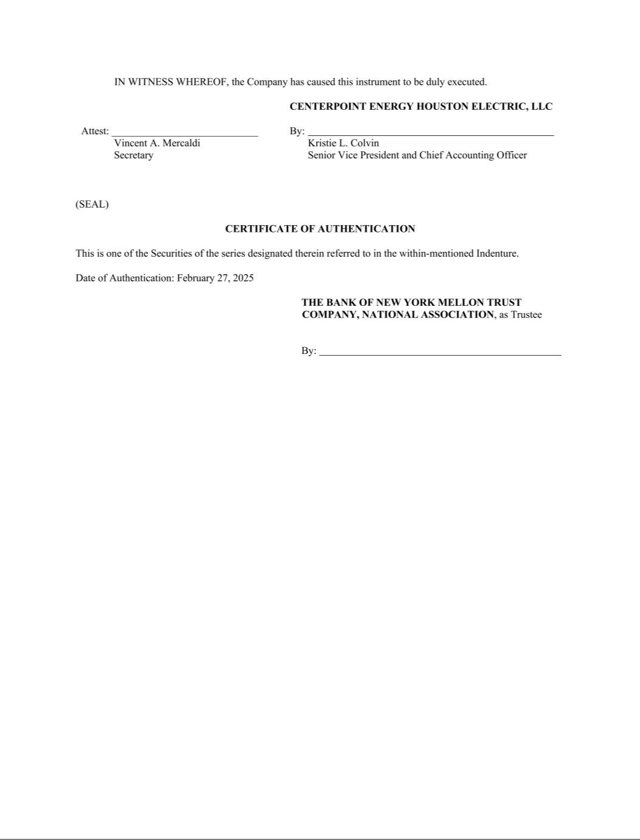

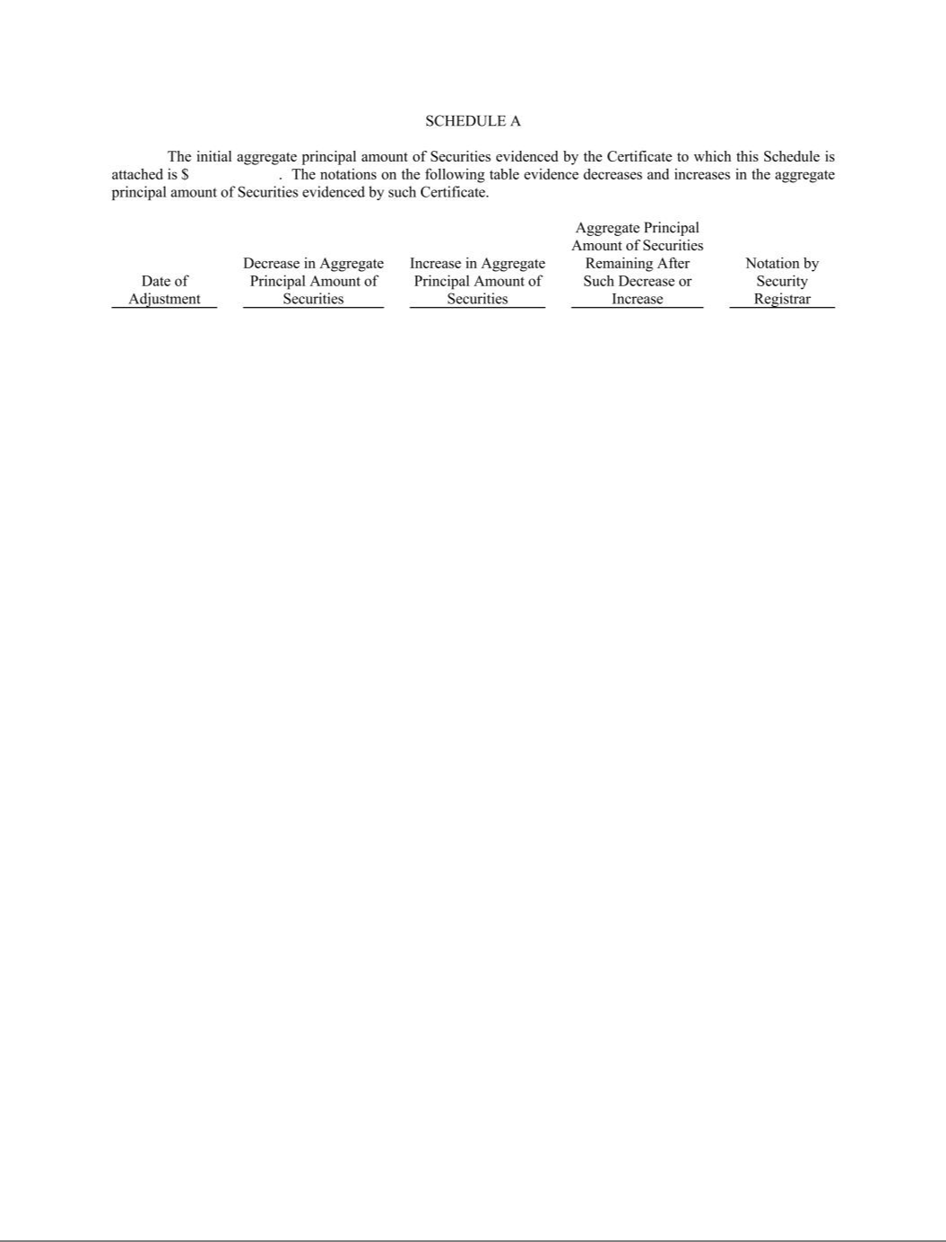

Exhibit 31.1.1

CERTIFICATIONS

I, Jason P. Wells, certify that:

- I have reviewed this quarterly report on Form 10-Q of CenterPoint Energy, Inc.;

- Based on my knowledge, this report does not contain any untrue statement of a material fact or omit to state a material fact necessary to make the statements made, in light of the circumstances under which such statements were made, not misleading with respect to the period covered by this report;

- Based on my knowledge, the financial statements, and other financial information included in this report, fairly present in all material respects the financial condition, results of operations and cash flows of the registrant as of, and for, the periods presented in this report;

- The registrant’s other certifying officer(s) and I are responsible for establishing and maintaining disclosure controls and procedures (as defined in Exchange Act Rules 13a-15(e) and

15d-15(e)) and internal control over financial reporting (as defined in Exchange Act Rules 13a-15(f) and 15d-15(f)) for the registrant and have:

- Designed such disclosure controls and procedures, or caused such disclosure controls and procedures to be designed under our supervision, to ensure that material information relating to the registrant, including its consolidated subsidiaries, is made known to us by others within those entities, particularly during the period in which this report is being prepared;

- Designed such internal control over financial reporting, or caused such internal control over financial reporting to be designed under our supervision, to provide reasonable assurance regarding the reliability of financial reporting and the preparation of financial statements for external purposes in accordance with generally accepted accounting principles;

- Evaluated the effectiveness of the registrant’s disclosure controls and procedures and presented in this report our conclusions about the effectiveness of the disclosure controls and procedures, as of the end of the period covered by this report based on such evaluation; and

- Disclosed in this report any change in the registrant’s internal control over financial reporting that occurred during the registrant’s most recent fiscal quarter (the registrant’s fourth fiscal quarter in the case of an annual report) that has materially affected, or is reasonably likely to materially affect, the registrant’s internal control over financial reporting; and

- The registrant’s other certifying officer(s) and I have disclosed, based on our most recent evaluation of internal control over financial reporting, to the registrant’s auditors and the audit committee of the registrant’s board of directors (or persons performing the equivalent functions):

- All significant deficiencies and material weaknesses in the design or operation of internal control over financial reporting which are reasonably likely to adversely affect the registrant’s ability to record, process, summarize and report financial information; and

- Any fraud, whether or not material, that involves management or other employees who have a significant role in the registrant’s internal control over financial reporting.

Date: April 24, 2025

/s/ Jason P. Wells

Jason P. Wells

President and Chief Executive Officer

Exhibit 31.1.2

CERTIFICATIONS

I, Darin M. Carroll, certify that:

- I have reviewed this quarterly report on Form 10-Q of CenterPoint Energy Houston Electric, LLC;

- Based on my knowledge, this report does not contain any untrue statement of a material fact or omit to state a material fact necessary to make the statements made, in light of the circumstances under which such statements were made, not misleading with respect to the period covered by this report;

- Based on my knowledge, the financial statements, and other financial information included in this report, fairly present in all material respects the financial condition, results of operations and cash flows of the registrant as of, and for, the periods presented in this report;

- The registrant’s other certifying officer(s) and I are responsible for establishing and maintaining disclosure controls and procedures (as defined in Exchange Act Rules 13a-15(e) and

15d-15(e)) and internal control over financial reporting (as defined in Exchange Act Rules 13a-15(f) and 15d-15(f)) for the registrant and have:

- Designed such disclosure controls and procedures, or caused such disclosure controls and procedures to be designed under our supervision, to ensure that material information relating to the registrant, including its consolidated subsidiaries, is made known to us by others within those entities, particularly during the period in which this report is being prepared;

- Designed such internal control over financial reporting, or caused such internal control over financial reporting to be designed under our supervision, to provide reasonable assurance regarding the reliability of financial reporting and the preparation of financial statements for external purposes in accordance with generally accepted accounting principles;

- Evaluated the effectiveness of the registrant’s disclosure controls and procedures and presented in this report our conclusions about the effectiveness of the disclosure controls and procedures, as of the end of the period covered by this report based on such evaluation; and

- Disclosed in this report any change in the registrant’s internal control over financial reporting that occurred during the registrant’s most recent fiscal quarter (the registrant’s fourth fiscal quarter in the case of an annual report) that has materially affected, or is reasonably likely to materially affect, the registrant’s internal control over financial reporting; and

- The registrant’s other certifying officer(s) and I have disclosed, based on our most recent evaluation of internal control over financial reporting, to the registrant’s auditors and the audit committee of the registrant’s board of directors (or persons performing the equivalent functions):

- All significant deficiencies and material weaknesses in the design or operation of internal control over financial reporting which are reasonably likely to adversely affect the registrant’s ability to record, process, summarize and report financial information; and

- Any fraud, whether or not material, that involves management or other employees who have a significant role in the registrant’s internal control over financial reporting.

Date: April 24, 2025

/s/ Darin M. Carroll

Darin M. Carroll

President and Chief Executive Officer

Exhibit 31.1.3

CERTIFICATIONS

I, Richard C. Leger, certify that:

- I have reviewed this quarterly report on Form 10-Q of CenterPoint Energy Resources Corp.;

- Based on my knowledge, this report does not contain any untrue statement of a material fact or omit to state a material fact necessary to make the statements made, in light of the circumstances under which such statements were made, not misleading with respect to the period covered by this report;

- Based on my knowledge, the financial statements, and other financial information included in this report, fairly present in all material respects the financial condition, results of operations and cash flows of the registrant as of, and for, the periods presented in this report;

- The registrant's other certifying officer(s) and I are responsible for establishing and maintaining disclosure controls and procedures (as defined in Exchange Act Rules 13a-15(e) and

15d-15(e)) and internal control over financial reporting (as defined in Exchange Act Rules 13a-15(f) and 15d-15(f)) for the registrant and have:

- Designed such disclosure controls and procedures, or caused such disclosure controls and procedures to be designed under our supervision, to ensure that material information relating to the registrant, including its consolidated subsidiaries, is made known to us by others within those entities, particularly during the period in which this report is being prepared;

- Designed such internal control over financial reporting, or caused such internal control over financial reporting to be designed under our supervision, to provide reasonable assurance regarding the reliability of financial reporting and the preparation of financial statements for external purposes in accordance with generally accepted accounting principles;

- Evaluated the effectiveness of the registrant's disclosure controls and procedures and presented in this report our conclusions about the effectiveness of the disclosure controls and procedures, as of the end of the period covered by this report based on such evaluation; and

- Disclosed in this report any change in the registrant's internal control over financial reporting that occurred during the registrant's most recent fiscal quarter (the registrant's fourth fiscal quarter in the case of an annual report) that has materially affected, or is reasonably likely to materially affect, the registrant's internal control over financial reporting; and

- The registrant's other certifying officer(s) and I have disclosed, based on our most recent evaluation of internal control over financial reporting, to the registrant's auditors and the audit committee of the registrant's board of directors (or persons performing the equivalent functions):

- All significant deficiencies and material weaknesses in the design or operation of internal control over financial reporting which are reasonably likely to adversely affect the registrant's ability to record, process, summarize and report financial information; and

- Any fraud, whether or not material, that involves management or other employees who have a significant role in the registrant's internal control over financial reporting. Date: April 24, 2025

/s/ Richard C. Leger

Richard C. Leger

President and Chief Executive Officer

Exhibit 31.2.1

CERTIFICATIONS

I, Christopher A. Foster, certify that:

- I have reviewed this quarterly report on Form 10-Q of CenterPoint Energy, Inc.;

- Based on my knowledge, this report does not contain any untrue statement of a material fact or omit to state a material fact necessary to make the statements made, in light of the circumstances under which such statements were made, not misleading with respect to the period covered by this report;

- Based on my knowledge, the financial statements, and other financial information included in this report, fairly present in all material respects the financial condition, results of operations and cash flows of the registrant as of, and for, the periods presented in this report;

- The registrant’s other certifying officer(s) and I are responsible for establishing and maintaining disclosure controls and procedures (as defined in Exchange Act Rules 13a-15(e) and

15d-15(e)) and internal control over financial reporting (as defined in Exchange Act Rules 13a-15(f) and 15d-15(f)) for the registrant and have:

- Designed such disclosure controls and procedures, or caused such disclosure controls and procedures to be designed under our supervision, to ensure that material information relating to the registrant, including its consolidated subsidiaries, is made known to us by others within those entities, particularly during the period in which this report is being prepared;

- Designed such internal control over financial reporting, or caused such internal control over financial reporting to be designed under our supervision, to provide reasonable assurance regarding the reliability of financial reporting and the preparation of financial statements for external purposes in accordance with generally accepted accounting principles;

- Evaluated the effectiveness of the registrant’s disclosure controls and procedures and presented in this report our conclusions about the effectiveness of the disclosure controls and procedures, as of the end of the period covered by this report based on such evaluation; and

- Disclosed in this report any change in the registrant’s internal control over financial reporting that occurred during the registrant’s most recent fiscal quarter (the registrant’s fourth fiscal quarter in the case of an annual report) that has materially affected, or is reasonably likely to materially affect, the registrant’s internal control over financial reporting; and

- The registrant’s other certifying officer(s) and I have disclosed, based on our most recent evaluation of internal control over financial reporting, to the registrant’s auditors and the audit committee of the registrant’s board of directors (or persons performing the equivalent functions):

- All significant deficiencies and material weaknesses in the design or operation of internal control over financial reporting which are reasonably likely to adversely affect the registrant’s ability to record, process, summarize and report financial information; and

- Any fraud, whether or not material, that involves management or other employees who have a significant role in the registrant’s internal control over financial reporting.

Date: April 24, 2025

/s/ Christopher A. Foster

Christopher A. Foster

Executive Vice President and Chief Financial Officer

Exhibit 31.2.2

CERTIFICATIONS

I, Christopher A. Foster, certify that:

- I have reviewed this quarterly report on Form 10-Q of CenterPoint Energy Houston Electric, LLC;

- Based on my knowledge, this report does not contain any untrue statement of a material fact or omit to state a material fact necessary to make the statements made, in light of the circumstances under which such statements were made, not misleading with respect to the period covered by this report;

- Based on my knowledge, the financial statements, and other financial information included in this report, fairly present in all material respects the financial condition, results of operations and cash flows of the registrant as of, and for, the periods presented in this report;

- The registrant’s other certifying officer(s) and I are responsible for establishing and maintaining disclosure controls and procedures (as defined in Exchange Act Rules 13a-15(e) and

15d-15(e)) and internal control over financial reporting (as defined in Exchange Act Rules 13a-15(f) and 15d-15(f)) for the registrant and have:

- Designed such disclosure controls and procedures, or caused such disclosure controls and procedures to be designed under our supervision, to ensure that material information relating to the registrant, including its consolidated subsidiaries, is made known to us by others within those entities, particularly during the period in which this report is being prepared;

- Designed such internal control over financial reporting, or caused such internal control over financial reporting to be designed under our supervision, to provide reasonable assurance regarding the reliability of financial reporting and the preparation of financial statements for external purposes in accordance with generally accepted accounting principles;

- Evaluated the effectiveness of the registrant’s disclosure controls and procedures and presented in this report our conclusions about the effectiveness of the disclosure controls and procedures, as of the end of the period covered by this report based on such evaluation; and

- Disclosed in this report any change in the registrant’s internal control over financial reporting that occurred during the registrant’s most recent fiscal quarter (the registrant’s fourth fiscal quarter in the case of an annual report) that has materially affected, or is reasonably likely to materially affect, the registrant’s internal control over financial reporting; and

- The registrant’s other certifying officer(s) and I have disclosed, based on our most recent evaluation of internal control over financial reporting, to the registrant’s auditors and the audit committee of the registrant’s board of directors (or persons performing the equivalent functions):

- All significant deficiencies and material weaknesses in the design or operation of internal control over financial reporting which are reasonably likely to adversely affect the registrant’s ability to record, process, summarize and report financial information; and

- Any fraud, whether or not material, that involves management or other employees who have a significant role in the registrant’s internal control over financial reporting.

Date: April 24, 2025

/s/ Christopher A. Foster

Christopher A. Foster

Executive Vice President and Chief Financial Officer

Exhibit 31.2.3

CERTIFICATIONS

I, Christopher A. Foster, certify that:

- I have reviewed this quarterly report on Form 10-Q of CenterPoint Energy Resources Corp.;

- Based on my knowledge, this report does not contain any untrue statement of a material fact or omit to state a material fact necessary to make the statements made, in light of the circumstances under which such statements were made, not misleading with respect to the period covered by this report;

- Based on my knowledge, the financial statements, and other financial information included in this report, fairly present in all material respects the financial condition, results of operations and cash flows of the registrant as of, and for, the periods presented in this report;

- The registrant's other certifying officer(s) and I are responsible for establishing and maintaining disclosure controls and procedures (as defined in Exchange Act Rules 13a-15(e) and

15d-15(e)) and internal control over financial reporting (as defined in Exchange Act Rules 13a-15(f) and 15d-15(f)) for the registrant and have:

- Designed such disclosure controls and procedures, or caused such disclosure controls and procedures to be designed under our supervision, to ensure that material information relating to the registrant, including its consolidated subsidiaries, is made known to us by others within those entities, particularly during the period in which this report is being prepared;

- Designed such internal control over financial reporting, or caused such internal control over financial reporting to be designed under our supervision, to provide reasonable assurance regarding the reliability of financial reporting and the preparation of financial statements for external purposes in accordance with generally accepted accounting principles;

- Evaluated the effectiveness of the registrant's disclosure controls and procedures and presented in this report our conclusions about the effectiveness of the disclosure controls and procedures, as of the end of the period covered by this report based on such evaluation; and

- Disclosed in this report any change in the registrant's internal control over financial reporting that occurred during the registrant's most recent fiscal quarter (the registrant's fourth fiscal quarter in the case of an annual report) that has materially affected, or is reasonably likely to materially affect, the registrant's internal control over financial reporting; and

- The registrant's other certifying officer(s) and I have disclosed, based on our most recent evaluation of internal control over financial reporting, to the registrant's auditors and the audit committee of the registrant's board of directors (or persons performing the equivalent functions):

- All significant deficiencies and material weaknesses in the design or operation of internal control over financial reporting which are reasonably likely to adversely affect the registrant's ability to record, process, summarize and report financial information; and

- Any fraud, whether or not material, that involves management or other employees who have a significant role in the registrant's internal control over financial reporting. Date: April 24, 2025

/s/ Christopher A. Foster

Christopher A. Foster

Executive Vice President and Chief Financial Officer

Exhibit 32.1.1

CERTIFICATION PURSUANT TO

18 U.S.C. SECTION 1350,

AS ADOPTED PURSUANT TO SECTION 906

OF THE SARBANES-OXLEY ACT OF 2002

In connection with the Quarterly Report of CenterPoint Energy, Inc. (the “Company”) on Form 10-Q for the quarter ended March 31, 2025 (the “Report”), as filed with the Securities and Exchange Commission on the date hereof, I, Jason P. Wells, Chief Executive Officer, certify, pursuant to 18 U.S.C. Section 1350, as adopted pursuant to Section 906 of the Sarbanes-Oxley Act of 2002, to the best of my knowledge, that:

- The Report fully complies with the requirements of section 13(a) or 15(d) of the Securities Exchange Act of 1934, as amended; and

- The information contained in the Report fairly presents, in all material respects, the financial condition and results of operations of the Company.

/s/ Jason P. Wells

Jason P. Wells

President and Chief Executive Officer

April 24, 2025

Exhibit 32.1.2

CERTIFICATION PURSUANT TO

18 U.S.C. SECTION 1350,

AS ADOPTED PURSUANT TO SECTION 906

OF THE SARBANES-OXLEY ACT OF 2002

In connection with the Quarterly Report of CenterPoint Energy Houston Electric, LLC (the “Company”) on Form 10-Q for the quarter ended March 31, 2025 (the “Report”), as filed with the Securities and Exchange Commission on the date hereof, I, Darin M. Carroll, Chief Executive Officer, certify, pursuant to 18 U.S.C. Section 1350, as adopted pursuant to Section 906 of the Sarbanes-Oxley Act of 2002, to the best of my knowledge, that:

- The Report fully complies with the requirements of section 13(a) or 15(d) of the Securities Exchange Act of 1934, as amended; and

- The information contained in the Report fairly presents, in all material respects, the financial condition and results of operations of the Company.

/s/ Darin M. Carroll

Darin M. Carroll

President and Chief Executive Officer

April 24, 2025

Exhibit 32.1.3

CERTIFICATION PURSUANT TO

18 U.S.C. SECTION 1350,

AS ADOPTED PURSUANT TO SECTION 906

OF THE SARBANES-OXLEY ACT OF 2002

In connection with the Quarterly Report of CenterPoint Energy Resources Corp. (the “Company”) on Form 10-Q for the quarter ended March 31, 2025 (the “Report”), as filed with the Securities and Exchange Commission on the date hereof, I, Richard C. Leger, Chief Executive Officer, certify, pursuant to 18 U.S.C. Section 1350, as adopted pursuant to Section 906 of the Sarbanes-Oxley Act of 2002, to the best of my knowledge, that:

- The Report fully complies with the requirements of section 13(a) or 15(d) of the Securities Exchange Act of 1934, as amended; and

- The information contained in the Report fairly presents, in all material respects, the financial condition and results of operations of the Company.

/s/ Richard C. Leger

Richard C. Leger

President and Chief Executive Officer

April 24, 2025

Exhibit 32.2.1

CERTIFICATION PURSUANT TO

18 U.S.C. SECTION 1350,

AS ADOPTED PURSUANT TO SECTION 906

OF THE SARBANES-OXLEY ACT OF 2002

In connection with the Quarterly Report of CenterPoint Energy, Inc. (the “Company”) on Form 10-Q for the quarter ended March 31, 2025 (the “Report”), as filed with the Securities and Exchange Commission on the date hereof, I, Christopher A. Foster, Chief Financial Officer, certify, pursuant to 18 U.S.C. Section 1350, as adopted pursuant to Section 906 of the Sarbanes-Oxley Act of 2002, to the best of my knowledge, that:

- The Report fully complies with the requirements of section 13(a) or 15(d) of the Securities Exchange Act of 1934, as amended; and

- The information contained in the Report fairly presents, in all material respects, the financial condition and results of operations of the Company.

/s/ Christopher A. Foster

Christopher A. Foster

Executive Vice President and Chief Financial Officer

April 24, 2025

Exhibit 32.2.2

CERTIFICATION PURSUANT TO

18 U.S.C. SECTION 1350,

AS ADOPTED PURSUANT TO SECTION 906

OF THE SARBANES-OXLEY ACT OF 2002

In connection with the Quarterly Report of CenterPoint Energy Houston Electric, LLC (the “Company”) on Form 10-Q for the quarter ended March 31, 2025 (the “Report”), as filed with the Securities and Exchange Commission on the date hereof, I, Christopher A. Foster, Chief Financial Officer, certify, pursuant to 18 U.S.C. Section 1350, as adopted pursuant to Section 906 of the Sarbanes-Oxley Act of 2002, to the best of my knowledge, that:

- The Report fully complies with the requirements of section 13(a) or 15(d) of the Securities Exchange Act of 1934, as amended; and

- The information contained in the Report fairly presents, in all material respects, the financial condition and results of operations of the Company.

/s/ Christopher A. Foster

Christopher A. Foster

Executive Vice President and Chief Financial Officer

April 24, 2025

Exhibit 32.2.3

CERTIFICATION PURSUANT TO

18 U.S.C. SECTION 1350,

AS ADOPTED PURSUANT TO SECTION 906

OF THE SARBANES-OXLEY ACT OF 2002

In connection with the Quarterly Report of CenterPoint Energy Resources Corp. (the “Company”) on Form 10-Q for the quarter ended March 31, 2025 (the “Report”), as filed with the Securities and Exchange Commission on the date hereof, I, Christopher A. Foster, Chief Financial Officer, certify, pursuant to 18 U.S.C. Section 1350, as adopted pursuant to Section 906 of the Sarbanes-Oxley Act of 2002, to the best of my knowledge, that:

- The Report fully complies with the requirements of section 13(a) or 15(d) of the Securities Exchange Act of 1934, as amended; and

- The information contained in the Report fairly presents, in all material respects, the financial condition and results of operations of the Company.

/s/ Christopher A. Foster

Christopher A. Foster

Executive Vice President and Chief Financial Officer

April 24, 2025

